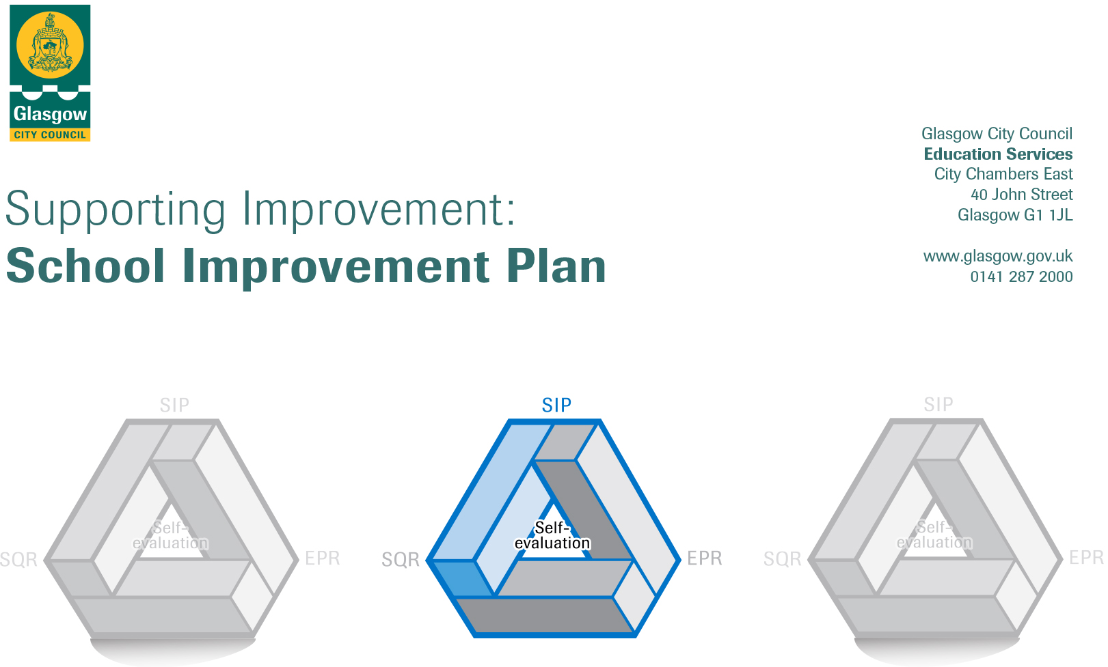

Establishment |  | Cloverbank Nursery
Head of Establishment |  | Janice McIntyre
Area/Local Improvement Group |  | NWL 1
Head of Service |  | Maureen McKenna
Area Education Officer/  Quality Improvement Officer |  | Jim Wilson

CONTENTS
1. Vision, Values and Aims
2. Summary of Self-Evaluation Process / Priorities for Improvement in the current session
3. Action Planning

Action Plan Summary for Stakeholders

1. Our Vision, Values and Aims
To support children to become successful learners, confident individuals, effective contributors and responsible citizens. With a commitment to continuous improvement we aim to provide quality learning experiences for children to help them to do their very best with an enthusiasm for learning within the principles and practices of “Curriculum for Excellence”. We aim to provide the highest standard of education and care for our children in a safe and stimulating environment where learning is fun and challenging.
Aims
- To work co-operatively with parents and carers to deliver the highest quality of learning and teaching.
- To support all children to reach their fullest potential.
- To continue to promote the raising the standards of literacy and numeracy.
- To develop skills to promote positive behaviour and good citizenship in consultation with children as reflected in the Children’s Charter
- To promote opportunities for all within an ethos of inclusion.
- To work effectively in partnership with parents and the wider community developing an enterprising approach to learning
- To establish a secure and welcoming environment where learning is exciting, challenging and is good fun.

Values
Our Values at Cloverbank Nursery School are the characteristics that we believe are essential for lifelong learning:
By supporting children in adapting to different experiences and achieve emotional well-being they can develop taking responsibility, recognising and managing their own feelings and begin to understand the feelings of others, have a sense of independence and self-worth, form and maintain positive, mutually respectful relationships with others, be able to solve problems and make informed decisions and have a sense of purpose and goals for the future.

Vision
Our vision is to provide a service that is responsive to the needs of our children, parents, carers and the community we serve:
- To support parents through engagement with external services to assist them in developing the confidence to enable them to access support systems as and when required therefore, securing outcomes for themselves.

We consulted with all our families on our vision and values within an overall audit for improvement planning.
Several of the returns we received indicated the parents felt that our vision and values were shared with them. Their aims were to ensure a safe, happy, relaxed, fun and stimulating learning environment for their children; we have now added this as a strand of our vision statement. Consultation with staff to analysing the responses from above in conjunction with staff’s views on our vision values and aims results in our staff being committed to developing their skills in engaging with parents and supporting children’s rights in all aspects of the nursery and the wider community.

2. Summary of our self-evaluation process.
Using HGIOELC all staff were involved in the systematic process of self – evaluation looking at areas that were embedded in practice, areas of emerging practice and areas which required to be developed.
We have ‘a whole school approach to ‘self-evaluation. Education monitoring calendar ensures that self-evaluation and reflective practice enables a collegiate approach to continuous improvement.
Collegiate self-evaluation is now embedded and stakeholder evaluations are firmly in place to help shape the support and engagement with families to ensure that it is targeted and relevant. Views of our parents and carers are sought through Questionnaires. Children’s views are considered in daily practice, children’s questionnaires and through our eco committee.

Strengths identified:
How good is our leadership and approach to improvement?
Our children are confident, motivated and ready to learn. They are making good progress in all aspects of their learning and development. All staff had a leader of learning role to support the quality in specific learning areas.
Areas for Improvement: Continue to use the process of self-evaluation to support targeted staff development and training to enhance the provision of learning and teaching for our children.

How good is the quality of care and education we offer?
Children experience a rich and creative curriculum both indoors and out. There is a good balance of child led and adult directed play and learning. Children are consulted and shape the curriculum to ensure relevance. To ensure depth in learning the learning the children’s experiences are planned to include our outdoor environment to support breadth and challenge.

Areas for Improvement: We intend to continue to embed our outdoor learning programmes for children and parents by including Lfs in our improvement plan 2020-21

How good are we at improving outcomes for all our learners?
Our systematic programme of self-evaluation within the playrooms demonstrates a commitment to improving our learning and teaching approaches. We have a robust self-evaluation process that includes tracking children’s individual learning and identifying gaps in learning leading to purposeful planning for improving learning outcomes.

Areas for Improvement: To further develop the tracking system to become slicker and joined up with easily identifiable gaps in children’s progression, development and learning.
Priorities for development:
1: Communication Friendly Nursery

2: Sustainability

3: Service Expansion

4: Nurture-Reconnecting

No. | Priority | Stage of development | Main driver of priority: |  |  | Alignment to:
 |  | Exploring, Developing or Embedding | Self- Evaluation/VSE | Education Scotland report |  | QI | Wellbeing  Framework | Service  Priorities | Collaboration and Partnership  Working
1 | Communication Friendly Nursery | Embedding | Self- Evaluation |  |  | 3.2 | Included  Achieving | √ | Working with Speech and Language therapy Department  Educational Psychologist
2 | Sustainability | Embedding | Self- Evaluation |  |  | 2.2 | Achieving  Included | √ | Working with both primary and early year’s colleagues.  Working with parents and third sector colleagues.  Lfs steering group  Leaders of Learning
3 | Service Expansion | Developing |  |  |  | 1.3 |  | √ | Working with Early years Manager, Expansion Manager, Cordia, Local Neighbourhood Heads of Nurseries, HR and Parents
4 | Nurture-Reconnecting | Embedding |  |  |  | 1.4 |  | √

3. Action Planning
Please see attached Driver Diagram used in line with the Three Horizons approach

No. | Quality Indicator | Priority
1 | 3.2 | Communication Friendly Nursery  Target: The whole nursery setting will show commitment to supporting and developing children’s Communication and Language skills.

Tasks to achieve priority | Timescale  and checkpoints | Evidence of Impact > (data, observation, views)
Staff training on what a Communication Friendly Nursery is. | Completed | Records of Staff training
Self –evaluation toolkit completed | Completed | Action plan derived from the development outcomes established from in the tool kit
Staff training on the use the Frère Leavers scale of engagement | In-service day /  Feb 2021 | Practitioner’s interactive styles are responsive to individual children’s needs. Adults talk encourages participation from all learners

Staff leading on this priority – including partners | Resources and staff development
- Head of Nursery (HON), Lead Practitioner of Attainment (LPA), Leader of Learning in communication/Language.  - Educational Psychologist  - Speech and Language therapy (SALT) | - In service on Communication Friendly Nursery delivered by SALT

No. | Quality Indicator | Priority
2 | 2.2 | Sustainability  Target: To support the development of children’s skills for life and learning, and an awareness of the world in which they live and grow.

Tasks to achieve priority | Timescale  and checkpoints | Evidence of Impact > (data, observation, views)
Nurture an enterprising culture to support sustainability by  developing a programme of events encouraging partnerships with parents in children’s Lfs | April 2021 | Food growing bags going home with children and parents to cook at home.  Parents active with their children in tending/planting and using the vegetables and herbs in the allotments.
Develop children’s and parent’s knowledge of relevant global issues and how we can contribute to sustaining our world. | Jan 2021 / May 2021 | Self-evaluation  Parent questionnaires  Children’s learning stories, Children’s assessments and profiles show progression in learning about the world around them.

Staff leading on this priority – including partners | Resources and staff development
- Depute HON, Leader of learning CDO for LFS (Alison Kerr) Sewing seeds, Green space, Glasgow’s LFS Network | - In-house training on Global Goals

No. | Quality Indicator | Priority
3 | 1.3 | Service Expansion  Target: To ensure all children and families have a service which is responsive to their needs and supports raising attainment, further education and socio economic growth.

Tasks to achieve priority | Timescale  and checkpoints | Evidence of Impact > (data, observation, views)
Staffing structure in place to support expansion and lunch provision. | October 2020 | New children’s routines, learning structure, planning and staff duties rotas
Scoping exercise to with returning families to ascertain the demand for extended year provision to ensure it is needs led. | August 2020 | All legacy children’s parents surveyed on what provision would suit them and their circumstances best.
Staff training and induction | August 2020 | New staff induction and training dates and PRD’s
Monitor the usage of the service and the impact it has on families and learners. | Jan 2020 / April 2021 | Uptake of provision monitored through click n go  Questionnaires to parents  Children’s progress

Staff leading on this priority – including partners | Resources and staff development
- HON  - All staff  - Early years’ service managers  - Human Resources  - Local Neighbourhood colleagues | - Physical resources  - Building upgrades  - Staffing compliment  - New staff development on curriculum, planning, assessment.  - Teambuilding with all staff

No. | Quality Indicator | Priority
4 | 3.1 | Applying Nurture as a Whole school Approach.  Target: To effectively engage in a whole school nurturing approach which is consistent and embedded in practice. To ensure that the nurturing principles drive effective staff/child engagement and that this approach has a positive impact on children’s health and wellbeing and closing the attainment gap.

Tasks to achieve priority | Timescale  and checkpoints | Evidence of Impact > (data, observation, views)
Staff training.  Revisiting training and building on prior knowledge of training resource ‘Towards the Nurturing school.’ GCC.  Ensure staff have a key understanding of the ‘Nurturing principles’ | August 2020 | Staff have a better understanding of the ‘nurturing principles’ and how these principles support and shape their practice and the service they deliver.
Self-evaluation and effectively implement ethos and priorities laid out in document ‘Applying Nurture as a whole school approach: A framework to support the self-evaluation of nurturing approaches in Schools and Early Learning and Childcare settings.’ | August 2020-June 2021 | Implementing document and guidance tool will ensure staff adopt a reflective approach to nurturing, positive, tailored engagement levels with children using the service.
Ensure staff become aware that a nurturing approach is key in supporting behaviour management, health and wellbeing, resilience levels and self-regulatory skills in children. | August 2020-June 2021 | More structured support for children in line with a GIRFEC approach and themes highlighted in the Children and Young Peoples Act. Children’s behaviour, wellbeing, attainment, and achievement levels increase and improve.
Continued monitoring of practice and the impact a nurturing approach has on children from an impoverished background and its effectiveness of closing the attainment gap. A ‘targeted approach and a universal approach’ for all children within the establishment. | August 2020-June 2021 | Using Boxhall, profile, Attunement profile and other monitoring tools which  highlights the impact a nurturing approach has on children and staff.  Questionnaires for staff.  Peer monitoring and assessment.  Children’s progress and curriculum engagement is monitored my SMT.  Adult/child interactions monitored by SMT.

Staff leading on this priority – including partners | Resources and staff development
- SMT  - Staff trained in 4 Day Nurture Training Course  - All staff  - Speech and language therapist/occupational therapists  - Local Neighbourhood colleagues i.e. primary teaching staff | - Staff training  - Robust self-evaluation programme.  - Physical resources i.e. Snug-Nurture/sensory room  - Staff development on curriculum, planning, assessment.  - Staff assessment of nurture principles within establishment.

