

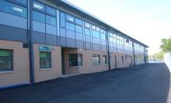
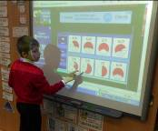
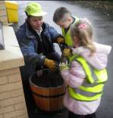

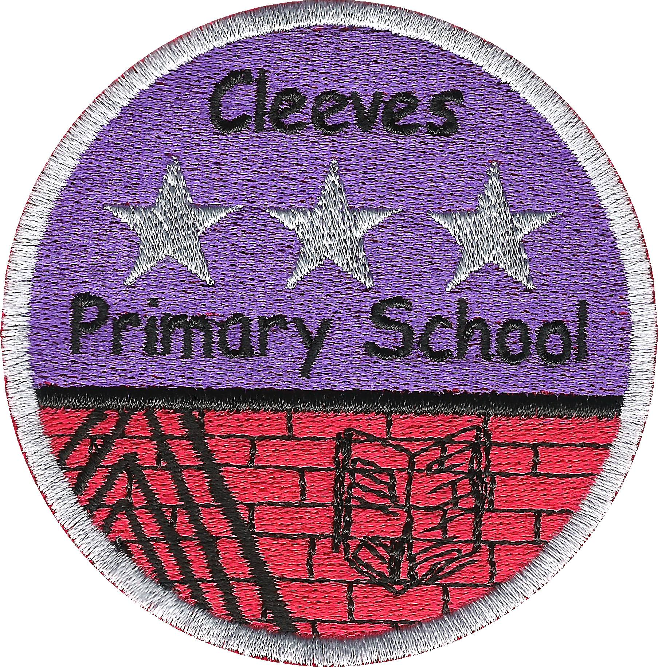

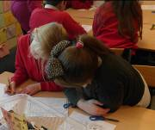
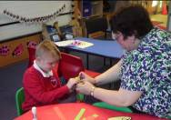

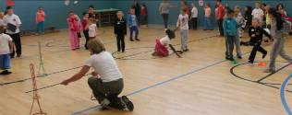

Welcome to Cleeves Primary School.
This handbook is designed to give parents and carers an insight into our school and how it works. I hope you find it interesting, informative and useful. Please do not hesitate to contact me if there is any matter which causes concern, or is of particular interest to you.

S. Beaton
Head Teacher
October 2017

Cleeves Primary School
271 Househillmuir Road
Glasgow G53 6NL

Headteacher: Mrs Susan Beaton

Telephone: 0141 880 5305
Fax: 0141 881 4781

Email: headteacher@cleeves-pri.glasgow.sch.uk

Website: www.cleeves-pri.glasgow.sch.uk

Twitter: @cleevesPS

Blog: blogs.glowscotland.org.uk/gc/cleevesps/

Parent Council Email: cleevesparentcouncil@yahoo.co.uk

School Capacity: 396 Present Roll: 270

Classification 2016 – 2017:
P1 | P2 | P3/2 | P3 | P4 | P5/4 | P5 | P6 | P7/6 | P7
23 | 28 | 21 | 28 | 33 | 24 | 32 | 33 | 25 | 23

Stages P1 – P7 are catered for and Cleeves is a non-denominational establishment teaching both boys and girls.

Classes are organised following guidelines set by the Scottish Government:
P1 maximum nos. 25
P2 & P3 maximum nos. 30
P4 - P7 maximum nos. 33
Composite classes maximum nos. 25 (pupils from more than one stage)

The school was officially opened on 7th December 2009. We are housed in a new two storey building which has a well-developed outdoor play area and houses 3Hills Community Garden of which we are a member.
School Staff:

Teaching Staff:
Head Teacher Mrs S. Beaton

Depute Head Teacher (Mon, Tues & Weds) Miss A. Burnet
Depute Head Teacher (Thurs, Fri) Mrs E. McCallum

Principal Teachers Miss H. Knox
Miss A. McAnish
Mrs A. Bissett

P1 Mrs Byrne / Mrs MacLean / Mrs McVey
P2 Mrs C. Mitchell
P3/2 Mrs F. Ali
P3 Miss R. Stewart
P4 Miss A. Fox
P5 Miss S. Shek
P5/4 Miss L. Blackwall
P6 Miss A. McAnish
P7/6 Mrs E. MacLaren
P7 Mrs S. Rendall

NCCT & Support Mrs J. Hope / Mr A. Murray / Ms C. McKelvie
Nurture (Busy Bee Base) Mrs G. Kirwan

Support Staff:
Pupil Support Assistants Mrs L. Docherty
Ms. D. McQueen
Mrs L. Gray (Busy Bee Base)
Mrs R. Long
Mrs L. McDougall
Mrs M. Tervit (Mon, Tues, Weds, Fri)
Mrs M. Jordan
Ms A. McCusker (Tues – Fri)
Ms V. Stewart

Admin. Support Mrs K. O’Rourke / Mrs K. Fyfe

Janitor Mrs K. Fulton

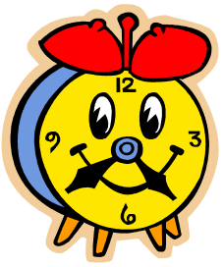
Catering Manager Mrs A. Humes

School Hours:

Breakfast Club 8.00am – 8.45am
Start 9am
Interval 10.30am – 10.45am
Lunch 12.15pm – 1.00pm
Dismiss 3.00pm
After School (Ypeople – 07876028651) 3.00pm – 6.00pm

P1 children are dismissed at lunch time until the first Monday in September, after which they will remain in school until 3pm.

School Holidays
Details of holiday dates are available on the Glasgow City Council website: www.glasgow.gov.uk/index.aspx?articleid=17024 or, on enquiry, at the school office: 0141 880 5305.

School Ethos

Our school vision, values and aims were drawn up in consultation with pupils, parents and staff. They were most recently reviewed in August 2016 and take account of Children’s Rights a leaflet on which can be found at: http://www.glasgow.gov.uk/childrensrights

Vision:
Cleeves Primary School provides a welcoming, nurturing and safe learning environment, giving pupils the opportunity to achieve their full potential. This will be achieved through working together with children, their families and the community, based on a shared sense of direction.

Values:
Respect Honesty Responsibility Aspiration Teamwork

Aims:

In Cleeves Primary School, we aim to
- Provide a high quality learning experience for all which supports all children in achieving their potential and celebrates success within school and in the wider community
- Build positive partnerships with families and the community to involve them in the children’s learning
- Encourage pupils to maintain high standards of behaviour at all times, following the ‘Cleeves Code’.
- Enable pupils to become responsible and environmentally aware global citizens who are able to make informed choices for their future
- Ensure everyone feels valued and respected by embracing social and cultural diversity

At Cleeves, we strive to enable every child in fulfilling their potential and in being all they can be. Achievements are recorded in Pupil Learning Plans, awards and certificates are celebrated at assemblies and our ‘Cleeves Achieves Wall’ is a visual celebration of wider achievements.

The pupil voice is further enhanced by active participation of children from all stages on a variety of pupil bodies:
Learning Council / Eco-Committee / Junior Road Safety Officers / Playground Pals / Health Committee

As part of the Hillpark Learning Community, we also work closely in partnership with Hillpark Secondary School / Ashpark, Darnley, Gowanbank, Merrylee, and Tinto Primaries / Burnbrae Children’s Centre and other Early Years Establishments, in taking forward developments in learning across the Learning Community.

Curriculum for Excellence 3-18

Curriculum for Excellence has been introduced to raise standards of learning and teaching for all 3 to 18 year olds. It aims to help prepare children and young people with the knowledge and skills they need in a fast changing world. As part of Curriculum for Excellence all children from pre-school to the end of S3 will receive a rounded education known as a Broad General Education (BGE). Curriculum for Excellence is all about bringing real life into the classroom and taking lessons beyond it with children fully involved in target setting and planning next steps in learning.

Through the experiences we provide at Cleeves Primary School we want our children to become Successful Learners, Confident Individuals, Responsible Citizens and Effective Contributors. We are committed to providing children with a broad general education and focus on eight curriculum areas.

Expressive Arts – Art, Dance, Drama & Music | Health & Wellbeing  Including P.E. | Literacy & English |   Numeracy & Mathematics
Religious & Moral  Education | Sciences | Social Studies | Technologies
Learning across the curriculum is the responsibility of all and includes:
Health and Well Being / Literacy / Numeracy and Mathematics

1+2 Languages: French is taught in P5, P6 & P7. Gaelic words and phrases continue to be developed across the school

Progress in learning is indicated through curriculum levels as detailed below.

Level | Stage
Early | The pre-school years and P1 or later
First | To the end of P4, but earlier or later for some
Second |   To the end of P7, but earlier or later for some
Third & Fourth | S1-S3, but earlier for some

Literacy and English: Literacy is fundamental to all areas of learning as it unlocks access to the wider curriculum. Our teachers make every effort to promote language and literacy development, including finding opportunities in every area of the curriculum to encourage young people to explain their thinking, talk about their ideas and read and write at a level which will help them develop their language skills further.

Numeracy & Mathematics: Mathematics equips us with the skills we need to interpret and analyse information, simplify and solve problems, assess risk and make informed decisions. The ability to work with numbers is an equally important life skill.

Health and Wellbeing: Learning in health and wellbeing ensures that children and young people develop the knowledge, understanding and skills which they need now and in the future to help them with their physical, emotional and social wellbeing. This includes PE.
Our Sexual Health and Relationships programme is delivered between Christmas and Easter by specially trained class teachers and an information session is held each January by the school’s Health Coordinator, Miss Knox.

Sciences: Science and its practical application in healthcare and industry is central to our economic future, for our health and wellbeing as individuals and as a society


Expressive Arts (Music / Art / Dance & Drama): The inspiration and power of the arts play a vital role in enabling our children and young people to enhance their creative talent and develop their artistic skills. All aspects of learning in expressive arts include opportunities to present and perform. On several occasions throughout the year, children will present their learning to their parents, carers and peers.

Technologies: The range of subjects in technical education has changed significantly over the last two decades and now includes craft, design, engineering and graphics.

We continue to develop the study of the STEM (Sciences, Technologies, Engineering and Mathematics) together, enhancing opportunities for developing these skills, linked to future careers. Each term, classes will undertake at least one interdisciplinary project where the context is decided in conjunction with the young people, this could have STEM / Social Studies as its main focus, but also include elements of, e.g. Expressive Arts / Literacy / Maths.

Social Studies: Through social studies, children develop their understanding of the world by learning about people and societies past and present, including their beliefs and values.

Religious and Moral Education: Religious and moral education includes learning about Christianity, Islam and other world religions, and supports the development of beliefs and values.

There are opportunities throughout the year for parents and carers to learn more about the curriculum, to engage with their child’s learning, e.g. on educational outings and to be consulted about significant changes as appropriate.

Useful websites
www.curriculumforexcellencescotland.gov.uk
www.educationscotland.gov.uk/parentzone/index.asp

Reflection Time
Our school is fortunate to have a close link with the local church. The minister, Rev Douglas Nicol and members of St Christopher’s, Priesthill and Nitshill church assist with the Christianity element of Religious and Moral Education and provide opportunities for reflection. Parents have the right to withdraw their child from religious observance and should inform the school in writing should they wish to do so.

Home Learning
Continuing to learn at home helps children achieve more and is a vital part of our partnership with parents. In October 2016, based on research evidence and consultation with stakeholders, we stopped issuing formal ‘homework’ tasks. The evidence shows that these tasks have no impact on children’s attainment. Instead therefore, we asked parents and carers to support their children away from school with a variety of activities proven to have a positive impact on learning. Things such as:
Reading together / good bedtime routines / eating as a family / participating in clubs, etc.
I am pleased to report that our attainment in Reading, Writing, Talking and Listening as well as Numeracy significantly improved last session. It is too early to yet, however if this is directly related to the increased teaching time created by the removal of formal ‘Homework’.

School Improvement
On an annual basis, our Standards and Quality Report is updated and available from the school office and on our website. The Standards and Quality Report highlights progress in key curricular areas and our priorities for improvement are detailed in our School Improvement Plan which is discussed with our Parent Council. Copies are available on request.

Teaching for effective learning, formative assessment and strategies for tracking children’s progress continue to impact positively on children’s attainment.
Our planning cycle includes regular audits of all stakeholders and these inform our next steps in improvement.

Assessment and Reporting
All children are assessed both formally and informally throughout the year. This allows children and their teachers to identify their strengths and areas for improvement. A variety of assessment methods is used to enable staff to pass on information to parents about the progress of their child. Assessment records are kept by the class teacher and form the basis of discussion at parents’ evenings in November and March. An annual report is sent to parents towards the end of each school year. Over the course of session 2017-2018, we will engage with the new Scottish National Standardised Assessments.

Pupil Profiles
Every child leaving primary school in Scotland has their key achievements in school, at home and in the community documented within a P7 profile. The content of the profile is decided by the young person. The profile is a positive record of their achievements and emphasises their strengths. The profile provides a valuable way for learners to share information about their achievements with their parents and with their teachers in secondary school. We now also use these profiles from P1 – P6 where they act as an effective tool in passing achievement information to class teachers for the coming year.

Support for Pupils

Glasgow City Council has a duty, as outlined in the Standards In Scotland’s Schools 2000 Act, to ensure that your child achieves their potential. Glasgow’s Education Services is committed to the inclusion of all children with additional support needs, where possible, in their mainstream schools. This is in accordance with the 2000 Act. It is also part of Glasgow’s policy to maintain a range of special educational establishments. This recognises the key role to be played by specialist provisions in addressing severe, low incidence disabilities. The authority recognises that there are a wide range of factors which may act as a barrier to your child’s learning.
The school has a duty to ensure that all pupils have equal access to the curriculum, with appropriate support for their needs as required. This applies to the content of lessons, teaching strategies and minor adaptations to the school environment. There is a wide range of factors which may act as barriers to learning. We are committed to working closely with parents and carers to ensure that they are fully involved in any decisions about support for their children’s needs. We also continue to engage with Glasgow’s Improvement Challenge and make use of the Government’s Pupil Equity Funding to support our most vulnerable youngsters.

We have a robust referral process in place and any concerns – behaviour / learning / social / emotional would, initially be investigated by the school’s support for learning coordinator – Ms A. Burnet (DHT).

The school also has a Glasgow nurture base, our Busy Bee Base, which supports children in P1-P3 with social and emotional needs every day, their families on a weekly basis and children in the upper school two afternoons a week. In session 2017-2018, this is staffed by Mrs Kirwan and Mrs Gray.

Any parent or carer seeking further advice regarding this policy should contact the head teacher in the first instance.

Further information relating to additional support needs is available on the Glasgow City Council website: www.glasgow.gov.uk/index.aspx?articleid=8627

Other organisations also provide advice and support to parents and carers of children with ASN:
- Children In Scotland: Working for Children and their Families, trading as “Enquire – the Scottish advice and information service for additional support for learning,” a charitable body registered in Scotland under registration number SC003527
- Scottish Independent Advocacy Alliance, a charitable body registered in Scotland under registration number SC033576
- Scottish Child Law Centre, a charitable body registered inj Scotland under registration number SCO12741

Pupil Absence
Within Cleeves Primary School, good attendance is encouraged at all times.

Parents are asked to inform the Absence Reporting Line: 0141 287 0039 if their child is going to be absent for the following reasons:
- Sickness absence: if the absence lasts more than one day, parents are required to call on subsequent days to provide an update. A letter should be provided to the school when the child returns from their absence.
- Medical or dental appointments: Parents and carers should call the team to report absences for medical or dental appointments. The school requires a letter or appointment card as evidence of the appointment to ensure permission is given to be absent from class.
Please phone the school directly to report the following absences
To ensure you receive the right support the school should be contacted directly to report absences of a sensitive or personal nature, for example:
Bereavement / Serious illness, e.g. an absence which will last more than one week / Injury, for example, broken limb / Contagious diseases or illness
The school uses daily text messaging to inform parents of their child’s absence if no contact is made. All unexplained and high levels of absence are investigated by the head teacher and appropriate action taken.

Appointments
If your child has an unavoidable appointment during the school day, please inform the school office in person or in writing and collect your child from the school office at the specified time.

Parent Council
Our parent council represents the views of all parents and carers. All members of our parent body are welcome to attend meetings and can become members at the annual general meeting which is usually held in September. Minutes of meetings are available on request and current members are listed on the school website.


Parent council can be contacted via email: cleevesparentcouncil@yahoo.co.uk or by telephoning the school: 0141 880 5305.

After School Activities
A variety of active after school clubs is offered to pupils, including such things as football, dance, basketball, table tennis and gardening.

Educational visits are arranged throughout the session related to topic work and we have close working relations with community partners – Silverburn, Tesco, 3 Hills Community Garden, Burnbrae Children’s Centre, St Christopher’s, Priesthill and Nitshill Church, Glasgow Life, Active School Coordinator, to name but a few.

Parents are encouraged to co-operate, join with partners and take part in the above whenever possible.

Promoting Positive Relationships
In Cleeves Primary School, the main emphasis is on the promotion of positive relationships and on the developing and sustaining of positive relationships between staff and pupils.
Children’s Rights as outlined in the United Nations Convention on the Rights of the Child (UNCRC) are fundamental to a positive school ethos and all adults in school work with children to ensure that they are aware of their rights and the responsibilities which come with them. We work, therefore to make sure that everyone fully respects the rights of others and use nurturing, solution oriented and restorative approaches to help children modify unacceptable behaviour choices.
Underpinning our policy for promoting positive relationships is our ‘Cleeves Code’, a set of rules drawn up in conjunction with children, with a view to creating a stable, orderly and safe environment to the benefit of all. Each class uses a ‘traffic light’ system with pupils earning ‘Golden Time’ for staying on green because they have made correct behaviour choices. A ‘Golden Time’ session is held each week according to time earned.

The highest standards of behaviour are expected at all times and if this is not the case, a variety of sanctions is used. Parents are asked to support and cooperate with the school in encouraging a sense of responsibility and good behaviour in their children.

School Dress Code
Our school uniform was agreed in consultation with pupils and parents. It is expected that all children attending Cleeves Primary School will adhere to this dress code:
- White shirt and school tie with grey or black trousers / skirt
- Red sweatshirts, cardigans and white polo shirts with the school logo
- Indoor shoes
The logoed items are available for purchase at the Trutex shop in Glasgow, beside Argyle Street railway station or online from tesco.com. More information on these is available at the school office.
We also have a school tie available from the school office – price £4.00

Parents are asked to ensure all items of clothing are clearly identifiable with their child’s name on a label. Peter P5

P.E. Kit
All children receive at least two hours physical education every week and it is important that they come properly prepared. No jewellery is permitted and children should bring shorts or jogging trousers and a tee shirt. Any child who is unfit to participate must bring a note from home.

In school, including P.E, there are forms of dress which are unacceptable. Items of clothing which:
- Potentially encourage factions (such as football colours)
- Could cause offence (such as anti-religious symbolism or political slogans)
- Could cause health and safety difficulties (jewellery)

Clothing & Footwear Grants
Parents / carers receiving Income Support, Job Seekers’ Allowance (income based), Working Tax Credit (with a total annual income of less than £15,050*) Housing Benefit, or Council Tax Benefit will normally be entitled to monetary grants for footwear and clothing for their children. Information and application forms may be obtained from schools and at: www.glasgow.gov.uk/index.aspx?articleid=17885


School Meals
Our school provides a lunch service which offers a variety of meals and snacks. Lunches are provided in the school dining room each day on a cash cafeteria basis. Pupils who pay for lunch do so on a daily basis. Money should be kept in a safe pocket / purse.
Children who bring packed lunches have them in the school dining hall.

Cleeves Breakfast Club operates daily 8.00am – 8.45am. It provides a healthy breakfast and an opportunity for positive social interaction at the start of the day.

We encourage our children to bring a healthy snack for morning break (NO chocolate, chewing gum, sugary sweets or fizzy drinks). There is also toast and a small selection of healthy snacks on sale daily in the cafeteria at 10.30am.

Any queries to do with Breakfast Club or lunchtime meals (range & quality of food / special diets) or any question on catering, please contact: Alison Humes (Catering Manager) – 0141 881 9531, in Cleeves, or Kathleen O’Donnell (Area Manager) 07766992129 at Cordia.

Children and young people of parents / carers receiving Income Support, Income-Based Job Seekers’ Allowance, Working Tax Credit (where income is less than £6,420), Child Tax Credit only (where income is less than £16,105*) and income-related Employment and Support Allowance are entitled to a free midday meal. Information and application forms for free school meals may be obtained from schools, and at: www.glasgow.gov.uk/index.aspx?articleid=17885

Currently, free school meals at lunch time are offered to all children P1 – P3, however, to qualify for a ‘free’ breakfast, an application must be submitted and approved, including for children in P1-P3.

All parents / carers eligible for free school meals for their children are encouraged to register their entitlement.

Transport

The education authority has a policy of providing free transport to all pupils and young people who live outwith a certain radius from their local school by the recognised shortest walking route. This means that the provision of transport could be reviewed at any time. Parents/Carers who consider they are eligible should obtain an application form from the school or at www.glasgow.gov.uk/index.asprx?articleid=17882

Medical and Health Care
The school nurse, nurse assistants and dental health professionals visit the school at various times during the year. Parents are requested to give their consent to medical and dental examinations and it is also important that the school is made aware of any medical condition affecting a child. If a child requires medication during the school day, this must be prescribed by a doctor and parents / carers must complete the appropriate form at the school office. If a child has an accident in school or falls ill during school hours, he/she may need to be sent home. It is essential, therefore, that telephone contact numbers are given and that these numbers are kept updated.

Minor cuts and scrapes which occur in the playground will be dealt with by school staff, however, if any child is suffering serious effects of an accident or illness, medical help will be obtained immediately and the parent informed of the action taken.
Parents are requested to ensure that the school is notified immediately of any change which occurs in the information supplied in the "Emergency Contact" or “Medical Information” forms as the session progresses.

Please examine your child’s hair on a regular basis. School staff / nurse can offer advice on the treatment of head lice should that be necessary.

Information in Emergencies
We make every effort to maintain a full educational service, but on some occasions circumstances arise which lead to disruption. Schools may be affected by, for example, severe weather, temporary interruption of transport, power failures or difficulties of fuel supply. In such cases we shall do all we can to let you know about the details of closure or re-opening by using letters, texts and the local media, including Glasgow City Council’s website.

Emergency Contact Information

At the start of every school session, a data check will be issued to all parents / carers. Please ensure that this is completed / updated and returned. It is also vital that you let us know of any changes to your telephone number(s) or those of your emergency contacts.

Enrolment:
Parents and carers of children due to start school in August 2018 (5th birthday between 1st March 2018 and 28th February 2019) should register their child to the appropriate local primary school during the week beginning Monday 6th November. To register an enrolment application should be completed online or on paper and submitted. Arrangements will be made by the head teacher who will host open visiting times when prospective parents are welcome to visit the school. (0141 880 5305).
Parents / carers who may wish to enrol their child in Gaelic Medium Education can do so at two schools:
- Glasgow Gaelic School, 147 Berkeley Street, Glasgow G3 7HP 0141 276 8500
- Glendale Gaelic Primary School, 2 Kenmure Street, Glasgow G41 1PH 0141 429 3183
Please check the local catchment primary school and Gaelic Medium School for your address.
Please note, as parent, carer, you have the right to apply to place your child in a school other than your local school, but you must complete an enrolment application before you submit a placing request.
It is usual practice for children to attend their local catchment primary school.
All information regarding the registration process can be found at:
https://www.glasgow.gov.uk/index.aspx?articleid=18007

Transfer from Primary to Secondary School:
Children normally transfer to high school between the ages of 11½ and 12½ so that they will have the opportunity to complete at least four years of secondary education. Parents and carers will be informed of the school arrangements no later than December of P7.

Hillpark Secondary is Cleeves’ associated Secondary School to which our pupils normally transfer. Ms Collins, Head Teacher at Hillpark, gives information to P7 parents each year and school staff meet to share information on all pupils transferring, particularly those with additional needs.

Transition visits start in P6 and continue through P7 with every effort made to make the transition as smooth as possible and to prepare the pupils for the transfer to:
Hillpark Secondary School
36 Cairngorm Road
Glasgow G43 2XA Tel: 0141 582 0110

Transition information is also made available to secondary schools other than Hillpark to support pupils’ transfer there, but placing request forms may need completed.

Communication with Parents / Carers:
At Cleeves Primary School, we use a variety of ways to keep in touch. Your child’s schoolbag is vital, so please ensure that you check it every night for newsletters, letters and notes from teachers.

The head teacher and depute head teacher are available at any time for all parents and carers, to discuss any aspect of school life, provided that they are not teaching or in another meeting. Please either pop into the school office or telephone to arrange an appointment.

Text messaging will also be used to remind our school community about events, attendance, etc. and the school website, Twitter account and Blog also carry current information.

In addition, there are various opportunities throughout the school year when parents can discuss their child’s progress with the class teacher and view children’s work.

Privacy Statement and Data Protection:
As a local authority, our schools and early years’ establishments process information about children and young people in order to provide education and care. In doing so, we must comply with the Data Protection Act (1998). This means, amongst other things that the data held about children and young people must only be used for specific purposes.
However, you should be aware that we may use this information for other legitimate purposes and may share this, where necessary, with other bodies responsible for administering services to children and young people, or where otherwise required by law. We may also use any information for research purposes. However, all personal data is treated as confidential and used only in accordance with the Data Protection Act and the Information Use and Privacy Policy approved by the City Council.
For further information please see our full privacy statement at:
http://www.glasgow.gov.uk/index.aspx?articleid=2908

Policies
All school policies are in line with those of Glasgow City Council and are available from the head teacher: headteacher@cleeves-pri.glasgow.sch.uk

More information is also available on Glasgow City Council’s website: www.glasgow.gov.uk

Comments and Complaints
In Cleeves Primary School we aim to have positive relationships across our school community. However, if you have a comment or complaint about any aspect of school life, please contact the head teacher in the first instance.

Glasgow City Council complaints procedures are available : www.glasgow.gov.uk/index.aspx?articleid=16133

Customer Care Team
Customer and Business Services
Glasgow City Council
City Chambers
Glasgow G2 1DU

Tel: 0141 287 0900
Email: customercare@glasgow.gov.uk

The above website also includes information on data protection and freedom of information.

Although this information is correct at time of printing, there could be changes affecting any of the matters dealt with in the document:

a) before the commencement or during the course of the school year in question.
- in relation to subsequent school years.

