Executive Director of Education  John McGhee | Education Services  Glasgow City Council  City Chambers East  40 John Street  Merchant City  Glasgow G1 1JL
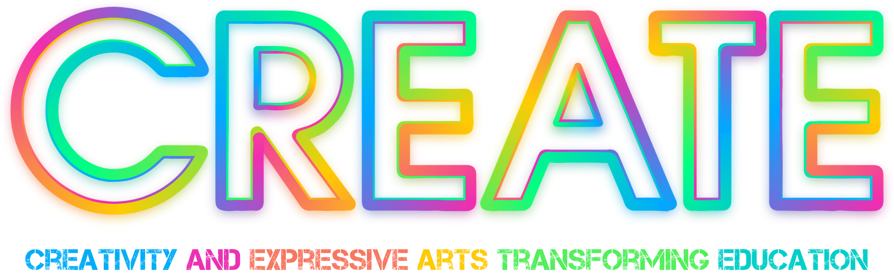

Invitation to join Oboe and Bassoon Instrumental Lessons

Dear parent/ carer,

Glasgow CREATE GCC Education Services are offering young children from P5-7 the opportunity to take part in weekly Oboe or Bassoon lessons, delivered by our resident double-reed tutor Katherine Nagl, as part of the “Endangered Species Project”. The classes take place on Thursday evenings, at CREATE’S Centre for Training and Performance, City Halls, 87-101 Albion Street, Glasgow, G1 1LH.

These sessions are aimed at complete beginners and are free of charge. Instruments are also provided free of charge.

Places will be offered after a “Come and Try” session held between 5:30 and 7 pm on Thursday 22nd October at City Halls, where your child is invited to try out these lesser-known instruments. Once children have reached a particular stage, they will also be offered a place with the Concert Band, which then leads into the Symphonic Wind Band and Symphony Orchestra. This is a fantastic opportunity for any young person interested in music.

For further information and to book a time for the taster session, please contact me via the email below.

Best wishes,
Pam

Pamela Black
Education Support Officer & Head of Instrumental Music

pamela.black@education.glasgow.gov.uk
www.glasgowcreate.online

