Establishment Name
Standards & Quality Report
Session 2025 – 2026

This summary report is provided for parents/carers and partners to outline our achievements and improvements during session 2025 - 2026 and to share our improvement priorities for 2026 - 2027. Throughout last session we took forward our improvement priorities as detailed in our school improvement plan. Using our approaches to self-evaluation, we have detailed in this report the impact of our work and identified how we plan to continue to improve outcomes for our children and young people.

The context of the school
Cleeves Primary School is a non-denominational, co-educational school which is part of Hillpark learning community. Our school, situated in the Priesthill area of Glasgow, is a new build and was officially opened on the 7th December 2009. It was an amalgamation of Burnbrae Primary, Househillmuir Primary and Nitshill Primary. It is a two-storey building with fourteen class bases, a gym hall, library and a dining hall. Two of our class bases house our nurture groups, ‘The Busy Bee Base’ and “The Coorie In”. Approximately 43% of pupils are entitled to Free School Meals. The school is surrounded by a mixture of rented accommodation and owner-occupied housing. The school benefits from some additional resources and funding which has recently been boosted by the Scottish Government’s allocation of Pupil Equity Funding to support ‘closing the gap’. The current school roll is 188. 78% of children and young people reside in SIMD Deciles 1&2. 43% of families are eligible for FSM. Attendance is presently 88%. Exclusions have been at 0% for the last few years. 70% of our learners are supported through the Staged Intervention Model.
Our achievements and improvements 2025 – 2026
We would like to highlight the following improvements/achievements agreed in consultation with school staff, parents and children.
Our priorities for 2025/26 were:
Achievement and Progress
- Improve the quality of teaching and learning and increase levels of attainment using Active and collaborative learning across all classes leading to improved attainment in Numeracy
- Improve the quality of teaching and learning and increased levels of attainment in writing through the implementation of the Write on Track programme
Engagement, Participation and Inclusion:
- Embedding inclusive practice within our classrooms and the wider school community with a focus on attendance, trauma informed practice and Developing the Young Workforce.

What we did
- We provided targeted Literacy support to raise attainment across P1-7 with the implementation of Write on Track. This has helped our children increase their standard of sentence building. It focuses on supporting the children to spell and write with confidence whilst developing co-operative behaviour and opportunities to articulate their ideas and understanding.
- We focussed on raising attainment through quality teaching and learning using Glasgow’s Pedagogy Active and Collaborative learning module across P1 – P7.
- A sustained focus on attendance has led to an increase in attendance by 2%, the biggest increase by any school in Glasgow for session 25/26. This has led to improved outcomes for learners by increasing their engagement and supporting children through early intervention strategies, partnerships with families and developing new partnership with Home-Start Glasgow South.

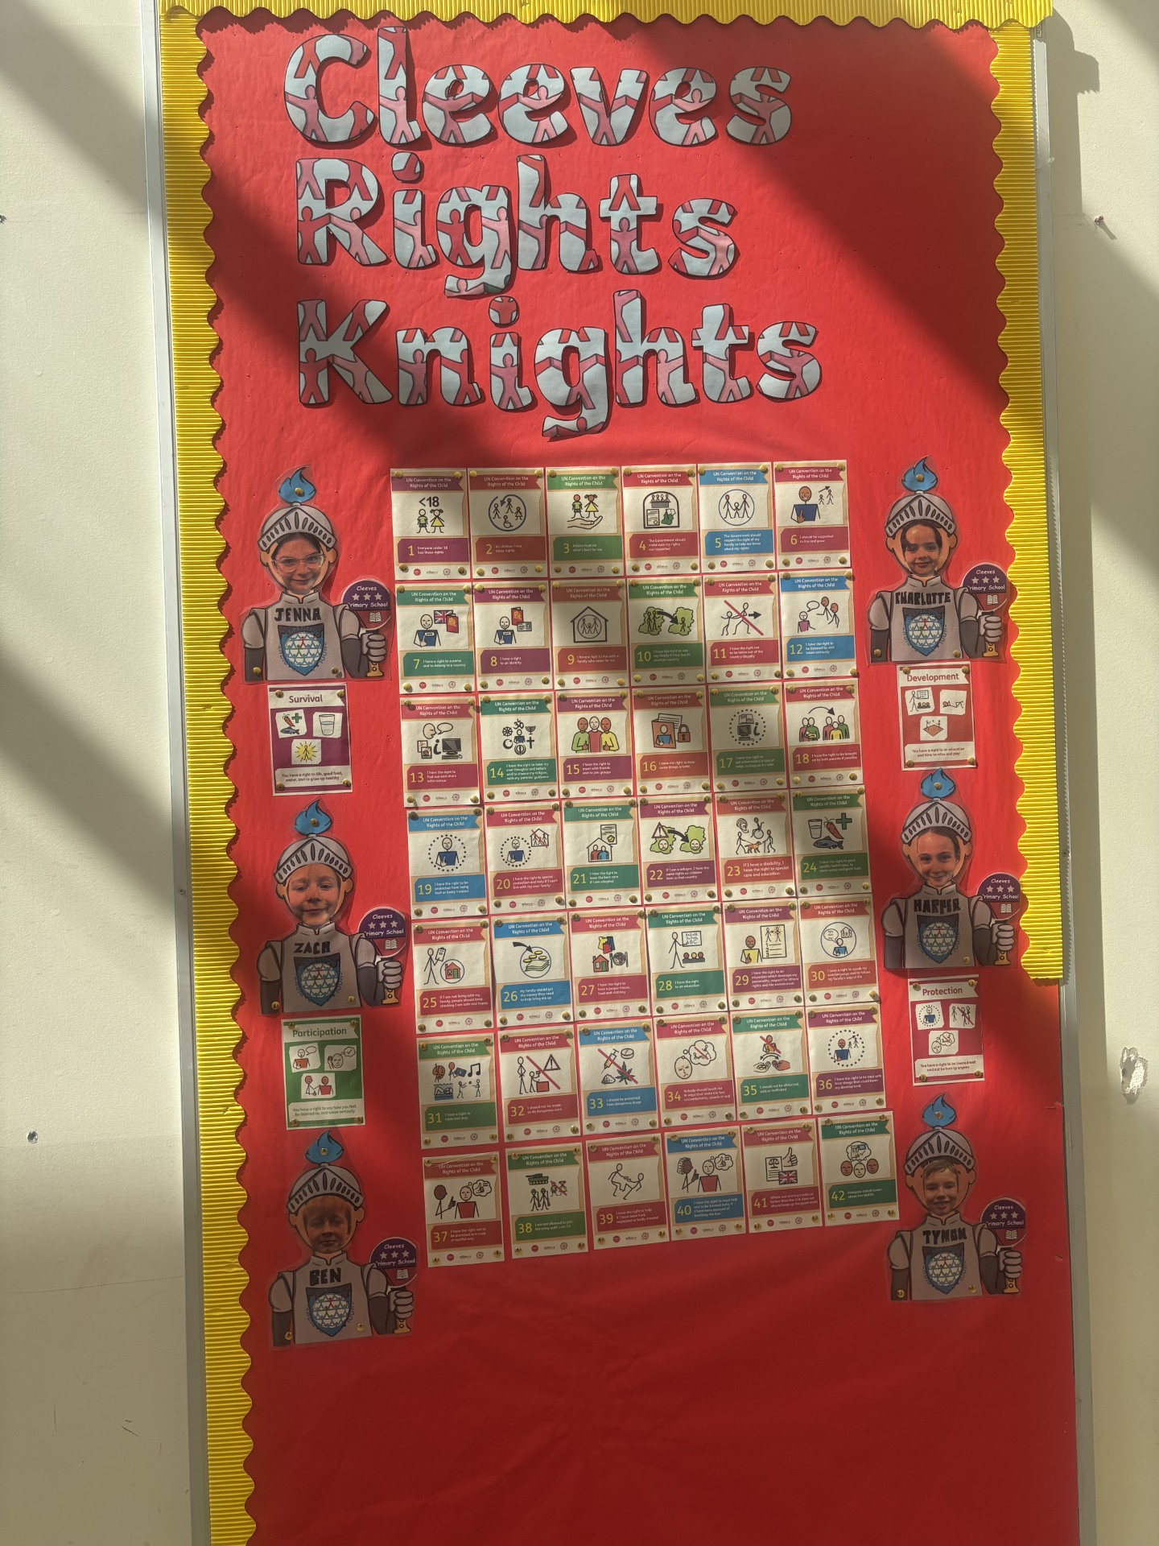
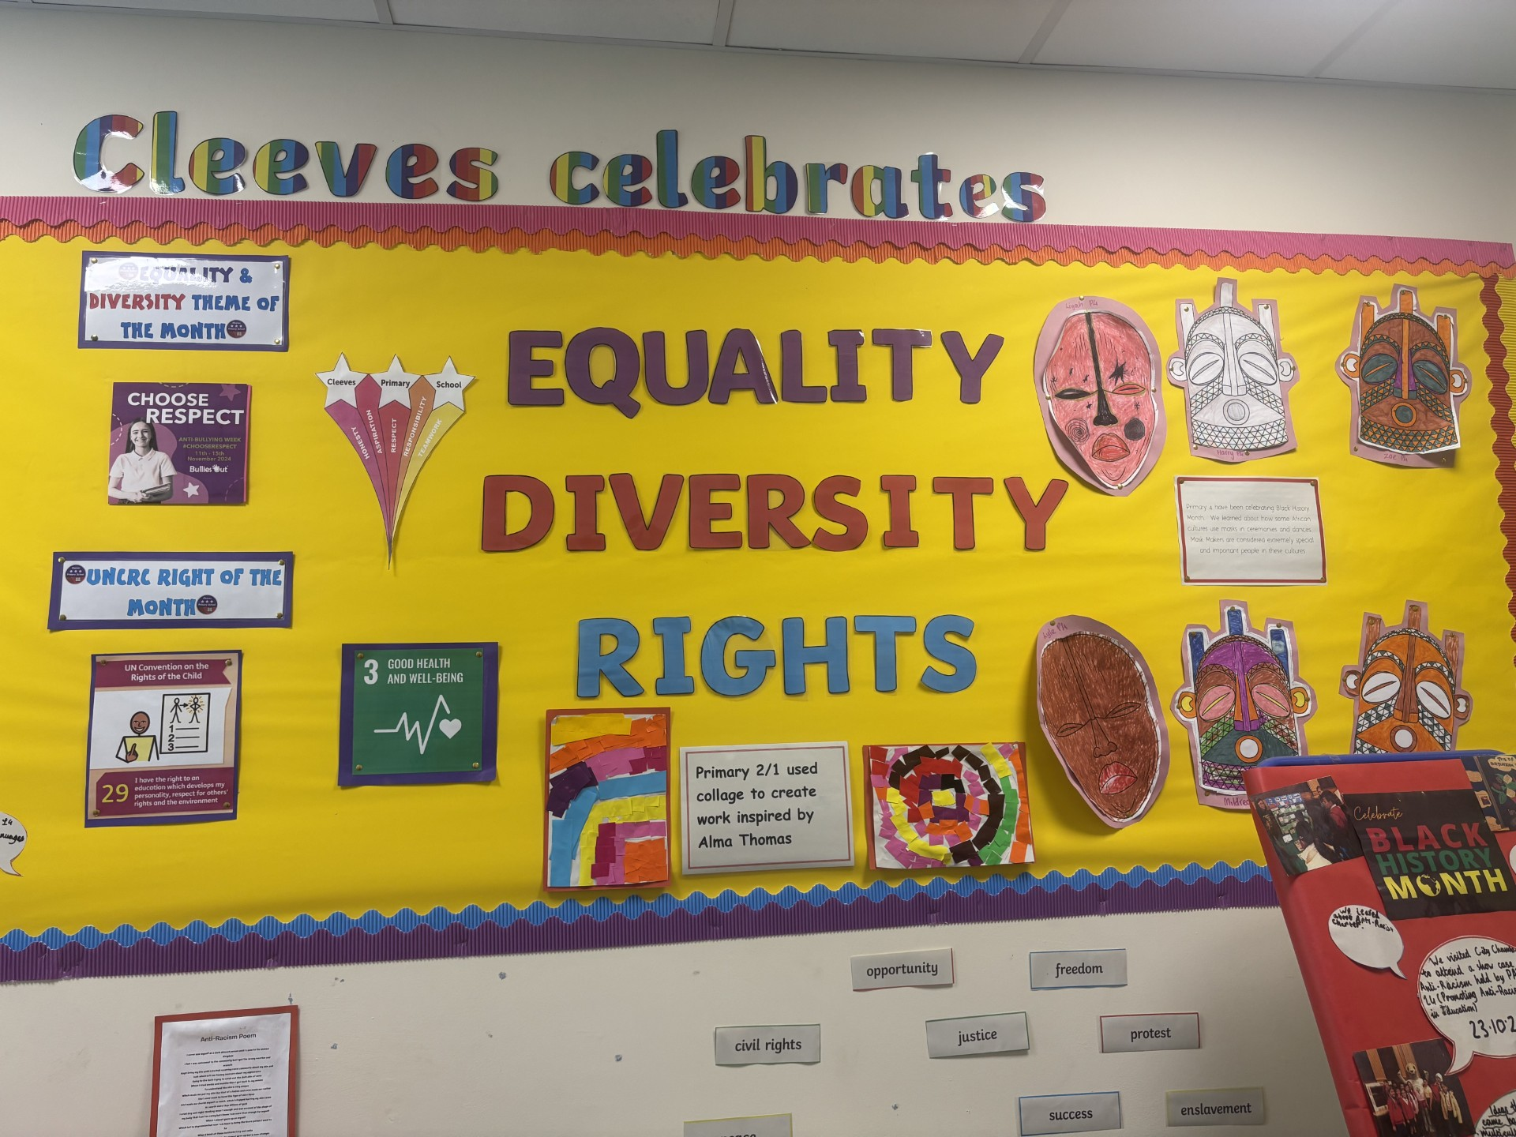

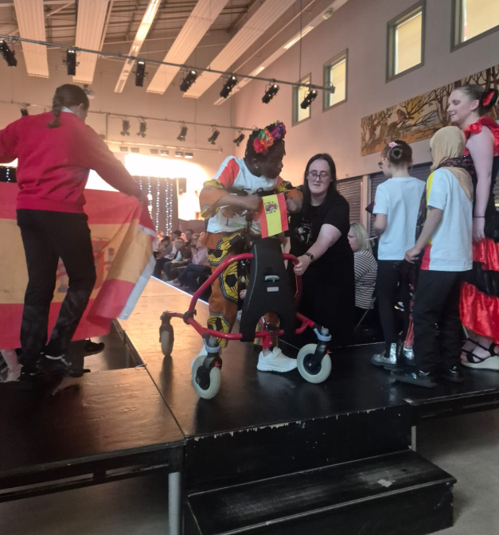
- Staff, children and parents worked together to embed the UNCRC into all aspects of school life to work towards the Gold Rights Respecting School Award. This included staff training, curriculum development, policy updates, pupil participation through committees, assemblies, campaigns as well as parent feedback and contribution and a whole community fashion show which ensured rights and equalities are part of the school culture where everyone understands and can talk about children’s rights.

- We have enhanced the quality of learning and teaching through the effective use of Digital Technology across the curriculum. This has included the introduction of Kaligo to support handwriting, Magma Maths to support the planning, learning and teaching and assessment of Numeracy and the introduction of new iPads in P6 & P7 has further enriched learning by increasing pupil engagement and collaboration.
- In P6, learners have developed their employability, personal and life skills through participating in learning around Developing the Young Workforce preparing our young people for the world of work by developing the skills, knowledge and attitudes employers value.
- Staff have engaged a wide range of professional learning activities to support inclusive practice including Trauma Informed Training, Time for Inclusive Education. Participation in this training has helped to create safe, inclusive and nurturing learning environments where every child can thrive.
- We developed our community links with Tesco through the Stronger Starts Fruit and Vegetable Grant which enabled children to access a wide variety of fruit daily, prepare soup/pasta/stir fry packs regularly throughout the year for parents and run family cooking workshop sessions during term 3 designed to bring families together, engaging in life skills and working on healthy, affordable, sustainable meals. Children followed recipes along with their adult learning different cooking techniques and cuisines from around the world.
- We introduced a Snack-tember workshop for parents and children, focusing on healthy snack choices. Families learned about the importance of healthy eating and worked together to prepare and make healthy snacks. The Oral Health Team also joined the session to deliver an informative talk on maintaining good oral health and the benefits of healthy eating. The workshop was recognised as good practice by the Family Learning Team, who subsequently developed a case study to share and highlight the success of the initiative.
- We issued newsletters, used our school app and text messaging to communicate with families and build relations. We continued to use Seesaw and Showbie and “X” to support our learning and promote parental engagement. Workshops such as ‘ ‘Bookbug’, ‘Read, Write, Count’ Post 5 play with Glasgow Life, Active and Collaborative learning workshops and Write on Track input, Cooking with Totnosh, Gardening and ‘Play Along Maths’ as well as Family Fun Nights and Community Garden days ran throughout the year.
- Highly effective Nursery to Primary and Primary to Secondary transitions took place from January 2025. Children had the opportunity to attend school in groups to meet their peers and class teacher. Enhanced transition meetings were held with parents to support new P1 /new 1st year children.
- We have expanded pupil voice and pupil leadership opportunities Pupil voice surveys showed a positive increase in how all the children were feeling across every area in comparison to the previous session. Pupil leadership experiences through our House Captains and Vice-Captain, Paths Pals, JRSO, Eco Committee, Rights Knights, Equality Ambassadors, Junior Librarians and Buddies as well as children attending the PARTIE anti racism in the City Chambers which has led to increased confidence, responsibility, motivation and engagement, as well as fostering a culture where children feel heard, included and respected.
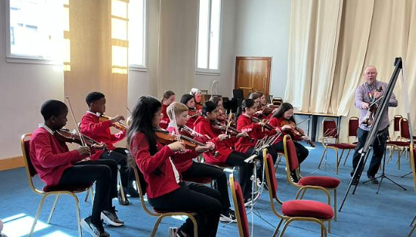
- Children have participated in a range of clubs and activities this session including football, multi sports, music, violin, basketball, athletics, swimming, storyteller. Eco workshops as well as trips to the pantomime, country parks including Palacerigg, Pollok, Bellahouston, Summerlee, bowling and a residential trip to Dalguise.
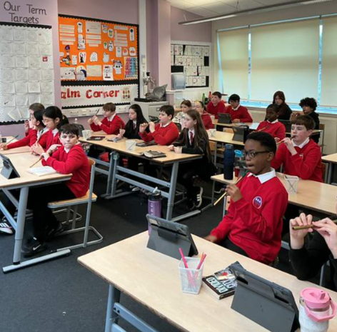
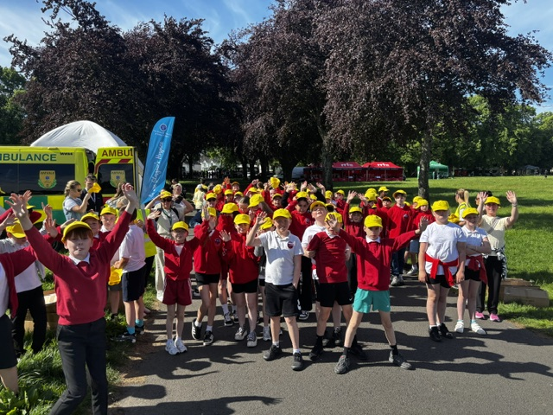
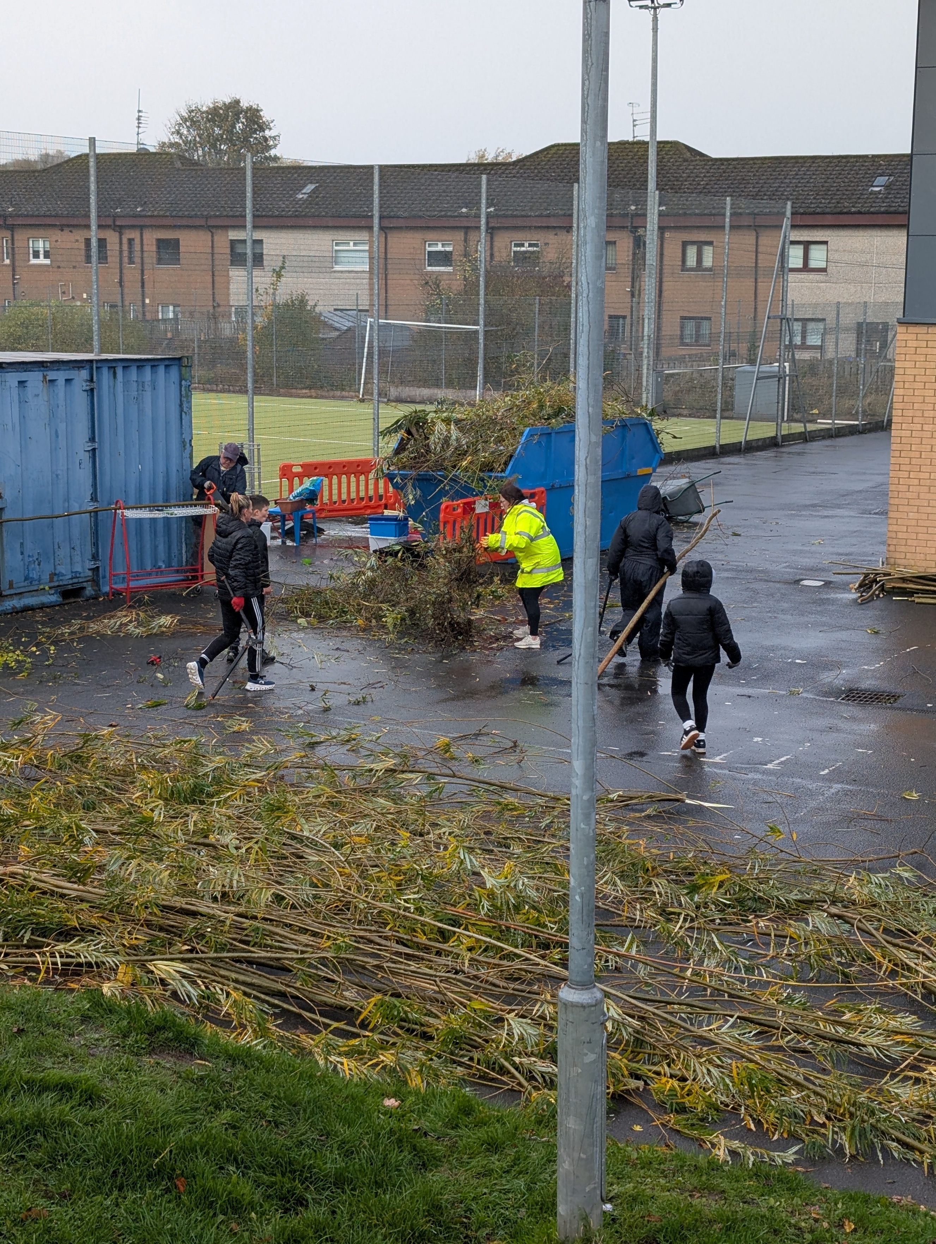
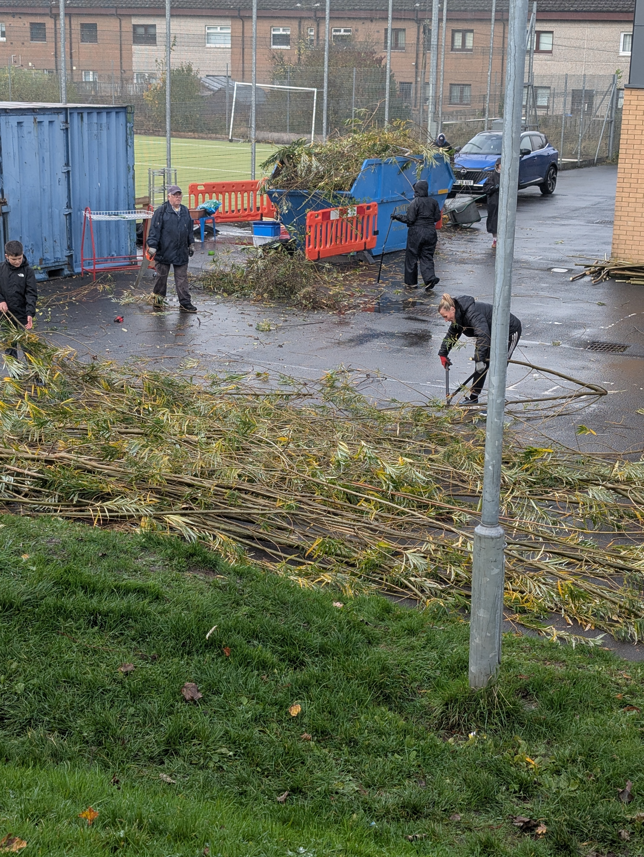

We were inspected by Education Scotland in October 2025 and they highlighted :-
“The outstanding approaches to nurture and inclusion”
“The friendly, confident children who display the school values very well, supporting each other to learn and achieve”
“The rich opportunities provided by staff and partners to enable children to engage in new experiences and develop a range of skills for learning, life and work”
Pupil Equity Funding
In session 2025-26, the school used the PEF allocation to directly raise attainment, improve attendance and engagement and support children’s wellbeing. The table below outlines our key interventions:

PEF Intervention
Two additional teachers: Raising Attainment in Literacy and Numeracy
Calming Minds Therapist: supporting children’s wellbeing and engagement
Music Therapist: supporting children’s wellbeing and engagement across the school
Support for Learning Worker to support increasing attainment
3 interactive smart boards installed in classrooms
Extra-Curricular Programme – Theatre visits to Pantomime and school outings to Summerlee Industrial Museum and Palacerigg Country park
Transport for P7 Residential Experience to Dalguise – Health and Wellbeing

Attendance and Exclusion data
Attainment
The table below summarises attainment as of June 2026.
We have collected data in a variety of ways and tracked pupil’s progress across the curriculum. The table below summarises achievement of a level and this information allows us to identify strategies to close the attainment gap.
Our Attendance was 88% and we had 0 formal exclusions during session 2025 – 2026.
 | Reading | Writing | L&T | Numeracy and Maths
Primary 1: Early | 87% | 73% | 80% | 87%
Primary 4: First | 76% | 70% | 73% | 63%
Primary 7: Second | 78% | 72% | 91% | 75%

Our improvement plan priorities 2026 – 2027
Here is what we plan to improve in session 2026 - 2027

1. Progress:
To develop consistency in Learning and Teaching and to raise attainment in Literacy and Numeracy by ensuring consistency of high-quality learning and teaching in Literacy and Numeracy in line with Glasgow’s
Pedagogy and the Good Lesson.

2. Progress and Inclusion & Wellbeing:
To ensure that the vision, values and aims at Cleeves are understood, lived and visible in practice, aligned with Glasgow’s pedagogy and the needs of all learners.

3. Inclusion and Wellbeing:
To further develop and sustain the whole school strategy to support improved attendance and inclusion at Cleeves.

We are continuing to work towards our Gold Rights Respecting School award, embed our Write on Track programme and develop the use of our community garden.

 | How Good Is Our School 4 Quality Indicator (QI) | Evaluation
 | Leadership of Change (QI 1.3) | Very Good
 | Learning Teaching and Assessment (QI 2.3) | Good
 | Ensuring Wellbeing Equality and Inclusion (QI 3.1) | Very Good
 | Raising Attainment and Achievement (QI 3.2) | Good

How to find out more about our school
Contact us directly if you require further information about our school or if you wish to comment on this report.

Our contact e-mail address is: Headteacher@cleeves-pri.glasgow.sch.uk

Our telephone number is: 0141 880 5305

Our school address is: Cleeves Primary School, 271 Househillmuir School, Glasgow, G53 6NL

Further information is also available in our newsletters, in our school handbook and on our school website http://blogs.glowscotland.org.uk/gc/cleevesprimary .

