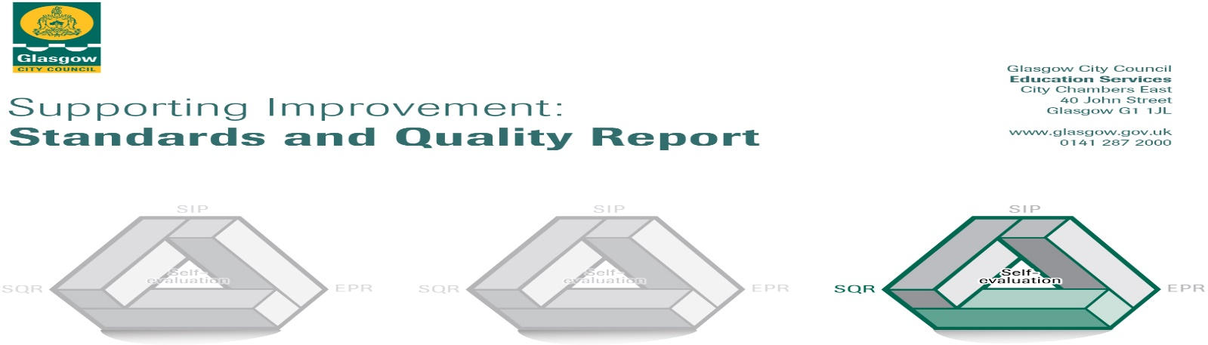
2023-2024

The summary report is provided for parents/careers and partners to outline our achievements this session and our priorities for next session. Throughout this session we have taken forward our priorities as detailed in our school improvement plan. Through our processes of self-evaluation, we have identified how we can improve outcomes for our children and young people.

Our achievements and improvements this year. 2023-24
We would like to highlight the following improvements/achievements:

Developments in Leadership of Change:
- The school updated the Curriculum Rationale, revisiting ‘What is it we want for our children?” and “What are we going to do to achieve it?”
- The school continued to promote Pupil Voice through surveys and ‘How Good is Our Classroom?’ floor books, initiating changes including more House activities and playground developments.
- Leadership opportunities for pupils were extended with the development of Language Ambassadors as part of the school’s EAL provision.
- Leadership roles were carried out by staff developing school provision in EAL, Inclusion, STEM, Anti-bullying and Outdoor Learning.
- Strong partnership working continued to take place in the school with links to Glasgow Caledonian University, Glasgow EAL services and many others.

Developments in Learning, Teaching & Assessment:
- Digital technologies continued to be utilised to enhance learning including the introduction of a writing and spelling support application- Kaligo.
- The school’s offer of support was further developed further through the introduction of attendance focused interventions including a Leapfrog Learning intervention and FSA football group.
- Staff engaged in peer and video observations to reflect on and share practice.
- Staff adopted Glasgow’s Digital Planning Format to support coherence and progression in planning for teaching and learning.
- The school engaged in whole staff development around Effective Feedback to improve learning.
- The school engaged in whole staff development to gain strategies to support EAL learners.

Developments in Ensuring Wellbeing, Equality & Inclusion:
- The school continued to embed the use of the CIRCLE Framework, soft starts, emotional check-ins, counselling and therapy services.
- Our wellbeing offer was enhanced through the introduction of afternoon Parent & Pupil workshops.
- The school linked with Glasgow Virtual Schools to provide a higher number of interventions and supports for our care experienced learners.
- The school built further strategies and supports to better meet the need of EAL learners i.e. Racing to English programme.
- The school continues to adapt processes to support improved attendance processes through more rigorous monitoring, tracking and intervention systems.

Developments in Raising Attainment & Recognising Achievement:
- Staff engaged in additional attainment dialogues supporting predictions and judgments around pupils’ achievement of a level. This also supported the implementation of timely supports.
- The school engaged in moderation activities within and out with the school supporting improved professional judgments around pupils’ achievement of a level.
- Wider achievements have been more consistently tracked and recorded using the school’s monitoring and tracking tool.

Here is what we plan to improve next year. 2024-2025
- We will continue to develop and embed our approaches to inclusion, focusing on becoming a ‘Language and Communication Friendly Establishment’.
- We will continue to focus on raising attainment in Literacy & Numeracy.
- We will continue to enhance our teaching and learning approaches, with a focus on effective feedback.
- We will continue to support raised attainment through promotion of high attendance levels.

How can you find out more information about our school?
Please contact us directly if you require further information or if you wish to comment on the report.

The contact e-mail address is: Headteacher@camstadden-pri.glasgow.sch.uk

Our telephone number is: 0141 944 2971
Our school address: 10 Bankglen Rd, Glasgow G15 7LG
Further information available on: School Newsletters, Twitter & School Website.

