
Camstradden Primary
School Handbook

Welcome to Camstradden Primary School. I hope that the information contained in this handbook will help you to gain a better understanding of our school’s core vision, values and aims, as well as providing practical information around day-to-day organisation.

Camstradden Primary School is a happy and vibrant school where we encourage a strong sense of community in which pupils are supported to flourish as individuals across all aspects of their development. Our staff are committed to providing a safe and nurturing environment in which optimal learning experiences and opportunities are provided for all.

Our partnerships with families are valued highly here at Camstradden Primary School. I look forward to working with you to support your child during their time here. Please do not hesitate to contact me, should you require any further information

Miss E Grace
Head Teacher

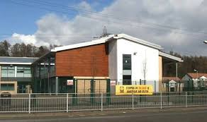

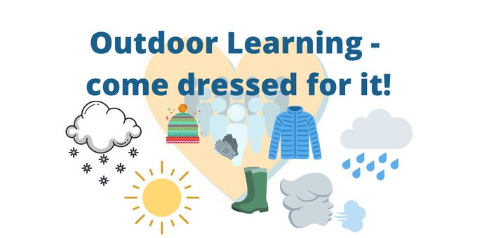
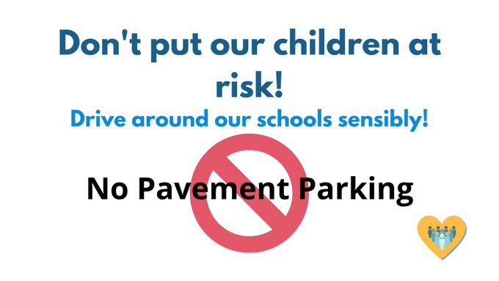


Last updated on 31/8/22
School Vision. Values & Aims

Camstradden CARES

Vision: At Camstradden Primary School we are committed to empowering our young people to succeed. Through working with our pupils, families, the wider community and partner agencies, we strive to create a nurturing, safe and stimulating learning environment in which our young people are supported to overcome barriers and achieve their full potential.

Values: Our school motto ‘Camstradden CARES’ illustrates the attributes valued by our young people. In 2021/2022, our school community reviewed the attributes related to the acronym CARES to ensure that they continue to represent what is important to us as a school community. Confident, Achieving, Respectful, Enthusiastic, Supportive. This compliments our school ‘Code of Conduct’ of Ready, Respectful, Safe.

Aims: Camstradden Primary School aims to:-
- foster positive relationships with families and the wider community to enhance learning.
- provide high quality learning experiences for all.
- promote and develop an ethos of trust and respect through which positive relationships can be developed and maintained.
- remove barriers to learning, ensuring an inclusive and equitable learning provision for all in which diversity is celebrated.
- equip our young people with the knowledge to become responsible and aware global citizens, with the skills needed for work and life- long learning.

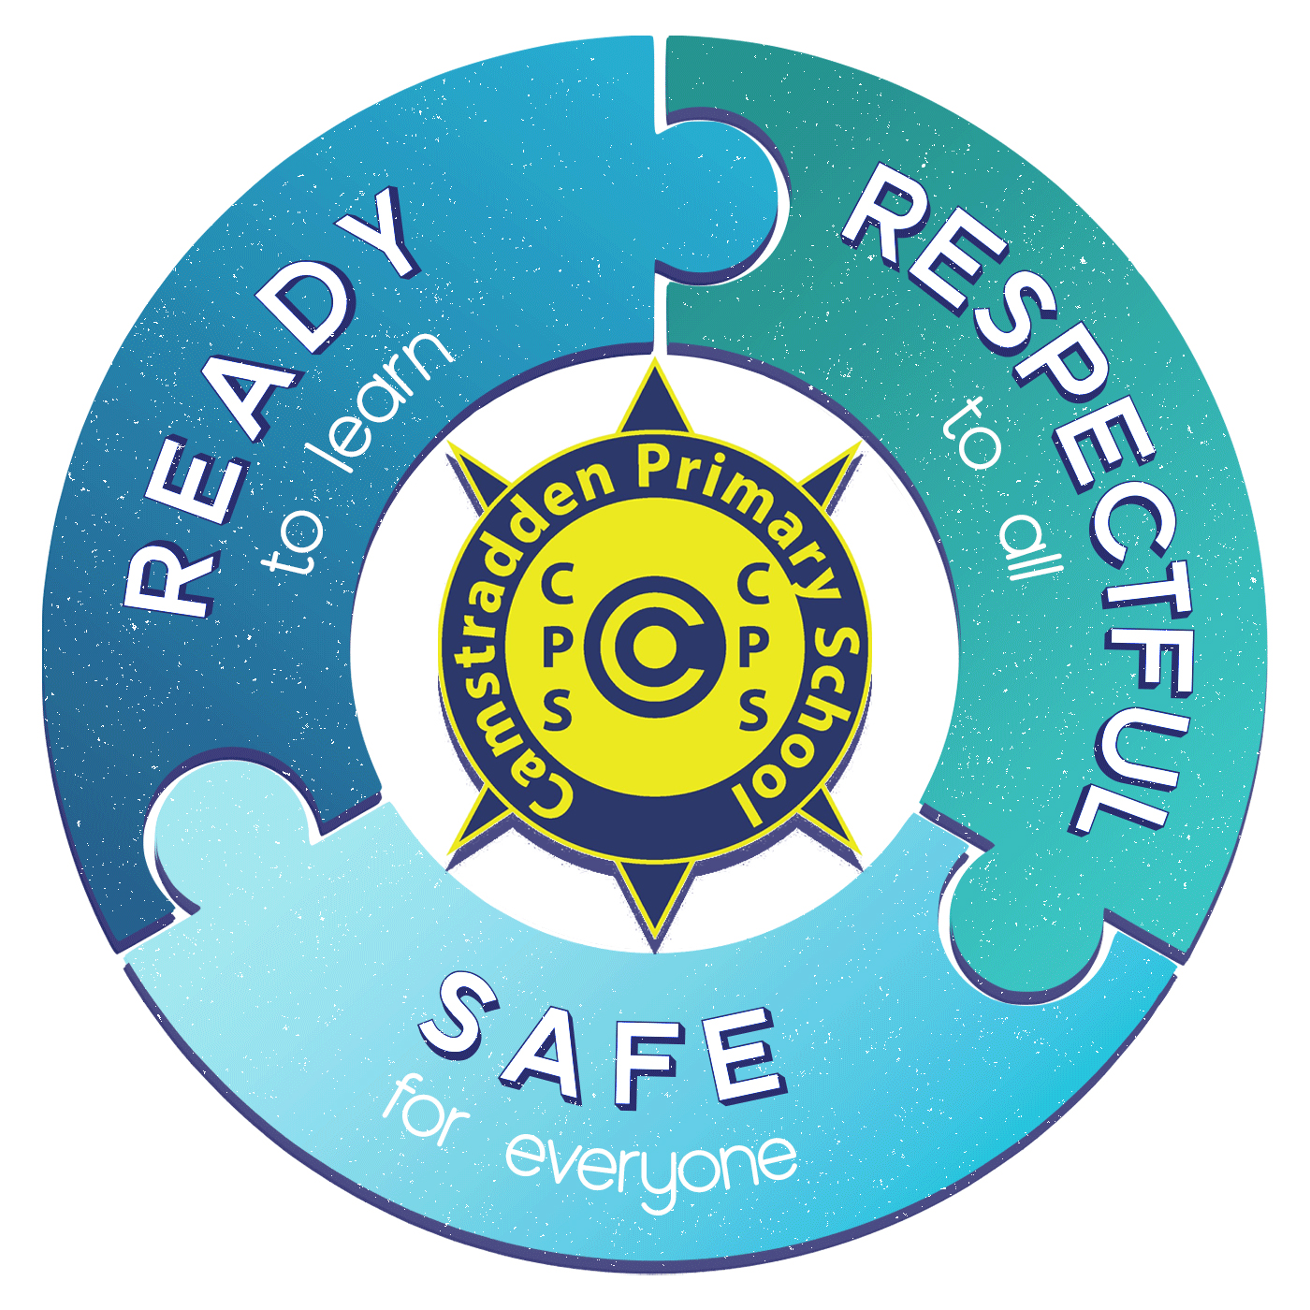

School Information

You can cut out the following information and have it on your fridge, purse or work desk etc. for ease of finding the numbers required.

Contact Details:

Camstradden Primary School
10 Bankglen Rd
Drumchapel
Glasgow
G15 7LG
Phone: 0141 944 2971
Email: headteacher@camstradden-pri.glasgow.sch.uk

Background information:

- Co-educational school
- Non-denominational
- Stages taught: P1-P7
- Current Roll: 260
- Capacity: 444

School staff

This session our staffing consists of the equivalent of 15 teachers, including our Nurture Teacher. We have three Principal Teachers, two Depute Head Teachers and a Head Teacher. We benefit from additional staffing for raising attainment through the Glasgow Improvement Challenge initiative and Pupil Equity Funding has supported us to provide additional teaching and leadership capacity to the meet the needs of our learners. We have also used our Pupil Equity Fund to provide Play Therapy and Counselling services to support the emotional and social wellbeing of our pupils. We also employ a Family Support Worker.

The non-teaching staff consists of 1.5 Clerical Assistants and 8 Support for Learning Workers.

Senior Leadership Team (SLT)
- Headteacher-Miss E Grace
- Depute Headteacher- Mr D Clark
- Depute Headteacher (PEF)- Mrs E Reside
- Principal Teacher-Miss N Gordon
- Principal Teacher (PEF)- Mr A Reid
- Principal Teacher (PEF)- Mrs S Weston
Teaching Staff
- P1- Mrs L Juttla / Mr A Reid (PT)
- P2/1- Mrs A Douglas
- P2- Ms M Harkins
- P3- Ms K Carrick
- P4/3- Mrs J Copeland/ Mrs A Fraser
- P4- Miss N Gordon (PT)
- P5- Ms C Graham
- P6- Mrs Mir / Mr A Reid (PT)
- P7/6- Mrs E Galashen
- P7- Mrs L Goodyear
- Bluebell Room (Nurture)- Mrs C Laird
- Acorn Room (Wellbeing)- Mrs S Weston
Support Staff
- Mrs M Cumming (Nurture)
- Mrs B Malloch (Acorn)
- Mrs K Neil
- Mrs C MacDonald
- Mrs E Flannagan
- Ms R Todd
- Ms C Salila
- Ms M Mundt
Clerical Staff
- Mrs H MacAulay
- Mrs G MacDonald
Janitorial Staff
- Mr F Lynch
Lead Cleaner
- Mrs J McTaggart
Kitchen Supervisor
- Mrs Y Sutherland
Family Support Worker
- Ms J Robertson

Enrolment

Registration of Primary 1 children takes place in November and is advertised widely in local press etc. Enrolment is now conducted online – see the link below.

Families living outwith the catchment area are welcome to make a placing request to attend Glasgow Primary School but must enrol their child online as a first step. Further information is available using the following

https://www.glasgow.gov.uk/index.aspx?articleid=15894

Organisation of Classes

Scottish Government guidelines state that class sizes can't exceed certain numbers:
Primary 1 - 25 pupils.
Primary 2 to Primary 3 - 30 pupils.
Primary 4 to Primary 7 - 33 pupils.
Composite classes - 25 pupils.

Composite classes have pupils from more than one stage. For more information about composite classes, please follow this link. https://tinyurl.com/2p83h8te

The School Day

School Begins 09.00
Interval 1 10.30 – 10:45
Lunch 1 12.15 - 13.00
School Ends 15:00

School Term Dates

Details of school term dates are available on the Glasgow City Council website:

https://www.glasgow.gov.uk/article/17024/School-Term-Dates

Pupil Absence

Within Camstradden Primary School good attendance is encouraged at all times and children rewarded accordingly. Parents are asked to advise if their son or daughter is going to be absent. This should be done as early as possible on the first day of absence. If the young person is going to be absent for some time, it would be helpful to know at the earliest opportunity. The school uses daily text messaging to inform parents and carers of absence if no contact is made. All unexplained absences are investigated by the school and appropriate action taken. All calls must be made to the Pupil Absence Reporting Line on 0141 287 0039. The line is open between 08.00-15.30 Monday to Friday. Alternatively, you can use the online form on the Glasgow City Council website:

https://www.glasgow.gov.uk/index.aspx?articleid=18832

Medical & Healthcare

The school nurse visits at various times during the year for routine health checks, vaccinations and medical examinations.

If a child becomes ill during the course of the school day, he/she may require to be sent home. Please ensure that you keep the school informed of all contact details.

Parents should inform the school of any medical requirements relating to their child. If a child requires medication during the school day, parents must complete the appropriate medical form. This is available on request from the school office.

Emergencies

We make every effort to maintain a full educational service, but on some occasions, circumstances arise which lead to disruption. Schools may be affected by, for example, severe weather, temporary interruption of transport, power failures or difficulties of fuel supply.

In such cases, we shall do all we can to let you know about the details of our closure or re-opening by using letters, texts and the local media etc.

School Uniform

The school uniform is:
- White shirt or White / Yellow Polo shirt
- School tie (optional)
- Grey/black/navy trousers
- Grey/black/navy skirt

Sweatshirts, cardigans, polo shirts and ties with the school logo can be purchased from:
Be Uniforms Glasgow
35 Argyle Street
Glasgow, Lanarkshire
G2 8AH

0141 221 4473
www.beuniforms.co.uk

Our uniform was agreed in consultation with pupils and parents. It is expected that all children attending Glasgow Primary School will adhere to this dress code.

We also have a supply of pre-loved uniforms available for free to all within the school. We welcome any donations of outgrown uniforms to replenish this throughout the year.

PE Kit

It is important that pupils come prepared to learn and for PE this requires appropriate clothing. All jewellery should be removed. False nails are also not permitted. Pupils who are not participating in PE must have a note or a medical certificate. Pupils who are unable to participate in practical PE should still bring their kit to allow them to assist in the lesson by refereeing, keeping scores or assisting with the distribution of equipment. This ensures that they are still able to take part in some way in the work of the class and do not miss out on the knowledge and understanding of the course.

There are forms of dress that are unacceptable in school, such as items of clothing which:

- Potentially encourage factions (such as football colours)
- Could cause offence (such as anti-religious symbolism or political slogans)
- Could cause health and safety difficulties (such as loose fitting clothing, jewellery)
- Could cause damage to flooring
- Carry advertising particularly for alcohol or tobacco
- Could be used to inflict damage on other pupils

Clothing & Footwear Grants

Parents/Carers receiving Income Support, Job Seekers Allowance (Income Based), Working Tax Credit (check link below for thresholds), Housing Benefit, Council Tax Benefit or Universal Credit (check link below for thresholds) will normally be entitled to monetary grants for footwear and clothing for their children. Information and application forms may be obtained online.

https://www.glasgow.gov.uk/schoolsandlearning

School meals

Our school provides a lunch service which offers a variety of meals and snacks.

Medical / Cultural and Religious diets for children can be provided.

Children who prefer to bring packed lunches will be accommodated in a suitable area.

All children in P1-4 are entitled to a free school meal.

If you plan to send your child/children to breakfast club, you should inform the staff of any medical dietary requirements.

Children and young people of parents/carers receiving Income Support, income-based Job Seekers Allowance, Working Tax Credit (check link below for thresholds), Child Tax Credit only (check link below for thresholds), Universal Credit (check link below for thresholds) and income-related Employment and Support Allowance are entitled to a free midday meal. Information and application forms for free school meals may be obtained at

https://www.glasgow.gov.uk/schoolsandlearning

We encourage all our parents to discuss the menus with the children and now using ParentPay, families can pre-select school meals from home.

Transport

The education authority has a policy of providing free transport to all pupils who live outwith a certain radius from their local school by the recognised shortest walking route. This means that the provision of transport could be reviewed at any time. Parents/Carers who consider they are eligible can apply online at
https://www.glasgow.gov.uk/index.aspx?articleid=17882

Before & After School Care
Our school has a Breakfast Club that opens from 8am. Breakfast Club costs £2 for the eldest child and £1 for additional siblings. Breakfast is free to any child who qualifies for a free school meal.

We also have a link with TASC after school care located at another local school- St. Clare’s. At the end of the school day (3pm-5:45pm) your child can be escorted by an adult along to the club where they will be able to engage in a range of stimulating activities. More information is available online, www.tascafterschoolcare.org.uk/
or a leaflet can be accessed at the main office.

Transfer from Primary to Secondary School

Children and young people normally transfer between the ages of 11 ½ and 12 ½, so that they will have the opportunity to complete at least 4 years of secondary education. Parents and carers will be informed of the school arrangements no later than December of P7. Children from our school normally transfer to:

Drumchapel High School
340 Kinfauns Dr,
Glasgow City Council
G15 7SQ

Phone: 0141 582 0070
Fax: 0141 582 0071

E-mail: headteacher@drumchapelhigh.glasgow.sch.uk

Drumchapel High School staff work with our pupils from Primary 6 onward to prepare them for the transfer to secondary school.

Communication with Parents

At Camstradden Primary School we use a variety of ways to keep in touch.

Open Door Policy – the senior leadership team attempt to make themselves available for all parents and carers at any time providing they are not teaching or in another meeting. Please phone for an appointment or ask at the front office.

Newsletters/ Curriculum News – Will be sent out on a regular basis to keep parents informed about the work of the school.

Letters – Further information which requires a response may be sent out in letter form.

School Twitter/ X – This will contain a great deal of information about the school. It is a good idea to check this regularly.

Email /Text messaging – You will receive the majority of communications via email about events/school closures etc. Text messaging will be utilised when communication is required more urgently.

Meetings – We look to offer individual meetings to parents throughout the year to discuss a range of matters.

Emergency Contact Information

Glasgow City Council are in the process of introducing Parent Portal which will allow parents to update records as changes happen. Until this is fully in place, please would parents continue to report any changes in address, phone numbers and emergency contacts to the school office.

Data Protection – use of information about children and parents/carers

We collect information about children attending school (and also about parents/carers, emergency contacts etc. provided in the annual data check) to allow us to carry out the Council’s functions as the education authority for the City of Glasgow. This may sometimes involve releasing personal information to other agencies and other parts of the Council, particularly in relation to child protection issues or criminal investigations, and it may also be used for research purposes (see the link below for more details regarding this).

Information held by the school is, in legal terms, processed by Glasgow City Council. The Council is registered as a data controller under the Data Protection Act 2018 and all personal data is treated as confidential and used only in accordance with the Data Protection Act, the General Data Protection Regulations, and the Information Use and Privacy Policy approved by the City Council. For more information on how we use personal information, or to see a copy of the Information Use and Privacy Policy, see https://www.glasgow.gov.uk/index.aspx?articleid=18010 .

Education specific privacy statements can be accessed at https://www.glasgow.gov.uk/index.aspx?articleid=22069 .

Appointments during school hours

If your child has an unavoidable appointment, please give them a letter for their class teacher or phone the school office and then collect them from the school office at the specified time.

Comments & Complaints

In Camstradden Primary School we aim to have positive relationships across our school community. However, if you have a comment or complaint about any aspect of school life, please contact the Headteacher in the first instance.

Glasgow City Council complaints procedures are available : https://www.glasgow.gov.uk/index.aspx?articleid=16133

Customer Care Team
Customer & Business Services
Glasgow City Council
City Chambers
Glasgow G2 1DU

Tel: 0141 287 0900
e-mail: customercare@glasgow.gov.uk or education.customercare@glasgow.gov.uk

The above website also includes information on data protection and freedom of information.

Curriculum

Curriculum for Excellence 3-18

Curriculum for Excellence has been introduced to raise standards of learning and teaching for all 3 to 18 year olds. It aims to help prepare children and young people with the knowledge and skills they need in a fast-changing world. As part of Curriculum for Excellence all children from pre-school to the end of S3 will receive a rounded education known as a Broad General Education(BGE). Curriculum for Excellence is all about bringing real life into the classroom and taking lessons beyond it.

Through the experiences we provide at Camstradden Primary School we want our children to become Successful Learners, Confident Individuals, Responsible Citizens and Effective Contributors. We are committed to providing children with a broad general education and focus on eight curriculum areas.

Expressive Arts | Health & Wellbeing | Languages | Mathematics
Religious & Moral | Sciences | Social Studies | Technologies

Progress in learning is indicated through curriculum levels as detailed below.

Level | Stage
Early | The pre-school years and P1 or later
First | To the end of P4, but earlier or later for some
Second | To the end of P7, but earlier or later for some
Third & Fourth | S1-S3, but earlier for some

Expressive arts: The inspiration and power of the arts play a vital role in enabling our children and young people to enhance their creative talent and develop their artistic skills.

Health and wellbeing: Learning in health and wellbeing ensures that children and young people develop the knowledge, understanding and skills which they need now and in the future to help them with their physical, emotional and social wellbeing.

Science: Science and its practical application in healthcare and industry is central to our economic future, for our health and wellbeing as individuals and as a society.

Social Studies: Through social studies, children and young people develop their understanding of the world by learning about other people and places both past and present, societies, their beliefs and values.

Religious and moral education: Religious and moral education includes learning about Christianity, Islam and other world religions, and supports the development of beliefs and values.

Languages: Knowing other languages and understanding other cultures is a 21st century skill set for students as they prepare to live and work in a global society.

Mathematics: Mathematics equips us with the skills we need to interpret and analyse information, simplify and solve problems, assess risk and make informed decisions.

Technologies: The range of subjects in technical education has changed significantly over the last two decades and now includes craft, design, engineering and graphics.

There will be opportunities throughout the year for parents and carers to learn more about aspects of the curriculum and to be consulted about significant changes if appropriate.

Useful websites

Education Scotland www.education.gov.scot
National Parent Forum of Scotland www.npfs.org.uk
RSHP - https://rshp.scot/

Religious Observance

Our school is fortunate to have a close link with the local church. The minister assists with the Christianity element of Religious and Moral Education and provides opportunities for religious observance. Parents have the right to withdraw their child from religious observance and should inform the school in writing.

In addition, parents and carers from religions other than Christianity may request that their children may be permitted to be absent from school in order to celebrate recognised religious events. Only written requests detailing the proposed arrangements will be considered. Appropriate requests will be granted on up to 3 occasions in any 1 school session.

Assessment & Reporting

All children are assessed both formally and informally throughout the year. This allows children and their teachers to identify their strengths and areas for improvement. A variety of assessment methods are used to enable staff to pass on information to parents about the progress of their child. Assessment records are kept by the class teacher and form the basis of discussion at Parents’ Evenings. An annual report is sent to parents towards the end of each school year.

If you have any concerns about your child’s progress do not hesitate to contact the school.

Support for Pupils

The school has a duty to ensure that all pupils have equal access to the curriculum, with appropriate support for their needs if required. This applies to the content of lessons, teaching strategies and minor adaptations to the school environment. There are a wide range of factors which may act as a barrier to learning. We are committed to working closely with parents and carers to ensure that they are fully involved in any decisions about support for their children’s needs.

Any parent or carer seeking further advice regarding this policy should contact the Headteacher in the first instance.

Further information relating to additional support needs is available on the Glasgow City Council website at https://www.glasgow.gov.uk/index.aspx?articleid=18941

Information on the Glasgow City Councils’ Parental Involvement Strategy can also be found at https://www.glasgow.gov.uk/index.aspx?articleid=17870

Nurturing City

The Glasgow City Council vision ‘towards the nurturing city’, puts building positive, trusting relationships at the core of our work. We ensure children, young people and families feel they belong, they are listened to and they are valued by embedding the principles of nurture across our early years, primary and secondary establishments. Staff are trained in attachment and nurture which deepens understanding of child development and enhances effective practice by responding to the needs of all children and young people in a consistent and caring way. Nurture is a universal approach which builds resilience, helping to reduce the impact of adversity. Effective communication and collaboration with parents and carers builds an ethos of partnership working putting the child at the centre, fostering high quality learning contexts.
Each of our nurturing establishments contribute to the development of Glasgow as a nurturing city, creating safe environments which allow our children and young people to flourish by raising attainment and promoting positive mental health and wellbeing.

School Improvement

On an annual basis, a copy of the Standards and Quality report will be shared with parents and carers. Copies from previous years will be made available upon request. The Standards and Quality report highlights progress in key curricular areas such as literacy, numeracy and health & wellbeing. Our priorities for improvement are detailed in our School Improvement Plan which is discussed with our Parent Council. Any parent or carer seeking a copy of the plan can contact the school office or access our online platforms.

Promoting Positive Behaviour

Children’s Rights as outlined in the UNCRC (United Nations Convention on the Rights of the Child) are fundamental to a good school ethos. Adults in our school will work with children to ensure they are aware of their rights and fully respect the rights of others. We all follow a shared code of conduct- “Ready, Respectful, Safe”.

The approach within Camstradden Primary School is to build a positive ethos that demonstrates care and respect for all. Positive behaviour is recognised and celebrated. Our school operates a system of class charters to set out expected behaviour. This is celebrated through awards at assemblies and certificates sent home to parents etc.

The highest standards of behaviour are expected of pupils at all times. Where this is not the case, a variety of restorative approaches are used. Parents are asked to co-operate with the school in encouraging a sense of responsibility and positive behaviour in their children.

Home Learning

Continuing to learn at home helps children to achieve more and is a vital part of our partnership with parents. Please check your child’s schoolbag for communication about home learning and specific tasks.

Parent Council

Our Parent Council continue to promote and reinforce the relationship between home and school. All parents are welcome to attend meetings called by the Parent Council.
They are always actively seeking new membership to widen the representation of families across the school. We provide a number of opportunities for parents and carers to become more involved in the learning and education of their children through workshops, open afternoons and showcases.

Parent Council minutes will be available on request from the school office.

Extra Curricular Activities

We have a wide range of activities that will run between Monday – Thursday to extend the learning experience. These will include drama, arts and crafts, dance, netball and football. Please check your child’s schoolbag for information as places are popular and usually limited.

Good links with community organisations and our Active Schools Co-ordinator support the ongoing success of these programmes.

Useful Contacts

Parentzone Scotland is a unique website for parents and carers in Scotland, from early years to beyond school. The website provides up-to-date information about learning in Scotland, and practical advice and ideas to support children’s learning at home in literacy, numeracy, health and wellbeing and science. Information is also available on Parentzone Scotland regarding additional support needs, how parents can get involved in their child’s school and education. Furthermore, the website has details about schools including performance data for school leavers from S4-S6; and links to the national, and local authority and school level data on the achievement of Curriculum for Excellence levels. Parentzone Scotland can be accessed at https://education.gov.scot/parentzone.

Connect

Connect is a national organisation that provides advice and resources for parents and carers. www.connect.scot

Enquire Scotland

Enquire is a national advice service for families with additional support needs. www.enquire.org.uk

Glasgow City Council

Education Services
City Chambers East
40 John Street
Glasgow G1 1JL

Tel: 0141 287 2000

www.glasgow.gov.uk

