

*Keeping You Posted*

***Primary 7***

*Camstradden Primary School*

*Glasgow*

***TERM 2***



Communication with our families and wider school community is very important to us. We want to keep in touch with you in order to keep you updated about your child/children’s progress. As such it is vitally important we have the most up to date contact details for you. Glasgow City Council are now using the Groupcall Xpressions app as a main method of communication with families. This is a free app for the school and for families. Further information about Groupcall Xpressions is attached to this newsletter.

***We still have a very large number of families who have not have not signed up for the Groupcall Xpressions app. As this is our main method of communication with families and as such it is vital that you download the app. We also have over 50 families who are still not provided the school with an email address.***

***Please contact the school to provide us with an email address if you have not already done so and download the Groupcall Xpressions app.***

**Primary 7**

Welcome back! We are looking forward to an exciting school term full of school trips, transition events and working with other educators across the city.

Our P.E. days are Monday and Wednesday. Children will need a full PE kit, to remove any jewelry, and have long hair tied up please.

Homework will be given out on a Monday and should be returned/submitted via Seesaw on or before the next Monday.

If you have any questions, please use Seesaw. Mrs Goodyear

***Other Information***



This term we will be focusing on extending our knowledge multiplication and division, and time. The class will have regular opportunities to use the iPads for additional practise, challenge, and assessment of their progress. Please help support practise with times tables, and telling the time or using calendars at home. Links for games to support learning, including Sum Dog, will often form part of Maths homework to be accessed via Seesaw.

***Numeracy & Mathematics***

Reading:

This term we will be focusing on the following reading strategies: clarifying, sequencing and summarising. We will be using a wide variety of fiction and non-fiction texts in a range of genres and a mix of topics. We will also be discussing our class novel, “Room 13” by Robert Swindells, a Halloween classic.

**FICTION –** **Setting & Character**

**NON-FICTION – Recount**

Writing:

Daily writing opportunities occur across the curriculum. We will be focusing on setting, character and recount writing this term. There will be more opportunities to investigate layout and publishing. We are also planning a written Christmas surprise for P1!

***Writing Focus:***

***Literacy***

Listening & Talking:

In Listening and talking, we will be learning how to share our opinions respectfully and explain what we base them on. We will be discussing some philosophical questions guaranteed to build thinking skills.

***Health and Wellbeing***

***Social Studies/Sciences/Technologies***

Social Studies: we will look at inequalities world-wide and investigate Fair Trade. We will also develop our understanding of finances and enterprise by setting up a business venture for the Christmas Fair.

Science: we will be visiting the Science Centre to learn about Electricity, and studying Inheritance and Genetics later in the school term.

We will continue to work on representing the school CARES values in our daily actions and words. In October, our focus is Healthy and we will discuss dental hygiene, peer pressure and long term risks associated with lifestyle choices. In December, we will develop Food Technology skills for Achieving.

P.E. lessons with Mrs Nolan will focus on Gymnastics.

***Expressive Arts***

***Religious and Moral Education***

Art: we will be creating digital art using photography and stop-go animation skills. We will also learn how to weave. Music: we will be learning to perform songs from different genres and countries. Dance: We will be learning some social dancing and have some lessons led by our Street Freakz dancers.

This term we will be learning about Sikhism. Our lessons will cover a variety of aspects of this religion including the symbols, main religious figures and holy writings that are central to this belief system. Our moral lessons will be part of our Philosophy exploration, and our continuing work on the school values.

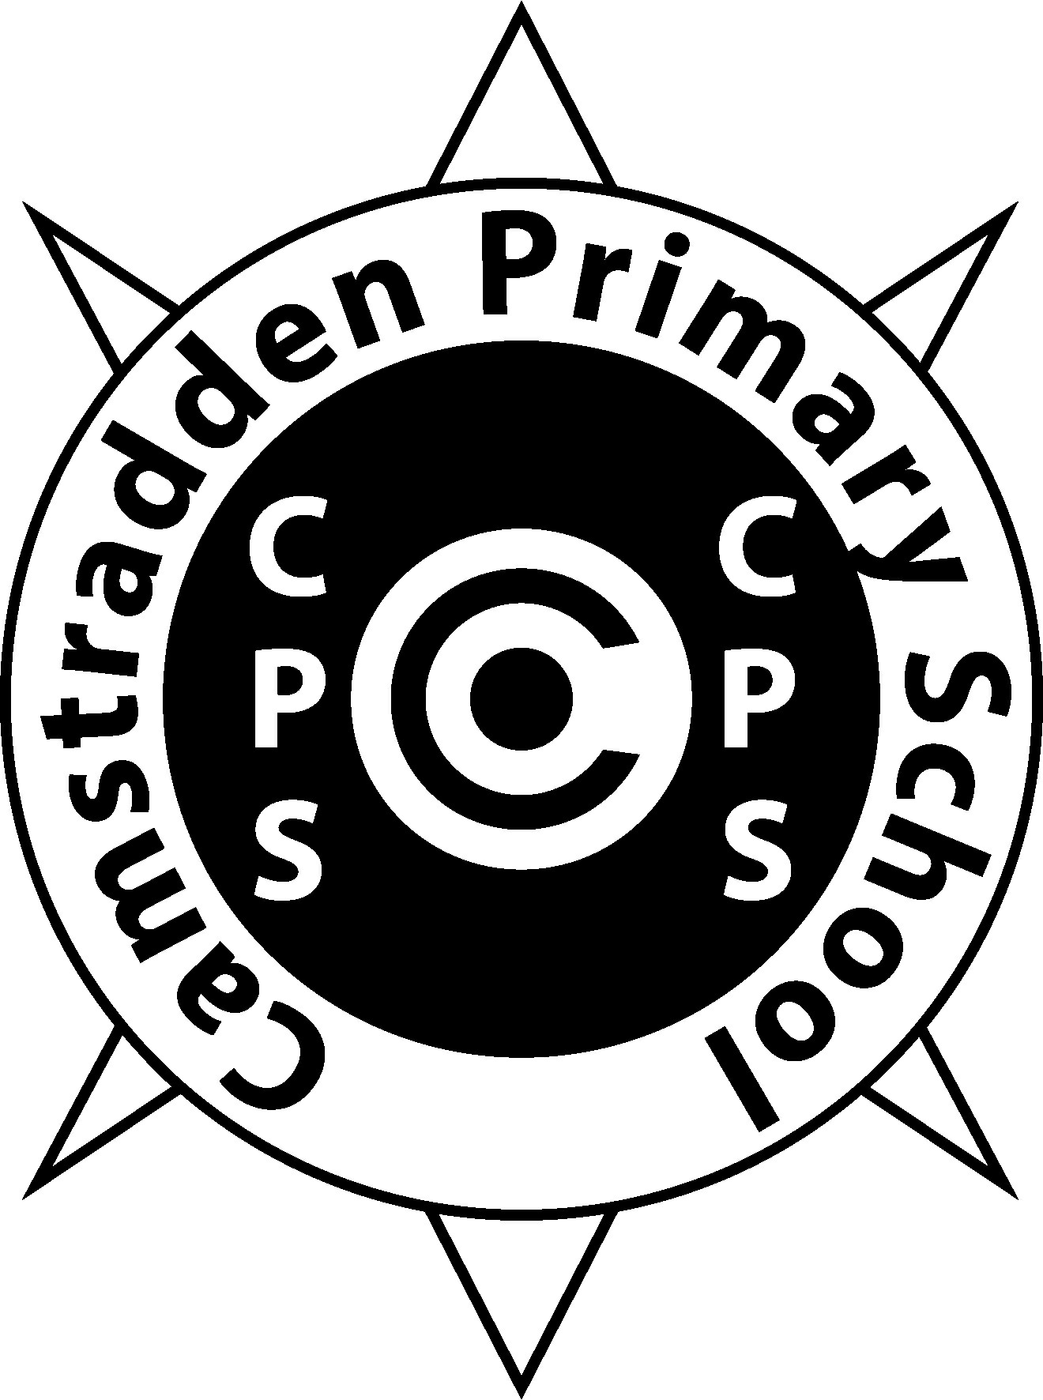

Camstradden Primary School