

*Keeping You Posted*

***Primary 7/6***

*Camstradden Primary School*

*Glasgow*

***TERM 1***



**Primary 7/6**

Welcome back! We are looking forward to an exciting school term. The children have been getting to know each other and becoming familiar with myself and their new classroom routines.

Our P.E. days this term are Wednesday and Thursday. Children should bring appropriate trainers and clothing to change into. Please support your child to remove any jewellery before coming to school on these days.

Homework will be given out on a Monday and should be returned by the Friday.

***Other Information***

***Please return the tear off slip to your child’s teacher to confirm that you have received this term’s curriculum news – thank you.***

**Child’s Name:** ______________________ **Primary**: ________ **Signed:** _____________________

**Description and Procedural**

Listening & Talking:

In listening and talking, we will be learning how to share our ideas coherently to the class and group discussions. We will practise answering questions in a logical way.

Reading:

This term we will be focusing on the following reading strategies: predicting, clarifying, questioning and summarising. We will be using a variety of fiction and non-fiction texts. Our class novel this term is “The Night Bus Hero” by Onjali Q. Rauf.

Writing:

This term we will be focusing on descriptive and procedural writing. Children will have daily opportunities to apply their writing skills across different aspects of the curriculum. Children will practise their spelling daily and should complete all spelling homework tasks.

Number, Money & Measure:  
This term we will be focusing on extending our knowledge of number and place value. We will learn how to use a variety of strategies to solve addition and subtraction problems. In addition, we will be developing our knowledge of 2D and 3D shapes.

***Numeracy & Mathematics***

***Writing Focus:***

***Literacy***

***Health and Wellbeing***

***Social Studies/Sciences/Technologies***

Our Social Studies topic this term is Natural Disasters. In Science we will be learning about the water cycle and carrying out a variety of experiments to investigate simple chemical reactions.

This term we have been focusing on how to develop a growth mind-set. Our Health and Wellbeing focus for September is SAFE. We will be discussing strategies for managing challenging social situations.

Our P.E. focus for this term is Basketball and Fitness.

***Expressive Arts***

***Religious and Moral Education***

This term we will be learning about Islam: Symbolism and Significant Figures.

This term in art we are learning about some of the visual elements used in art such as line, tone, colour and texture and are learning to use this in our work.

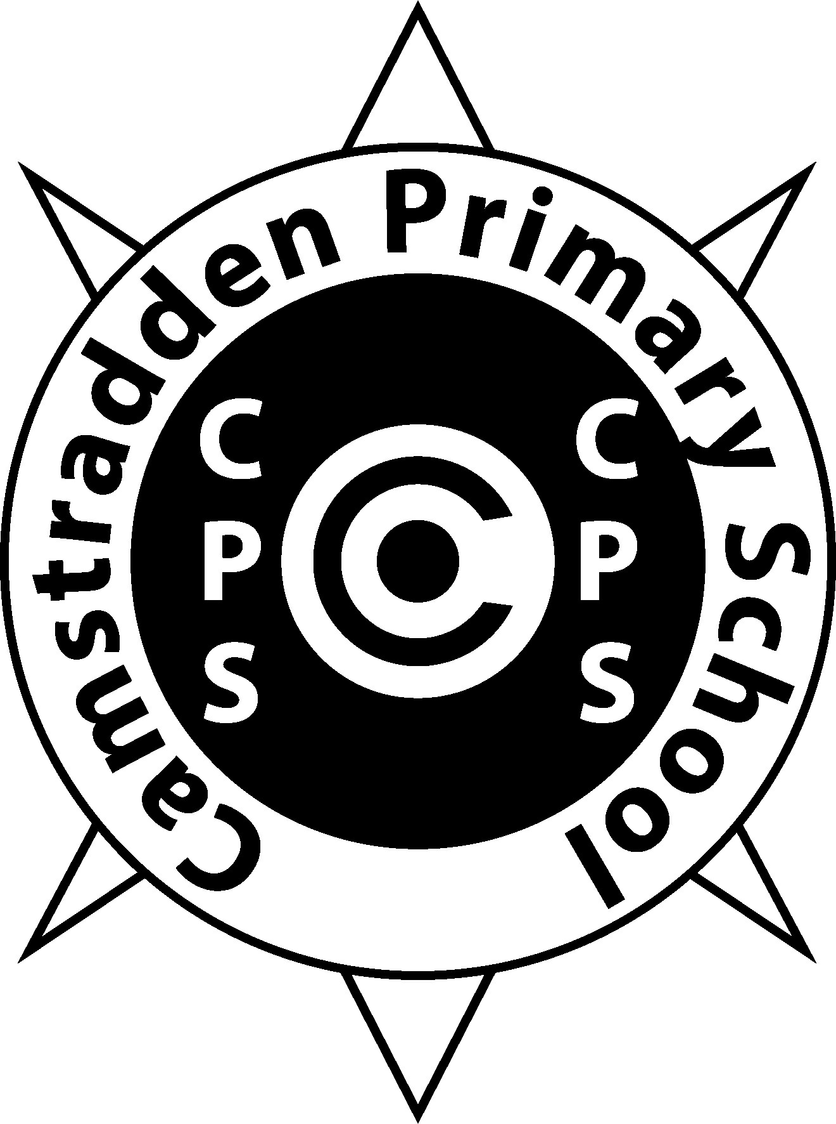

Camstradden Primary School