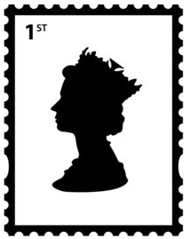

*Keeping You Posted*

***Primary 1B***

*Camstradden Primary School*

*Glasgow*

***TERM 1***

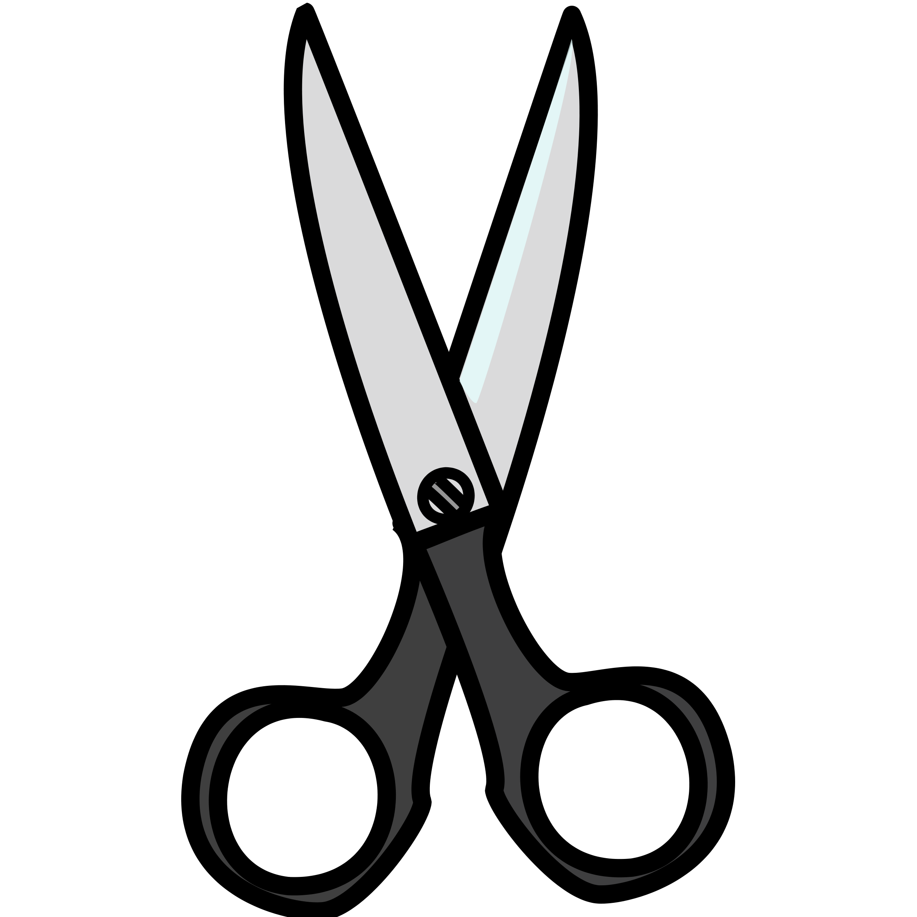

**Primary 1B**

I have enjoyed getting to know the children in the class. They have settled in very well and are full of fun and enthusiasm. Miss Murray is the main class teacher. We have assistance from Mrs Flannigan for part of each day too.

We have PE on **Thursday afternoon** with Mrs Nolan and on **Friday afternoon** with Miss Murray. During PE days, we would encourage you to dress your child in joggers/leggings and a school polo shirt. Please ensure all your children’s clothes and belongings are labelled.

Primary 1 will be given homework from mid-September. This will be given out on Monday and should be returned to school on Friday. We will post information and photographs on SeeSaw. Please get in touch if there is anything you would like to know more about.

Miss Murray – Class Teacher

Mrs MacMahon

***Other Information***

***Please return the tear off slip to your child’s teacher to confirm that you have received this term’s curriculum news – thank you.***

**Child’s Name:** ______________________ **Primary**: ________ **Signed:** _____________________



***Numeracy & Mathematics***

**Reading:**

P1B will work on rhyming this term. We will begin to identify rhyming words in texts and generate our own rhyming words. We will learn about features of books, including author, illustrator, spine and blurb. During this term, we will learn our first sounds and letters.

Foundations of Writing: drawing and writing to convey an idea.

Tools for writing: pencil control

**Writing:**

This term we will be learning to make marks to share ideas. We will use a variety of materials to draw, write and make marks and will be encouraged to write and make marks during play. The children will learn to write their names.

**Shape, Position & Movement :**

The children will be learning about 2-dimensional shapes. They will learn the properties of shapes including circles, squares, rectangles and triangles and will be able to name these.

**Number, Money & Measure:**

P1 will be learning about numbers from 0 to 10. The children will learn to write the numerals and put them in order. We will learn to count to 10, using objects and pictures. We will learn about the number before/after.

***Writing Focus:***

***Literacy***

**Information Handling:**

Primary 1B will not be focusing on Information Handling this term.

**Listening & Talking:**

The children will join in with stories and songs. We will learn about rhyme and be introduced to new vocabulary. The children will learn to listen carefully, take turns, ask questions and share their own ideas and opinions.

***Health and Wellbeing***

***Social Studies/Sciences/Technologies***

This term we will be learning about science, technology and social studies through our topic, Toys, using stories and play to help us learn. We will learn about how toys are made and have a go at creating our own toys using different materials. We will also explore toys of the past and how they have evolved over the years.

In P.E. we will be focusing on developmental play and gymnastics. The children will learn to use the gym hall and our outside space safely and will be introduced to some of the equipment. We will also learn about ways we can stay safe when we are learning and playing. Later in the term we will learn about being healthy. We will talk about healthy eating and exercise.

***Expressive Arts***

***Religious and Moral Education***

This term we will be talking about what is important to each of us and how we can show respect and kindness to one another, even if we are different. We will enjoy some stories from Christianity, including The Good Samaritan and Moses and the Bulrushes.

We will focus on developing the children’s skills in drawing this term. The children will learn to draw different lines and shapes and will be encouraged to talk about their drawings and what they show. During play they will have opportunities to express their ideas using a variety of materials. As part of our Toys topic the children will be involved in role-play (drama).



Camstradden Primary School