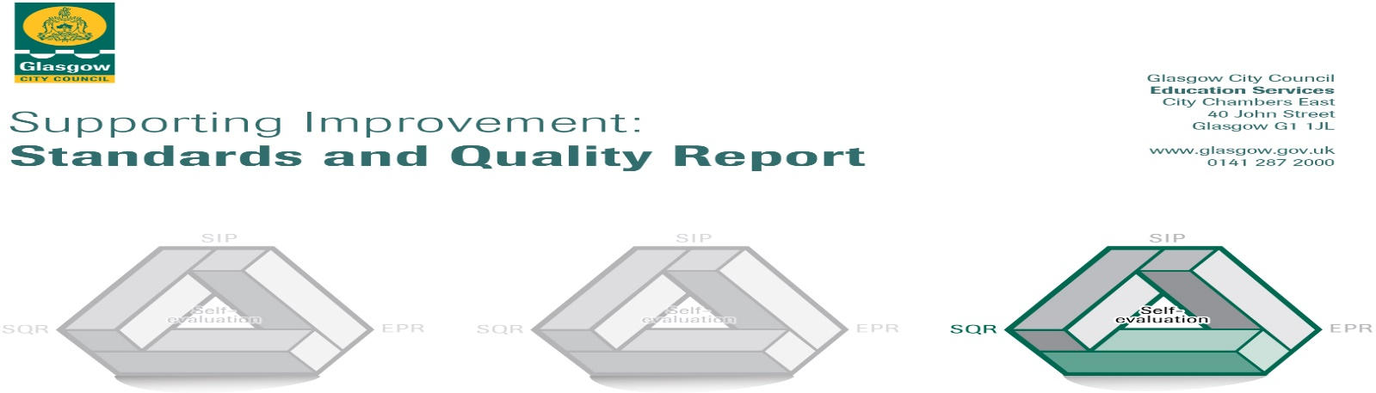

The summary report is provided for parents/carers and partners to outline our achievements this session and our priorities for next session. Throughout this session we have taken forward our priorities as detailed in our school improvement plan. Through our processes of self-evaluation, we have identified how we can improve outcomes for our children and young people.

Our achievements and improvements this year.

We would like to highlight the following improvements/achievements from session 2023 - 2024:
Key Developments:
- We were inspected by His Majesty’s Inspectorate of Education (HMIe) in September. Our report can be accessed here or using the QR code ->
- Our Family STEM Event was attended by over 100 members of the school community with a wide range of partners providing workshops.
- Team teaching, staff training and modelling of lessons led by Challenge Leaders of Learning supported staff in adopting new approaches to improve attainment in writing and numeracy in addition to their work with targeted intervention groups.
- In partnership with the Parent Council, pupil enterprise projects raised £2400 towards a community defibrillator.
Developments in Learning, Teaching and Assessment:
- We have developed our practice in reading and numeracy across the school with teachers reporting improved confidence from working with the Challenge Leaders of Learning.
- Our staff regularly share practice and visit each other’s classrooms to support improvements in teaching and learning.
- We have developed approaches to differentiation, ensuring all learners are well supported and appropriately challenged in class.
- Showbie has been used effectively to facilitate communication between home and school.
- Our Play Pedagogy approaches have been further improved after extensive staff training and we presented our work to the city at Glasgow’s Play Conference.
- We worked with Bannerman Learning Community to develop a shared understanding of achieving a level within writing and science.
- All learners benefited from a range of visits including to the local library, Blairvadach Outdoor Education Centre, Dynamic Earth, Glasgow Science Centre, Whitelee Windfarm, Top Golf, Linn Park, the Sensory Hub, Free Wheel North, Wagamama and the GOMA.
- We continue to develop children’s awareness and understanding of the United Nations Convention on the Rights of the Child through class charters, our health and wellbeing curriculum and through assemblies.
- Our annual pupil survey highlighted a wide range of strengths and year-on-year improvements in how children feel about their learning.
- Our Assessment Framework supported teachers in ensuring assessment of pupil learning is gathered and used effectively.
Progress in Promoting Wellbeing, Equality and Inclusion:
- 90% of pupils feel the Pupil Council is good at getting improvements made in the school.
- Almost all pupils identified that staff make sure pupils behave well and are good at dealing with bullying behaviour in our annual pupil survey.
- The Sports Committee contributed to the organisation of Sports Day.
- LCR learners benefited from inclusion opportunities in classrooms, PE lessons, school assemblies, in the lunch hall, through enterprise projects and at the STEM Event.
- Our Community Larder, uniform bank and FAYRE ALDI vouchers supported a few families.
- A few learners benefited from art therapy and engagement with Frog Life to support wellbeing.
- A few learners benefited from a our wellbeing intervention in school using Thistle Grove.
- We have significantly improved the Meadow in partnership with a range of volunteers and thanks to significant fundraising.
- Most learners in the mainstream attended an extra-curricular club. The majority of learners attended an active schools after-school club.
- The pupil Equalities Group have produced a video to support anti-bullying work in school.
- All learners benefited from a range of wellbeing activities developed with partners as we celebrated Leap Day.
Progress in Children’s Learning/Raising Attainment and Recognising Achievement:
- 64 children were supported in accelerating their progress in writing or numeracy during after-school sessions at Caley Crew led by our Support for Learning Workers.
- Almost all children had their achievements in demonstrating our school values celebrated in our assemblies
- Almost all learners in targeted groups in writing and numeracy showed accelerated progress in their learning.
- Our fact, story, action approach to tracking learners’ progress enabled us to robustly target support for learners where it is most needed.
- Our primary 7 learners benefited from a working across the P7 teaching team to prepare them for secondary and made better than expected progress in their learning.
- Pupils’ wider achievements are celebrated weekly in assemblies.
- Almost all pupils across the mainstream and LCR participated in school performances including the Christmas show, The Greatest Snowman

Here is what we plan to improve next year.
- Achievement and progress: to improve attainment in literacy
  - To improve learners’ attainment in reading
  - To improve learners’ attainment in writing
- Wellbeing and learning: to improve learners’ wellbeing
  - To improve pupils’ experience of equalities
  - To improve pupils’ experiences through targeted wellbeing interventions and a range of universal supports

How can you find out more information about our school?
Please contact us directly if you require further information or if you wish to comment on the report.

The contact e-mail address is: Headteacher@caledonia-pri.glasgow.sch.uk

Our telephone number is: 0141 771 8214

Our school address is: Calderwood Drive, Baillieston, G69 7DJ

Further information is available in: newsletters, the school website and the school handbook

