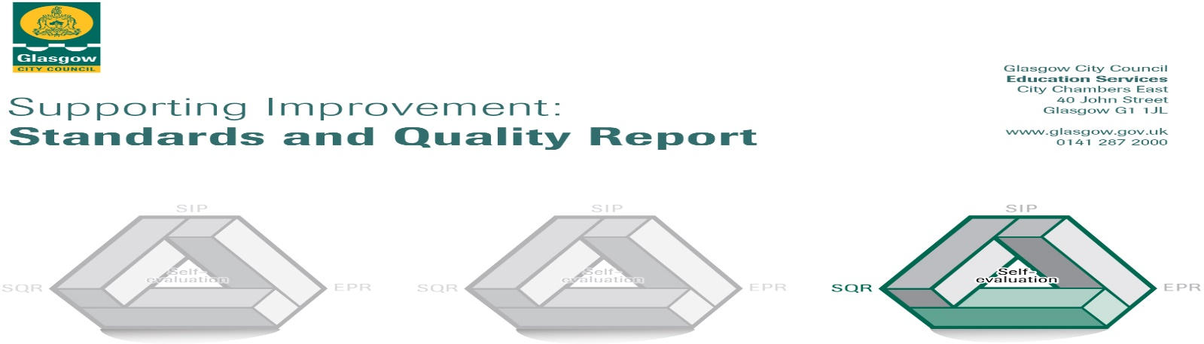

The summary report is provided for parents/carers and partners to outline our achievements this session and our priorities for next session. Throughout this session we have taken forward our priorities as detailed in our school improvement plan. Through our processes of self-evaluation, we have identified how we can improve outcomes for our children and young people.

Our achievements and improvements this year.
We would like to highlight the following improvements/achievements from session 2022 - 2023:
Key Developments:
- Our relaunched Family STEM Event was attended by over 200 members of the school community with a wide range of partners providing workshops.
- We developed a whole school, consistent approach to active learning with a policy poster created, displayed and shared with staff. This policy poster has been added to our teaching and learning policy.
- Team teaching, staff training and modelling of lessons led by Challenge Leaders of Learning supported staff in adopting new approaches to improve attainment in writing and numeracy in addition to their work with targeted intervention groups.
Developments in Learning, Teaching and Assessment:
- We have developed our practice in writing and numeracy across the school with teachers reporting improved confidence from working with the Challenge Leaders of Learning.
- We have ensured we meet the Language and Communication Friendly Establishment standard in our classrooms and have worked to improve teacher talk.
- Our staff regularly share practice and visit each other’s classrooms to support improvements in teaching and learning.
- Showbie has been used effectively to facilitate communication between home and school.
- Our Play Pedagogy approaches have been further improved after extensive staff training. This session training and play pedagogy approaches were extended into the LCR. A play policy was developed by staff to capture our good practice.
- We worked with Bannerman Learning Community to develop a shared understanding of achieving a level within Writing and numeracy.
- Learners benefited from visits including to the Wee Write Festival, the local library, Greenoakhill woodland, Blairvadach Outdoor Education Centre and a local taxi garage to enhance learning.
- Outdoor learning remains a key feature of our learning. All learners benefit from learning in our school grounds on a regular basis.
- We continue to develop children’s awareness and understanding of the United Nations Convention on the Rights of the Child through class charters, our health and wellbeing curriculum and through assemblies.
- Our annual pupil survey highlighted a wide range of strengths and year-on-year improvements in how children feel about their learning.
- Our Assessment Framework supported teachers in ensuring assessment of pupil learning is gathered and used effectively.
Progress in Promoting Wellbeing, Equality and Inclusion:
- 90% of pupils feel the pupil council is good at getting improvements made in the school.
- The Eco Committee continue to embed Learning for Sustainability across the school and we achieved our 7th Green Flag.
- Almost all pupils identified that staff make sure pupils behave well and are good at dealing with bullying behaviour in our annual pupil survey.
- The Sports Committee contributed to the organisation of Clash of the Classes; supported a P1 after-school club and organised distribution of indoor shoes for pupils who needed them.
- LCR learners benefited from inclusion opportunities in classrooms, PE lessons, school assemblies and in the lunch hall.
- Our ASD parent group supported a few families.
- Our Community Larder, uniform bank and FAYRE ALDI vouchers supported a few families.
- Pupil council members attended a number of Glasgow-wide pupil forum events.
- A few learners benefited from art therapy and engagement with Frog Life to support wellbeing.
- A few learners benefited from a new wellbeing intervention in school using a newly developed space, Thistle Grove.
- Our Junior Road Safety Officers promoted road safety in assemblies, with parents and across classes.
- The majority of learners in the mainstream attended active schools after-school clubs. Less than half of learners in the mainstream attended an Expressive Arts after-school club.
Progress in Children’s Learning/Raising Attainment and Recognising Achievement:
- 80 children were supported in accelerating their progress in writing or numeracy during after-school sessions at Caley Crew led by our Support for Learning Workers.
- Almost all children had their achievements in demonstrating our school values celebrated in our assemblies
- Almost all learners in targeted groups in writing and numeracy showed accelerated progress in their learning.
- We have enhanced our fact, story, action approach to tracking meetings to enable us to better target support for learners where it is most needed.
- Our primary 7 learners benefited from a new way of working across several teachers to prepare them for secondary and made better than expected progress in their learning.
- Pupils’ wider achievements are celebrated weekly in assemblies.
- Almost all pupils across the mainstream and LCR participated in our school show, ‘What’s The Crime Mr Wolf’

Here is what we plan to improve next year.
- Achievement and progress: to improve attainment in literacy and numeracy
  - To improve learners’ attainment in reading
  - To improve learners’ attainment in numeracy
- Engagement and participation: to improve learners’ experiences through consistently high-quality learning and teaching
  - To improve consistency in highly effective teaching and learning
  - To use moderation across the Bannerman Learning Community to improve the quality of learners’ experiences and pupil judgements about learners’ progress
- Wellbeing and learning: to improve learners’ wellbeing
  - To improve pupils’ experience of equalities and anti-bullying practice
  - To improve pupils’ experiences through targeted wellbeing interventions and a range of universal supports

How can you find out more information about our school?
Please contact us directly if you require further information or if you wish to comment on the report.

The contact e-mail address is: Headteacher@caledonia-pri.glasgow.sch.uk

Our telephone number is: 0141 771 8214

Our school address is: Calderwood Drive, Baillieston, G69 7DJ

Further information is available in: newsletters, the school website and the school handbook

