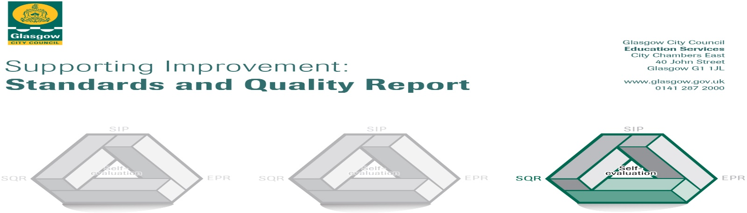

The summary report is provided for parents/careers and partners to outline our achievements this session and our priorities for next session. Throughout this session we have taken forward our priorities as detailed in our school improvement plan. Through our processes of self-evaluation, we have identified how we can improve outcomes for our children and young people.
2021 2022

Our achievements and improvements this year.
We would like to highlight the following improvements/achievements:

- Parent council met regularly to assist school improvement and successfully raised funds to assist with school trips, activities and sports kits.
- Poverty Equity Funded (PEF) Child Development Officer (CDO) worked with targeted Intervention groups from P1-P3 to help reduce the attainment gap.
- PEF used to fund salary of CDO, literacy, numeracy, outdoor and health and wellbeing resources to enhance children’s learning experiences.
- Overall increase in school Curriculum for Excellence Achievement of a Level data from previous year
- Recognition boards used in conjunction with school/nursery values and aspirations linked to house points system
- Established and resourced Literacy, Numeracy and Outdoor Learning boxes for every class and stage
- Lunch time clubs ran to assist children with creativity and to build/rebuild relationships
- Children had wider learning experiences including trips to science centre, BBC studios and filming of Swashbuckle, local community exploration, Westend Adventures outdoor learning, COP26 event: meeting First Minister to celebrate free transport for under 21’s, Participation in Lost Woods project and P4’s took part in Clyde River Foundation Salmon Project at the River Kelvin where they learned about salmon DNA assisted in collecting samples to send to USA for analysis
- Linked to health and Wellbeing P4 completed the Virtual Great Scottish Schools Run.
- Nursery visited the library, solar panel spotting, the Tall Ship and Transport Museum as part of their sea and pirate literacy and interdisciplinary learning
- P5/6 created iMovie’s linked to sustainability and COP26.
- P6&7 took part in Show Racism the Red Card sessions and also the Standing for Diversity Together Competition
- GCC Roots Through Writing refreshed within school/nursery and consistently used to develop children’s literacy skills from Nursery to P7
- Consistent spelling and phonics throughout all stages of school/nursery – incorporating ReadWriteInc
- Take A Book Stand: Every child had the opportunity to take a book home to keep
- Book Week Scotland, Nov 2021: Reading challenges at home to encourage reading for pleasure
- Author Event for Pre-schoolers at Partick Library (Wee Write Festival) with a STEM focus
- Author Event: Creative Writing workshops for P5-7 to develop storyline
- Three whole school/nursery vocabulary fortnights - Sustainability (Nov 2021) Scots Words (Jan 2022) and STEM March 2022
- Literacy Challenge Leader of Learning (CLOL) has developed a progressive writing display, organised family reading events within wider community and introduced Tools for Writing targets and assessment prompts for children at all levels (Early to Second)
- Celebration station established by CLOL to motivate and engage children in their literacy learning
- Literacy CLOL has established strong connection with Nursery Class to be included in our establishment’s progression framework, learning and teaching
- Seesaw accessed by almost all parents in school/nursery to share learning and create a learning journey for every child
- Links with Rangers Charity Foundation allowing sessions of Get Ready for Sport and The + Sport Move and Learn Project to encourage physical activity, promote nutritional education and build awareness of the importance of a healthy diet and active lifestyle.
- Moderation continued within the school/nursery and across wider learning community to ensure agreed and high standards of learning and teaching (numeracy and literacy)
- Playful pedagogy extended throughout the school (P5-P7) to engage children in problem solving and contextualised learning
- Tracking and monitoring expanded to include Fact, Story and Action for every pupil to help identify and fill gaps in needs and learning
- Counselling provided by Life-Link to assist groups of pupils to prepare for transition to secondary school
- Seasons for growth sessions held for Groups of children P4-P7
- As part of the Caldercuilt journey towards becoming a Language and Communication Friendly Establishment (LCFE), four of our staff trained and disseminated knowledge to allow PECS and Boardmaker to be used consistently throughout the school/nursery. One staff member also trained to Level 4 in Makaton and sharing knowledge with all stages
- Period poverty resources have been provided throughout establishment and information shared with second level pupils
- Preloved uniform available for all families within foyer of school
- STEM funding from Education Scotland to fund community learning resources and staff training.
- Nursery acquired grant funding to provide outdoor clothing for children and staff
- Supporting British Science week STEM activity week run across whole establishment
- Buddy benches placed around school for children during break times and P1-2 playground developed with play benches
- Whole school focus on climate change and sustainability linked to COP26 events which enhanced knowledge and supported school values
- Two P7 pupils won a design competition for their wind turbine logo design which was displayed throughout Glasgow during COP26 in collaboration with Katrick Wind Technologies.
- P7 class won a £50 gift voucher for their work on breaking down gender bias in STEM
- All P7 children achieved Young STEM Leaders award.
- Senior pupils worked with community Police and achieved Junior Cop Awards
- Representatives from P6 and P7 took part in the Children’s Forum to express views of Caldercuilt children.
- Children’s wider achievements celebrated and displayed in assembly hall
- Whole School refresh of STAR approach to Teaching vocabulary November 2021
- Policies, new and updated: New Equity & Equalities Policy Oct 2021, New Vocabulary Policy Nov 2021, Updated Writing policy May 2022, Updated Spelling Policy April 2022, Updated Talking and Listening policy May 2022 and Updated Digital Literacy Policy.
- Three staff members achieved GTCS recognition

Here is what we plan to improve next year.
- Continue to raise attainment and achievement in Literacy and Tools for Writing through GIC Glasgow Literacy for all, including exploring and developing pedagogy and equity across all stages.

- Continue to prioritise Health and Wellbeing throughout whole school/nursery with nurturing approaches and increased participation in physical activity including personal and targeted support.

- Work towards being a Language and Communication Friendly Environment (LCFE) across school and nursery.

- Develop Restorative Practices, whole school Emotion Works, Rights Respecting Schools Silver Status in line with UNRC and promoting positive behaviour.

- Interdisciplinary learning, Science, Technology, Engineering, and Maths (STEM) integrated with Literacy through consistent planning and assessment resources, developing pedagogy and continued Glasgow Improvement Challenge intervention supported by Literacy for All.

- Improve awareness of imbalance and gender equality, sustainable employability skills and continue to Develop Young Workforce through career education standards and building meta-skills.

- Increase face to face family connections through community wide and school/nursery events. Inviting in family members for workshops and as volunteers whilst increasing Parent Council Members

How can you find out more information about our school?
Please contact us directly if you require further information or if you wish to comment on the report.

The contact e-mail address is: Headteacher@caldercuilt-pri.glasgow.sch.uk

Our telephone number is: 01419450633

Our school address is: Caldercuilt Primary School & Nursery Class, 101 Invershiel road, Glasgow, G23 5NR

Further information is available in: newsletters, Twitter, the school website, and the school handbook
@Caldercuilt
http://www.caldercuilt-pri.glasgow.sch.uk/

