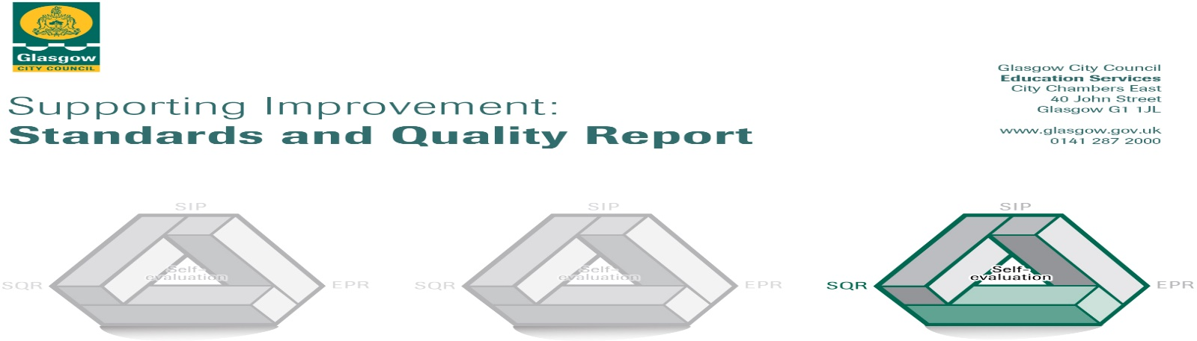
Caldercuilt Primary School and Nursery Class 2022-2023
The summary report is provided for parents/careers and partners to outline our achievements this session and our priorities for next session. Throughout this session we have taken forward our priorities as detailed in our school improvement plan. Through our processes of self-evaluation, we have identified how we can improve outcomes for our children and young people.

Our achievements and improvements this year.
We would like to highlight the following improvements/achievements:

Key developments (leadership of change)
All teachers and CDO’s are confident with nurture principles and restorative practice vision across our school and nursery. All staff completed in house and learning community moderation activities: planning, lessons, observations, focus weeks. Almost all staff completed Curriculum Rationale training and provided input to development of a new refreshed rational which reflects our curriculum, context and vision. The Young Leaders of Learning and STEM awards were achieved by all pupils in P6 and P7.
Almost all teachers and Child development Officers (CDO’s) have a leadership role within Caldercuilt e.g. Place2Be lead, CREATE lead, digital leader, STEM leader, Health and Wellbeing and children’s rights. Our nursery Team Leader worked closely with our Challenge Leader of Learning (CLOL) in literacy and enhanced writing and tools for writing from early to second level. This model was shared across staff at Glasgow’s Improvement Hub and Early years establishments. Our learning and Communication Friendly Establishment (LCFE) team supported staff on journey, establishment changes observed physically and through dialogue with children. The LCFE team surveyed children, staff and parents to identify strengths, weaknesses, opportunities and threats (SWOT) analysis and quality indicator evaluations to ensure appropriate next action points.
This year staff worked to develop a new learning community STEM policy and have begun refreshing our numeracy policy to ensure understanding and progression whilst providing a wide range of experiences and opportunities for our young people. All staff and all children have given input to our refreshed curriculum rationale and next session we will invite parents and wider community to contribute to this. With the implementation of digital learning across all stages most of our children are progressing at an appropriate level, All support staff have contribute supported staff on journey, establishment changes observed physically and through dialogue with children. All staff across Caldercuilt consistently implement nurturing approaches and this was evident from positive and high quality feedback of the Nurture Quality Assurance visit in the summer term.

Developments in learning and teaching and assessment
We continued to develop the quality of delivery of literacy. Staff continue to engage with professional learning focussing on Glasgow’s Routes Through Writing, Word Aware approaches, Talk practices, PM Benchmarking, tools for writing, Thinking Routines and reading into writing. As a result, most children’s engagement and motivation in writing has improved. With Poverty Equity Funding we provide a Child Development Officer who works with P1-P3 children to target attainment gaps in literacy, numeracy and health and wellbeing. All staff have enhanced their understanding of progression and attainment through learning community moderation events. Through a whole establishment approach to interdisciplinary learning (IDL) and pupil voice, children have increased opportunities for personalisation and choice in their learning and are provided opportunities to lead improvement through their participation in children’s working parties and wider school community events. Second level teachers have increased engagement with Cleveden secondary staff and have worked together to link children’s learning to real life contexts, Skills Development Scotland and Developing the Young Workforce. This has greatly enhanced children’s understanding and engagement with a wide range of interdisciplinary topics.
Staff confidence in tracking and monitoring children has greatly improved through the use of the ‘Fact, Story, Action’ approach which has allowed for targeted intervention at key points.

Progress in promoting well-being, equality and inclusion
Across our establishment during session 2022-2023 school attendance was 93% with zero exclusions. There were 40% of our school pupils eligible for clothing grants and 14% of our children had English as an additional language. Our school community is establishing a shared understanding of wellbeing and inclusion. This has been enhanced with our journey to becoming an LCFE school and our continued shared learning and use of Makaton. All children within the school take part in children’s working party activities and most children are confident to take a lead role or feedback to a wider audience. Most of our children feel safe, healthy, achieving, nurtured, active, respected, responsible and included. Through development of our restorative approaches and our positive Relationships Policy, relationships across Caldercuilt are positive and supportive and we have shared values and a positive school ethos with high expectations. All children from every stage have opportunities to be active participants in decisions which affect their learning and are provided with opportunities for wider achievement and participation. Through Counselling for Schools Funding four groups of P6-P7 boys and girls undertook counselling with Quarriers and a group of 5 girls undertook Art Therapy with impact Arts. Most children gave positive feedback. Our Nurture room, Sunnybrook, had a core group of P1 – P3 children for three terms to support them with social, health and wellbeing strategies to assist them to be ready to learn. A small group of children from P4-P7 continued to have nurture check ins throughout the year on an ‘as need’ basis. All classes continued to provide resources and strategies to include all children and support their emotional wellbeing and learning. We continue to develop supports for all children with additional support needs in a bid to remove barriers to their learning, Through whole school assemblies, children’s working party groups, house meetings, focus groups and the use of Twitter (X) and Seesaw we involved children and families in developing a shared understanding of children’s learning needs at Caldercuilt. Our focus on LCFE approaches has ensured inclusion and equality with improved outcomes for almost all of our children. Our Caldercuilt aspirations and values of honesty, respect, responsibility and cooperation helps to ensure our establishment is a place where children feel nurtured and are safe to undertake experiences and opportunities to play and learn.

Progress in children’s learning /raising attainment and recognising achievement
At all stages, most children learn and achieve well. Almost all children are enthusiastic and keen to learn. They work well in pairs and groups and support each other in their learning. Most children are able to discuss their skills when reflecting on their own learning and can give a real-life context where their learning could be applied. Most aspects of children’s learning are shared with families and wider community through X (Twitter), assemblies, Seesaw journals, assemblies, workshops and stay and play sessions. Children’s wider achievements are shared within classes on a daily basis, home links though Seesaw, on our recognition boards and at assemblies. Children have leadership roles within the nursery and within the school through House Captain/Vice opportunities, seven different working party groups, Junior road safety officers, Young peoples forum representatives, buddies, paired reading, show case events, Young STEM leader awards and local events including enterprise opportunities. At assembly every class recognises children who meet the four capacities of Curriculum for Excellence (successful learners, confident individuals, responsible citizens, effective contributors) as well as being recognised with school citizenship awards.
Overall most children are making good progress in literacy, numeracy and mathematics. Most children listen and talk well within class and wider events. Children continue to develop skills to allow them to research, question and create. Most children show increased writing acceptance, motivation and engagement with writing across establishment, this is evident from individual writing awards and celebration stations and books or reports created by children at home and brought into school to showcase. From nursery to P7 children use a variety of mental maths strategies and have daily opportunities to apply skills in a real-life context. Most children with additional support needs are making good progress and meeting targets within their wellbeing plans.

Here is what we plan to improve next year.
Challenge 1:
Build high-quality, inclusive practices, improving overall outcomes for all of our learners.
Challenge 2:
Provide best possible outcomes and learning contexts to develop learner’s creativity and employability skills.
Challenge 3:
Improve attainment and achievement in reading across all stages in school and nursery.

How can you find out more information about our school?
Please contact us directly if you require further information or if you wish to comment on the report.
The contact e-mail address is: headteacher@caldercuilt-pri.glasgow.sch.uk
Our telephone number is: 0141 945 0633
Our school address is: Caldercuilt Primary School & Nursery Class,101 Invershiel Road, Glasgow, G235NR
Further information is available in:
- Newsletters
- Our school website: https://blogs.glowscotland.org.uk/gc/caldercuilt/?page_id=194
- Our X feed (formerly Twitter): @Caldercuilt
- Our school handbook: https://www.glasgow.gov.uk/index.aspx?articleid=18091

