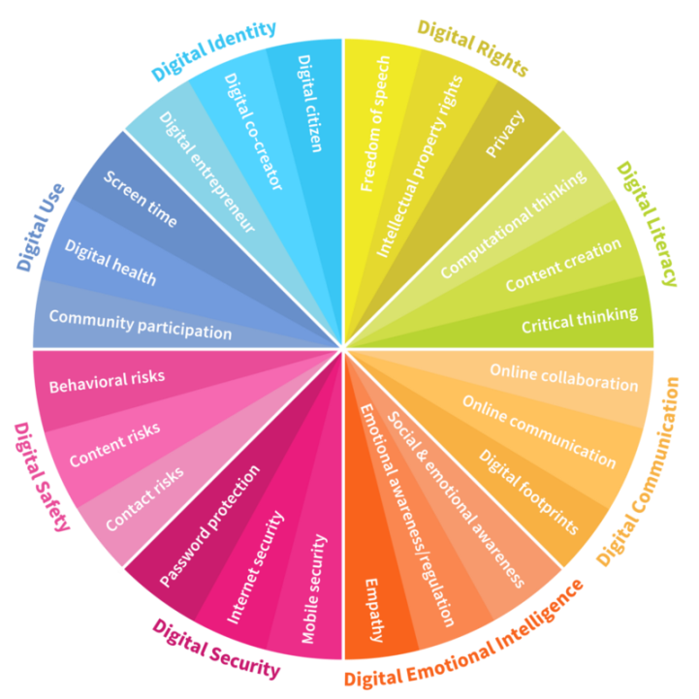
Caldercuilt Primary School and Nursery Class Digital Strategy
Our Vision
At Caldercuilt Primary School & Nursery our vision for all our children, staff and families, is to enhance learning and teaching through the use of digital technology. We have a positive attitude towards digital technology and by integrating digital technologies across the curriculum we believe we will improve outcomes and raise attainment for all our learners.
Our staff demonstrate a clear understanding of how digital technology can be used to improve learning and have been developing their ability to utilise the full potential of digital technology in all areas and at all levels. Teachers are aware of the positive impact digital technology has on the quality of learning and teaching, pupil attitudes and behaviour.
Caldercuilt Primary School & Nursery is committed to investing in digital technologies, in order to motivate and inspire our learners. We aim to maintain and extend our digital technology resources and facilities, including hardware, software and infrastructure to support our learning environments.
Our overarching aim is to ensure our children have access to current digital technologies, enabling them to make a significant contribution to our growing digital world, and successfully equipping them with essential skills for life and work. We aim for all our learners, staff and families to access digital technology. This will empower our learners within our growing digital world.
Rationale
- Increasing pupil and staff engagement with digital technology is to recognise its distinctive contribution to learning and teaching.
- Digital technology is integrated into the whole school vision and the School Improvement Plan (SIP), (in line with GCC & Scotland’s Digital Learning and Teaching Strategy)
Our Digital Learners will:
- Identify and use a range of digital strategies to support their learning.
- Develop the skills and abilities to experiment and create innovative digital solutions.
- Be able to understand and demonstrate the benefits of digital technology in their learning.
- Adhere to acceptable use protocols, applying their skills and knowledge to use the internet safely and responsibly.
- Participate in learning that will develop skills and provide opportunities to work
- collaboratively using digital technology.
- Have opportunities, and the means to use digital technology, to access online content.
- Display a positive mindset towards technology with the confidence and competence to embrace digital technology and the internet.
- Acquire the skills, ability and agility to select and use appropriate digital technology for learning, life and the world of work.
- Make effective use of Glow tools, including Glow mail, One Drive, Office 365 and Glow Forms.
- Be treated equitably; all learners with Additional Support Needs (ASN) will benefit from digital technologies and will be guided on the use of assistive and other technologies for their on-going support.
- Have quality learning experiences where digital technology supports and enhances learning already taking place.
- Use new technology that reflects our ever changing and adapting digital society.
- Have the tools and knowledge to use technology appropriately at school and home.
- Have the opportunity to explore a wide range of resources through both work in their own learning environment and in collaboration with others across the learning community through partnership working.
- Be provided with the skills to critically evaluate materials they find online and understand how to safely and legally use this content.
- Will be educated about online etiquette; identity and reputation to ensure they build positive relationships with their peers online.
Our Staff will:
- Have the skills and abilities to experiment and create digital technology solutions collaboratively.
- Understand and demonstrate the benefits of digital learning for themselves and their learners.
- Participate in digital technology professional learning opportunities in a range of formal and informal contexts including whole-school teaching, peer-to-peer learning, the use of external organisations and formal training.
- Have opportunities to observe modelled lesson and have specialist visitors who can demonstrate the value of digital learning and allow teachers to share examples of good practice in this context.
- Have the opportunities and means to use digital technology and access online content, when planning, assessing and tracking.
- Make effective use of Glow for communication, collaboration and learning and teaching - e.g. Glow Teams, Glow Forms, Office 365, Glow mail, Forms, etc.
- Have confidence in their own skills and knowledge to use the internet and digital devices safely and responsibly.
- Be equipped to deliver key safety messages regarding digital technology to pupils
- Ensure they are confident and competent at supporting children with additional support needs using digital technologies.
- Share our digital strategy with all stakeholders.
- Liaise with our DLOL to meet with and share updated information on our city’s digital landscape.
- Allocate Time for digital review meetings and evaluating digital experiences within our school’s working time agreement.
- All PRDS will include developments in aspects of Digital Learning and the school calendar will be tailored around agreed aspects of development.
- We will continue to instil collaboration and innovativeness between all staff in order to incorporate personalisation and choice and indeed using technology to remove barriers for learning for all stakeholders.
- We will continue to develop and sustain our strong partnership links with schools in our learning community, Glasgow Digital Leaders of Learning and many more.
- Be supported to experience new and innovative hardware, software or other digitally based pedagogical approaches.
Parents Carers and families
- Our Digital Learning Strategy will be shared with parents, carers and families.
- We will continue to work with parents, carers and families to ensure they are made aware of the technologies we are using to enhance teaching and learning.
- We will continue to use Seesaw, Twitter, YouTube etc. to engage in digital sharing of the 4 contexts of the curriculum.
- We will continue to provide information for parents, carers and families on Cyber resilience, internet safety/e-safety, digital literacy & critical literacy.
- We will continue to offer and arrange support for our parents, carers and families to help them support their child with digital learning and in coping with demands of an evolving digital world.
- We will liaise with the parent council group to discuss our digital learning policy & digital strategy and they will play a vital role in evaluating it’s progress.
- We will continue to incorporate many digital family learning experiences and continually seeking new ideas and ways to improve communication virtually.
Measuring Impact
We will measure our starting point by...
- Learner conversations regarding teaching and learning experiences, purchase of new technology, in house training, workshops, in-service days and specialist visitors.
- Staff feedback linked to PRDS, in house calendar, modelling of lessons and sharing of good practice through QA calendar and specialist visitor evaluations.
- Parental consultation
- Attainment and Achievement figures.
- School Improvement Plan
We will measure the impact of our Digital Strategy by...
- Pupil Voice
- Parental consultation
- Digital Action Plan
- Staff consultation
- Partnership working consultation with agencies
- Attainment and Achievement figures
- The increase and recruitment of Digital Leaders and Digital Leadership from pupils and the increase of Digital Leadership from staff.
- Digital Learning and Teaching in house training and modelled lessons from Digital Leaders.
- Continuing to establish partnership working opportunities from schools within and out with learning community and council.
- Progression forward for the Digital Schools Awards

Current position:
- Many staff have identified a digital target for CLPL in their PRD’s and all staff have signed up to courses.
- A number of staff have attended Glow training hosted by SSERC PCP Mentors and are making use of the tools with colleagues and pupils.
- Staff have received formal training in using the iPads, Greenscreen, Chatterpix, Cllassroom, Seesaw, OneDrive, Barefoot computing, Spheros and Microbits.
- All staff plan lessons using digital formats and are growing in confidence to access and share teaching resources from online sources (Yammer groups, TigTag, ReachOut, Teams, PL Communities, Sharepoint, Seesaw, Twitter, Pinterest, internet etc.)
- Almost all staff have a Glow login and can access Glow Mail, OneDrive, and all Microsoft Office suite software, P6 and P7 have glow emails and are actively using them.
- Many staff members are working collaboratively within the school and beyond using Microsoft Teams and Zoom.
- Staff use digital technology in all areas of the curriculum (some examples include Charanga and GarageBand in music; Let’s Dance, You Tube Yoga and online demo’s in PE; Active Learn Primary, YSL, Sumdog challenges and competitions in Maths; Literacy Shed, Study Ladder, Pobble and RWI in Literacy)
- Many staff engage in online self-study as part of their CLPL including TechTeach, Seesaw Pioneer/Ambassador, Futurelearn, Apple Teacher and Microsoft Educator.

Our Digital School will next:
- Become a Digital School with nationally recognised accreditation (Digital Schools Award) this session and will support the schools within our cluster to gain Cluster Award status.
- Have 2 Seesaw Ambassadors complete Refreshers Training and have 2 teachers complete Pioneer training.
- Have our DLOL certify as a YSL Tutor Accessor.
- Follow GCC’s clear progressive digital framework for digital technologies across the cluster.
- Run the SSERC Young STEM Leader programme with Primary 7s with a digital technologies and employability focus across the learning community, including a transition programme with our feeder secondary with a Digital STEM focus.
- Provide additional appropriate materials and resources to enable all staff and pupils to access plan and deliver digital learning opportunities.
- Audit current digital technologies including kindles, ipads, cameras etc. and alter timetabling where necessary.
- Ensure equipment and resources are maintained and renewed where necessary
- Ensure the DLOL, DigiTech Superstars and Digital Leaders have a proactive, operational and evaluative role in supporting learners’ digital capability and teachers’ use of digital technology.
- Provide on-going support to less experienced / new staff members in their use of digital technologies.
- Collaboratively review our digital strategy by evaluating the potential of emerging technologies and best practice scenarios for Lockdown.
- Embed current and emerging e-safety messages in teaching and learning and build consistency in cyber resilience across P4-7.
- Support, develop and embed approaches to assessment that make effective use of digital technology.
- Non-timetabled PCs - one in each classroom.
- Interactive White Boards (IWB) with touchscreen technology are installed in all classrooms. We also have a touchscreen IWB in Room 12 as well.
- The hall PC projects onto a large pull-down screen.
- We have an iPad ratio of 1:5 at each stage (P1-P6) and a timetabled iPad trolley. As well as 37 x 1-1 P7 iPads (all iPads are installed with learning games and approved GCC apps)
- Every teacher and CDO has an iPad and access to a computer as well as an iPad connector or ScreenMirroring use with Apple TV.
- Every Support Worker has access to shared ipads.
- Significant investment from school fund have boosted Kindle ratios and supplied additional storage.
- Investment in software including RWI Phonics, RWI Spelling, Seesaw, Languagenut, Charanga, Active Learn, Sumdog, and Emotion Works.
- Digital assessment tools are in used across the curriculum including SNSA’s, NGRTs, Pass Surveys, Sumdog, RWI and Google Docs, Survey Monkey and GLOW Forms.
- New digital learning planning ‘Seesaw’ formats introduced in August 2019 to pilot and then rolled out across the school from August 2020.
- Have close links with our associated cluster primary and secondary schools; Working collaboratively and sharing good practice with associated primary and secondary schools through the SSERC Primary School Cluster Mentors.
- Continue to offer and arrange guidance for our parents and carers to help them support their child with digital learning and in coping with the demands of the digital world, including 1-1 digital family learning experiences where appropriate.
- Links with parents via digital technology have strengthened - Communication channels have increasingly moved to digital formats including digital newsletter, emails, Seesaw, Groupcall news alerts and updates, parents’ night system, Class Dojo, Class Dojo Stories, School Twitter feed, blog and website.
- DLOL took staff through Cyber Resilience/Internet e-safety training.
- Class Dojo & Class 123 promote positive relationships
- DLOL regularly attends authority wide meetings and links with feeder secondary.
- There will be further in-house training sessions to staff as and when required.
- There will be a demonstration of QR code scanning to enhance teaching and learning.
- SLT will host an e-safety refresher for teachers to reinforce and update e-safety messages prior to Safer Internet Day.
- The school network of computers will be upgraded with the refresh.
- Wi-Fi capability will be reviewed and issues addressed through CGI.
Financial Sustainability
- Research costs for covers, screen protectors, storage, charging solutions keyboards and other accessories.
- Saving will be made through reduced reliance on textbooks, paper, stationery and other consumables.
- On-going costs will be monitored and evaluated regularly.
Managing Technology
- We will work closely with GCC and XMA to continue our roll out in line with local authority requirements.
- All staff use CGI number 0141-287-4000 to report issues to the GCC help desk.
- A dedicated member of staff (Digital Leader of Learning) will be in charge of the digital resources and any issues should be reported to the correct team.
- Devices and data will be stored securely as per the council requirements.
- All staff and pupils trained annually on data security processes.

