Dear Parent/Carer,

Pupils can now get free bus travel by applying for a new or replacement Young Scot National Entitlement Card (NEC). To make this process as easy as possible Education have published a simplified version of the government application form on Smart Survey for parents/carers of children under 12. Your application will go to Glasgow Life who will process your details and arrange for the cards to be delivered to your home address. You can access the survey here:

Link

https://www.smartsurvey.co.uk/s/YoungScotNEC/

QR Code

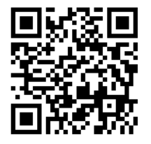

The survey will close on March 18^{th.} If you would prefer a hard copy of the application, please contact your school. After March 18th you will need to apply using the government website or in person at a Glasgow Life library.

