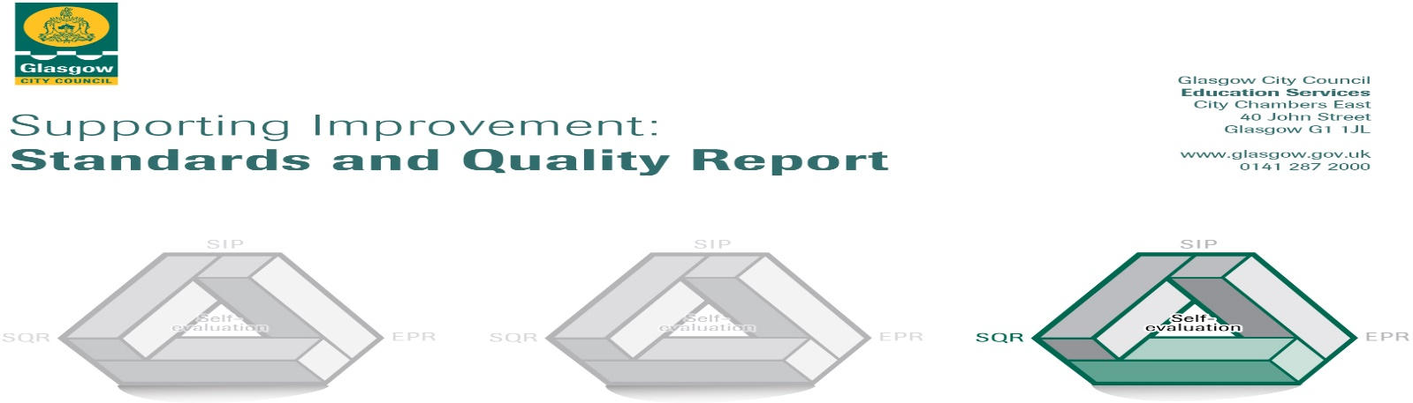

The summary report is provided for parents/carers and partners to outline our achievements this session and our priorities for next session. Throughout this session we have taken forward our priorities as detailed in our School Improvement Plan. Through our processes of self-evaluation, we have identified how we can improve outcomes for our children and young people.

Our achievements and improvements this year.
I am pleased to give you an update on the improvements at Cadder Primary School for session 2019-20. The school continues to be committed to offering a range of opportunities that promote citizenship, diversity and promote the school values of Kindness, Respect, Teamwork and Ambition.
It is fully recognised that school closure, due to Covid 19, had an impact on the delivery from the school, however this was completely out with the schools control and best efforts were made by staff to offer support to pupils and their families during the period of national lockdown. Staff have remained committed to providing a service and been incredibly creative in the situation they have found themselves in. We hope that our pupils and families observed this in their experience from us.
The priorities for 2019-2020 have remained the same for 2020-21 due to the period of closure having an impact on the improvement agenda, however please see below the excellent progress made in the four main areas identified for improvement.
- To improve the delivery of STEM (Science, Technology, Engineering and Mathematics) learning opportunities to all pupils with a focus of the Glasgow Improvement Challenge on Maths and Numeracy.
A group of staff formed a working party to take lead in this area within the school. This included being involved with SSERC (Scottish Schools Education Research Centre). All staff took part in training which, in turn, benefited our learners as new and innovative methods were introduced on how to engage children in these areas. Part of this training took part as a learning community which gave the school the opportunity to share good practice and learn from other school staff in the local area. The school received iPads from GCC for sole use of P6 and P7 as well as a bank of shared iPads for use throughout the school. This enhanced opportunities for digital learning greatly.
Mr Hamilton was the Maths CLOL (Curriculum Leader for Learning). Mr Hamilton worked with staff using strategies from Glasgow Counts to improve the teaching and learning of maths.
In recognition of the excellent work conducted by the staff in the area of Digital Literacy, the school was awarded The Scottish Digital Literacy Award and have been asked to mentor other schools in this area.
- Literacy - To further raise attainment in reading and writing and enhance the teaching and learning of talking and listening.
Following on from the successful introduction of ‘Talk for Writing’ from the previous year, staff further committed to embedding this method into pupil writing experiences. Both staff and pupils became more confident with the strategies and this had a very positive impact on improved writing skills across the school. The method offered continuity in approach and provided a sound platform for children to build on as they progressed.
All staff received training on improving the teaching of talking and listening. A pilot of the new strategies was introduced but this was not fully developed due to school closure. This has become an area for development for 2020-21.
- Health and wellbeing: Further understanding of a nurturing and inclusive approach including accreditation, as a school, for Language and Communication Friendly School.
A group of staff formed a working party to lead this area of development. All staff was trained on how to ensure appropriate language was used to include all learners within the school. This included looking at improving support for children with English as an additional language, using simplified and pictorial methods of communication for some, up-levelling of vocabulary for some learners to improve communication with others, improving the teaching of French for all, continue to use Emotion Works to increase pupil’s bank of “emotional” words. A pupil focus group decided to have a language of the month and agreed that Spanish should be the first language to celebrate as this related to one of the languages spoken by some of our newer pupils. The application for accreditation as a Language Friendly Establishment has been delayed due to the impact of lockdown. We hope to be awarded this soon.
Nurture continues to be an integral part of the Cadder ethos. Miss Wilson and Miss Sutherland attended a wealth of training which was then shared with staff to help us support the health and wellbeing of pupils. This included looking at supporting children through bereavement and issues related to child mental health.
Achieve More continued to support the school with their lunch and afterschool provision. This helped with positive role modelling, fair play, friendships as well as giving opportunities for organised sport to keep healthy. Support continued during the period of lockdown and this was appreciated among the community very much.
A group of staff formed a working party to lead the area of play. This group promoted play pedagogy throughout the school with a particular focus on the infant department. This work has enhanced play opportunities for learners, as well as develops the use of some of our outdoor spaces. Sadly this area for improvement has been hindered by “out of school hour visitors” who have vandalised a number of improvements created in the spaces. We continue to develop these.
- Improve moderation and assessment to inform best individualised support for every pupil
Our staff team all took part in training to identify how we could improve moderation and assessment within the school. Staff took part in school, inter school and inter authority moderation to ensure we assessed our pupils in line with national standards.

In addition to the main areas for development, Cadder Primary had a number of other successes including Bikeability Awards for some P6 and P7 pupils, a successful P7 residential for some pupils at Blairvadoch Outdoor Centre, kayaking awards for some senior children and awards given to Junior Road Safety Officers. Once again the school celebrated the success of graduates of the Brilliant Club which involved a group of six children taking part in a joint project with Strathclyde University. This was a major achievement and once again promoted the school value of “Ambition”. The school was incredibly proud to be awarded another Green Flag from Eco Schools Scotland. This is in recognition for the outstanding work by every member of our school community. We continue to be committed to promoting our Eco message!

Here is what we plan to improve next year.
The school has four main areas for development outlined in the School Improvement Plan.

- To improve the delivery of STEM learning opportunities to all pupils with a focus of the Glasgow Improvement Challenge on Maths and Numeracy.
- Literacy –To further raise attainment in reading and writing and enhance the teaching and learning of talking and listening.
- Health and wellbeing: Further understanding of a nurturing and inclusive approach including accreditation, as a school, for Language and Communication Friendly School. To deliver the 3R curriculum of Recovery, Resilience and Reconnection.
- Improve moderation and assessment to inform best individualised support for every pupil.

PEF The school was allocated £84500 for 2020-21. Two part-time support staff, one full time CDO, one day a week Family Links Worker and Achieve More coaches continue to be paid through PEF. Some of the money will be used to further improve our outdoor space and some STEM resources, however as we are committed to providing the best service for our pupils, we believe, and in consultation with our Parent Council, that additional trained staff can support our learners get the best experience, hence the majority of PEF is allocated in this way.

How can you find out more information about our school?
Please contact us directly if you require further information or if you wish to comment on the report.

The contact e-mail address is: Headteacher@cadder-pri.glasgow.sch.uk

Our telephone number is: 0141 946 3036
Our school address is: Cadder Primary School, 60 Herma Street, Glasgow. G23 5AR

Further information is available from school and class newsletters, the school website, Twitter, Facebook and the school handbook.

