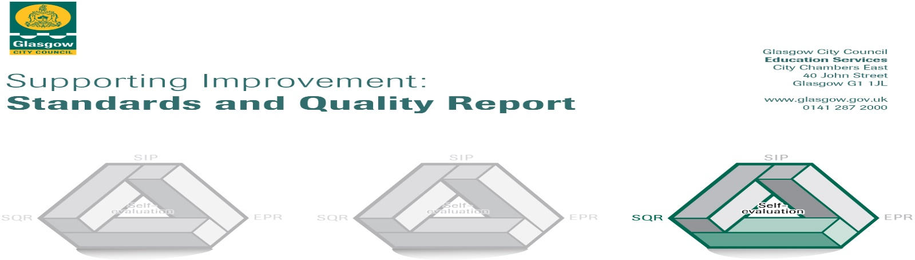

The summary report is provided for parents/careers and partners to outline our achievements this session and our priorities for next session. Throughout this session we have taken forward our priorities as detailed in our school improvement plan. Through our processes of self-evaluation, we have identified how we can improve outcomes for our children and young people.

Our achievements and improvements this year.
I am pleased to give you an update on the improvements and developments at Cadder Primary School for the session 2017-18.
Health and Wellbeing was identified as one of the priorities to develop. The school participated in an emotional regulation pilot project where almost all children are able to talk about “Lizard brain” “Belly breathing “and “ACB” to help take ownership of their own actions. A resource purchased called Emotion works was introduced and, as well as restorative practice that had been introduced, children demonstrated a greater understanding and were able to identify strategies to help regulate their behaviour.
The school continued to embed improved reading and writing to further raise attainment. Almost all of our pupils have also shown raised attainment in their numeracy. Teaching became more responsive to assessment via Tapestry training which is a Glasgow City Council Initiative taken on by some schools in the city. Learning through play was introduced into the infant department last year with a particular focus in P1. This was fully supported with the knowledge and skill from our PEF funded, Child Development Officer. This has benefited our pupils greatly and raised attainment as well as raised confidence levels was recorded in P1 in both literacy and numeracy using this approach.
The school continues to be pleased to offer counselling to some children from specialists from the company called, “SPARK”. Although only a small number of children have received this support, feedback from both pupils and adults has shown that this specialist support has made a positive impact on the mental health of the pupils.
The school was awarded the Silver School Sport Award from Sports Scotland in recognition of the wealth and range of sports activities offered during the day and as after school opportunities. Cadder Primary was pleased to have offered a wide range of clubs including tennis, boys and girls football, yoga, dance and rugby. The school is now working towards the Gold Sports Award. Cycling has been promoted throughout the school year. The school was successful in securing funding for a new bicycle shed and it has become increasingly popular. The parent council successfully planned a health promotion day in collaboration with Lambhill Stables, a local community group, to promote cycling. Lambhill Stables continue to work with the school to enhance the outdoor classroom and allotment area. This also links with John Muir Award certification for our P6 and P7 classes.
To date, a number of workshops have been offered as part of commitment to work in partnership with parents and carers there have been a number of workshops offered. These included, Positive Parenting discussions, Road Safety, Autism awareness, Support for autism in the family, Parent Council, Welfare rights drop in sessions and SPARK family support where requested. P1 hosted Stay and Play and P1 Physical Literacy sessions.
We look forward to working in partnership with you building on the successes of 2017-18 into 2018-19.

Here is what we plan to improve next year.
There are a number of developments in place to further improve Cadder Primary school. Many of these are funded through PEF (Pupil Equity Funding). The school was awarded £82 000 this year. This has been used to fund a school councillor one day a week from SPARK, two members of support staff, one for four days and one for three days. Some of PEF has also been allocated to fund staff from A and M Sports for some lunch times to promote positive choices. We are also using PEF to help fund the developments in our P1 and P2 classroom where play is being used to engage and support learning opportunities.
Priorities for development are outlined in our School Improvement Plan:
1: Health and Wellbeing – Further support pupils to understand and explore emotions and improve physical literacy. Gain accreditation, as a school, for Language and Communication Friendly School. (LCFS)
Further to our focus on Emotional literacy from last year using a resource called “Emotion Works” we have introduced a new resource called “Knowing Me, Knowing You.” This will enhance our pupil support in health and provide more opportunities to encourage our pupils to make positive health choices. We also aim to offer Bikeabilty lessons to pupils this year to build on our promotion of cycling from last year. Our staff are also committed to working together on training for the LCFS. This will aid communication with all pupils, including those with additional support needs.
2: Literacy – Glasgow’s Improvement Challenge with a focus on raising attainment in writing. Improving Talking and Listening will be a focus for the Cleveden Learning Community.
The school continues to embed good practice in all areas of literacy as a focus to further raise attainment. Our Challenge Leader for Learning will train staff on improving writing lessons and therefore upskill our staff team.
3: Improve effective assessment – Tapestry project
We are pleased to be moving into the final period of this initiative within the school. This involves the teaching staff looking at how assessment can improve teaching and learning. This supports our pupils and allows staff to be more responsive to the needs of every pupil.
4: To offer more STEM learning opportunities to all pupils with a particular focus on digital literacy.
STEM (Science, Technology, Engineering and Maths) offers many opportunities for our children to learn and build on the skills they are developing in the classroom. We are using knowledge and understanding from Glasgow City Council called “Glasgow Counts” to support this. A variety of resources bought last year have been added to every classroom and this will give every child the chance to use concrete materials to help their understanding. We have made links with both Strathclyde and Caledonian University who are offering us opportunities to provide even more challenge in our learning.
The school will also continue to enhance opportunities for pupil voice and leadership. Pupils will be asked to apply for a range of committees and take part in clubs. Pupils will be encouraged to show leadership within their classrooms by entering into discussions about what they would like to learn more about, develop skills and plan how they will achieve their own individual targets. An example of this is during literacy circles in the middle and senior school where children choose which book they would like to explore. We have now established links with Caledonian University and are pleased that many of our pupils will benefit from workshops and projects that are planned throughout the year. We also have a small group of senior pupils that are being offered a unique experience from Strathclyde University that may inspire them for further positive choices as part of lifelong learning.
The school will continue to work with partners to enhance learning experiences for pupils. To date we have had Maasai Warriors, had a class spectating at the Davis Cup tennis competition, P1 Stay and Play, Junior Road Safety Officers at the City Chambers, and classes on a canal trip on a barge. We look forward to more events and opportunities to add to our school calendar as the year progresses.
As always, we look forward to working in partnership with you to support your child in their primary school journey. We are very proud to have this role in your child’s life and strive to inspire and encourage them to do their very best at all times.

How can you find out more information about our school?
Please contact us directly if you require further information or if you wish to comment on the report.

The contact e-mail address is:Headteacher@cadder-pri.glasgow.sch.uk

Our telephone number is: 0141 946 3063

Our school address is: Cadder Primary School, 60 Herma Street, Glasgow. G23 5AR

Further information is available in: newsletters, the school website, Twitter, Facebook and the school handbook.

