Cadder Primary School
Digital Learning Strategy
(Revised March 2020)

Digital technology can enhance learning and teaching, equip our children and young people with vital digital skills and crucially, it can lead to improved educational outcomes. (A Digital Learning and Teaching Strategy for Scotland, 2016)

- Cadder’s strategy
In August 2019, Cadder Primary School started an exciting digital refresh. So that digital learning can flourish at Cadder Primary School, a strategic action plan has been created to ensure step-wise progression during after the refresh. This strategy is aligned with Glasgow City Council’s (GCC) Transformation Council Programme. The self-evaluation tools HGIOS4 and HGELC Digital Technology have been used to evaluate current digital practice in Cadder Primary School, to inform the development of the school’s Digital Learning Strategy.

Digital learning is underpinned by the three work-streams;
- Digital Leadership and Culture
- Digital Services
- Digital Foundations,
Which are clearly aligned with Education aims and priorities:
- Raising attainment and achievement
- Enhancing the leadership of staff
- Supporting families to be better able to support their children’s learning and development
- Make best use of resources.

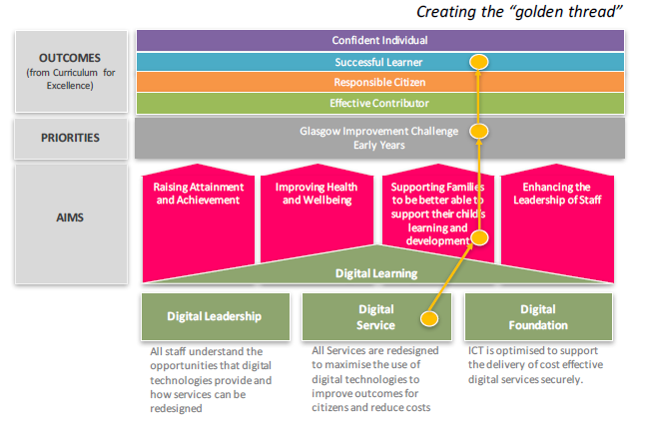
2. Cadder’s vision
Cadder Primary’s vision considers the school learning community while articulating with the GCC vision.

Within our community, children are using digital technologies and media at an increasingly younger age, for longer periods of time. Digital learning experiences at Cadder Primary School will aim to shape the identity and emotional intelligence of our learners. We will endeavour to continue to communicate with our parent community providing opportunities and information regarding rights

They spend an average of seven hours a day in front of screens – from televisions and computers, to mobile phones and various digital devices. This is more than the time children spend with their parents or in school therefore it is imperative that we harness this time and develop capacity for our learners to be literate with ICT. Overload of screen time can have a significant impact on learners’ health and well-being.

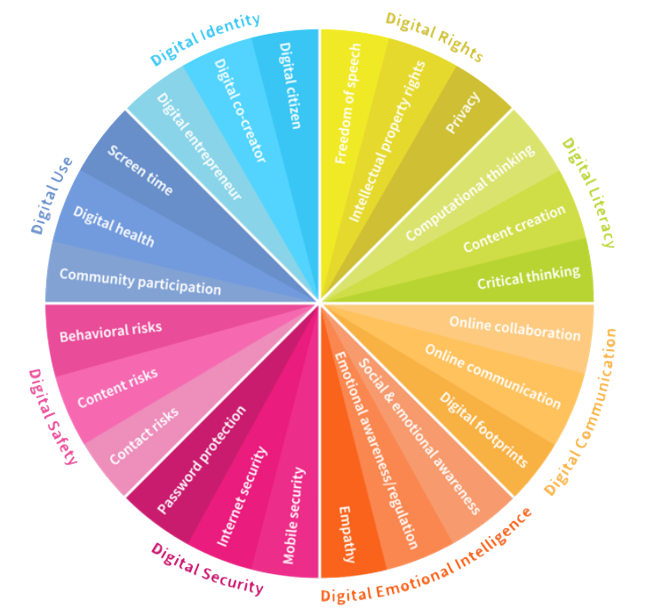

What digital content they consume, who they meet online and how much time they spend onscreen – all these factors will greatly influence children’s overall development.

Considering these aspects, our vision will demonstrate how we can promote best practice for use and create awareness so that our learners know how to stay safe and secure using digital technology.

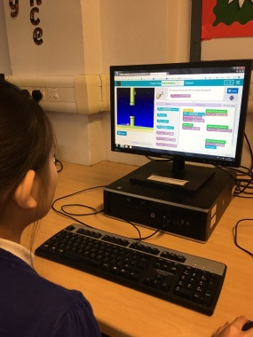
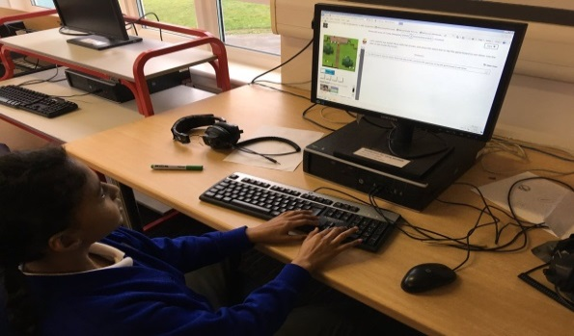

- Outcomes (Pupils)
Digital Identity
The ability to create and manage your online identity and reputation. This includes an awareness of your online persona and management of the short-term and long-term impact of your online presence.
Digital Use
The ability to use digital devices and media, including the mastery of control in order to achieve a healthy balance between life online and offline.
Digital Safety
The ability to manage risks online (e.g. cyber bullying, grooming, radicalisation) as well as problematic content (e.g. violence and obscenity) and to avoid and limit these risks.
Digital Security
The ability to detect cyber threats (e.g. hacking, scams, malware), to understand best practices and to use suitable security tools for data protection.
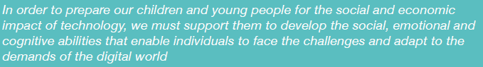
Digital Emotional Intelligence
The ability to be empathetic and build good relationships with others online.
Digital Communication
The ability to communicate and collaborate with others using digital technologies and media.
Digital Literacy
The ability to find, evaluate, utilise, share and create content as well as competency in computational thinking
Digital rights
The ability to understand and uphold personal and legal rights including the rights to privacy, intellectual property, freedom of speech and protection from hate speech.

- Outcomes (Staff)
All practitioners will have opportunities to engage in professional learning to develop skills in Digital Technologies and Computing Science:

  - Using digital products and services in a variety of contexts to achieve a purposeful outcome
  - Searching, processing and managing information responsibly
  - Cyber resilience and internet safety.

In line with Cadder Primary School’s Digital Strategy Action Plan, opportunities will be developed to identify and share evolving practice, to increase the digital technology skills of practitioners in the school. In June 2019, a grant was secured from Education Scotland to develop professional learning in Digital Technologies and Computing Science. Across 2019/20, all staff have taken part in collegiate activities that have developed skills and abilities in iPads and various applications. There has also been specialist training led by SSERC Digital Manager, Darren Grant.

From August 2020, staff will use GCC’s progression pathways in Digital Technologies and Computing Science across all stages.

Through self-evaluation and engaging with professional learning opportunities all staff will have increased confidence in the use of digital technology to enhance learning and teaching. They will recognise that professional learning in digital technology is integral to their professional development and that learning from and with children and young people is pertinent to developing digital technology skills for all.

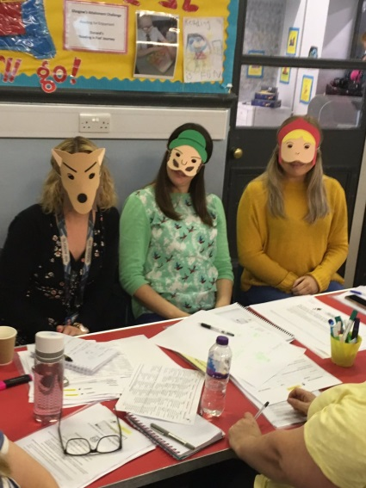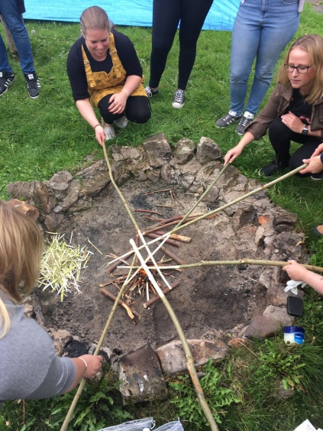

- Outcomes (Parents)
Access for parents and carers to information on children and young people’s progress will improve through digital technology. Opportunities to engage with parents will be more innovative, improving collaboration and communication. The school currently operates a parent-led Coding Club on a Friday lunch time.
Parents and carers will be supported in improving children and young people’s digital literacy and understanding of e-safety. They will be aware of the social, emotional and cognitive abilities that enable individuals to face the challenges and adapt to the demands of the digital world. In partnership with the establishment they will support their children to develop the eight digital intelligence skills.

Cadder Primary School Digital Action Plan

