Cadder Primary promotes and celebrates community involvement
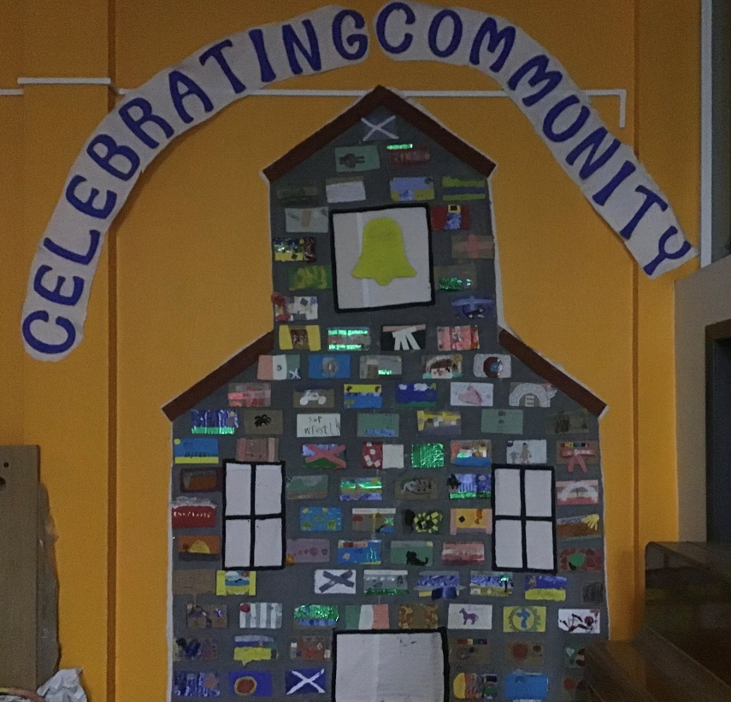
As part of the ongoing Eco work that Cadder Primary is involved in, this mural was created using recycled materials. Every pupil was asked to contribute and to create a brick that displayed an element of being part of the community that was important to them. This mural is on display at the entrance to the school and demonstrates the importance of community to the school community.
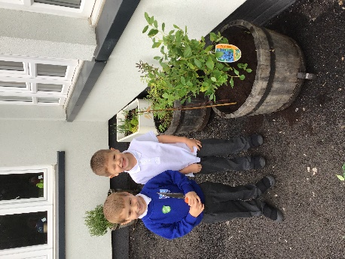
Pupils of every age are involved in creating better school grounds. This photograph shows two P1 pupils planting tubs in their playground. The pupils tend the plants and the enthusiasm for developing their outdoor space is impressive.

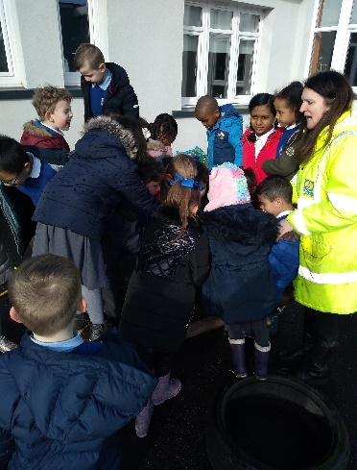
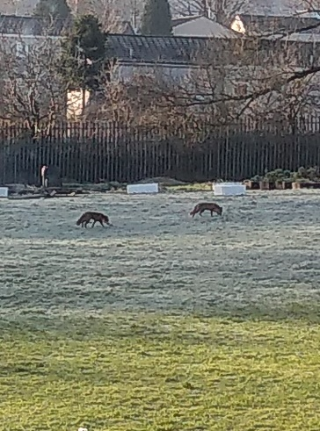

Staff plan learning opportunities that are responsive. The school grounds offer a variety of opportunities including occasional visits from foxes, deer and even toads!
Pupils from the school took part in a recent clean up the community Sunday event organised by Cadder Community Centre.

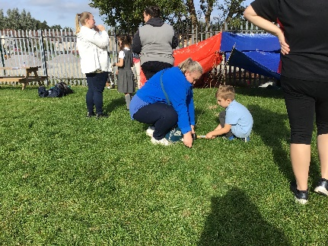
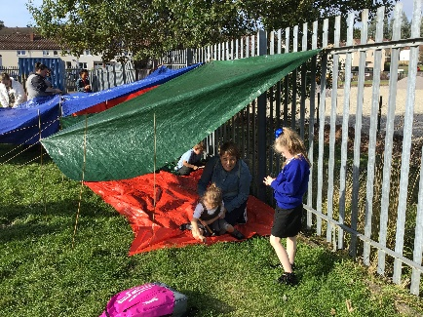
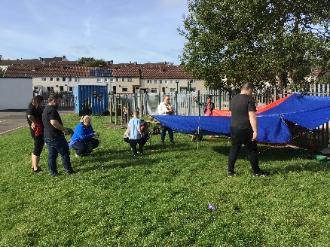
Outdoor learning and effective use of the school grounds is encouraged as often as possible. These photographs show family den building which was one of the activities that promoted positive family fun time as part of our school community. There were many smiles and lots of laughter! This event was organised by a community partner that organised weekly family events every week between Aug -Nov 2019.

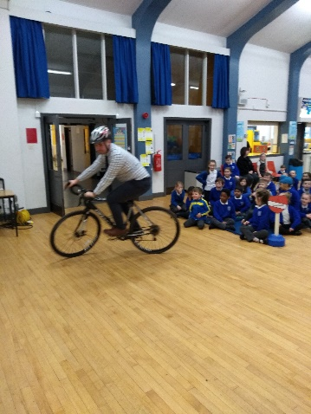
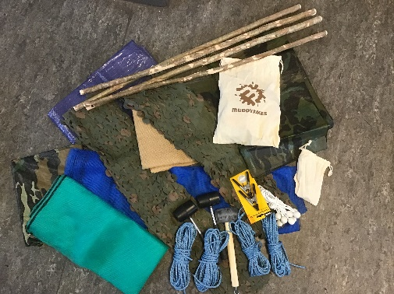
New outdoor equipment is bought when possible. “Teamwork” is school value. Many of the planned activities outdoors promote this value. This new den building equipment is available to all classes as well as part of the annual nursery to primary transition activities. Nursery children, P1 pupil and the following years buddies, build dens then sit in them to enjoy stories together.
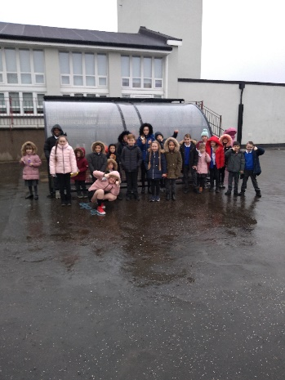
Linked with the theme of “Transport”, cycling became a major focus for the school. As members of the community the school was recognised by community members that we were promoting cycling and trying to find ways of reducing the use of cars. It was a very positive for the school to secure finds for a bike shed. Cycling was frequently promoted at assemblies by both staff and the eco committee.
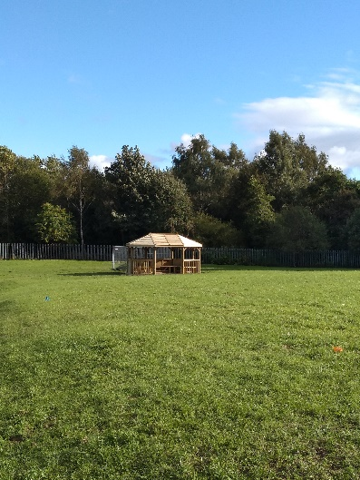

A major development as part of improving the school grounds was the construction of our outdoor classroom.

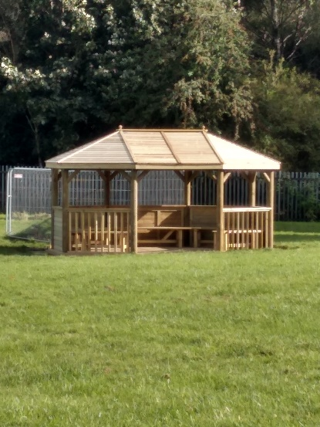
The Parent Council secured £5000 funding from a community grant. The school matched this with Pupil Equity Funding. This is a major focus of development for our outdoor space. The grant was agreed due the criteria that this space would be used by both the school and local community members. In our community the school is booked (let) by a number of agencies. This outdoor area will become one of the resources on offer to share. Each year, the local gala is held in the school grounds. It is hoped that this space will become an area that can be enjoyed by all. The school and parent council volunteers are currently working together to create a wheelchair accessible path.

Cadder Primary is fully committed to promoting and contributing to the Eco School Scotland Green Flag journey. This has become an integral part of the school curriculum and is noted on the school’s curriculum rationale. Many pupils are passionate about what they want to do, their voice is valued, listened to and acted upon.

The school is committed to the ongoing contribution to make an impact on our school, our community, our country, our world! The journey is on!

