Eco Code 2017-2019
The 2017 – 2019 code was written to encorporate litter, school grounds, transport (cycling) and care of the land.

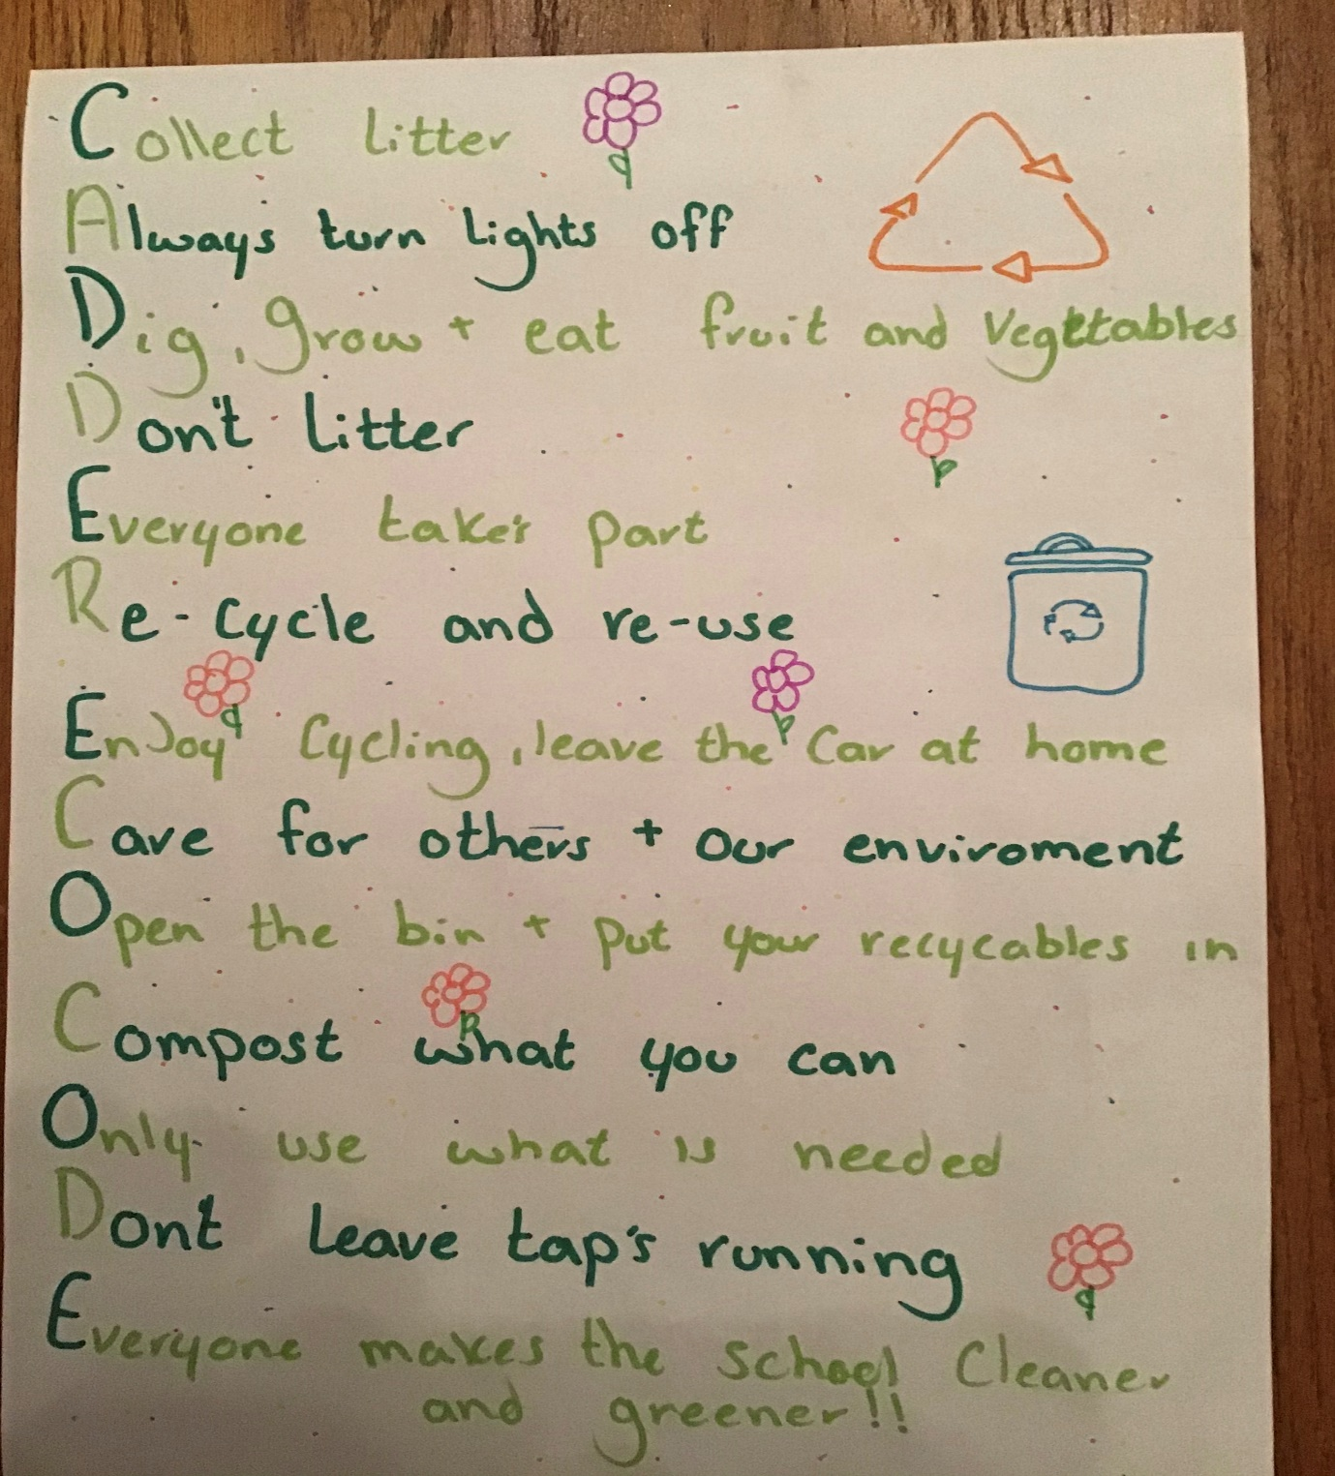

New Eco Code for 2020 is written. It refelects the children’s concern for global issues as well as other areas of their eco action plan.

