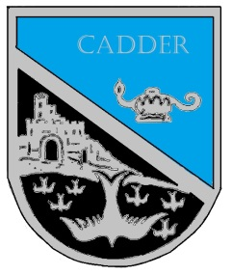

Cadder Primary School
Pupil Council Agenda
Meetings date: 27.09.18

Present:

Article 12: You have the right to an opinion and for it to be listened to and taken seriously.
Article 15: You have the right to be with friends and join or set up clubs or organisations.

Discussion points | Notes | Action
- Promote values within school
- Better use of houses
AOCB:

Next Meeting:

