Early Level Numeracy Guide for parents, carers and other adults!
Counting
Scan this for a Subitize song
https://youtu.be/ib5Gf3GIzAg

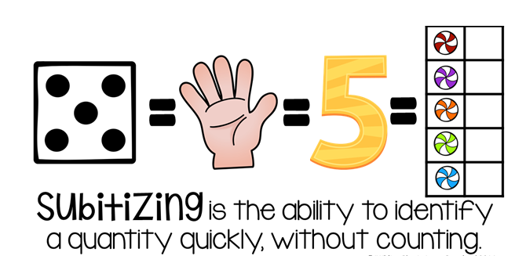
One of the counting skills we focus on in P1 is Subitizing. This is the ability to identify a quantity quickly without counting. For example looking at a dice and recognising a 5 without counting the dots. Watch the video for a fun song we use for our subitizing!

We also use Ten Frames to help us count. In P1 we start with 5 frames first and then move on to numbers to 10. They are great tools to help pupils visualise numbers.

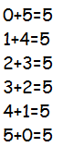
Number bonds and Part-Part whole
Number bonds are pairs of numbers that can be added together to make another number. They are some of the most basic and most important parts of maths for children to learn and are just as important as learning their times tables.
Use sweets, buttons, toys, pasta, dice, and dominoes to find number bonds to 5 at home, then move on to 10 when they are ready.
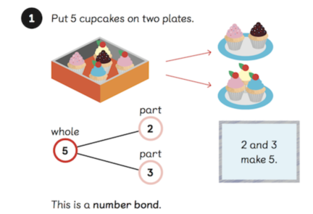
Scan the code to watch a video about number bonds or visit https://mathsnoproblem.com/en/approach/number-bonds/

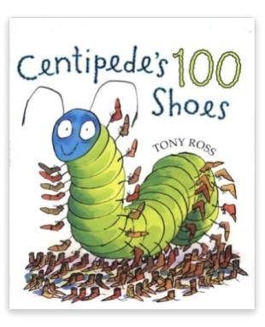
Stories and Maths
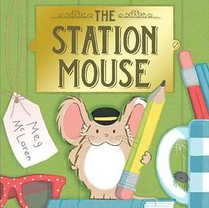
There are lots of opportunities to use picture books to help them with Maths at home. Use these prompts to think about Maths during your next family story time.
- How many characters in the book?
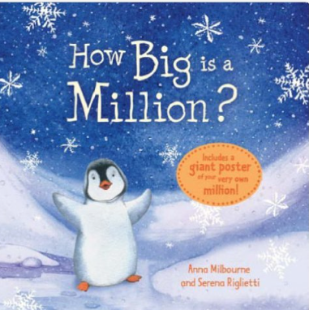
- What numbers do we see?
- How many pages? Guess and check!
- Talk about the time of day in the book. What happened before/ after?
- Goldilocks and the three bears- play with different sizes of bowls/containers at home.
Play and games
Playing games with your child is a great way to support their maths learning. Here are some suggestions for games below.
- Snakes and ladders or other board games
  - Pupils have to count how many dots on the dice, move that many spaces, move forwards/backwards
- Card games: So many things to play with a pack of cards! Play snap for number recognition. More math games with cards are available on our school website.
Maths is everywhere!
- Look at numbers on the bus or add up numbers on licence plate
- Measure food for recipes when baking and cooking with your child
- What time does the film start on TV. How long does the TV show last. How long until Bedtime?
- Look at prices in supermarkets and store catalogues. Find the right amount of change to pay for bread etc.
- Count things you see when you go for a walk, how many cars/birds?
Please scan this code to take part in our family maths survey. If you have any suggestions on how we can further support families at home with maths we would love to hear them. Thank you.

