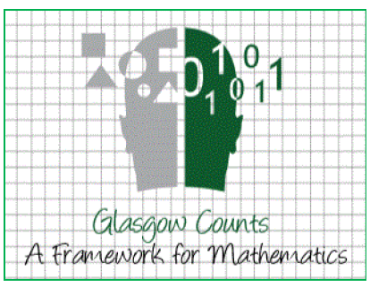

**Blairdardie Counts**

Second Level Numeracy Guide for parents, carers and other adults!

**Multiplication and Division Strategies**

A multiplication strategy that you can use at home in the **grid method.** Here is an example:

Here is a video of a demonstration of how to use the grid method for multiplication:

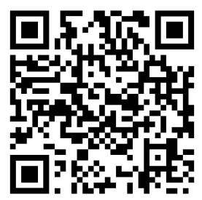

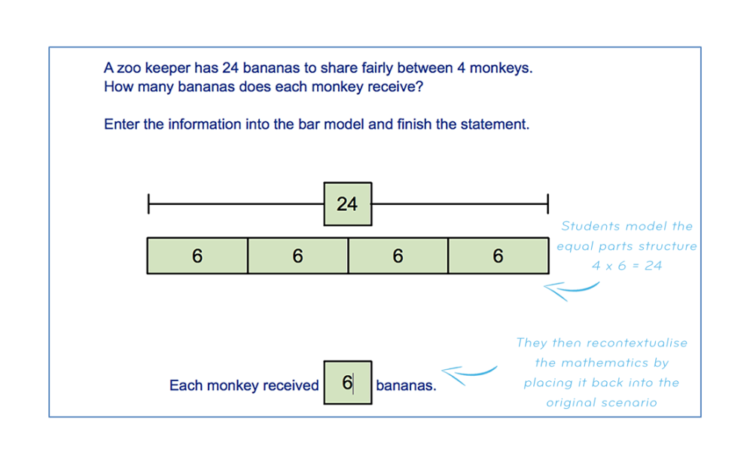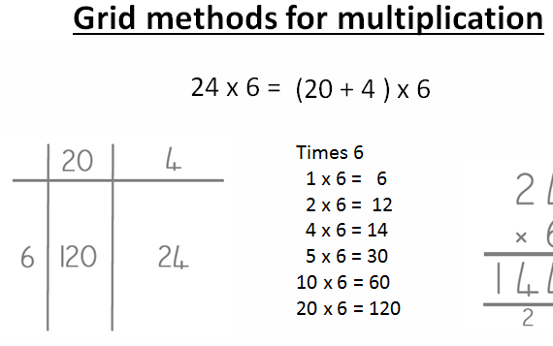  
  
  
  
  
  
  
  
  
  
  
  
  
  
  
Another strategy is the **bar model**. Bar models help children to visualise word and number problems by showing the parts of a number. Here is an example:

**Multiplication and division language**

**Ways You Can Practice Multiplication and Division at Home**

**Times Table Tennis**

Choose a times table to focus on. Take it in turns to say the next number in the times table sequence. You could pretend to serve and pass a tennis ball between you or use a real one.

**Fastest Times Tables Facts**

Choose a times table to focus on and have a competition to see who can write down the times tables facts the fastest. You can decide whether to write the number sentences out in full (e.g. 1 × 2 = 2, 2 × 2 = 4, 3 × 2 = 6 ) or just the numbers (e.g. 2, 4, 6).

* **Multiply**
* Product
* By
* Times
* Lots of
* **Divide**
* Goes into
* How many times
* Share equally
* Groups

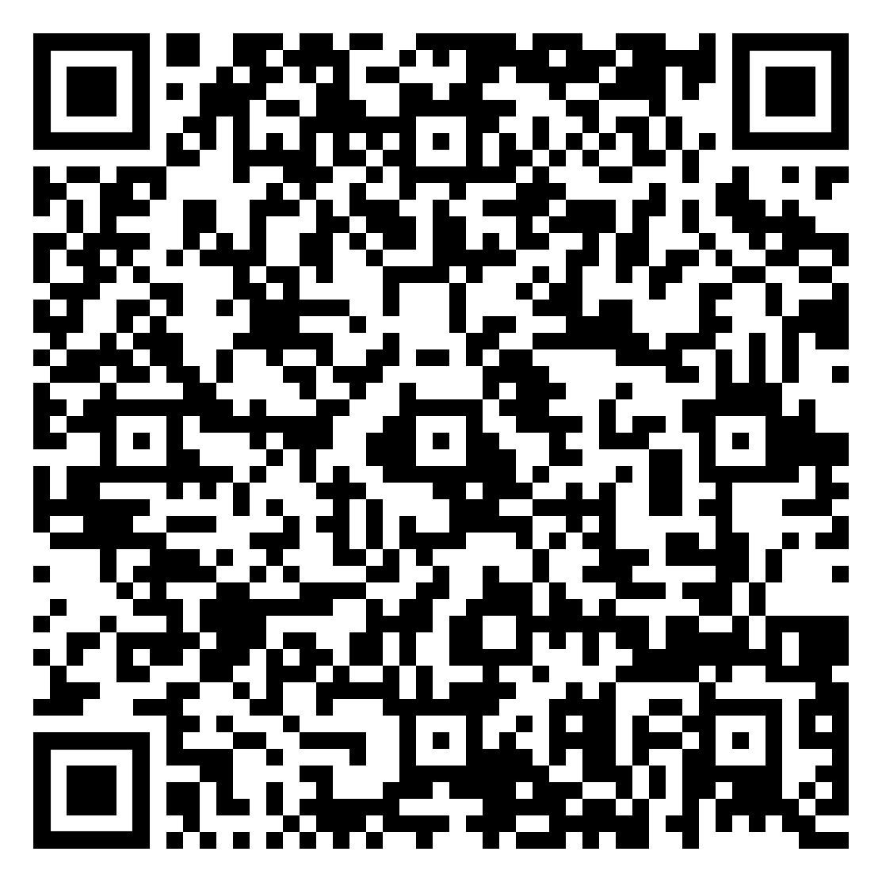

Here are some videos that explain the concept of place value and provide tips to help you support your child's understanding.

**Practicing maths in a real life context:**

**Working with money**

* Calculate costs when shopping

**Measurement**

* Estimating and measuring when cooking/baking

**Time**

* Look at the bus/train timetable. How long until the next train? How long will it take until you arrive at your destination?

**Useful websites for games and practise:**

[**www.topmarks.co.uk**](http://www.topmarks.co.uk)

[**www.sumdog.com**](http://www.sumdog.com)

Please scan this code to take part in our family maths survey. If you have any suggestions on how we can further support families at home with maths we would love to hear them. Thank you.

