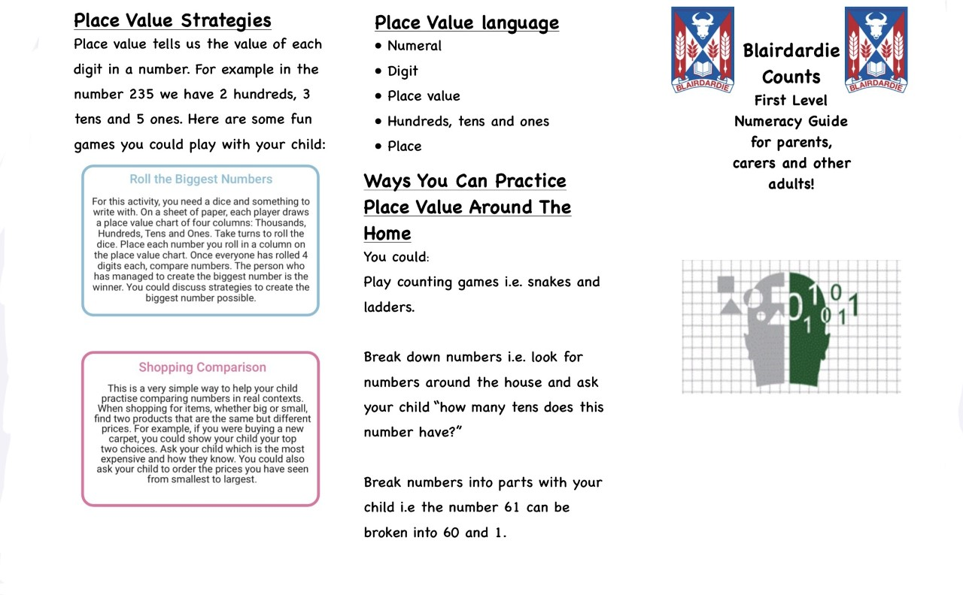

Find us on Twitter- @Blairdardiepri

Website-https://blogs.glowscotland.org.uk/gc/blairdardieprimaryschool/

Please scan this code to take part in our family maths survey. If you have any suggestions on how we can further support families at home with maths we would love to hear them. Thank you.



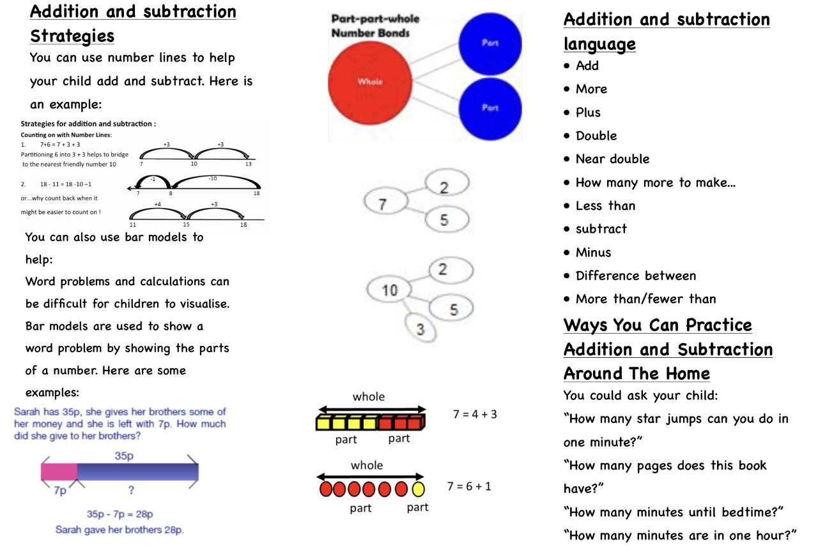

Please scan this code to take part in our family maths survey. If you have any suggestions on how we can further support families at home with maths we would love to hear them. Thank you.