Apprenticeship opportunities within The Royal Bank of Scotland:
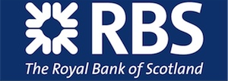

Location: Multiple locations in Scotland
Apprenticeship qualification: Professional Banker Certificate (Chartered Bankers Institute) at level 2 or 3
Minimum qualification requirements: 2 National 5’s at grade C or above in English and Maths or equivalent qualifications.
Salary: £13,169 - £16,625 per annum

Company Description

By 2020, RBS aim to be the number one bank for customer service and the most trusted bank in the UK. We will do this by becoming a smaller, simpler and smarter UK-focused bank that has the needs of our 24 million customers at the heart of everything we do. We exist to serve them, and we earn their trust by focusing on their needs and delivering an excellent service.

Vacancy Overview

Thanks to initiatives like the RBS Apprenticeship scheme, you can earn while you learn and still gain a professional qualification at the end of the programme. Here at RBS, we have big ambitions for our apprentices.

Each role will be based in a variety of areas across the business. Job descriptions can be found on the Get My First Job website (please see link below).

DON’T MISS OUT ON THE AMAZING OPPORTUNITY, APPLY NOW

To apply:
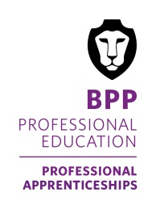
Please register and apply via www.getmyfirstjob.co.uk, RBS vacancies can be found by searching for ‘The Royal Bank of Scotland’.

We currently have hundreds of vacancies available to view and apply for at www.getmyfirstjob.co.uk.

Should you require any further information, advice or guidance please email apprenticeshipqueries@bpp.com or call the apprenticeships team on 0203 131 5165.

For further information in regards to qualifications, apprenticeship vacancies and summer school, please visit: www.bpp.com/apprenticeships

