NEW HIGHER

PHYSICAL EDUCATION

MENTAL, EMOTIONAL, SOCIAL and PHYSICAL

FACTORS IMPACTING ON PERFORMANCE

NEW HIGHER EXAM QUESTIONS

Thanks to

Russell Imrie Lenzie Academy @mrimrie

Kelly McShannon Broxburn Academy @kmcshannonPE

Muir Morton Fortrose Academy @muirmorton7

Nicola McShannon Penicuik High School @NMcShannonPE

John Miller Denny High School @satpe1

Jonny MacWhirter Bo’ness Academy School @MrMacWhirterPE

Jane Kelly St Mungos High

Lorna Drummond Graeme High School

Euan Lawson Cults Academy @LawsonPE

Darren Leslie Ross High @dnleslie

Tommy Lennox Loudoun Academy @loudounpe

Alan Fingland Bearsden Academy

Barry Kane Douglas Academy

Kieran Dowds Dunbarton Academy

Barry Petrie Banchory Academy @bazpetrie

Ewan McRae Boclair Academy

Susan McGrenaghan St Aloysius Academy

John McQuade Bishopbriggs Academy

Gary Sloan Turnbull Academy @MrSloanPE

Linsey Kerr Turnbull Academy

Andrew Kennedy Kirkintilloch High School @MrAkennedy

Edinburgh University

Roddy McPherson Calderside Academy @RoddyMcP

Ruari Nicolson Craig Royston Community High @Mr_Nic

Andy Marshall Forfar Academy @andymarshall19

David Cargill Forfar Academy @andymarshall19

About this Document

(Published: December2014, version 1)

This document has been produced by Physical Education teachers to support the New National Qualifications –New Higher.

The aim of this booklet is to provide information to teachers/pupils with possible New Higher PE exam questions.
Readers should note that the questions that are within this document are speculative examples only. This document has not been approved by SQA.

In section 1 – the word MESP has been used frequently. This means that teachers should adapt this question for either Mental, Emotional, Social or Physical. An SQA exam question would not give you the choice of the 4 factors (eg MESP).
In Section 2 – there are some excellent scenario questions provided. However there are some scenarios that are too specific and would not be used in an SQA exam. These have been kept in the document as teachers/pupils may still benefit from these.

Please feel free to use or share any of the material in this booklet. However should you adapt, create or improve the content please do reciprocate. You will be acknowledged for your contribution and it will be added to future versions of this booklet.

To help build this resource, please send any new questions to
Russell Imrie – rimrie@lenzieacademy.e-dunbarton.sch.uk

SECTION 1

Methods of Collecting Information – Question 1
a) Describe 2 different methods that could be used to collect information about MESP factors that impact on performance.
b) Explain the advantages and disadvantages of using these methods to collect information about the potential impact of MESP factors on performance.

- Describe in detail one method of gathering information on the MESP factor within an activity.
- Evaluate the benefits and limitations of using the method you have chosen in part (a) to gather information on the MESP factor.

- Describe two different methods that could be used to collect information to identify any MESP factor of your performance.
- Select one of the methods described in part (a). Outline why this method is appropriate and give a brief account of the information gathered.

- Describe two different methods that could be used to collect information about the potential impact of MESP factors on performance.
- Select one of the methods described in part (a). Evaluate one benefit and one limitation of using this method to collect information and give a brief account of your findings.

- Explain why it is important to collect information on your performance.
- Evaluate the effectiveness of one method you have used to collect information on MESP factors.

- Describe a method that could be used to collect information about the potential impact of MESP factors on performance?
- From the method described in part (a). Analyse the method you used to gather information on MESP factors?

- Explain why it is important to collect information about the impact of MESP factors on performance before starting a development plan.
- Evaluate your MESP strengths and development needs in comparison to a model performer.

- In relation to MESP factors; analyse your performance compared to a model performer.
- Explain the advantages of considering a model performance when developing performance.

- Explain the advantages of considering a model performance when developing performance.
- Choose an activity. Describe how you compared your whole performance to that of a model performer in this activity.

- Explain the advantages of considering a model performance when developing MESP performance.
- Choose an activity. Describe how you compared your whole performance to that of a model performance in this activity.

- Describe a method(s) you could use to gather information about the impact the MESP factor has on performance.
- Analyse the information gathered from the method used in part (a)

- Analyse the appropriateness of two methods for collecting information on MESP factors impacting on performance.
- Based on the data collected, evaluate the MESP factors which were strengths in your performance.

- You will have collected data on one MESP factor. Analyse what the data tells you about your performance.
- Explain how you know your data to be valid and reliable.

Approaches to Develop Performance – Question 2

- Choose a MESP factor that impacts on performance. Explain one approach to develop this factor.
- Evaluate one advantage and one disadvantage of applying this approach prior to a performance.

- Choose a MESP factor that impacts on performance. Evaluate what impact this had on your performance.

- Explain how you used performance development goals to improve this factor.

- Choose a MESP factor that impacts on performance. Explain one approach to develop this factor.
- Evaluate one advantage and one disadvantage of applying this approach during a performance.

- Choose an activity and a MESP factor that impacts on performance. Describe an approach you could use to develop this factor.
- Choose a different MESP factor that impacts on performance. Evaluate a different approach to develop this physical factor.

- Select one MESP factor that has had a negative impact on your performance. Explain how you developed this factor to help improve your performance.
- Describe how improving this MESP factor can impact on performance.

- Explain the decisions you would need to make when preparing a performance development plan to improve the MESP factor
- Choose one MESP factor that impacts on performance. Explain one approach to develop this factor.

- Explain the importance of two mental factors on performance.
- Analyse the benefits of setting short and long-term goals to develop a performance.

- Explain two goals that you have set to develop performance in MESP factors.
- Analyse the impact these goals could have on your performance in developing MESP factors.

Recording, Monitoring and Evaluation of Performance Development – Question 3

- Explain, in detail, why it is important to monitor and evaluate performance development.
- Explain the difficulties that might be encountered when monitoring and evaluating the impact of MESP factors on performance.

- Describe how you monitored and evaluated the social factors that impacted on your performance.
- Explain the difficulties you might experience when monitoring and evaluating the impact of MESP factors on performance.

- Explain the purpose of monitoring and evaluating performance.
- Explain at least two difficulties that might be encountered when monitoring and evaluating the impact of MESP factors on performance.

- Describe two different methods that could be used to monitor and evaluate MESP factors impacting on performance.
- Choose one method mentioned in Part (a). Explain at least one advantage and one difficulty of using this method to monitor and evaluate the impact of MESP factors on performance.

- Describe performance development goals that a performer could set for MESP factors.
- Explain why a performer might use each of the following when monitoring the development of MESP factor:
      - Qualitative information
      - Quantitative information

- Explain the purpose of monitoring and evaluating performance.
- Analyse the benefits of collecting both subjective and objective data

- Explain the purpose of monitoring and evaluating performance
- Describe one approach you could use to record the impact of MESP factors on performance

- Explain why it is important to monitor and review your programme of work to develop MESP factors impacting on performance.
- During your training you will have made adaptions to your programme of work, explain what adaptations were made and why.

- Describe two methods you have used to monitor performance within MESP factors.
- Explain how you used this information to set future development targets in relation this factor.

SECTION 2

This picture shows a girl performing in trampoline.
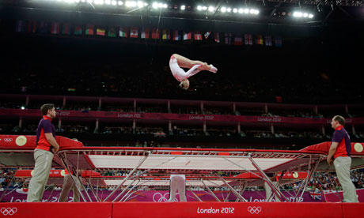

- Analyse which factors would impact on her performance. You must refer to the mental factor and one other from emotional, social or physical. (8)

- For each of these two factors, explain what you would consider when planning a performance development programme for this individual. (8)

That the tennis that preceded the most nerve-shredding of final moments varied hugely in quality did not matter. Murray, stretching emotions to the limit, needed four match points to break the resistance of the toughest fighter in tennis and said afterwards: "I have no idea what happened. I don't know how long it was. Sorry." – Guardian, 7th July 2013
In the final of Wimbledon 2013, Andy Murray was leading 40 – 0 in what could be the final game of the Championship needing just one point to win. Djokovic won the next three points to bring the game back. Murray then closed out the win to be crowned Wimbledon Champion.

- Analyse the possible reasons why Andy Murray lost those three points. You must refer to the following factors impacting on performance: emotional and one other from mental, social or physical. (8)

- Explain how performers can prepare themselves for these situations referring to the two factors chosen in a). (8)

Scenario – Glasgow Commonwealth Games 200m Breast Stroke Final
Race Preview
Michael Jamieson is a 25 year old Scottish Swimmer who won the silver medal in the 200m breaststroke at the London 2012 Olympics Games. Since then he went on to become the ‘poster boy’ for the Glasgow 2014 Commonwealth Games and is favourite to win gold in the above event. Ross Murdoch is a 20 year old Scottish Swimmer and is relatively inexperienced at competing at senior level. Both swimmers are from Glasgow and will therefore be eager to perform at their best in front of the home crowd.

Ross Murdoch
Pre-Race Thoughts

Let’s do this.
Start well. Maintain focus.
Finish strong.
Believe.

Michael Jamieson
Pre-Race Thoughts

Wow! What an atmosphere. I need to win this race. I can’t lose and let all of my supporters down.

Results
1st - Ross Murdoch
Distance (metres) | Stroke Count | Split Time | Overall Time
0-50 | 15 | 31 secs | 31 secs
50-100 | 16 | 33 secs | 1 min 4 secs
100-150 | 16 | 33 secs | 1 min 37 secs
150-200 | 15 | 30 secs | 2 min 7 secs
2nd – Michael Jamieson
Distance (metres) | Stroke Count | Split Time | Overall Time
0-50 | 15 | 32 secs | 32 secs
50-100 | 16 | 33 secs | 1 min 5 secs
100-150 | 16 | 32 secs | 1 min 38 secs
150-200 | 16 | 32 secs | 2 min 9 secs

Question 1
- Using all of the information above analyse reasons why Michael Jamieson lost the race. In your answer you must refer to the following factors impacting on performance: physical and one other – from mental, emotional or social. (8)

- Describe one approach that Michael could use to develop his performance of any one of the factors you selected in part (a) and explain the benefits of using this approach. (8)

On May 6th, 1954, Bannister became the first human to run a sub 4-minute mile. Prior to this moment many in the medical and running communities considered the 4-minute mile “unconquerable”. So great was the perceived barrier that Bannister stated, somewhat facetiously, “Doctors and scientists said that breaking the 4-minute mile was impossible, that one would die in the attempt. Thus, when I got up from the track after collapsing at the finish line, I figured I was dead.”
Runners flirted with the 4-minute mile for decades, unable to eclipse the mark. But a funny thing happened soon after Bannister’s accomplishment: runner after runner broke the 4-minute mile. It is now commonplace for elite runners, and even the occasional high school star, to eclipse the mark.

- Analyse the factors which impact on performance for athletes running a sub-4 minute mile. You must refer to the mental factor and one other from physical, emotional or social. (8)

- Why do you think so many runners were able to break the 4-minute barrier so soon after Bannister did? You must refer to the two factors from your answer in a). (8)

The Medal Bounce
“Home nations were shown to win approximately three times more medals in home Olympics, they reported, and approximately two times more in Olympic Games either side of their home Olympics.”
At London 2012, Team GB won 28 gold, 17 silver and 18 bronze – a total of 63 medals their highest total since 1908 – when the Olympics were also held in London.

- Referring to the social factor and one other from physical, mental or emotional. Analyse what you think causes the “medal bounce”. (8)

- For each factor from a) analyse a method which could be used to collect data to support your suggestions in. (8)

This is an extract of a newspaper report:

(a) Based on the evidence above, analyse reasons why one performance might be superior to another. In your answer you must refer to the following factors impacting on performance: physical and one other — from mental, social or emotional. (8)
See Page 72...

(b) Explain how you could plan future performance development following a defeat or loss. You must refer to the two factors chosen above. (8)

Read the scenario below and attempt the questions which follow:
The below quotes are taken from a Sports Report in a local Newspaper Article:

“THE PLAYER’S LOOKED OFF THE PACE AND UNFIT”
“THE TEAM LACKED LEADERSHIP”
“TOWARDS THE END OF THE GAME THE PLAYERS GAVE UP AND VERBAL ARGUMENTS BROKE OUT ”
“TWO PLAYERS WERE SENT OFF FOR MISCONDUCT”
“A NUMBER OF SIMPLE MISTAKES WERE MADE WHEN PERFORMING BASIC SKILLS”

- (a) Analyse reasons why a performer might receive this feedback.
In your answer you must refer to the following factors impacting on performance:

- Emotional

- one other — from Mental, Social or Physical. 8

(b) For each of the factors (Physical and your chosen factor from Mental, Social and
Emotional), analyse an approach a performer could use to enable them to improve their performance. 8

After losing heavily in the opening competition of the season; you need to prepare for your next competitive performance…
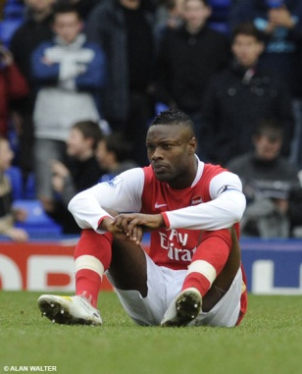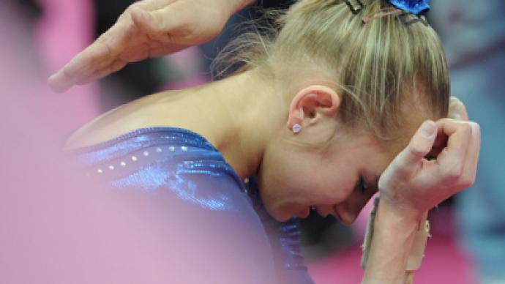

- Explain how social factors could have an impact on performance. (4)
In your answer you must refer to the following factors impacting on performance: Social and one other – from mental, physical or emotional.

- Analyse 2 methods that could be used to gather data on the factors that impact on performance. (6)

- Having gathered data, explain what you would take into account when setting goals to ensure improved performance in the future. Use examples to further develop your answer. (6)

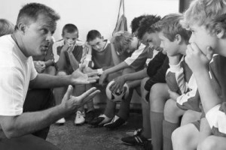
View the pictures below and attempt the questions which follow :
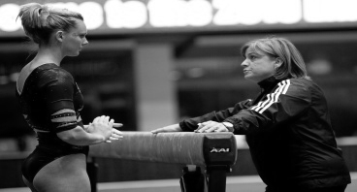

- Explain two emotional factors a performer might feel during coach feedback. (6)

- In your answer you must refer to the following factors impacting on performance: emotional and one other – from mental, social and physical.
Explain the importance of using different types of feedback when developing performance. (4)

- Analyse improvements that could be made as a result of the feedback in the picture(s) (6)

Read the scenario below and attempt to answer the following questions.
This is an extract from a performers self-evaluation log:

- Today I did not feel that this was my best performance….
- I was criticised by the team for making mistakes and being out of position…
- I continuously was beaten by my opponent…
- I felt we were not working as a team and I probably was trying to do too much in the game because they were criticising me…

- Analyse the reasons why the performer may have logged this information about their performance. In your answer you must refer to the following factors impacting on performance: social and one other from physical, mental or emotional. (6)

- Describe an approach to develop each of the mentioned factors impacting on performance in question a. (4)

- Analyse the improvement that could be made as a result of the approaches used to develop the factors selected in question 1b. (6)

After playing the first match of the new competitive season, there are factors impacting on performance.
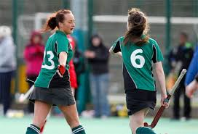
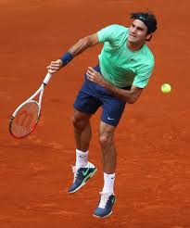

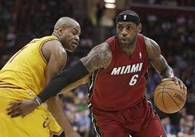

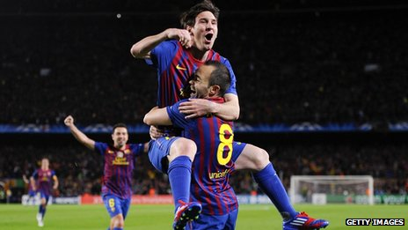

In all of your answers you must refer to the following factors impacting on performance: social and one other – from mental, emotional and physical.

- Analyse the picture(s) and give examples of feedback a performer may receive on their performance based on the two factors selected. (6)

- Evaluate the considerations you would make when planning a training programme to prepare for the new competitive season.
(6)

- Explain the benefits of comparing your performance to a model performer?
(4)

This is an extract from a Performer’s Training Diary:
- I was not performing at my best due to my poor decision-making…
- I was feeling very anxious and lacked confidence…
- My opposition are a very high standard…
- I struggled to motivate myself during this performance…

- Analyse factors that can influence your performance. In your answer you must refer to the following factors impacting on performance: mental and one other – from physical, social or emotional.
(8)

- In relation to part (a) and the factors that you have selected, explain how a performer’s decision making can affect their performance.
(8)

- Your teams' performance lacks cohesion.
- There are also a number of errors appearing in your performance.
- There are a number of opportunities that your team has missed

Your answer must refer to social factors and one other from mental, emotional and physical.
- Explain why this feedback may be relevant to a performer. (8)

- Analyse an appropriate course of action to improve both factors highlighted in part (a). (8)

The following are comments taken from a performer’s self evaluation of their own performance:
      - After the game today I felt so tired and disappointed....
- We went 2-0 down in the first half and I had no drive in the second, we were already beat...
- We ended up losing 3-0 and I made so many mistakes, especially in the second half...
- I missed a penalty and got booked for having a late challenge and arguing with the referee. ...
- I got so distracted by the crowd and felt so under pressure....
- I can’t be bothered with training tomorrow. I am worried what my coach and team-mates will say...

You must refer to the following factors: Mental and one other- from physical social or emotional.
  - Analyse the negative factors impacting on this individual’s performance. (8)

  - Using the factors you have mentioned in part (a). Evaluate two approaches that could be used to develop this individual’s performance as part of a future development plan. (8)

Read the scenario below and attempt the two questions that follow.
This describes part of a game situation for a team activity;
- The play broke down due to our lack of concentration and failing to be a cohesive unit.
- The team reacted negatively to our opponent’s effective play.
- The coach analysed all the problems and gave us feedback.
- We were more positive with a new strategy.

You must refer to the following factors: Mental and one other- from physical social or emotional.
- Explain the factors that may have contributed to the poor team performance. (8)

- Evaluate the changes the coach made for a more effective team performance. (8)

Look at the two images below and attempt the question which follows.

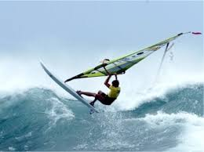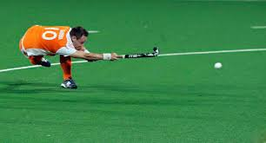
In your answer you must refer to the following factors impacting on performance: physical and one other — from mental, social or emotional.

(a) Analyse the factors which are similar to both performers in the images above. (8)

(b) Explain how you would plan and develop future performance for the two chosen factors in 1(a). (8)

The extract is a summary of a footballer’s performance in a recent game
- Pass completion rate was only 40%
- Booked in 40 minutes, sent off in 71 minutes
- Was at fault for the oppositions first goal, not tracking the opponent
- Appear agitated and distracted by the crowd

In your answer you must refer to the following factors impacting on performance; Mental and one other – from physical, social and emotional.

  - Analyse some of the reasons for the footballer putting in this kind of performance. (8)

  - Explain possible approaches to development that may be used to improve the footballers performance within the two factors mentioned in part (a). (8)

Physical | Social | Mental | Emotional
Did you get tired towards the end of your performance? | Did you get along with everyone who is involved in your activity; team mate, coach, referee? | Did you lose concentration at any stage during performance? | Did you ever feel anxious or nervous when performing?
Generally felt good throughout the performance.  Did start to feel a bit sluggish towards the end of the game.  Legs started to feel heavy in the second half | We have a great team spirit and we work well together to achieve our goals | I did make a few mistakes towards the end of the game. | I did start to feel a little anxious when they got back level.  I started to worry about making mistakes which would result in the other team scoring
Did you successfully carry out all the skills required to perform effectively? | Did you always follow the rules of the activity during performance? | Did you find it easy to make the correct decisions during performance? | Did you lose your temper during performance if you or someone in your team makes a mistake?
Skill level was good in the first half  However as the game progressed and they got back level I started to make silly mistakes | Generally I did manage this, however I bit receive a booking towards the end of the game for a bad challenge | I made a few bad passing decisions when placed under pressure | Throughout the game we supported each other and help each other to overcome the mistakes that were made.
Did you understand the tactics that we used to beat your opponent? | Is your performance affected because there are limited facilities for you to train? | When performing did you find it easy to remain mentally tough at all times? | Did you always believe that you can perform well in your activity?
Didn’t fully understand out 2nd set play that had planned.  Was happy with the role & responsibilities that I had to carry out | This week has been tough as due to the bad weather there were no suitable training facilities for us to use | When the opposition scored I did start to fear the worst and that they would go on and score again | As I started to tire and did find it difficult to maintain my motivation and belief in my ability

You must refer to mental factors and one other factor from physical, emotional or social.

- Using the data collected, analyse the strengths and development needs of this individual. (8)

- Explain a personal development plan which could lead to improvement for this performer. (8)

Below is specific data collected out-with the performance.
ASPECT OF FITNESS | TEST | RESULT |  |  | STANDARD  POOR BA A G E
C.V.E. | MULTI STAGE SHUTTLE RUN | Excellent | M | < 6 |  | 6 - 7 | 8 - 10 | 11-12 | 12 +
FLEXIBILITY | SIT AND REACH | Poor | M | < 2 |  | 2 - 5 | 6 - 8 | 9 - 13 | 13 +
SPEED | 30 METRE SPRINT | Excellent | M | 4.6 < |  | 4.6-4.5 | 4.4-4.3 | 4.2-4.0 | <4.O
AGILITY | ILLINOIS AGILITY  RUN | Good | M | 15.9< |  | 15.9 -14.7 | 14.6 –13.8 | 13.7-12.5 | <12.5
POWER | STANDING BROAD  JUMP | Average | M | < 178 |  | 178-197 | 198-217 | 218- 228 | 228+
POWER | STANDING VERTICAL  JUMP | Average | M | <30 |  | 30-39 | 40-49 | 50-65 | 65<
BALANCE | BALANCE BEAM TEST | Below average | M  &  F | < 19 |  | 19 - 29 | 30 - 40 | 41 - 59 | 60 +
REACTION TIME | STICK DROP TEST | Average | M  &  F | < 22 |  | 22 – 29.5 | 29.6 -37 | 37.1-42.5 | 42.5<
LOCAL MUSCULAR ENDURANCE | 30 SECOND SIT  UP TEST | Good | M | < 16 |  | 17 - 19 | 20 - 25 | 26 - 29 | 30 +
Also:
The results from my SCAT test were 26, which indicates I have a HIGH level of arousal
The results from Measuring Motivational Behaviour indicated that I had a high level of motivation.
You must refer to mental factors and one other factor from physical, emotional or social.
- Analyse the strengths and development needs of this individual. (8)

- Explain a personal development plan which could lead to improvement for this performer.
(8)

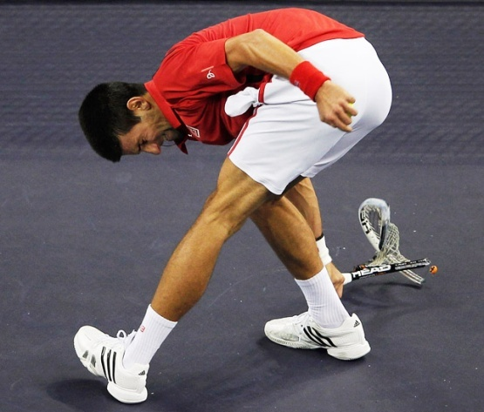
The performer made mistakes as the performance went on...
Was losing a game against a lower world ranked opponent...
Was blaming the umpire and his equipment for poor shots...

You must refer to physical factors and one other factor from mental, emotional or social.
- Analyse which factors could have been impacting on this performance? (8)

- Explain what the performer could do to in future development to improve their performance in the two factors selected in (a). (8)

Following a period of rehabilitation after a fall….

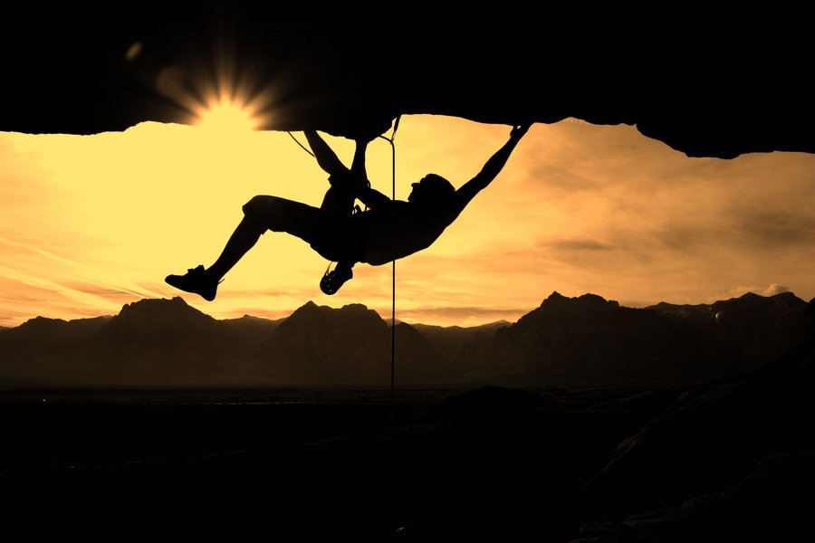

You must refer to physical factors and one other factor from mental, emotional or social.
a) Analyse the factors that could impact on a performer returning to an activity of this nature. (8)
b) Explain the approaches that they may use in a development plan to return to their best level of performance. (8)

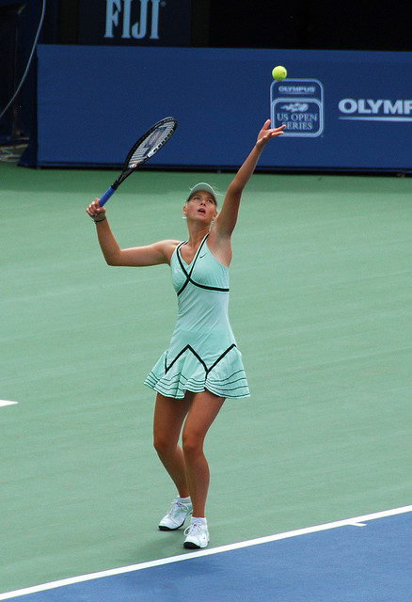

- Describe a method that could collect data on this type of performance. (4)

- Explain why the data collected would be useful to the performer. (4)

- Analyse how a ‘model’ of performance can help in planning performance improvement. (8)

Look at the image below and attempt the question which follows.

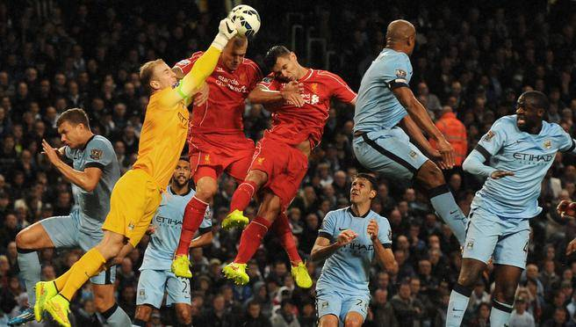
ATTACKERS
DEFENDERS
GOAL-KEEPER
You must refer to the following factors impacting on performance: mental and one other – from social, emotional or physical.
  - Analyse the picture above and evaluate the demands of the situation on the goal-keeper.
(6)

  - Describe one method of gathering specific data from each of the factors selected in 1 (a).
(4)

  - Select one of the methods outlined in 1 (b) and explain how the data collected can be used to plan a performance development programme. (6)

Read the scenario below and attempt the questions that follow:-

“In sport , as in life, there are times when we do not deliver our best when called to do so”

You must refer to the following factors impacting on performance: emotional and one other – from social, mental or physical.
- Analyse reasons why you, as a performer, might find yourself in this situation. (8)

- Explain how you might develop a programme of work to show continued improvements in the two factors. (8)

Study the picture and comments from the performer to the coach below:
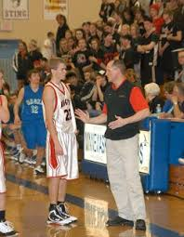

Performers says to teacher "My performance of the lay up in Basketball has not improved"

You must refer to the following factors impacting on performance: mental and one other – from social, emotional or physical.
- Explain the possible reasons for this for this comment (8)

- Analyse the considerations needed to make improvements. (8)

A 16 year old female performers test results are as follows:

Method of Testing | Score | Comparison to Normative Values
Multi Stage Fitness Test | Level 3.9 | Very Poor
12 Minute Cooper Test | 1400m | Poor
50m Timed Sprint | 8.1 secs | Good
Illinois Agility Test | 17.2 secs | Good
Standing Broad Jump | 187cm | Above Average
60 secs Push Up Test | 5 | Poor
60 secs Squat Test | 18 | Poor

Making reference to Physical Factors and one other from: Emotional, Mental or Social

- Analyse the results and the possible impact that these results could have on the performance. (8)

- Explain the considerations which would be made to ensure continued improvements. (8)

Look at the picture below and attempt the question which follows.

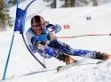

In your answer you must refer to the following factors impacting on performance: physical and one other — from mental, social or emotional.

- Evaluate the factors which might impact on the performer in this activity. (8)

- Explain the approaches that this performer could use to develop performance. (8)

.

Below is an extract from a training diary from a swimmer.
Week: 2 POOL Session Number: 4
DAY: Monday DATE: 02/02/14
Aim of Session | To continue to develop CRE within the swimming pool to improve my 200metre Front crawl swim.
Description of Session  (Brief overview of structure and what you did: how many lengths? What was focus? etc | 6 Lengths Warm Up (Any Stroke, 20 sec rest)  Interval Training – 6 x 2Lengths (30 sec Rest)  2 x 1 Length Sprints (Dive Start)  4 Lengths Cool Down (Any stroke, slowly)
Evaluation of session  (What went well? What didn’t go well? Did you receive any feedback? *Internal/External* What did it tell you? | I definitely felt that the interval training was much easier today. Last session I felt out of breath almost all of the way through it, but today I felt that my pulse rate had dropped considerably before I had to begin the next 2 lengths.  I am still too scared to dive into the pool during the 2 sprints at the end of the session. This means that my classmates usually beat me because they are diving into the pool and getting an advantage.

In your answer you must refer to the following factors impacting on performance: physical and one other — from mental, social or emotional.

- Explain what this swimmer might do in their next pool session. (8)

- Evaluate the goals they may set to ensure continued improvement. (8)

As a performer you are preparing to compete in the biggest event of your season/career.
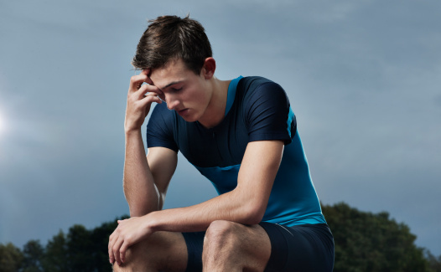

By making reference to the Mental Factor and one other from either: Physical, Social or Emotional.

- Explain some of the challenge(s) you may face in the period leading up to this event. (8 marks)

- Evaluate the advantages and/or disadvantages of the approaches used leading up to this event. You must make reference to your performance development. (8 marks)

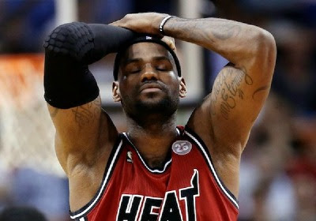

- Analyse reasons why the performer above may not be performing to his potential.
Your answer must make reference to Social and one other factor (8 marks)

- Explain what this performer could do to ensure his next performance is improved. (8 marks)

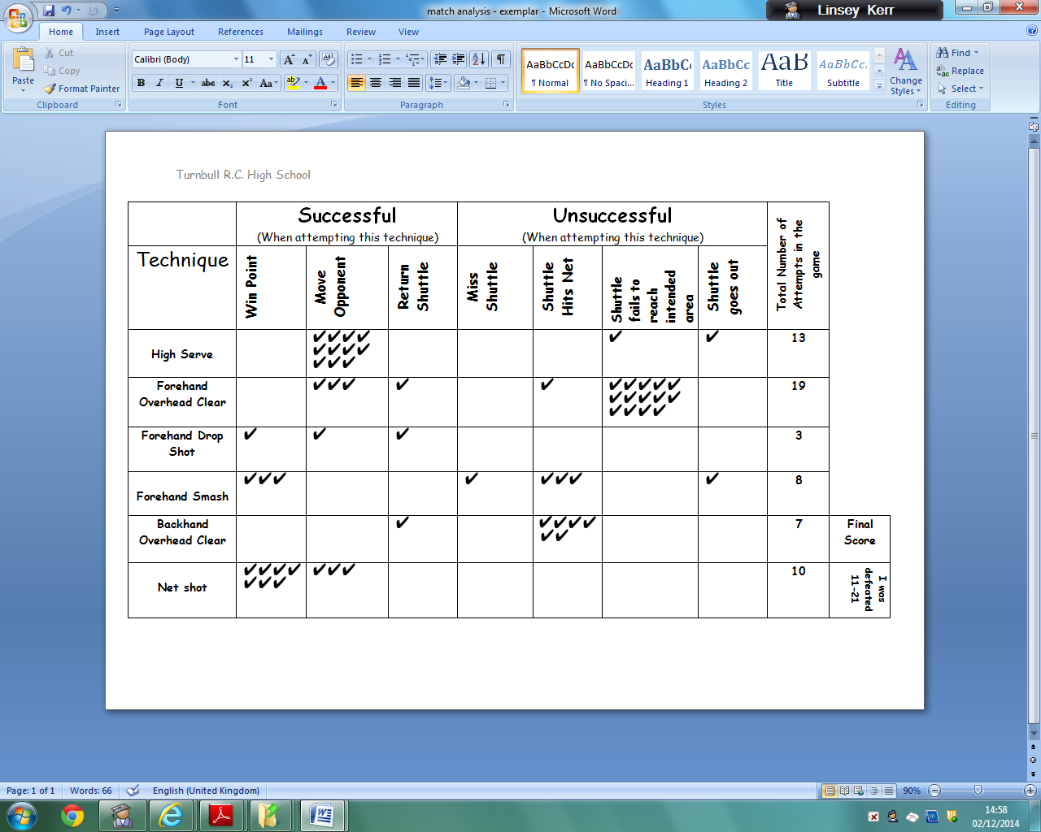

(a) Analyse the match analysis sheet above. Evaluate the factors that could be impacting on this player’s performance. Choose from the Physical factor and one other factor (Emotional, Social and Mental).
(6)
(b) Describe in detail a training approach(es) this performer could carry out to improve their performance.
(6)
(c) Describe the monitoring tools this performer could use to keep track of their progress. (4)

Read the scenario below and attempt the following questions:

Less mistakes were made as the performance progressed…….
Focus and determination improved ………
This was a very good performance………..
Signs of concentration and determination overshadowed anger and frustration…….

- Analyse reasons a performer might receive this feedback. You must refer to two factors that impact on performance. (8)

- Explain were there are development needs for this performer and suggest a plan for improving this development need. (8)

An extract of feedback to a performer…

- Performance full of skill related mistakes
- A lack of concentration and motivation in the latter stages
- Not the performers usual level of performance
- Signs of anger and fear were observed

  - Analyse reasons why a performer might receive this feedback. You must refer to The Physical Factor and one other from – Mental, Emotional or Social. (8 Marks)

  - Explain how this feedback might be used to plan future performance development for the two factors chosen in part a. (8 Marks)

Judges/Coaches Critique:

- Towards the end of the performance the athlete’s performance deteriorated significantly. They lost control and fluency during the execution of their skills. Anxiety levels appeared to increase and they were easily distracted by the audience, affecting their performance further.

- What would you advise they do in preparation for future performances? Identify suitable approaches and evaluate their appropriateness. (8 marks)

- You must refer to The Mental Factor and one other (Physical, Social or Emotional).

- Explain how this feedback might be used to plan future performance development for the two factors chosen in part a. (8 Marks)

A pupil has been selected to represent the authority. They are a good performer, however, they have been defeated on 3 successive occasions by their fiercest rival and risk not being selected for national level. Their coach has highlighted the following weaknesses within their performance when competing against elite opponents.
- Anger management
- Confidence issues
- Decision making
- Tactical awareness
- Fitness levels

- In relation to The Emotional Factor, describe approaches that could be used to develop the performance weaknesses identified by the player’s coach. (6 marks)

- Utilising the coach’s feedback, explain the reasons for poor performance against this particular rival. (10 marks)

You must refer to The Emotional Factor and one other from – Physical, Mental or Social.

A new player has joined your team/club/class. They appear distant and don’t interact well with the group. They have a fantastic skill repertoire though and outperform everyone else in training. However, their lack of confidence has hindered their performances in a competitive situation.

- With reference to The Social Factor and one other (Physical, Mental or Social), analyse approaches that could be implemented that may improve the athlete’s overall performance. (10 marks)

- Explain the importance of feedback when trying to develop the future performance levels of an underachieving athlete. (6 marks)

As a performer you are preparing to compete in the biggest event of your season/career:

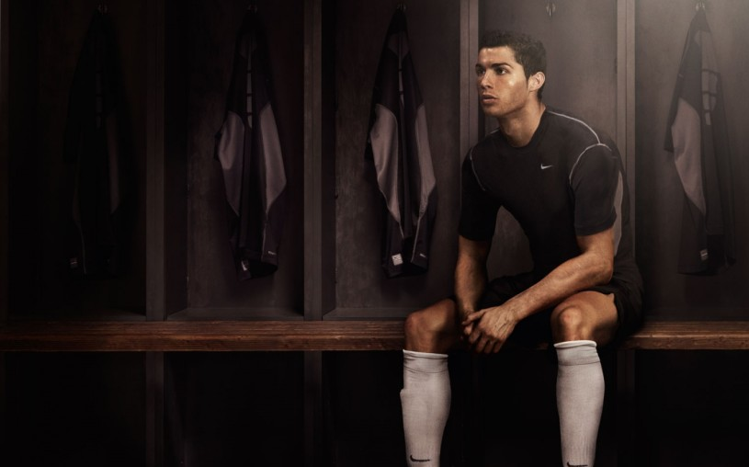

By making reference to The Mental Factor and one other from either: Physical, Social or Emotional.
  - Explain some of the challenges you may face in the period leading up to this event.

(8 marks)

  - Evaluate the advantages and/or disadvantages of the approaches used leading up to this event. You must make reference to your performance development.
(8 marks)

Feedback from peer/coach/teacher

- Performer was unable to execute skills effectively
- Performer displayed seemed de-motivated throughout performance
- Performer did not display correct etiquette after performance
- Performer did not perform to potential throughout performance

- Analyse reasons why a performer might receive this feedback. In your answer you must refer to the following factors impacting on performance: physical and one other - from mental, social or emotional.
(8)
- Explain how this feedback might be used to plan future performance development for the two chosen factors in (a).
(8)

Feedback from peer/coach/teacher

- Performer’s discipline was poor throughout the game
- Performer’s accuracy and control deteriorated from the start
- Performer did not work well with team mates / coaching staff
- Performer started to make unforced errors

  - Analyse reasons why a performer might receive this feedback. In your answer you must refer to the following factors impacting on performance: physical and one other - from mental, social or emotional.
(8)
  - Explain how this feedback might be used to plan future performance development for the two chosen factors in (a).
(8)

Feedback from peer/coach/teacher

- Skill level dropped towards the end of the performance
- Nerves got the better of the performer
- Mistakes were made at the start of the performance and the performer was easily distracted
- Communication broke down and signs of anger were observed

- Analyse reasons why a performer might receive this feedback. In your answer you must refer to the following factors impacting on performance: physical and one other - from mental, social or emotional.
(8)

- Explain how this feedback might be used to plan future performance development for the two chosen factors in (a).
(8)

