S5/6 REVISION ANSWERS
Calculator
1a. 120 b. 4 c. 250 2a. 133 b. 4.78 c. 56.5
Percentages
- 500 members 2. 150 pupils 3. £200,000. 4. £12,000.

Appreciation/Depreciation
5. £92,317.44 6. £212.24 7. £6,300,000,000. 8. £1536 9. £564,480.

Circle
1a. 50cm b. 14.3cm 2a. 100cm b. 171.4cm or 1.71m 3. 102cm
4. 54° 5. 28° 6a. 112° b. 60.6cm

Arcs and Sectors
- 54.5cm² 2. 6.8m 3. 7775.4cm² 4. 11.2m² 5. 33.1cm²
6. 40° 7. 173.2cm²

Standard Deviation
- Glasgow – mean 4.3 degrees – standard deviation 1.49
London – mean 6.3 degrees – standard deviation 2.83
The weather in Glasgow is colder on average than London but the weather is also more consistent in Glasgow because the standard deviation is less than London.
Non Calculator
Straight Line
- m=3/2, c=2 2. y=-3/4+6 4. m=3/4, c=-3 5. y=-3/2+2
6. m=-3, c=9/2 7. Diagram 8a. m=1/4 b. T=1/4v+10 9. m=2/3, c=2
10. 3y=2x-12 or y=2/3x-4 11a. m=3/4, c=3/2 b. y = -1/2x + 3/2

Algebra
1a. 11a-3 b. 7x+6 c. 8b+7
2a. x²+5x+6 b. s²-11s+28 c. p2-8p-20
d. 25y²+20y+4 e. 2x³+4x²+6x f. x³+14x²+39x-54
3a. 3(x-1)(x+1) b. 2(p+1)(p+5) c. 9(x-2)(x+4) d. 5(x²+5x+6) e. a(x²+5x+6)
f. 3(y-5)(y+1) g. 3(5c+4)(c+1) h. 2(4b+1)(2b+3) i. 3(3q+2)(q+3) j. 5(2s-1)(s-3)
k. 4(2m-3)(m-1) l. 4(2a-3)(a-3) m. 2(2t-7)(t+4) n. 10(3d+6)(3d-4) n. 4(10x+1)(10x-1)

Completing the square
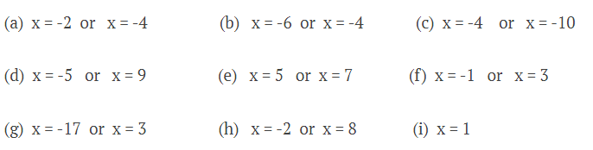

Inequalities
a) $x>6, or 6<x$ b) $c≤-5, -5≥c$ c) $t≥\frac{25}{3},\frac{25}{3}≤t$

Fractions

a) $\frac{107}{20} or 5\frac{7}{20}$ b) $\frac{5}{8}$ c) $\frac{5}{12}$

Change the subject $.$
