National 5 S4 October Assessment revision booklet (calculator)

1a) A car is sold for £13000. Every year, its value drops by 6%. How much will it be worth in 7 years? Round your answer to 2 decimal places.
b) In 2020, a town has a population of 20,000, after a 15% increase from last year. What was the town’s population in 2019? Round your answer to the nearest whole number.
c) A T-Shirt is sold at 20% off, at £33.80. How much was the original price?
d) In 2016, John put £5600 into a savings account, which has an interest rate of 5.5%. How much interest would John have in 2020? Round to the nearest pound.

Q2) Over a 10-day period, the temperature at noon is measured in Glasgow and London (in $°C$).
Glasgow | 3 | 4 | 3 | 5 | 6 | 6 | 5 | 3 | 2 | 6
London | 0 | 4 | 7 | 9 | 8 | 7 | 10 | 7 | 6 | 5

- For each city, find the mean and the standard deviation of the temperature, round your answers to 2 decimal places.
- Use the mean and standard deviation from part (a) to make two valid comments comparing the temperatures in Glasgow and London.

Q3a) Solve the following quadratic functions, rounding your answers to 1 decimal place:

- $x^{2}+6x+3=0$ | - $3x^{2}+4x-1=0$ | - $5x^{2}-x-7=0$ | d)$1-7x+4x^{2}=0$

Q4) Find the arc length for the following sectors (round to 3 significant figures):
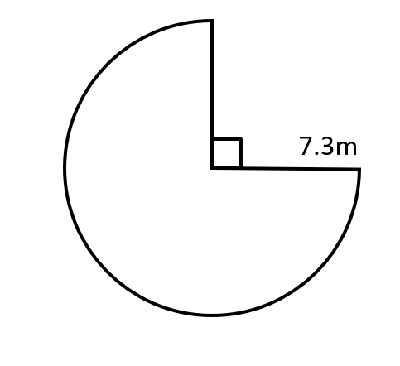
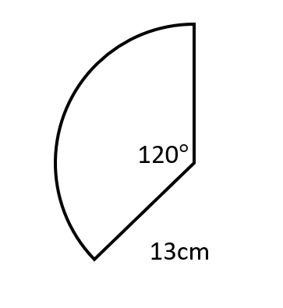
b)
a)

Q5) Find the area of the following sectors:
b)
a)
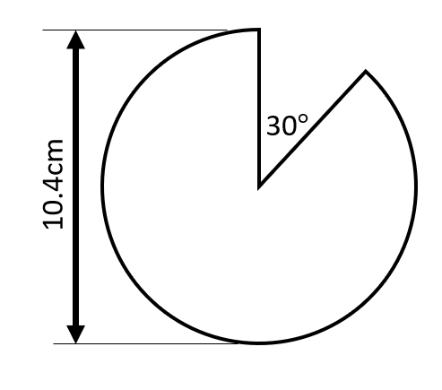
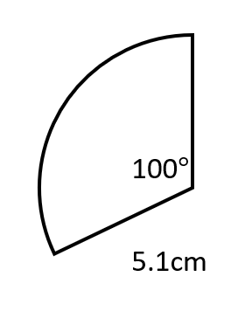

Q6) Find the size of angle $x$ in the following sectors (round your answer to the nearest degree):
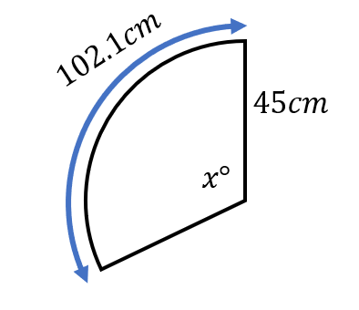
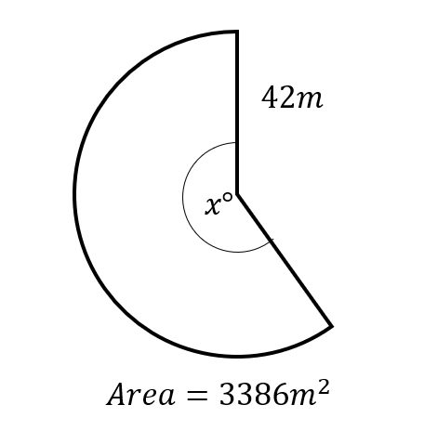
b)
a)
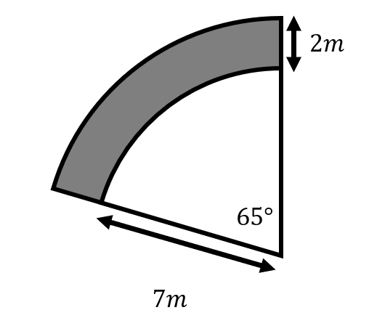
Q7) Calculate the area of the shaded area, rounding to 2 decimal places.

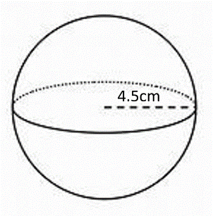
Q8a) Calculate the volume of a sphere with a radius of 4.5cm. Round your answer to 3 significant figures.

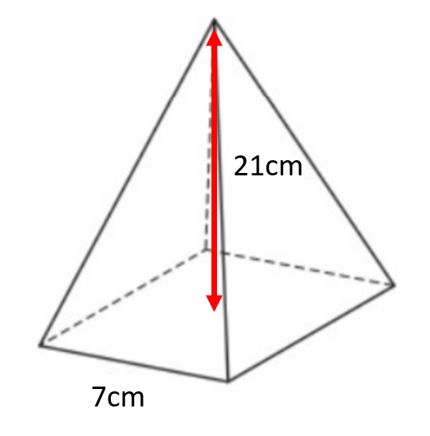
- The height of the square-based pyramid below is 21cm. Calculate the pyramid’s volume.

Q9) Calculate the height of the following shapes. Round your answer to 1 decimal place:
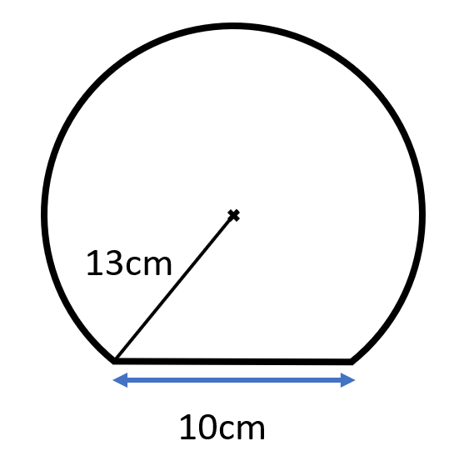
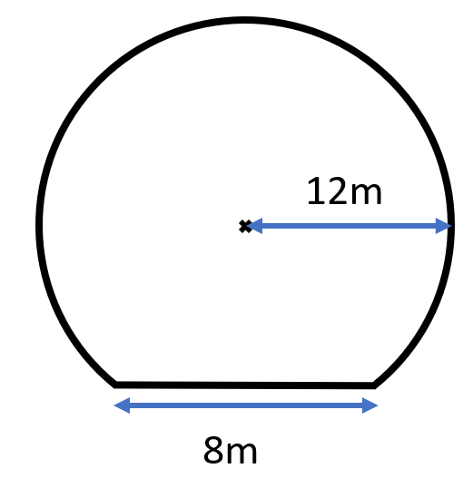
a)
b)
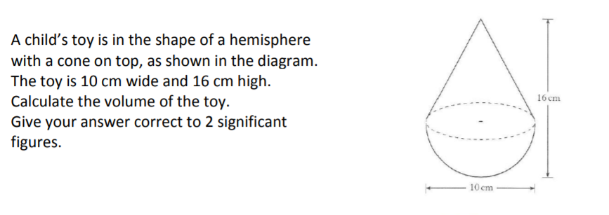
Q10)

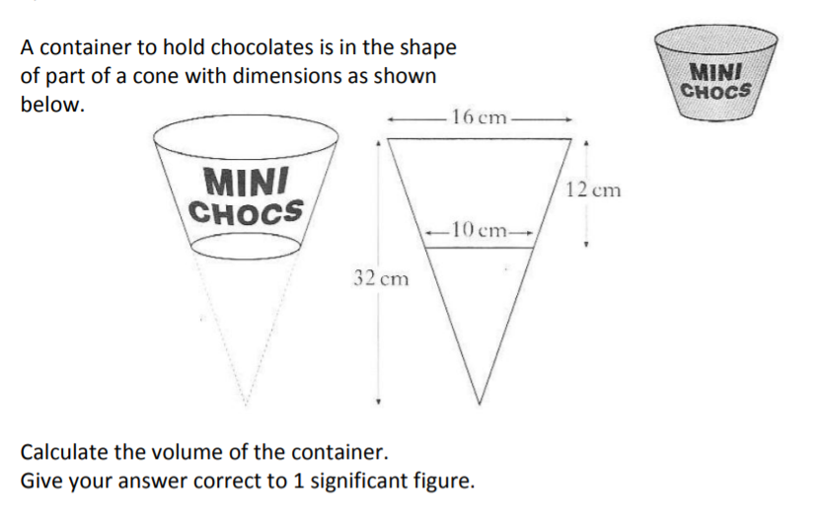
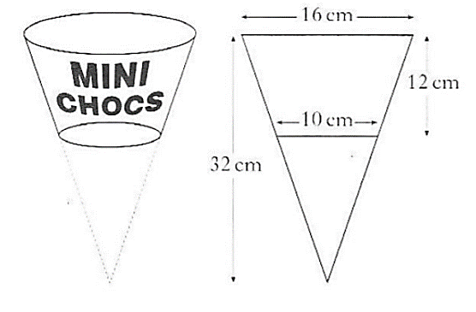
Q11)

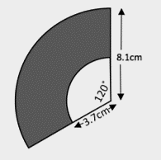
Q12) Calculate the perimeter of the shaded area. Round your answer to 2 significant figures.

