Q1a) For $f\left(x\right)=5x-2x^{2}$ find $f(4)$ | b) For $g\left(x\right)=4x^{2}-15$ find $g(-3)$ | c) For $h\left(x\right)=15+4x-x^{2}$ find $h(-2)$
National 5 S4 October Assessment revision booklet (non-calculator)

Q2) Fully factorise the following:

a) $5x^{2}-25xyz$ | b) $16x^{2}-49y^{2}$ | c) $2x^{2}-12x+10$
d) $5x^{2}+x-4$ | e) $16x^{2}-8y^{2}$ | f) $9{tx}^{2}-81t$

Q3) Expand and simplify the following:

a) ${\left(4x-5\right)}^{2}$ | b) $(2x+1)(3x-2)$ | c) $(x+4)(2x^{2}-4x-3)$
Q4) Calculate the following:

a) 1$\frac{3}{5}+3\frac{3}{4}$ | b) $3\frac{1}{4}÷5\frac{1}{5}$ | c) $\frac{1}{5}×\left(\frac{3}{4}+1\frac{1}{3}\right)$
Q5a) Find the equation of a straight line passing through the point (4,8), with a gradient of -5.
b) Find the equation of a straight line passing through the point (3, -4) and (5, 0).
c) Find the equation of a straight line passing through points (0, -3) and (4,7).
$$x$$ | -3 | -2 | -1 | 0 | 1 | 2 | 3
$$y$$
Q6) Copy and complete the table below, then by drawing a pair of axes and plotting the points, draw the straight line for the equation $y=3x-1.$

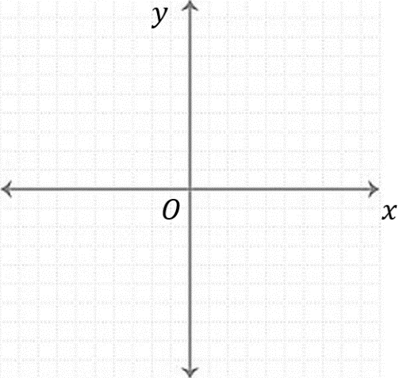

Q7) Change the subject of the following formulae to $x.$
- $T=\frac{xr^{2}}{5}$ | - $B={tx}^{2}-\sqrt{y}$ | - $C=\frac{y}{t-x}$

Q8) Solve the following quadratic equations for $x:$
- $x^{2}-7x-30=0$ | - $5x=2x^{2}$ | - $3x^{2}+4x-7=0$

Q9) Solve the following equations for $x:$

- $4x+2=-4x+8$ | - $5\left(5-x\right)=4(x+1)$ | - $\frac{1}{3}\left(10x+25\right)=x-1$

Q10) Solve the following inequalities:
- $-9x<18-6x$ | - $-4c+8≥7c-23$ | - $4\left(t+5\right)≤5(2t-6)$

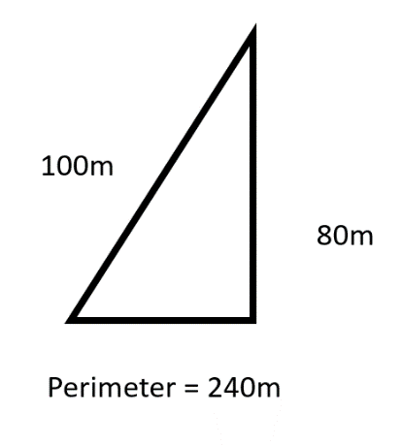
Q11) Determine whether or not the following triangles are right-angled. Show your working.
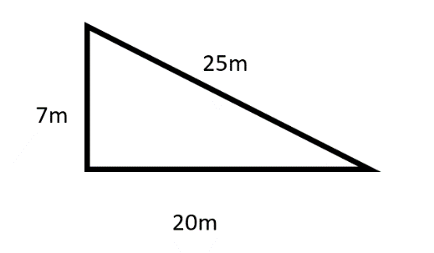
b)
a)

Q12)
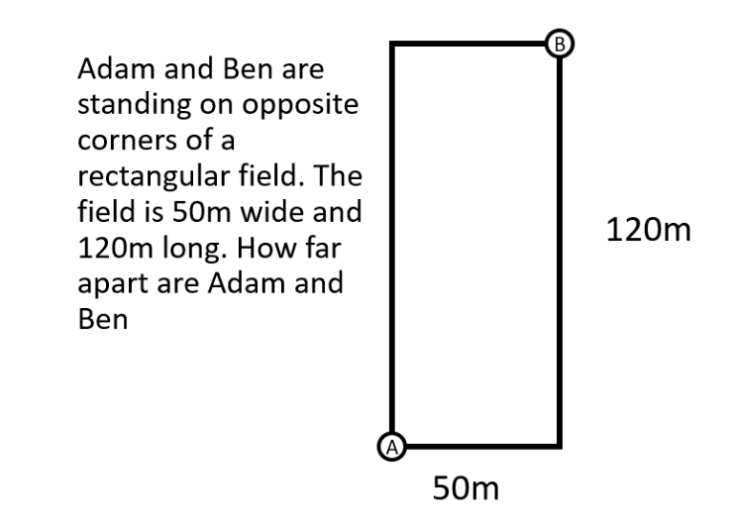
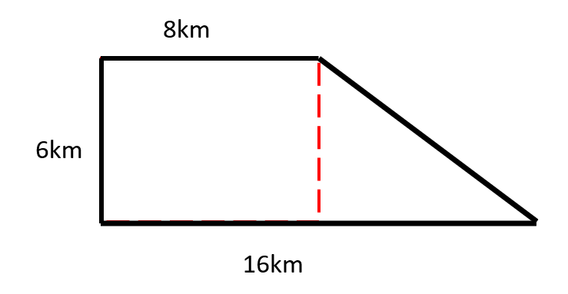
Q13) Calculate the perimeter of the following shape.

