Parent Pre Selection
Guide to Ordering Meals via ParentPay

A - for those pupils that have an agreed medical diet, their personal menu daily choices are not on the system. The pupil & their parents will continue to agree with catering what the pupil will eat from their menu. On the system there are only the choices to record a meal required, packed lunch, eating out of school, or a packed lunch for a school trip.

B - the school office will set-up trips on ParentPay, if parents should book a packed lunch for the trip (or the pupil can bring a packed lunch from home), this should be pre-ordered.

C - once live, parents can pre-order meals up to 4-weeks in advance. Meals cannot be booked on holidays, no menu choices will be visible on these days. Meals can be selected until 08.30am for each day.

Step 1 – Log on to your ParentPay account. Click on the ‘Make Meal Bookings’ box under the child
you would like to book meals for

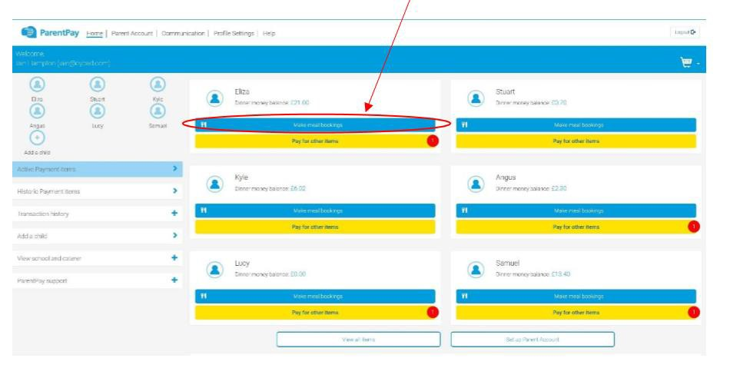
Step 2 – Ensure the drop down box is set to ‘Lunchtime’. Click ‘Make or View Bookings’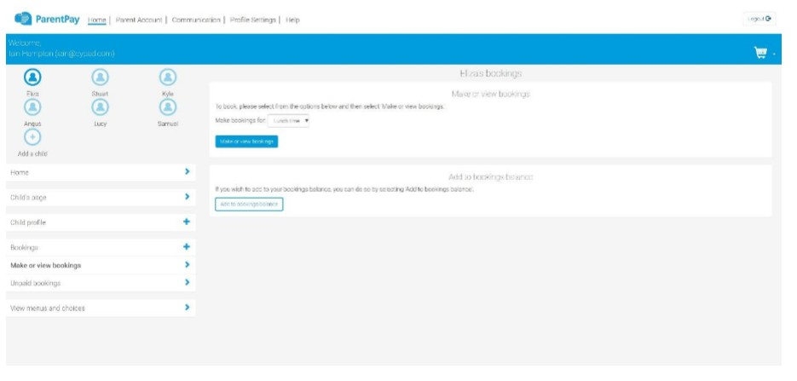

Step 3 – This will take you through to the menu where you can select the meals for your child. You can navigate through the available weeks, to select meals in advance, by clicking on the box under the date.
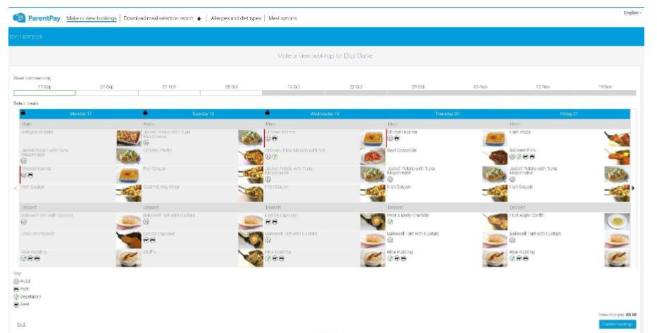

Step 4 – Once you have made the selections you must click ‘Confirm Bookings’ in the bottom right corner. If your child is UIFSM or FSM you will still need to follow through to payment screen, however no payment will be taken from your account
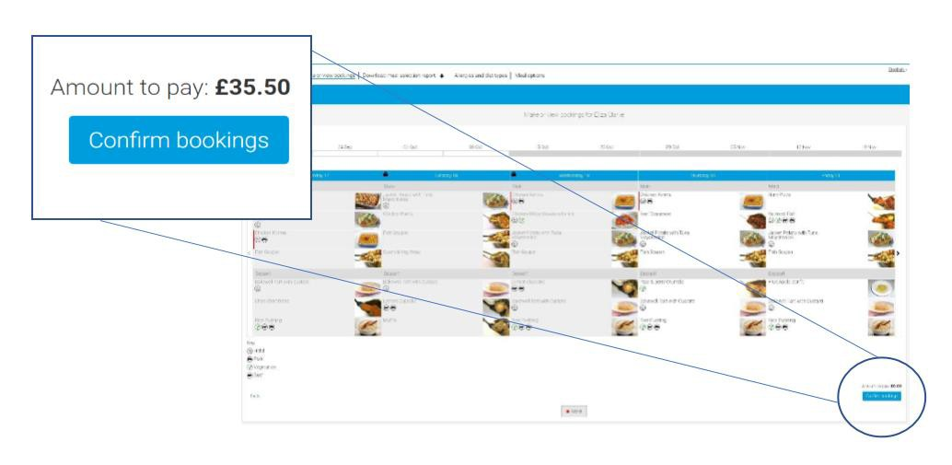

Step 5 – You have now confirmed your meal bookings and will see the following screen.

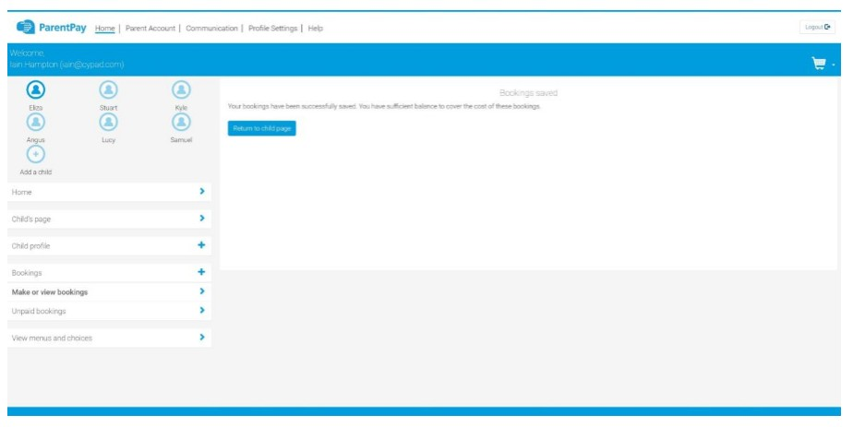

If you would like to view the pre-selections you have made, you will need to go back through Step 1
& 2 to reach the menu screen. You will see an option to ‘Download Meal Selection Report’, click this option and open the downloaded PDF file. This will show you all selections you have made for your child over the coming weeks. You can print this out and stick it on your fridge to remind yourself/your child what meal choice they are having on each day.

