Balornock Primary
November Newsletter

May Newsletter


Welcome to our November Newsletter. The clocks have gone back and our weather is much more unsettled. Please make sure that your child comes to school each day with a waterproof jacket and suitable shoes.

I would like to take this opportunity to welcome Mr Ul--Hassan to our staff. He has joined us to replace Mrs McMillan and Miss McCarte who have both started their maternity leave.
We hope he enjoys his time here with us at Balornock.
Letter from Maureen McKenna, Executive Director of Education.
You should all have received a letter from our Executive Director of Education, Maureen McKenna this week. This outlines the new government guidelines and the implications they have on our school and wider community. We will continue to regularly review our school Risk Assessments in line with local and national guidelines and policy. By working together we can ensure that we protect ourselves and each other in these difficult times.
Adults should now wear face coverings when dropping off and picking up children.
Further information can be found here:
https://glasgow.gov.uk/article/25947/Recovery-Resilience-and-Reconnection-2020
You can also find it here:
https://www.gov.scot/publications/coronavirus-covid-19-guidance-on-reducing-the-risks-in-schools
There is also the latest advice on children and transmission – it is available here:
https://www.gov.scot/publications/coronavirus-covid-19-children-and-transmission

A copy of our school Risk Assessments are available on our school Blog:
https://blogs.glowscotland.org.uk/gc/balornockprimary

PE and Outdoor Learning
Government guidelines have stated that we will be able to carry out some PE activities indoors. We are currently reviewing our Risk Assessements around this. However, throughout this term we will continue to take our learning outdoors as much as we can. The weather is unpredictable, but with the right clothing we can all enjoy learning safely outside in our school grounds and local area.
Please make sure that children come to school each day dressed appropriately with a waterproof jacket and footwear. For our younger children you may want to include a change of clothes in their school bag.

Ventilation
Good ventilation is vital if we are to limit the spread of COVID 19 virus. All schools are required to have well ventilated rooms by opening windows and doors. It is important that we follow these guidelines while trying to keep staff and pupils comfortable during the day. Throughout the winter months pupils wil be allowed to wear warm jumpers and additional layers on top of school uniform. I would ask that these items of clothing stick as closely as we can to our school uniform and that no football colours are worn.


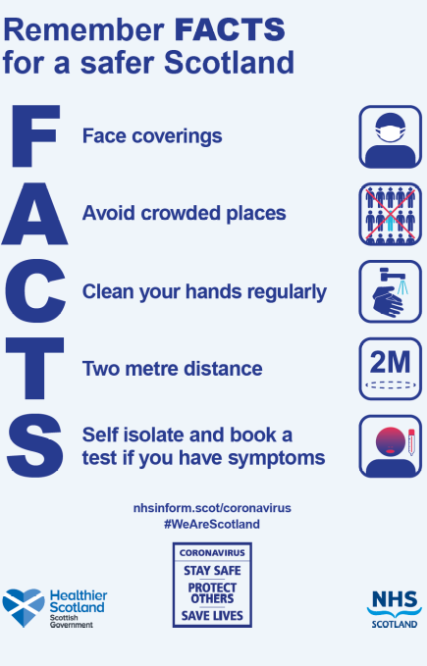



Eco Spot
We are very proud to introduce our new Eco Heroes. They have already been hard at work starting a crisp packet recycling scheme through Terracycle with St Benedict’s Primary, as well as delivering a virtual presentation to the Parent Council and Mrs McSorley.
Wow! Keep up the good work!
Remember you have until Nov 30th to complete your Eco logo design for our whole school competition.
Good Luck everyone!

Parent Council
‘Chuck it in the Bucket’ fundraiser.


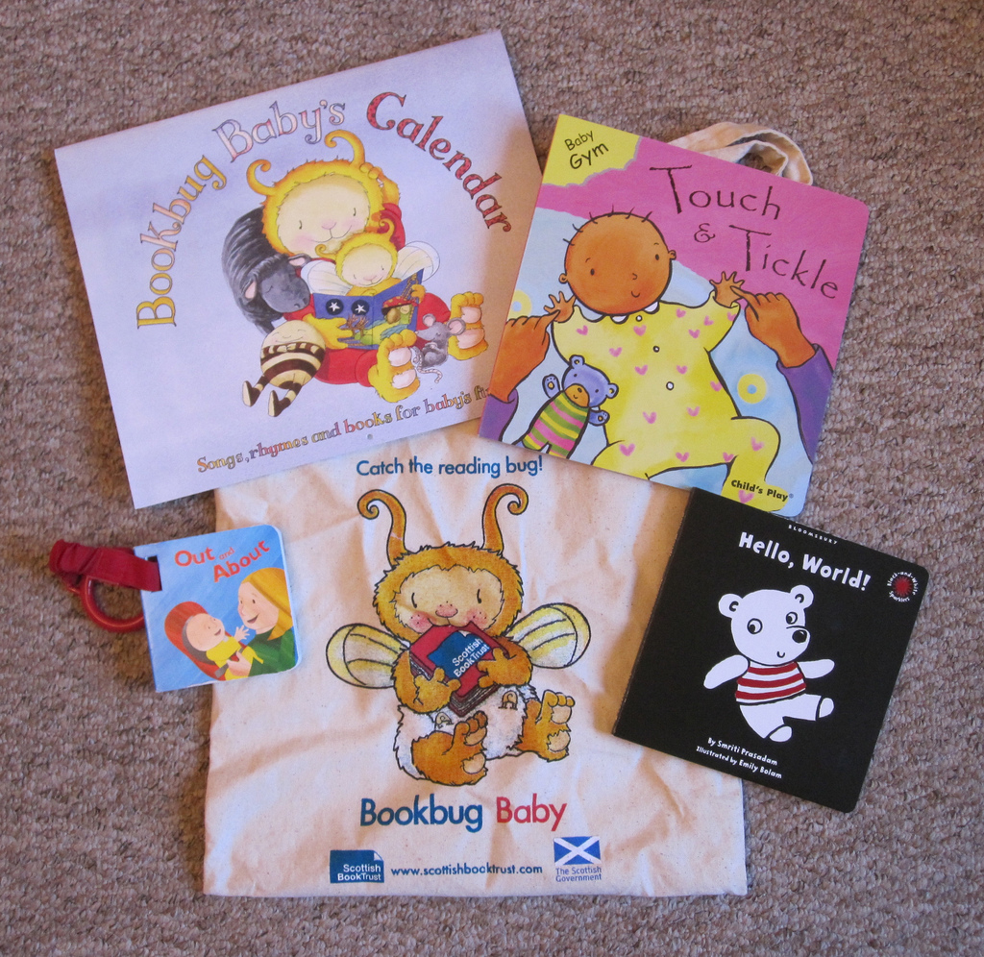
A big THANK YOU to everyone who supported this fundraising event. Together with our Parent Council we raised the amaxzing sum of £397.27. We all managed to enjoy our Hallowe’en celebrations while staying safe.

Literacy
Book Bug Bags
On Friday 6th November Primary 1s will receive their Bookbug bags donated by the Scottish Book Trust. Due to covid restrictions this year we are unable to have our usual celebration assembly but we are not letting this stop us! On Friday morning Mrs Woolfries and Mrs Harris will be joining the Primary 1 classes to have a virtual assembly to gift the bags to the children remotely. We are looking really forward to this new experience.
We hope you enjoy reading the books and completing this year’s activities. Remember to post any photographs of your Bookbug activities on Seesaw. We would be delighted to see them.
Glasgow Loves Reading 
Over the past two weeks all classes have been taking part in the Glasgow Loves reading campaign to help promote reading for enjoyment. They have had great fun taking part in fun activites from writing book reviews to listening to various celebrities talk about their favourite books. We are hoping to make a display of all the children’s work in our main foyer. Look out on Twitter for some photographs of our finished display.

School Holidays 2020-21
December
Christmas and New Year Schools close at 2.30pm on Tuesday 22 December 2020
January 2021
Schools return
Wednesday 6 January 2021
February 2021
Mid-term Holiday Friday 5th , Monday 8th and Tuesday 9th
In-Service day Wednesday 10th
April 2021
Spring Holiday
Thursday 1st school closes at 2.30
Good Friday 2nd April
Easter Monday 5th April
School returns Monday 19th April
May 2021
May Day -Monday 3rd
Inservice Day Thursday 6th
May Weekend
Friday 28th and Monday 31st
June 2021
Summer Break- Thursday 24th June School closes at 1pm
August 2021
Teachers Return:
Inservice Day Thursday 12th
Inservice Day Friday 13th
Pupils return Monday 16th

Useful Numbers/Contacts
Pupil Absence Reporting Line
0141 287 0039
School contact number 0141 558 5224
Email-
headteacher@balornock-pri.glasgow.sch.uk
Website- https://blogs.glowscotland.org.uk/gc/balornockprimary
Follow us on Twitter page @BalornockPS

Achieve
Nurture
Respect





