Night | What did you do an hour before bed? | How many hours sleep did you get? | How did you feel in the morning?
EXAMPLE
Mon
Tue
Wed
Thu
Fri
Sat
Sun
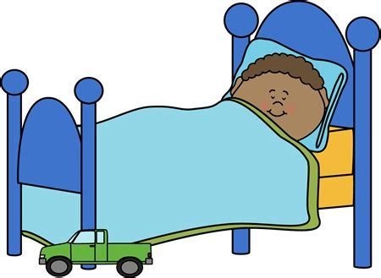
Sleep Diary
