All of the activities this week are to do with Outdoor Learning!
Choose as many of the activities as you like to work on. Share your photos on Seesaw, our school Twitter page or blog!

Outdoor Learning / IDL
STEM  Create your own sundial and use it to tell the time.  https://thehomeschoolscientist.com/how-to-make-a-sundial/ | Art / Technology  Make an eye-catching windchime.  https://www.pinterest.co.uk/pin/174514554295204511/ | PE  Go for a bike ride!  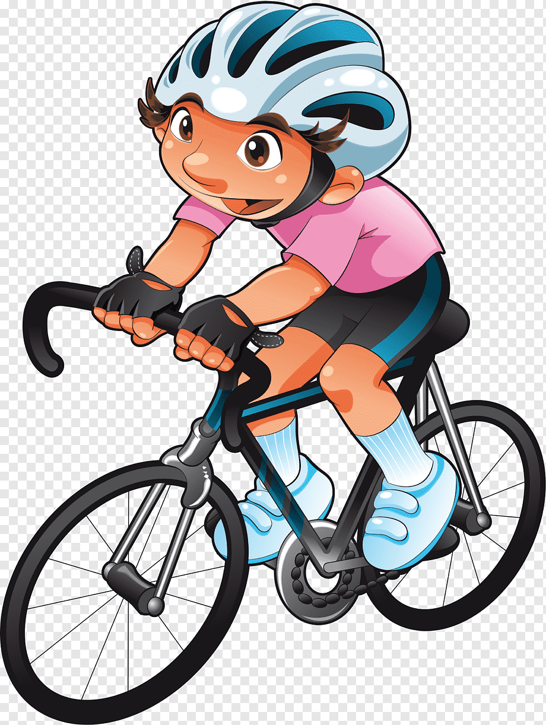 | Weights & Measures Scavenger Hunt  Collect:  The lightest object  A coin  The smallest stone  The longest leaf  A stick which is about 10cm long  Something that will fall the slowest  Something that is longer than a hand span  The widest piece of bark  A flower that is smaller than a thumbnail  Something that will float on water  A blade of grass the same length as your thumb
  Science  Make Your Own Minibeast Hotel.  https://www.twinkl.co.uk/resource/t-t-27093-make-your-own-minibeast-hotel-outdoor-activity | Literacy / Maths  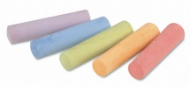  Practice your spelling words and/or times tables using chalks on the ground. | Food Technology / HWB  Prepare a picnic to have in the garden with your family.   | Science  Design and keep a weather diary for the week noting the weather at various points of the day e.g. morning, afternoon and evening. Which type of weather happened least often?
Art  Create a landscape drawing of what you see in your garden, local park or other scenic place. | Technology  Make a paper kite! Post a video on Seesaw of you flying it!  https://www.youtube.com/watch?v=_gbv6TJQclk | Art and Design  Find some pebbles, paint them and turn them into creative creatures. | Golden Family Time  Have a water fight!  

