Choose as many of the activities as you like to work on. Tick / highlight and date the task once it’s completed.
Literacy | Numeracy | Health and Wellbeing | IDL
Film Literacy  Watch the short film ‘Taking Flight’ http://takingflightfilm.com/  Write down your answers in complete sentences to these questions about the film:  - How is Tony feeling in the car on the way to grandpa’s house?  - What ‘adventures’ do Tony and his grandpa go on together in the Radio Flyer wagon?  - Why do you think Tony’s dad is happy when he sees the wagon?  - Who is the little boy staring back at Tony’s dad when he looks inside the wagon? | Maths Challenge:  Grand Designs: Perimeter and Area  You will become an architect for this project and design your own dream house by creating a floor plan. A floor plan is a visual representation of what a house will look like when viewed from above.  You will find the perimeter and area of ALL the rooms in your dream house, so the builder knows how much material they will need to get for the build!  You will need to work out the perimeter and area for each room, add all the perimeters together to get the Total Perimeter for the whole house, and then add all the areas together for the Total Area. You MUST include a minimum of 7 rooms in your house.  You need:  1 bathroom, 1 kitchen, 1 master bedroom, 1 bedroom, 1 living room, 2 other rooms of your choice (ideas: game room, dining room, office etc).  You may have other rooms, but you must have at least these 7 rooms.  If you can, draw the design on graph paper. You must use a ruler to draw your lines. I would suggest 1 cm = 1 metre.  - Decide on how many rooms (at least 7) your house will have.  - Draw each room.  - Label each room.  - Label the perimeter and area of each room.  - Add up the total perimeter.  - Add up the total area.  - Make sure you include your workings on a separate sheet of paper and that your workings are neat and organised!  - For each room, include the name of the room, the formula and the answer e.g.  - Bathroom (Perimeter)  P = 10 + 10 + 6 + 6  P = 32  Bathroom (Area)  a = 10 x 6  a = 60 cm2  Remind yourself how to work perimeter and area by watching these videos:  https://www.bbc.co.uk/bitesize/articles/zbcnf4j  https://www.bbc.co.uk/bitesize/guides/z2mtyrd/revision/1  SHARE YOUR FINISHED DESIGN AND WORKINGS ON SEESAW | HWB  Draw a picture of yourself on a large sheet of paper. Then, around your drawing, write 5 things you like about the way you look and 5 things you like about your personality. e.g. ‘I like the colour of my eyes.’, ‘I try to be kind to everyone.’  Colour in your drawing and upload a photo of it on Seesaw or the school twitter page / blog if you like! | French - Can you match the greetings in French to the meanings in English?  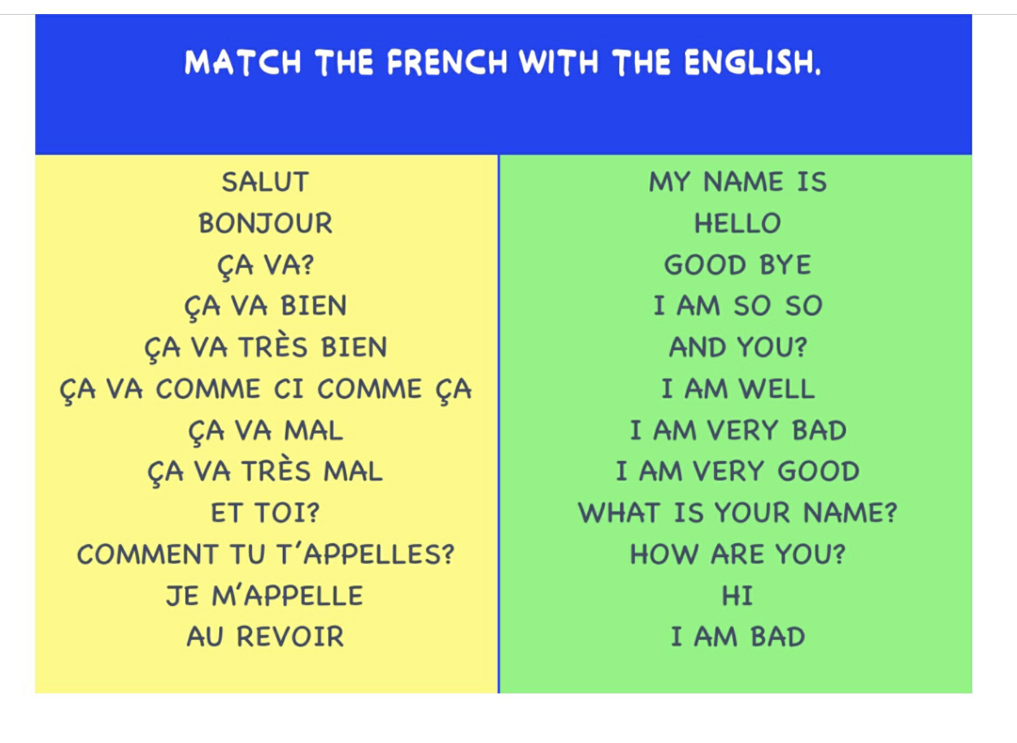  Watch this fun video to help you! https://www.bbc.co.uk/teach/supermovers/ks1--ks2-mfl-french-greetings-with-ben-shires/zdpdvk7  Challenge: Can you say each of the words and phrases in French?
Writing  Write and perform to your family, your own report for Newsround. It could be about Coronavirus and the lockdown or any topic which interests you!  You can include a song, rap or poem you have made up in your report. Record a video of your performance and upload it to Seesaw / the school Twitter page or blog if you like! |  | P.E  - Create an Obstacle Course!  Create your own obstacle course either indoors or outdoors. You can use items from your house such as boxes, chairs, cushions or pillows. Make sure you ask an adult for permission first!  - Decide if you are going to build your obstacle course indoors or outdoors ( check the weather!).  - Start to build your course in a circle so that it can be followed.  - Ask everyone in your family to get involved! | HWB / Art and Design  – Build a Wellbeing/self-soothe Box  Decorate a shoebox / small cardboard box with pens, crayons, tissue paper or with anything else you have at home. Use it to store items which help you feel calm or which make you think of nice memories - e.g. family or funny photos, a small cuddly toy, or nice smelling products. Write down any favourite quotes or song lyrics which make you feel good and put them in too. If you are feeling worried, anxious or upset, find a quiet place & go through your box to help you feel better.
Spelling  There are different ways to spell the ‘sh’ sound e.g. sh, ch, t(ion), ci and ss. Practice the spelling words below using any spelling strategies. Ask someone at home to call them out for you to spell out loud.  shimmering, parachute, fraction, addition, delicious, financial, magician, discussion.  Then, create your own wordsearch using your spelling words. Give it to someone at home to solve! |  | PE  Choose at least one activity from the following:  Move, stretch and refresh your body and mind with some fun yoga with Cosmic Kids Yoga  https://www.youtube.com/watch?v=mz9Qq7vIUfw  Get moving with Joe Wicks  ‘The Body Coach’ 9am live stream  https://www.youtube.com/channel/UCAxW1XT0iEJo0TYlRfn6rYQ  Choose a dance to follow at YouTube- Just Dance  https://www.youtube.com/channel/UChIjW4BWKLqpojTrS_tX0mg | Family Shout Out Board  1. Use paper, post-it notes or pages from your jotter to create a shout out board to go on a wall in your home.  2. Write down a family member’s name and write something lovely they have done or something you are thankful for.  3. Ask someone to write something lovely about you too.  You can do this for everyone in your family or pick one person a day. You can include people from a different household and write a shout out for them too! Take a picture of your family shout out board and upload it to Seesaw.

