Balornock Primary ~ Home Learning in Primary 1 Over the next week, try and complete some/all of the tasks on the grid. Tick and date the task once it’s completed. Feel free to share your work on Seesaw. Have fun!
Reading/Phonics  Listen to the story by Miss McMillan on Seesaw. You will be able to practise your pre-reading strategies and answer some fun questions!  Practise your common words:  are dad not | Writing  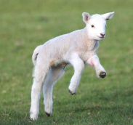  Write and illustrate a sentence (or two) about your favourite Spring animal. You could write what it looks like, sounds like and why it is your favouite. | Listening and Talking  Mrs Woolfries has created 3 listening and talking challenges for you to do!  To find out more please go to the listening and talking post.  Have fun!
Numeracy  Youtube - search ‘double addition facts song’ and watch the first video. This is one of our favourite songs.  Now can you write your doubles all the way from 1 – 12? Eg. 1+1 = 2+2= 3+3= | 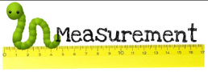  Maths  Collect 10 objects of different lengths and put them into a carrier bag. Close your eyes and pick to objects at random. Can you state which one is longer, which is shorter and describe how you know this. |   STEM  Egg Parachutes!  Using materials in your house (i.e cups, kitchen roll, paper, straws) try and create a parachute for an egg. Remember that it has to keep the egg safe when you test it out!  Helpful Hint: Drop the egg from a height when testing.
Health and Wellbeing  Take a break outside and get some fresh air in your garden or on a walk. Whilst you are resting go on a scavenger hunt and see if you can find….  - a flower - a tree  - an insect - a post box  - a traffic light - an aircraft  - a cat or dog - a nest | Play  Play a game with your family. This can be an activity of your choice i.e board games, jigsaw puzzle, i-spy, knots and crosses.   | Family Learning  Working with an adult in your house, can you gather items of different colours and try and make a rainbow circle.  