Balornock Primary ~ Home Learning in Primary 1
Over the next week, try and complete some/all of the tasks on the grid. Tick and date the task once it’s completed. Feel free to share your work on our school Twitter or Glow page. Have fun!
Reading/Phonics  Shared Reading!  Visit the website readon.myon.co.uk and search ‘Animals in Spring’. Enjoy this lovely non-fiction book with an adult! | Writing  Write and illustrate a sentence (or two) about Spring. You could write about some of the signs of spring leading on from your listening and talking task e.g  In spring I see…  In spring I hear… | Listening and Talking  Spring is Here!  From your window/door/balcony/garden observe the beauty of the great outdoors. Use your senses to help you discuss with an adult:  What you see/hear/smell/taste/feel
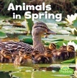  Numeracy  Supermarket Sweep!  Label some items from the food cupboard between 1p and 10p and go on a shopping spree! How much would two items add to? How much would three items add to? What would your change be from 10p? From 20p? | Maths  Information Handling!  Conduct a traffic survey from your window. You could categorise the traffic into types (car, bus, bike, etc). How many of each type did you see? Can you display this in a pictogram? | STEM  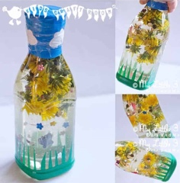  Make a spring sensory bottle!
Health and Wellbeing  Create a springtime collage! You could use resources and materials that you have in your house or natural resources from your garden or that you gather during your daily walk. Be creative! | Play  Take time out of your busy day to relax and enjoy doing something that you love! | Family Learning  Help your adult with a household chore! This could including making the bed, brushing the floor, helping to write the shopping list. The choice is yours!

