Balornock Primary ~ Home Learning in Primary 1
Over the next week, try and complete some/all of the tasks on the grid. Tick and date the task once it’s completed. Feel free to share your work on our school Twitter or Glow page. Have fun!
Reading/Phonics  Read a story for enjoyment! Remember to use your reading strategies if you get stuck.  - Look at the pictures  - Sound it out  - Word within a word  Common words- have, just, to | Writing  Have a go at writing a news recount on what you have been doing during lock down. Think of your common words and have a go at sounding out the trickier words you would like to use in your sentences!  Also.. practice the date for P2  e.g.- Monday 27th April 2020 | Listening and Talking  ‘I see, I think, I wonder’ (The pupils are experts in this exercise)  Parents- choose a picture of ANYTHING, i.e. - (famous landmark, space, character etc) and encourage your child to discuss what they see, think and wonder. Remember take turns with each section.
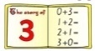  Numeracy  Youtube- Jack Hartman, Big number song, number blocks. Encouraging your child to be learning their numbers daily in fun and different ways.  Complete 10 of each addition/ subtraction sums within 10-20. | Maths  - 2D/ 3D shape hunt around the house.  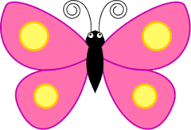  - Revisit money (identifying coins from 1p- £2 / addition within 10p/20p) | Science  Collect various objects around the house and predict which ones will float or sink.  Give reasons why…
Health and Wellbeing  Discuss with your adult and then write a sentence on the following:  How do you feel about not being at school? Remember and illustrate your sentence! | Play  Can you create a springtime picture using natural resources?  It could be on paper or on the ground! | Family Learning  Try baking/ making something simple with your little one (cakes, fruit kebabs)  Discuss the importance of the recipe and instructions!

