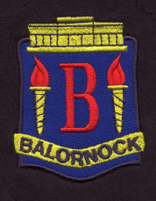
Balornock Primary’s
Christmas Penny Post
This term as part of their money topic Primary 2 are taking part in a Christmas Enterprise Project – The Penny Post. This project helps students to set up a delivery service within school. The Penny Post is designed to develop pupils understanding of the concept of money as well as allowing pupils to take responsibility for and run a project that will impact the whole school.

So how will it work? Primary 2 have designed stamps that will be sold to staff and pupils in school for 1p each. These stamps should be placed on any cards the staff and pupils wish to be delivered to people in our school in the lead up to Christmas. Once envelopes are stamped they should be placed in our Penny Post Post Box at the school office. The post box will be emptied every day at 3om and cards will be delivered to recipients the following morning. Stamps will be available to buy from the Lower Gym every break time.
Pupils can still deliver their cards by hand if they so wish. All money collected will be donated to the Springburn Alive and Kicking Project. The Penny Post will run from Thursday the 24th of November until Friday the 16th of December.
Thank you for your continued support.
Kind Regards
Miss Davidson
Principal Teacher

