Additional Activities to be Completed. | 9.15 – 10.30 | 10.45 – 12.15 | 1 – 2 | 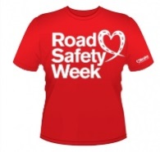  2 – 3
Mon |  |  | WHOLE SCHOOL PLEDGE | Learn the Green Cross Code Song  STOP, LOOK, LISTEN
Tue | HANDS UP SCOTLAND SURVEY  WOW AWARD WINNERS |  | Holding Hands Activity  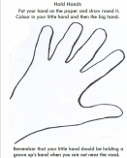  ALL  CLASSES  (in pack) | Learn the Green Cross Code Song  STOP, LOOK, LISTEN
Wed | Stars Team  Assembly  9.30 – 10am |  | Activity From The Pack | COMPETITION TIME
Thurs | Activity From The Pack |  | CROSSING THE ROAD  P7b – 1.15pm  P7a – 1.15 – 1.35pm  P6a – 1.35 – 1.55pm | CROSSING THE ROAD  P1a – 2.00- 2.20pm  P1b – 2.25 – 2.45pm
Frid | Balornock’s Bright Day  CROSSING THE ROAD  P2 9.15 – 9.40am  P3/2 – 9.45 – 10.25 | Balornock’s Bright Day  CROSSING THE ROAD  P3 – 10.55 – 11.15am  P4 – 11.20 – 11.40am  P5 – 11.45 – 12.05pm | Balornock’s Bright Day  CROSSING THE ROAD  P6b – 1.15 – 1.35pm  P5/4 – 1.35 – 1.55pm | 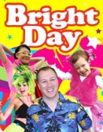  Balornock’s Bright Day

