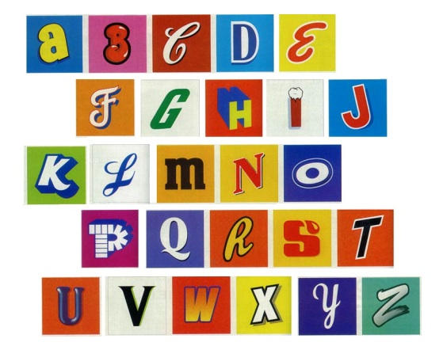

Dear Parents or Guardians

We will be holding a parent information afternoon next week on Literacy. This will be an opportunity to introduce you to our new phonics programme and give you some practical tips about how to help at home.

It will be held in the Challenge Room at 2.30pm on Wednesday 12th October.

We look forward to seeing you there.

Miss Smith

Mrs Harris