
ANNETTE STREET PRIMARY SCHOOL
Parent and Carer Communication Strategy
OWNER  Head Teacher | UPDATED  August 2026 | NEXT REVIEW  June 2029

Parents and carers are children’s first educators and our most important partners. All our communication should be clear, respectful, inclusive, timely and accessible.

1 Vision and aims
Effective communication builds trust, strengthens relationships and supports improved outcomes for children. We are committed to enabling every family to engage fully in their child’s education.
We aim to develop positive relationships with all families; provide clear, accurate and timely information; ensure communication is inclusive and accessible; celebrate children’s successes; support parental engagement in learning; respond professionally and respectfully to concerns; promote two-way communication; and ensure consistency across the school.
This strategy reflects the Glasgow City Council Family Learning and Parental Engagement Strategy; the Scottish Schools (Parental Involvement) Act 2006; the Learning Together National Action Plan; the National Improvement Framework; GIRFEC and the UNCRC; and Glasgow City Council customer care standards and digital communication guidance.

2 How we communicate
Channel | Used for
Seesaw and Facebook | Our primary communication tools: newsletters, reminders, trips, school events, emergency updates, achievements and permission forms.
Email and Messenger | Individual communication and follow-up information.
Telephone | Urgent matters, attendance and wellbeing concerns, safeguarding matters, consultation, and sensitive conversations.
Face-to-face meetings | Parent consultations, additional support needs meetings, Child’s Plan meetings, pastoral support and resolving concerns.
Website | School policies, curriculum, school improvement, children’s rights and child protection, the school calendar and contact information.
Social media | Promoting learning, achievements and community events, following Glasgow City Council guidance on confidentiality and consent.

3 Response times
Communication | Response
Telephone messages | Within 1 working day
Emails | Within 2 working days
Complaints | In line with the GCC complaints procedure
Urgent safeguarding concerns | Immediately

Where a full response cannot be provided immediately, families will receive an acknowledgement.

4 Accessibility
As a highly multilingual school we use interpreters where appropriate, provide translated information where possible, use visuals, communicate in plain English, support families completing forms, and provide accessible formats when required.
Communication should never become a barrier to parental engagement.

5 What we communicate about
Positive communication is central to our approach. Families regularly receive information about learning, achievements, attendance, awards, pupil leadership, school events, curriculum projects and wider achievement. We also communicate regularly about curriculum learning, attendance, wellbeing, online safety and family learning opportunities.
In line with Glasgow City Council guidance we monitor attendance regularly, contact families promptly regarding unexplained absence, work collaboratively where attendance concerns arise, and provide support before difficulties become entrenched.

6 Sensitive conversations and raising concerns
Where concerns relate to behaviour, wellbeing, additional support needs, safeguarding or complaints, communication normally takes place privately, respectfully and in partnership, with agreed actions recorded in pastoral notes.
Parents are encouraged to raise concerns as early as possible, normally through the class teacher, then the Depute Head Teacher, then the Head Teacher, and where appropriate the Glasgow City Council complaints procedure. Most concerns can be resolved informally through open discussion.

7 Respectful communication and confidentiality
School staff will listen carefully, remain professional, seek solutions and maintain confidentiality. Parents and visitors are expected to communicate respectfully, avoid abusive, threatening or discriminatory behaviour, work collaboratively, and respect the confidentiality of other children and families. The school follows Glasgow City Council procedures where behaviour towards staff is unacceptable.
Information about individual children or families is shared only where appropriate, with consent where required, where safeguarding responsibilities apply, and in accordance with UK GDPR and data protection legislation.

8 Roles and responsibilities
Who | Responsibility
Head Teacher | Leads the whole-school communication strategy, ensures consistency, responds to complex concerns and monitors effectiveness.
Senior Leadership Team | Supports communication with families, promotes positive relationships and responds to concerns promptly.
Class teachers | Maintain regular communication about learning, wellbeing and class activities such as trips, events and assemblies, and build positive relationships with families.
Office staff | Provide welcoming, efficient first contact and support communication systems.
Parents and carers | Keep contact details up to date, engage respectfully with staff, share relevant information about their child, and support regular attendance and learning.

9 Monitoring and success measures
Effectiveness is evaluated through Parent Council feedback, parental surveys, complaints analysis, Seesaw engagement, attendance at school events, family learning participation and school improvement planning.
We will know this strategy is working when parents report feeling informed and valued; communication is timely and consistent; attendance at school events increases; parental engagement improves; concerns are resolved early; complaints reduce; families from all backgrounds report that communication is accessible; and children benefit from strong home–school partnerships.

Appendix 1 — Our communication standards
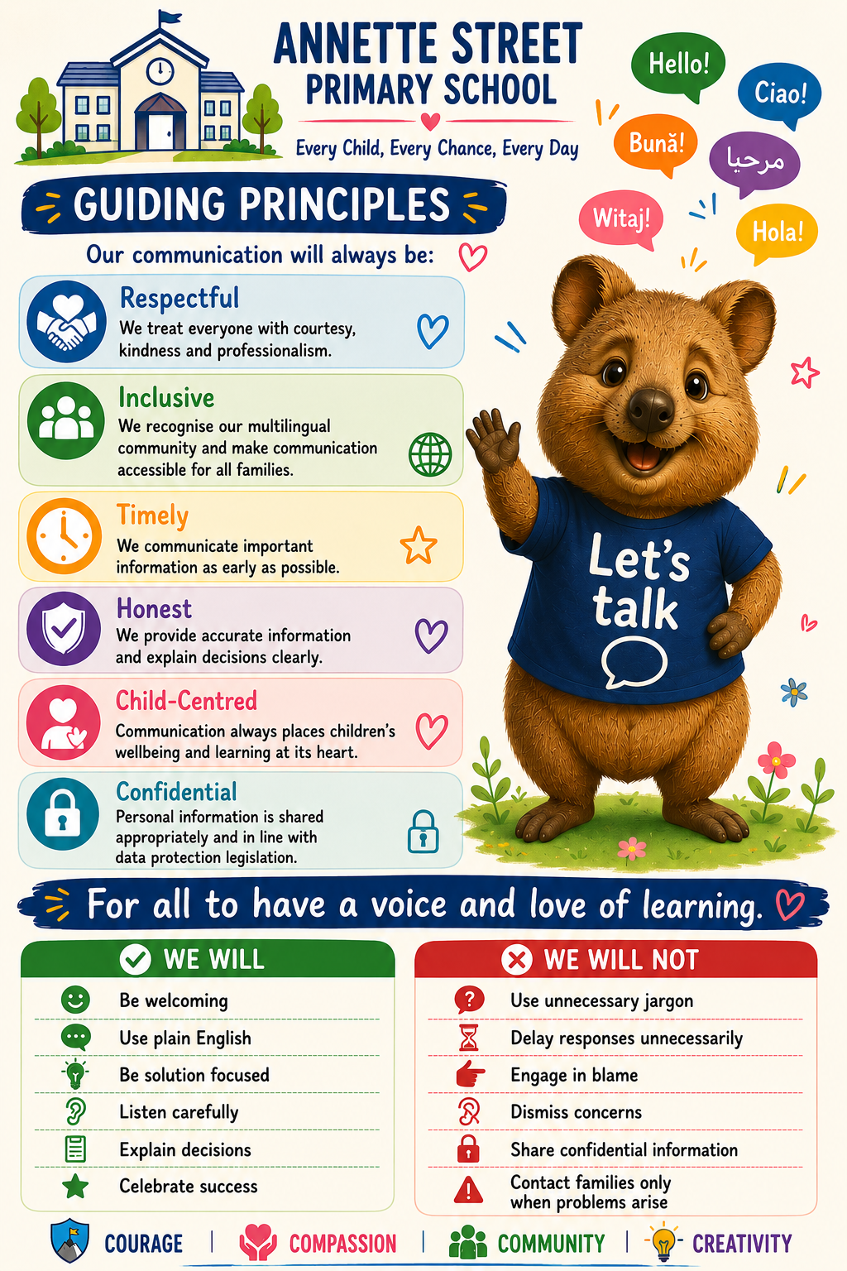

Appendix 2 — Summary poster
