
ANNETTE STREET PRIMARY SCHOOL
Educational Excursions and Visits Policy
Every Child, Every Chance, Every Day

OWNER  Head Teacher | WRITTEN  June 2026 | NEXT REVIEW  June 2029

Every child should have access to high-quality educational experiences beyond the classroom.

1 Vision
Educational visits are an integral part of learning at Annette Street Primary School. They enrich the curriculum, develop children’s confidence and independence, promote health and wellbeing, and provide memorable experiences that support Curriculum for Excellence.
Visits are planned to be safe, inclusive, educational, well organised and accessible to all. This policy reflects Glasgow City Council Management Circular 48, Curriculum for Excellence and GIRFEC.
We aim to enhance learning through real-life experience, promote curiosity and enjoyment, develop independence and resilience, keep visits safe and well managed, remove barriers to participation, support inclusion and equity, and strengthen our partnerships with families and the wider community.

2 Educational purpose and planning
Every visit must have a clear learning purpose linked to Curriculum for Excellence. Planning should identify the intended learning outcomes, the curricular links, the skills for learning, life and work being developed, and the opportunities for pupil voice and reflection.
Every visit will also include an educational rationale, an appropriate risk-benefit assessment, Head Teacher approval, suitable staffing, transport arrangements, emergency and medical arrangements, communication with parents, and an evaluation once the visit is over.

3 Risk assessment
A suitable and sufficient risk-benefit assessment is completed well in advance of every visit. It should identify foreseeable hazards and set out control measures, take account of medical and additional support needs, cover transport arrangements and weather conditions, include emergency procedures, and allow for dynamic risk assessment during the visit itself.
Risk assessments are approved by the Head Teacher, stored electronically, and available during the excursion.

4 Staffing and volunteers
Staffing arrangements are determined through the risk assessment, taking account of the age of the children, the complexity of the activities, the location, transport, medical needs, behaviour, weather and any individual risk assessments. Appropriate supervision is maintained throughout.
Parents and volunteers may support educational visits where appropriate. They receive a briefing, work under the direction of school staff, maintain confidentiality and follow safeguarding procedures. They never supervise groups independently unless specifically authorised.

5 Inclusion and cost
Educational visits should be accessible to every learner. Planning takes account of additional support needs, English as an additional language, medical needs, mobility, communication needs, dietary requirements, religion and culture, sensory needs and emotional wellbeing. Reasonable adjustments are made wherever possible, and no child is excluded because of additional support needs.
Visits are planned in line with the school’s Cost of the School Day Policy. The school seeks to minimise costs and provide support where it is required, and no child is excluded because of their family’s financial circumstances.

6 Medical needs
Before every visit, staff ensure that medical information is up to date, that any required medication travels with the child, that trained staff are identified where necessary, that emergency contact information is available, and that individual healthcare plans are followed. The school first aid kit accompanies all visits.

7 Behaviour and safeguarding
Children are expected to follow adult instructions, remain with their allocated group, show respect to others, care for property and the environment, and represent Annette Street Primary School positively. Restorative approaches are used wherever appropriate.
Safeguarding is everyone’s responsibility. Staff maintain appropriate supervision, carry out regular head counts, agree meeting points in advance, follow emergency contact procedures, keep in communication with the school office, and report any safeguarding concern immediately.

8 Information for parents and carers
Parents receive information covering the educational purpose of the visit, the destination and timings, transport, clothing requirements, food arrangements, medical arrangements, emergency contact details, and consent arrangements where these are required.

9 Photography and data protection
Photography complies with the school’s GDPR and Photography policies. Staff use approved school devices wherever possible and never use personal devices without Head Teacher approval. Parental permissions are respected and images are stored securely.

10 Environmental responsibility
Where possible, educational visits promote sustainability by walking where appropriate, reducing waste, recycling, respecting wildlife and caring for the local environment.

11 Evaluation
Following each visit, staff reflect on the learning outcomes, the organisation, health and safety, inclusion, pupil feedback and any improvements for future visits. Evaluations are submitted using the school’s Educational Visit Evaluation form.
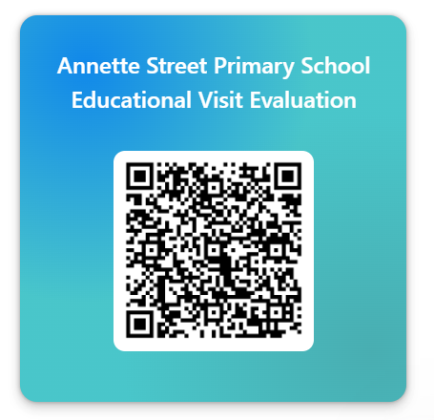

12 Linked policies
This policy should be read alongside the Child Protection and Safeguarding Policy, the Health and Safety Policy, the Cost of the School Day Policy, the Additional Support for Learning Policy, the Behaviour and Relationships Policy, the GDPR Policy, and the Educational Visits Risk Assessment Procedures.

Appendix 1 — Before the visit
✓ | Task
 | Educational purpose identified
 | Head Teacher approval obtained
 | Risk-benefit assessment completed
 | Venue booked
 | Transport booked
 | Finance completed
 | Parent information issued
 | Consent received (where required)
 | Medical information checked
 | Medication prepared
 | First aid kit checked
 | Emergency contacts printed
 | Staffing confirmed
 | Volunteers briefed
 | Cost of the School Day considered
 | Inclusion arrangements made
 | Packed lunches ordered
 | Water bottles organised
 | Weather forecast checked
 | Clothing information issued
 | Mobile phone charged

Appendix 2 — On the day
✓ | Task
 | Staff briefing completed
 | Register taken before departure
 | Head count completed
 | Medication packed
 | First aid kit packed
 | Risk assessment available
 | Emergency contacts available
 | Packed lunches collected
 | Water bottles packed
 | Regular head counts throughout visit
 | Toilet arrangements monitored
 | Dynamic risk assessment undertaken where required
 | Register taken before return journey
 | Register completed on return
 | Any accidents or incidents recorded
 | Visit evaluated and improvements noted

