
ANNETTE STREET PRIMARY SCHOOL
Cost of the School Day Policy
Every Child · Every Chance · Every Day

OWNER  Depute Head Teacher P4-7 | APPROVED  August 2026 | NEXT REVIEW  June 2029

No child should miss out on learning or opportunities because of their family’s financial circumstances.

1 Vision
We are committed to reducing financial barriers so that every child can participate fully in school life, achieve their potential and feel included. This policy reflects Scottish Government guidance, Glasgow City Council priorities, the Scottish Attainment Challenge, GIRFEC and the UN Convention on the Rights of the Child.

2 Our principles
Our approach is equitable, providing additional support where it is needed, and inclusive, ensuring every child can take part. It is respectful, supporting families with dignity and confidentiality, and collaborative, listening to children, families and staff. It is transparent about costs and the support available, and evidence-informed, reviewing practice regularly to improve outcomes.

3 Our commitment
We will actively reduce unnecessary costs. That means promoting affordable school uniform and uniform recycling, providing essential learning materials where we can, keeping school trips affordable and offering payment options, and increasing access to free and subsidised clubs. It also means supporting digital inclusion, promoting access to free school meals, the Breakfast Club and financial support, and using Pupil Equity Funding strategically to remove barriers to participation.

4 Poverty-aware practice
We will avoid practices that stigmatise children or families, minimise requests for voluntary contributions, and consider affordability when planning learning experiences. Support is always provided discreetly and respectfully, and we will challenge barriers that prevent children taking part.
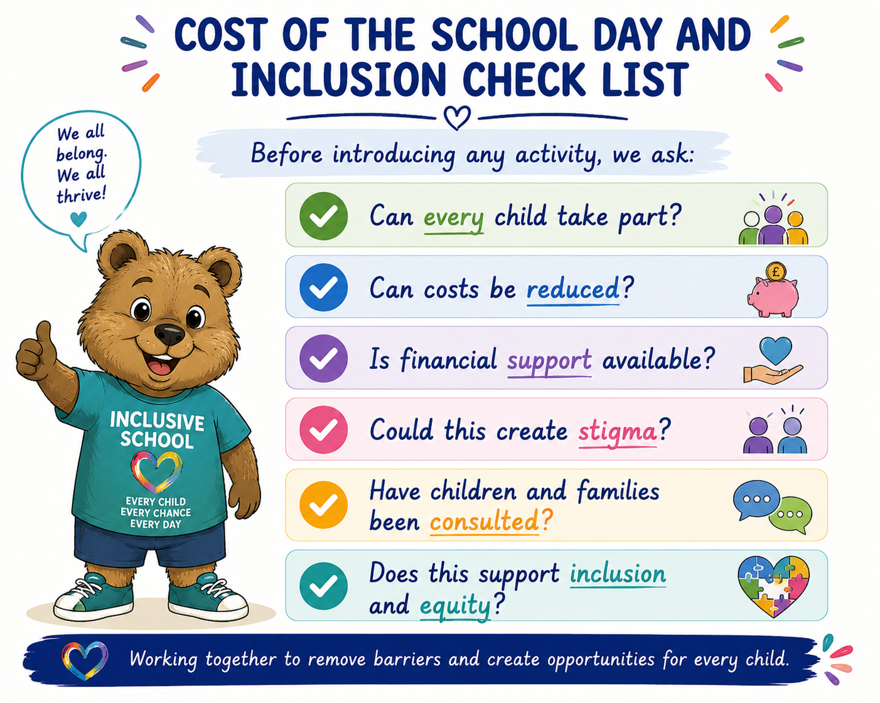

5 Listening to our community
Children, families and staff shape our approach through learner voice, parent consultation, the Parent Council, surveys, participatory budgeting and an annual Cost of the School Day review.

6 Monitoring impact
Each year we review attendance, participation in trips and clubs, learner wellbeing, family feedback, the impact of Pupil Equity Funding, and our Cost of the School Day priorities. The findings inform our School Improvement Plan and PEF planning.

7 Roles and responsibilities
Who | What they do
Head Teacher | Leads the Cost of the School Day strategy, allocates resources and monitors impact.
Staff | Identify barriers, promote inclusive practice and signpost families to support.
Learners | Share their experiences and ideas, and help shape improvements.
Parents and carers | Provide feedback and work in partnership with the school.

8 Success criteria
We will know this policy is working when every child can participate fully in school life, financial barriers are reduced, families feel respected and supported, participation in learning experiences increases, and the cost of the school day is considered in all school planning.

