Lourdes Secondary School
School Improvement Plan 2021 - 2022

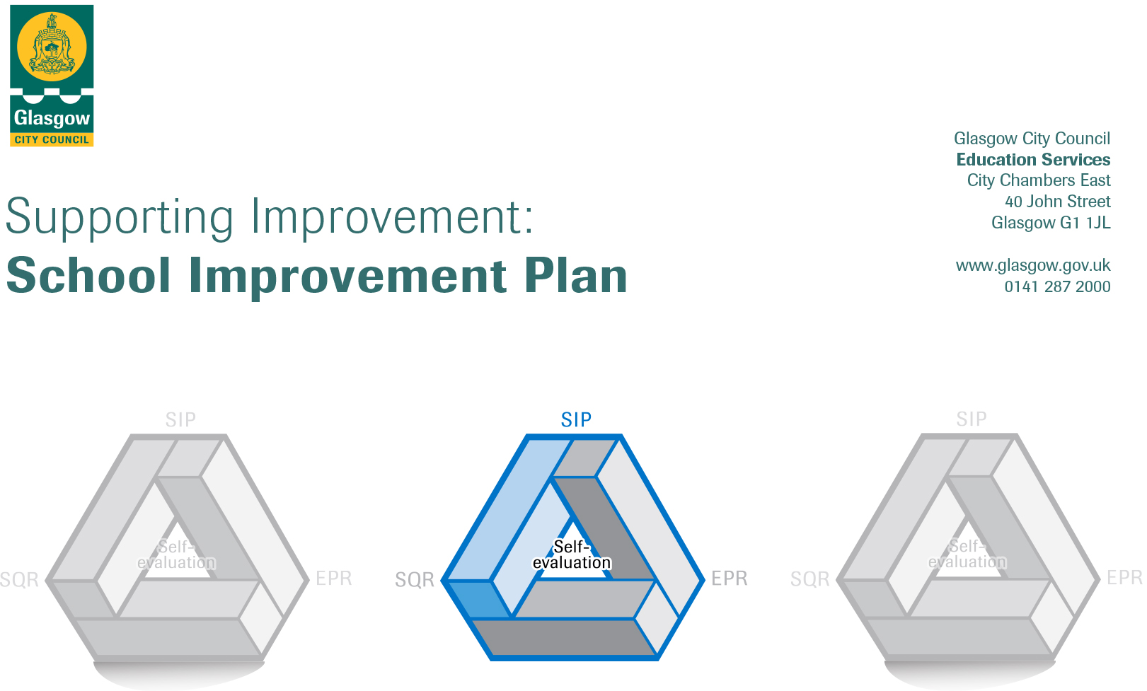

Establishment | Lourdes Secondary
Head of Establishment | Gerry McGuigan
Area/Local Improvement Group | South LIG 1
Head of Service | Donnie McLeod
Area Education Officer/Quality Improvement Officer

CONTENTS
1. Vision, Values and Aims
2. Summary of Self-Evaluation Process / Priorities for Improvement in the Current Session
3. Action Planning

Action Plan Summary for Stakeholders

1. Our Vision, Values and Aims
Vision
Lourdes Secondary is a community where the love of Christ directs our words, our actions and our relationships to reflect and promote School and Gospel Values.

We Value

Love

Opportunity

Understanding

Respect

Diversity

Equity

Support

Aims
Our school aims are straightforward. Our commitment to our pupils is that, like your parents and carers, we will:
- Love You
- Teach You
- Take Care of You

2. Summary of our self-evaluation process.
Strengths identified:
Full details relating to our self-evaluation findings can be found in our Education Perspective Report. A brief summary of identified strengths includes:
- A shared vision, values and aims based on Gospel Values which shapes our distinct Catholic identity
- A strong school culture of collegiality and collaboration among pupils, staff and parents
- Systems, structures and high expectations which facilitate high standards as we aim for excellence in all aspects of the work of the school
- High quality learning and teaching in classrooms across the school
- High quality support for learners focused on the team around the child
- An upward trend in improving outcomes, both academic and personal, for all learners

Priorities for development:
1: COVID Recovery

2: Continue to develop leadership capacity at all levels (Q.I 1.3)

3: Continue to improve the quality of Learning and Teaching (Q.I 2.3) & improve the attainment and achievement of all pupils (Q.I 3.2)

4: Continue to improve our work supporting pupils (Q.I 3.1)

5: Revisit our Curriculum Rationale focusing on curricular pathways (Q.I 2.2)

6: Ensure we have a programme of online learning available should we need to move to a model of blended learning (Q.I 2.2)

3. Action Planning

No. | Quality Indicators | Priority - Continue to develop leadership capacity at all levels
1 |  | COVID Recovery

Tasks to achieve priority | Timescale  and checkpoints | Evidence of Impact - (data, observation, views)
Restructure the whole-school timetable to minimise movement around the building while extending time in class to enable greater depth to learning | August 2021 – June 2022 | - Collegiate Working  - INSET Days  - Focus Groups  - Professional Dialogue  - Questionnaires  - CLPL/PRDs  - Classroom Visits  - Parent Council  - PT Meetings  - Whole School Meetings  - Year Group Assemblies  - Nurture CPD  - GWMP records  - JST minutes  - SIIM minutes  - Planning meeting minutes  - Information sharing (informal)  - Case conferences  - GIRFEC profiles  - Planned Learning  - Insight Data  - Reporting  - Parents’ Nights  - Prelim Scores and Prelim Review meetings  - Curriculum Reviews  - Moderation activities
Introduce timetabled Recovery Planning Periods (RPPs)
Identify lost learning through effective diagnostic assessment
Use data to identify pupils who require targeted interventions to support lost learning
Continue to support the mental and emotional wellbeing of pupils
Plan activities to facilitate greater opportunities for social interaction among pupils
Continue to employ the following PEF funded posts:
- PT Numeracy
- PT Parental Engagement
- Additional Counsellors
- PT Nurture
- Admin Support
- PT Development (Science)
Consider additional PEF funded posts to support recovery
Refocus on achieving excellence in Learning, Teaching and Assessment to support recovery of learning

Staff leading on this priority – including partners | Resources and staff development
- SLT  - PTCs  - PTPCs  - Class Teachers  - All support staff | - Professional Learning Time  - Whole-school and departmental collegiate time  - CLPL opportunities  - CLPL Budget  - PEF

No. | Quality Indicators | Priority - Continue to develop leadership capacity at all levels
2 | 1.3  1.1 | Leadership of Change  Self-Evaluation for Self-Improvement

Tasks to achieve priority | Timescale  and checkpoints | Evidence of Impact - (data, observation, views)
Continue to develop staff capacity and confidence in the use of Insight data. | August 2021 – June 2022 | - Collegiate Working  - INSET Days  - Focus Groups  - Professional Dialogue  - Questionnaires  - CLPL/PRDs  - Classroom Visits  - Parent Council  - PT Meetings  - Whole School Meetings  - Year Group Assemblies
Continue to use Professional Learning Periods for all staff to support research-based and evidence-led approaches to improving pedagogy.

Facilitate a planned programme to assist in the use of I-pads for all staff in preparation for “roll out” in 2020.

Increase opportunities for staff to develop leadership skills at all levels across the school.

Continue to develop and enhance partnerships with outside agencies.

Continue to develop our whole-school culture of positive engagement with self-evaluation leading to self-improvement.

Staff leading on this priority – including partners | Resources and staff development
- Insight – SLT & PTs  - Professional Learning – All staff  - I-pads – Digital Learning Strategy Team/ SLT  - Leadership roles- SLT/ PTs  - Partnerships – All staff | - Professional Learning Time  - Whole-school and departmental collegiate time  - CLPL opportunities  - CLPL Budget

No. | Quality Indicators | Priority - Continue to improve the quality of Learning and Teaching & improve the attainment  and achievement of all pupils
3 | 2.3  3.2 | Learning, Teaching and Assessment  Raising Attainment and Achievement

Tasks to achieve priority | Timescale  and checkpoints | Evidence of Impact - (data, observation, views)
Continue to develop and embed research-based classroom strategies as appropriate in all departments. | August 2021 – June 2022 | - Classroom Visits  - Pupil Questionnaires  - Focus Groups  - Professional Dialogue  - CLPL Programme/PRDs  - Self-Evaluation work  - Tracking Data  - SEEMIS Referrals  - PT Meetings  - Attainment Data  - Planned Learning  - Insight Data  - Reporting  - Parents’ Nights  - Prelim Scores and Prelim Review meetings  - Curriculum Reviews  - Moderation activities  - Number of pupils participating in activities outwith classrooms  - Wider Achievement Programmes and Award-Bearing courses  - Senior Options Programmes  - Awards Ceremonies  - Positive destination figures
Continue to develop and enhance further opportunities for parental engagement.

Further develop staff understanding and practice of moderation procedures.

Continue to develop opportunities for effective feedback to pupils and parents.
Raise the attainment and achievement of all pupils at all stages.
Enhance tracking and monitoring systems through the introduction of “On the Button”.

Review the use of PEF in closing the poverty-related attainment gap.

Staff leading on this priority – including partners | Resources and staff development
- PTCs  - SLT  - PT of Parental Engagement  - All staff | - Working Time Agreement  - Whole-School Collegiate and Departmental meetings  - CLPL as required  - Additional Parents Information Evenings  - INSIGHT/ BGE/ Pastoral reviews  - Opportunities for sharing best practice

No. | Quality Indicators | Priority - Continue to improve our work supporting pupils
4 | 2.1  2.4  2.5  2.6  3.1 | Safeguarding and Child protection  Personalised Support  Family Learning  Transitions  Improving Wellbeing, Equality and Inclusion

Tasks to achieve priority | Timescale  and checkpoints | Evidence of Impact > (data, observation, views)
Enhance the school’s approach to Nurture. | August 2021 – June 2022 | - Nurture CPD  - GWMP records  - JST minutes  - SIIM minutes  - Planning meeting minutes  - Information sharing (informal)  - Case conferences  - GIRFEC profiles  - Memorandum updates on young people  - School trips  - After school clubs  - School shows  - Faith celebrations  - Attendance at after school events  - Discipline / behaviour referrals  - PPR policy  - Round Robins  - Attendance statistics  - Wellbeing referrals  - Discipline / behaviour referrals  - Counselling referrals  - Evaluative questionnaires  - Observations  - Pupil Voice  - PTPC reviews  - Extended pupils support team meetings  - Personal support curricular content  - RE curriculum content  - PRD records  - SDS enhanced group work  - Positive destinations
Further develop staff understanding of trauma and resilience.
Enhance our whole school approach to GIRFEC by further developing partnerships with external agencies to improve outcomes for young people.

Increase opportunities to celebrate the achievements and successes of our pupils.
Develop pupil understanding of mental health, emotional well-being and resilience.
Complete a full review of Promoting Positive Relationships policy.
Continue to enhance transition programmes at all stages of the pupil journey.

Staff leading on this priority – including partners | Resources and staff development
- DHT – Pupil Support  - Extended Pastoral Support Team  - PT DYW  - PT Nurture  - Educational Psychologists  - Other 3rd sector organisations as appropriate  - PTs | - Meeting time  - Whole school collegiate time  - Awards Ceremonies  - Praise Cards/Letters  - Website/Twitter/Newsletters/Tannoy  - Funding for rewards as required  - CLPL as required  - Raise Awareness of policy among new members of staff

No. | Quality Indicator | Priority - Revisit our Curriculum Rationale focusing on curricular pathways
5/6 | 2.2 | Curriculum

Tasks to achieve priority | Timescale  and checkpoints | Evidence of Impact - (data, observation, views)
Pathways  - Increase opportunities for pupils to undertake Wider Achievement awards across the curriculum at all levels.  - Use data to direct pupils into the most appropriate curricular pathways | August 2021 – June 2022 | - Curricular Structures  - Planned Learning  - Classroom Visits  - Calendared Events (Eg. Health Day)  - Questionnaires  - Focus Groups  - Attendance and engagement in liturgical events  - Collegiate working  - INSET Days  - Professional Dialogue  - Whole-school meetings  - PT Meetings
Literacy
- Raise awareness of literacy as a responsibility of all
- Begin strategic planning by gathering evidence to develop a holistic picture of progress across this curricular area

Numeracy
- Raise awareness of numeracy as a responsibility of all
- Embed common methodologies and strategies across all curricular areas
Health and Well-Being
- Continue to have a consistent approach to GIRFEC across the school
- Continue to develop and improve our Personal Support curriculum
Digital Learning
- Support pupils, parents and staff in development of new digital learning strategies
- Ensure blended learning is available to pupils at all levels to allow for home learning to occur in the event of school closure/lockdown

Chaplaincy
- Promote and support faith life and Gospel values of the school

Staff leading on this priority – including partners | Resources and staff development
- SLT  - PT Maths and PT Numeracy  - PT English  - Digital Strategy Team  - DHT – Pupil Support and PTPCs  - PT RE and Chaplaincy Team | - CLPL as required  - Collegiate Time  - Funding as required

