

# Lourdes Secondary School

# School Improvement Plan 2022-23

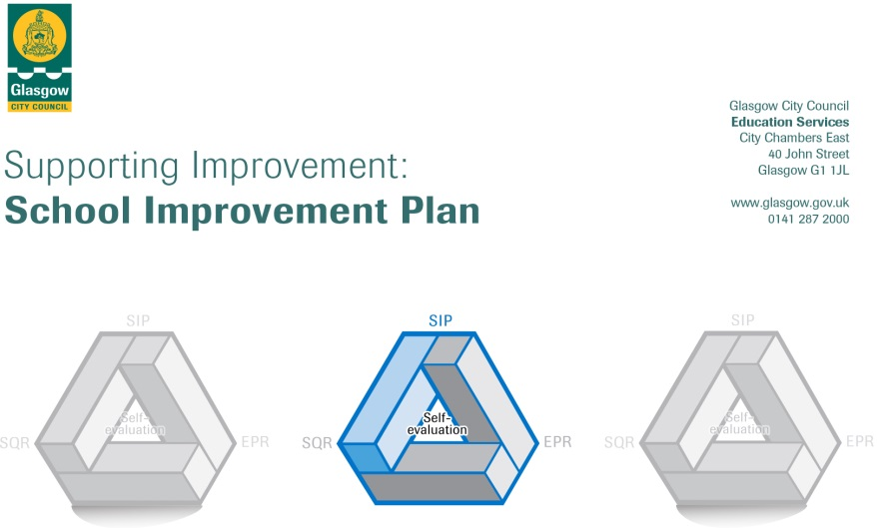

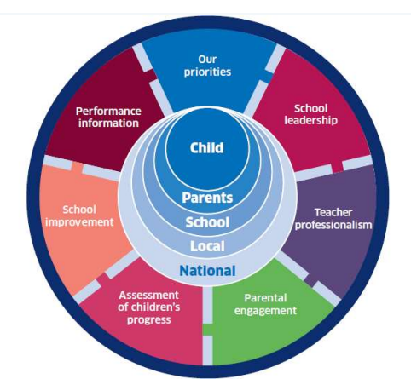 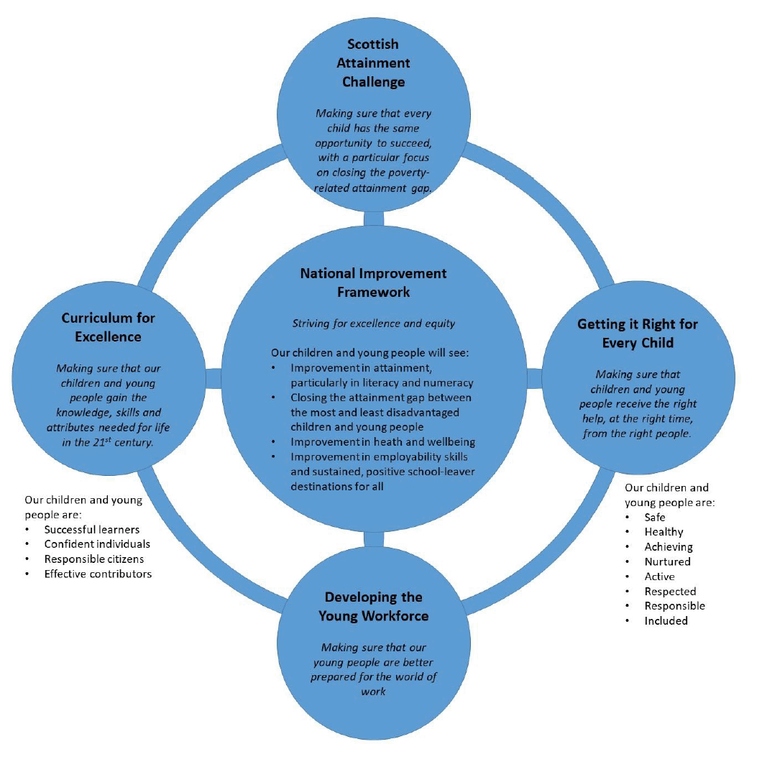

|  |  |
| --- | --- |
| Establishment | **Lourdes Secondary** |
| Head of Establishment | **Paul Monaghan** |
| Area/Local Improvement Group | South LIG 1 |
| Head of Service | Donnie McLeod |
| Area Education Officer/Quality Improvement Officer |  |

# CONTENTS

1. Vision, Values and Aims
2. Overview of Improvement Drive to ‘25

3. Summary of Self-Evaluation Process / Priorities for Improvement in the Current Session

4. Action Planning

# Vision

Lourdes Secondary is a community where the love of Christ directs our words, our actions and our relationships to reflect and promote School and Gospel Values.

Our commitment to our pupils is: **We will love, teach and care for you as your parents and carers do.**

**We Value**

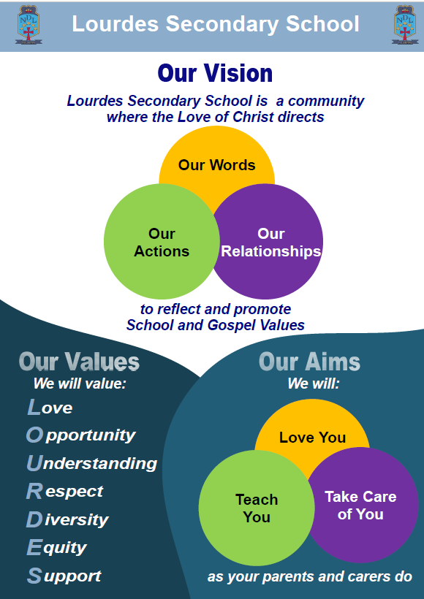**L**ove

**O**pportunity

**U**nderstanding

**R**espect

**D**iversity

**E**quity

**S**upport

**Aims**

Our aims for our pupils focus on two key areas:

· Improvements in Academic Outcomes

· Improvements in Personal Outcomes

# Improvement Drive to ‘25

# Overview of Improvement Drive to ‘25

|  |  |  |
| --- | --- | --- |
| **No** | **Improvement Area** | **Targets** |
| 1 | **Curriculum, Learning, Teaching and Assessment** | * Continue to improve the quality and consistency of Learning and Teaching (Q.I 2.3) & improve the attainment and achievement of all pupils (Q.I 3.2) * Review Curriculum Rationale focusing on curricular pathways (Q.I 2.2) * To further enhance our Professional Learning, developing informed teacher agency, empower teacher leadership of learning at all levels.(Q.I 1.3) | |
| 2 | **Ethos, Equity and Equality** | * Continue to develop Catholic ethos and chaplaincy, developing and embedding our faith across our school community. (Q.I 1.3) * To promote inclusion and support learners’ needs through the development and implementation of a programme of Nurture and the further development of our approach to Promoting Positive Relationships (Q.I 3.1) * Further development of parental engagement in their children’s learning and in the life of our school (Q.I 2.7) * Further development of Pupil voice and positive recognition to ensure all learners are empowered and included. (Q.I 1.2) * Continued improvements to targeted and universal support for our Pupils to ensure barriers to learning are removed. (Q.I 2.4) | |
| 3 | **Health and Wellbeing** | * Continue to improve targeted and universal support for our Pupils to ensure barriers to learning are removed. (Q.I 2.4) * Develop and deliver opportunities, which develop the spiritual wellbeing and faith of our Pupils (Q.I 1.3) * Increase opportunities for staff to develop leadership skills at all levels across the school. (Q.I 1.3) * Development of planning to ensure improved physical, mental, emotional and spiritual wellbeing of all (Q.I 3.1) | |
| 4 | **Learning for Sustainability** | * Develop planning and opportunities to develop Pupils for a changing world, building a more sustainable and equitable future for all.(Q.I 2.2) * Develop and embed Digital Strategy to develop Digital Innovation and Digital Literacy for all. (Q.I 3.3) | |

| 3. Summary of our self-evaluation process. |
| --- |
| Strengths identified: Full details relating to our self-evaluation findings can be found in our Education Perspective Report. A brief summary of identified strengths includes:   * A shared vision, values and aims based on Gospel Values which shapes our distinct Catholic identity * A strong school culture of collegiality and collaboration among pupils, staff and parents * Systems, structures and high expectations which facilitate high standards as we aim for excellence in all aspects of the work of the school * High quality learning and teaching in classrooms across the school * High quality support for learners focused on *the team around the child* * An upward trend in improving outcomes, both academic and personal, for all learners |
| **Priorities for development 2022-23:**  1: **Curriculum, Learning, Teaching and Assessment**   * Continue to improve the quality and consistency of Learning and Teaching (Q.I 2.3) & improve the attainment and achievement of all pupils (Q.I 3.2) * Review Curriculum Rationale focusing on curricular pathways (Q.I 2.2) * To further enhance our Professional Learning, developing informed teacher agency, empower teacher leadership of learning at all levels.(Q.I 1.3)   2: **Ethos, Equity and Equality**   * Continue to develop Catholic ethos and chaplaincy, developing and embedding our faith across our school community. (Q.I 1.3) * To promote inclusion and support learners’ needs through the development and implementation of a programme of Nurture and the further development of our approach to Promoting Positive Relationships (Q.I 3.1) * Further development of parental engagement in their children’s learning and in the life of our school (Q.I 2.7) * Further development of Pupil voice and positive recognition to ensure all learners are empowered and included. (Q.I 1.2) * Continued improvements to targeted and universal support for our Pupils to ensure barriers to learning are removed. (Q.I 2.4)   3: **Health and Wellbeing**   * Continue to improve targeted and universal support for our Pupils to ensure barriers to learning are removed. (Q.I 2.4) * Develop and deliver opportunities, which develop the spiritual wellbeing and faith of our Pupils (Q.I 1.3) * Increase opportunities for staff to develop leadership skills at all levels across the school. (Q.I 1.3) * Development of planning to ensure improved physical, mental, emotional and spiritual wellbeing of all (Q.I 3.1)   4: **Learning for Sustainability**   * Develop planning and opportunities to develop Pupils for a changing world, building a more sustainable and equitable future for all.(Q.I 2.2) * Develop and embed Digital Strategy to develop Digital Innovation and Digital Literacy for all. (Q.I 3.3) |

|  |
| --- |
| 4. Improvement Planning 2022-23 |

# Improvement Area 1

|  |  |  |
| --- | --- | --- |
| **NIF** | **Quality Indicators** | **Priority - Curriculum, Learning, Teaching and Assessment** |
|  | **1.3**  **2.2**  **2.3**  **3.2** | Leadership of change  Curriculum  Learning, teaching & assessment  Raising attainment & Achievement |
| * Continue to improve the quality and consistency of Learning and Teaching (Q.I 2.3) * To further enhance our Professional Learning, developing informed teacher agency, empower teacher leadership of learning at all levels.(Q.I 1.3) * Review Curriculum Rationale focusing on curricular pathways (Q.I 2.2) * Continue improve the attainment and achievement of all pupils (Q.I 3.2) | | |

|  |  |  |  |  |
| --- | --- | --- | --- | --- |
| **Tasks to achieve 2022-23** | **Resources required** | **Staff development requirements** | **Staff leading on this priority** | **Evidence of impact/progress** |
| **Continue to use Professional Learning Periods for all staff to support research and evidence based approaches to improving pedagogy.** | PLP Periods | PL Resources  CLPL Funds | DHT L&T & PTCs | * Attainment Data * Awards Ceremonies * Classroom Visits * CLPL Programme/PRDs * CLT&A Leads for each PL Strand * Collegiate Working * Core materials and timeline of meetings/events for each strand * Curriculum Reviews * Delivery of taster sessions * Department return identifying PL strand * Departmental and Staff feedback to CLT&A Group * Departmental meeting minutes * Evaluation of taster sessions * Focus Groups * Insight Data * Moderation activities * Number of pupils participating in activities out with classrooms * Parents’ Nights * Planned Learning * Planning meeting minutes * Positive destination figures * Prelim Scores and Prelim Review meetings * Professional Dialogue * PT Meetings * Pupil Questionnaires * Qualitative - (survey responses, staff and pupil focus groups) * Quantitative – (attainment data the following session/s) * Reporting * SEEMIS Referrals * Self-Evaluation work * Senior Options Programmes * Tracking Data * Wider Achievement Programmes and Award-Bearing courses |
| **Continue to develop and embed research-based classroom strategies as appropriate in all departments** | PLP Periods  Collegiate  Outline of LT&A Strategy  Articles/Texts  Staff (PTCs & LT&A group members) | Professional Reading  PL Resources  CLPL Funds | DHT L&T & PTCs |
| **Liaise with departments to identify staff to support/lead professional learning for L&T** | School staff & time  Collegiate time (and launch event documentation) | - | DHT L&T; PTCs; CLT&A group members |
| **Develop PL outlines for each PL Strand** | Time/collegiate support/curated materials as appropriate to strand | Professional reading on what makes effective PL.  Strand-specific PL & on-going support for lead staff as appropriate | DHT L&T; PTCs; CLT&A Leads |
| **Plan and host the LT&A Launch Event which will include taster sessions for each strand** | In-Service  Meeting space for all staff; food/drink/concise documentation outlining the PL offer | - | DHT L&T; PTCs; CLT&A Leads |
| **Staff consultation on departmental pathways and skills reviews** | Collegiate time | Professional Reading  Business Meetings | DHT Pathways; DHT L&T PTCs; CLT&A group members |
| **Consultation with parents, pupils and staff on changes to timetable rationale and timetable design** | Pupil Council Meetings  Focus Group  Survey  Collegiate time | - | DHT Pathways; DHT L&T PTCs; CLT&A group members |
| **Review curriculum and plan visits to identified schools to further develop understanding of curricular pathways** | Staff and time (Collegiate) | CLT&A Group - Visits to other schools | DHT Pathways; DHT L&T; PTCs; CLT&A group members |
| **Further develop staff understanding and practice of moderation procedures.** | Professional Learning Time  Whole-school and departmental collegiate time | GCC Moderation Procedures  SQA Understanding Standards  Education Scotland | DHT L&T; DHT RA&A; PTC |
| **Raise the attainment and achievement of all pupils at all stages.** | Professional Learning Time  Whole-school and departmental collegiate time | Professional Reading  PL Resources  CLPL Funds | DHT L&T; DHT RA&A; PTC |
| **Continue to fund PEF PTs focused on raising attainment and achievement** | Staff  Planning Meetings | - | DHT PS; DHT RA&A, DHT Parental Engagement; DHT Learning Pathways; PT Numeracy; PT Literacy; PT Parental Engagement; PT Reengagement; PT Digital Strategy; PT Development (Science); PT Recovery; PT Nurture |

# Improvement Area 2

|  |  |  |
| --- | --- | --- |
| **NIF** | **Quality Indicators** | **Priority - Ethos, Equity and Equality** |
|  | **1.2**  **1.3**  **2.1**  **2.4**  **2.6**  **2.7**  **3.1** | Leadership of Learning  Leadership of Change  Safeguarding and Child protection  Personalised Support  Transitions  Partnerships  Ensuring wellbeing, equality and inclusion |
| * Further development of Pupil voice and positive recognition to ensure all learners are empowered and included. (Q.I 1.2) * Continue to develop Catholic ethos and chaplaincy, developing and embedding our faith across our school community. (Q.I 1.3) * Continued improvements to targeted and universal support for our Pupils to ensure barriers to learning are removed. (Q.I 2.4) * Further development of parental engagement in their children’s learning and in the life of our school (Q.I 2.7) * To promote inclusion and support learners’ needs through the development and implementation of a programme of Nurture and the further development of our approach to Promoting Positive Relationships (Q.I 3.1) | | |

|  |  |  |  |  |
| --- | --- | --- | --- | --- |
| **Tasks to achieve priorities** | **Resources required** | **Staff development requirements** | **Staff leading on this priority** | **Evidence of impact/progress** |
| **Celebration of events within liturgical calendar, developing opportunities to enrich the Catholic Ethos of our school** | Planning meeting  Funding for events/resources  Links with parishes and wider agencies | - | DHT L&T, PT RE; Chaplaincy team; EE&E Group; School Chaplin | * Attainment Data * Attendance at after school events * Attendance statistics * Awards Ceremonies * Case conferences * Classroom Visits * CLPL Programme/PRDs * Counselling referrals * Curriculum Reviews * Discipline / behaviour referrals * Evaluative questionnaires * Extended pupils support team meetings * Faith celebrations * Focus Groups * GIRFEC profiles * GWMP records * Information sharing (informal) * Insight Data * JST minutes * Memorandum updates on young people * Moderation activities * Number of pupils participating in activities out with classrooms * Nurture CPD * Observations * Parents’ Nights * Personal support curricular content * Planned Learning * Planning meeting minutes * Positive destination figures * PPR policy * PRD records * Prelim Scores and Prelim Review meetings * Professional Dialogue * PTC Meetings * PTPC reviews * Pupil Questionnaires * Pupil Voice * RE curriculum content * School shows * School trips * SDS enhanced group work * SEEMIS Referrals * Self-Evaluation work * Senior Options Programmes * SIIM minutes * Tracking Data * Wellbeing referrals * Wider Achievement Programmes and Award-Bearing courses |
| **Development of opportunities for celebrating faith across our school community** | Planning Meetings  Parental Engagement  Focus Groups  External Partners | - | DHT L&T, PT RE; Chaplaincy team; EE&E Group; School Chaplin |
| **Development of Youth Chaplaincy Team** | Pupil Meetings | - | DHT L&T, PT RE; Chaplaincy team; School Chaplain |
| **Training in building and maintaining positive relationships** | Staff and time (Collegiate)  Professional reading | Training for PPR group | PPR Group + |
| **Training in Nurture Principles** | Staff and time (Collegiate)  Professional reading | Training for PPR group | PPR Group + K McBride |
| **Training in dealing with Anger, Trauma, Resilience and De-escalation in Young People** | Staff and time (Collegiate)  Professional reading | Training for PPR group | PPR Group + |
| **Consistent approach to start of lessons** | Whole school staff and time | Collegiate time | PPR Group |
| **Develop resources through PSE to ensure that all pupils know the Pupil Support Team and how to seek help when required** | Staff and time (Collegiate) | - | DHT PS, PTPC & PSL |
| **Expand the work of the Equalities Working Group** | Pupil Meetings  Equalities Working group  Collegiate time | PL Equalities Training | DHT PS & Equalities Working Group |
| **Use data to identify pupils who require targeted interventions to support lost learning** | Data  Staff  Planning meetings | - | DHT PS; PTPC; PT Reengagement &  PT ASN |
| **Continue to develop opportunities for effective feedback and partnership working with parents.** | Pupil and Parent Focus Groups & Surveys | - | DHT Parental Engagement; PTPC; PT Parental Engagement |
| **Develop opportunities to develop pupil voice and celebrate pupil achievement** | Pupil Meetings  Planning Meetings  Collegiate time | - | DHT PS, PTPC, PTC |

# Improvement Area 3

|  |  |  |
| --- | --- | --- |
| **NIF** | **Quality Indicators** | **Priority - Health and Wellbeing** |
|  | **1.3**  **2.4**  **2.6**  **3.1** | Leadership of Change  Personalised Support  Improving Wellbeing, Equality and Inclusion  Ensuring wellbeing, equality and inclusion |
| * Continue to improve targeted and universal support for our Pupils to ensure barriers to learning are removed. (Q.I 2.4) * Plan and deliver opportunities, which develop the spiritual faith and wellbeing of our Pupils (Q.I 1.3) * Development of planning to ensure improved physical, mental, emotional and spiritual wellbeing of all (Q.I 3.1) * Increase opportunities for staff to develop leadership skills at all levels across the school. (Q.I 1.3) | | |

|  |  |  |  |  |
| --- | --- | --- | --- | --- |
| **Tasks to achieve 2022-23** | **Resources required** | **Staff development requirements** | **Staff leading on this priority** | **Evidence of impact/progress** |
| **Continue to build relationships with external partners including 3rd Sector organisations** | Planning Meetings | - | DHT PS; extended Pastoral Support Team; PT DYW; PT Nurture; Educational Psychologists; Other 3rd sector organisations as appropriate | * After school clubs * Attendance at after school events * Attendance statistics * Case conferences * Counselling referrals * Discipline / behaviour referrals * Evaluative questionnaires * Extended pupils support team meetings * Faith celebrations * GIRFEC profiles * GWMP records * Information sharing (informal) * JST minutes * Memorandum updates on young people * Nurture CPD * Observations * Personal support curricular content * Planning meeting minutes * Positive destinations * PPR policy * PRD records * PTPC reviews * Pupil Voice * RE curriculum content * School shows * School trips * SDS enhanced group work * SIIM minutes * Wellbeing referrals |
| **Continue to create opportunities for learning beyond the classroom to support social development** | Planning Meetings  Pupil Council Meetings  Focus Groups | - | DHT PS; PTPC; PTC;HWB Group |
| **Developing faith celebrated and faith in action** | Planning Meetings  Pupil Council Meetings  Focus Groups | - | DHT L&T, PT RE; Chaplaincy team; School Chaplin |
| **Develop opportunities to Serve the Common Good, developing Catholic Social Teaching and promoting social justice** | Planning Meetings  Pupil Council Meetings  Focus Groups | - | DHT L&T, PT RE; Chaplaincy team; Youth Chaplaincy Team; School Chaplin |
| **Co-ordination of extra-curricular activities with a focus on physical, emotional and mental wellbeing** | Staff and time (Collegiate)  HWB Group Planning Meeting | - | DHT S1/2; PTPC, PTC |
| **Developing policy and culture to ensure all stakeholders equipped with the tools required to support their physical, emotional, mental health and wellbeing.** | HWB Group Planning Meeting | Mental Health First Aid Training | DHT PS; HWB Group |
| **Increase opportunities for staff to develop leadership skills at all levels across the school.** | Staff and time (collegiate)  PL Opportunities | School Improvement Groups  Pupil Support Leaders  CLPL Funds  CLPL Programmes | HT, DHT L&T, PTPC, PTC, PT PEF |

# Improvement Area 4

|  |  |  |
| --- | --- | --- |
| **NIF** | **Quality Indicators** | **Priority – Learning for Sustainability** |
|  | **2.2**  **3.3** | Curriculum  Increasing creativity & employability |
| * Develop planning and opportunities to develop Pupils for a changing world, building a more sustainable and equitable future for all.(Q.I 2.2) * Develop and embed Digital Strategy to develop Digital Innovation and Digital Literacy for all. (Q.I 3.3) | | |

|  |  |  |  |  |
| --- | --- | --- | --- | --- |
| **Tasks to achieve 2022-23** | **Resources required** | **Staff development requirements** | **Staff leading on this priority** | **Evidence of impact/progress** |
| **Reviewing curriculum & policy to ensure every learner receives their entitlement to learning for sustainability** | Planning Meetings  Planned Learning  Departmental links | Sustainability CLPL | DHT Pathways; PTCs; LfS Group | Curricular Structures  Planned Learning  Classroom Visits  Calendared Events (Eg. Health Day)  Questionnaires  Focus Groups  Collegiate working  INSET Days  Professional Dialogue  Whole-school meetings  PT Meetings  LfS Policy  LfS Planning  Digital Strategy group Minutes  LfS Group Minutes |
| **Developing planning & policy to create**  **coherent whole school and learning community approach to Learning for Sustainability** | Planning Meetings  Planned Learning  Departmental links | Sustainability CLPL | DHT Pathways; Departmental Links; LfS Group |
| **Reviewing practice and environment to plan for improvements in sustainability across our school community.** | Planning Meetings | Sustainability CLPL | DHT Pathways; Departmental Links; LfS Group |
| **Continue to explore appropriate progression pathways and destinations for all learners** | Staff and time (Collegiate) | - | DHT Pathways; DHT L&T PTCs; CLT&A Group; LfS Group; PT DYW; 16+ Team |
| **Further development of Pupil Digital Literacy through Digital Learning Day and Safer Internet Month** | Digital Strategy Group Planning Meetings | - | DHT RA&A; PT Digital Strategy; Digital Strategy Group |
| **Continue programme of Staff training workshops to develop digital capacity** | Digital Strategy Group Planning Meetings  Collegiate Time | Training through the Digital Strategy Group | DHT RA&A; PT Digital Strategy; Digital Strategy Group |
| **Review digital policies and processes such as mobile phone/iPad, new pupil enrolment, pupil leaving and leave of absence** | Digital Strategy Group Planning Meetings | - | DHT RA&A; PT Digital Strategy; Digital Strategy Group |
| **Achieving Digital Wellbeing Award** | Digital Strategy Group Planning Meetings |  | DHT RA&A; PT Digital Strategy; Digital Strategy Group |