|  |  |
| --- | --- |
| Supporting wellbeing |  |
|  |  |

|  |
| --- |
| Useful numbers, information and signposting for young people, parents and carers |

# Food

☎️ If you can’t access food, for whatever reason, help is available. You can phone the national helpline on 0800 111 4000. The Scottish Government has set this up to provide help to those in high risk groups who don’t have a network of support.

**Food support at Lourdes**

We know that for a range of reasons, including shielding families and those who are self-isolating as well as financial circumstances created by the Covid 19 crisis, many in the Lourdes community may require support at some point over the coming weeks. If you require a weekly delivery of food from the school and do not currently receive one, please text your details including name, address, post code, number in family and any other relevant information to 07725337686. This information will be treated confidentially, and you will receive a delivery of essential shopping to your door.

## ☎️**Energy Suppliers**

If you are experiencing difficulty with bills or have worries about anything related , the major energy suppliers have set up help lines . You will be able to speak with someone who can support you with this.

The energy provider phone numbers are as follows:

Energy Helpline : 0800 9903503

British Gas: 0333 202 9802

EDF: 0333 200 5100

E. On : 0345 O52 0000

Money Matters: 0141 445 5221

NPower: 0800 073 3000

Scottish Power: O800027 0072. SSE : O345 026 2658

## **Young Carers**

If someone is being cared for within your household then the young people in the family may be entitled to be registered as Young Carers. They will then have access to a range of supports including grants and other financial support.

Newly identified Young Carers can now simply self-refer online at : <https://glasgow.gov.uk/article/25856/Carers-Self-Referral>

However, you can still call the Carers Information Line 0141 353 6504 for further information.

**Social, Emotional and Mental Wellbeing**

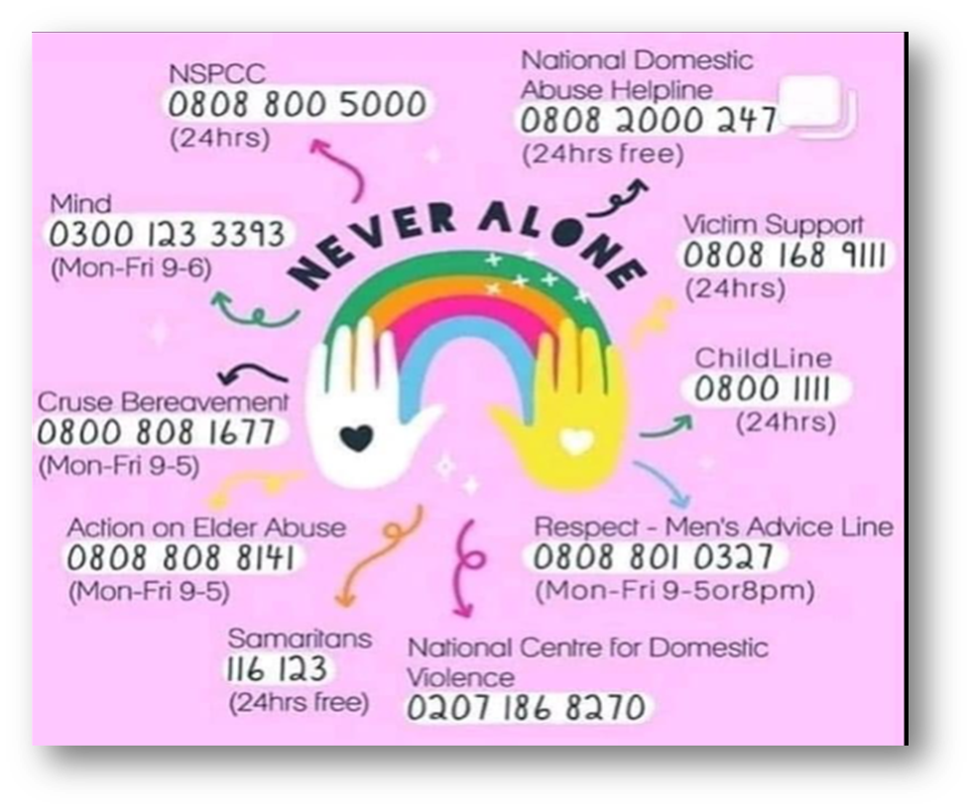

**Key websites and helplines to support your mental health and wellbeing**

You may be worried about yourself and your family and how you can look after your mental health at this time. It’s normal to feel stressed, scared, confused and even angry during these times. If you or a family member have any of those feelings, only get information and advice from credible and reliable sources. There is lots of support available from a range of organisations. Don’t cope alone!

**Childline : 0800 1111**

**Samaritans :** The Samaritans are here to listen to any problems or worries. They can listen if you are worried about someone else. You can talk freely to someone you don’t know.

Phone : 116-123 Email : jo@samaritans.org. ( this won’t be an immediate response)

**Worried about Corona Virus?**

* NHS Inform will give you all the advice you need to keep yourself safe. [www.nhsinform.scot/coronavirus](http://www.nhsinform.scot/coronavirus)

**Worried about the wellbeing of a family member?**

* You can find a range of NHS Trusted Mental Health and Wellbeing Apps here: <https://www.nhs.uk/apps-library/category/mental-health/>
* **Pregnant and new parents**: [www.parentclub.scot](http://www.parentclub.scot)
* Cardinal Winning Pro-Life for practical support in a crisis pregnancy -0141 422 2634
* **Children and Young People:** Young Minds [www.youngminds.org.uk](http://www.youngminds.org.uk)
* **Parent helpline;** 08088025544 NSPCC [https://www.nspcc.org.uk/keeping-children-safe/childrens-mental-health/depression- anxiety-mental-health/](https://www.nspcc.org.uk/keeping-children-safe/childrens-mental-health/depression-%20anxiety-mental-health/)
* **Mental Wellbeing** and COVID-19 - SAMH – [www.samh.org.uk](http://www.samh.org.uk)
* How to look after your mental health – [www.mentalhealth.org.uk](http://www.mentalhealth.org.uk) General Anxiety: [www.anxietyuk.org.uk](http://www.anxietyuk.org.uk) Text service 07537416905
* **Domestic Abuse** - For anyone needing support for domestic abuse as well as family members, this is a confidential, sensitive service for anyone to call. You can speak to a professional in your preferred language: 08000271234 or email [helpline@sdafmh.org.uk](mailto:helpline@sdafmh.org.uk)
* **Bereavement** – [www.cruse.org.uk](http://www.cruse.org.uk) helpline and listening support.
* Family bereavement centre provides counselling free of charge by anyone affected by the death of a child - [www.lauracentre.org](http://www.lauracentre.org)
* For a wide range of organisations dealing with Bereavement please see [www.supportline.org.uk](http://www.supportline.org.uk)
* **Loneliness** – loneliness has many different causes and can affect people of all ages. <https://www.mind.org.uk/information-support/tips-for-everyday-living/loneliness/about-loneliness/>
* **Self-Harm;** [https://www.mind.org.uk/information-support/types-of-mental-health-problems/self- harm/about-self-harm/](https://www.mind.org.uk/information-support/types-of-mental-health-problems/self-%20harm/about-self-harm/)
* **Suicidal thoughts; Samaritans telephone 116 123 lines open 24 hours, Breathing Space, 0800 83 85 87 lines open 24 hours at weekends. Do you need help now? If so dial 999 right away** –**Don’t Cope Alone!**

**Useful Emergency Numbers:**

Our school chaplain, Canon David Wallace : [ollourdes@rcag.org.uk](mailto:ollourdes@rcag.org.uk)

Cardinal Winning Pro-Life for support in a crisis pregnancy -0141 422 2634

**Downloadable self- help** booklets including some produced by CAMHS (Child and Adolescent Mental Health Services)

<https://www.mentalhealth.org.uk/>

<https://www.camhs-resources.co.uk/downloads>

**Remember – you are not alone!**