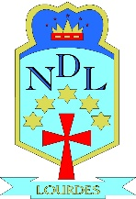

**Plan for S7 Open Evening**

**Thursday 8 November 2018**

**Parents/Carer will be divided into 4 groups:**

**Blue, Yellow, Green, Red**

|  |  |  |  |
| --- | --- | --- | --- |
| **Group** | **7:00 to 7:40pm** | **7:40 to 8:20pm** | **8:20 to 9:00pm** |
| St Monica’s Primary  St George’s Primary | Workshop 1 | Workshop 2 | Concert Hall |
| St Constantine’s Primary  St Saviour’s Primary | Workshop 2 | Workshop 3 | Concert Hall |
| OLOR Primary  St Marnock’s Primary | Workshop 2 | Concert Hall | Workshop 1 |
| Lourdes Primary  P7 pupils outwith the LC community | Concert Hall | Workshop 1 | Workshop 2 |