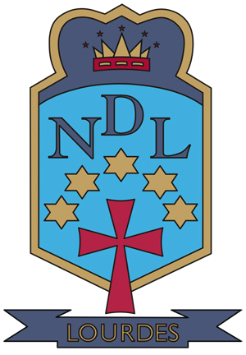


Summer Newsletter

June 2016

Summer Greetings

Dear Parent/Carer

This has been another successful year in Lourdes Secondary. As you will see from the many stories in the newsletter it has been a busy term to end a busy year. I am delighted to hear from feedback that our newsletters are very much enjoyed by parents and are giving you a real insight into the life of our school community. I am sure you will really enjoy this summer 2016 edition.

Our recent S1, S2 and S3 Award Ceremonies gave us a wonderful opportunity to celebrate all the learning, the many gifts, talents and the wide range of achievements demonstrated by our young people in those year groups. On each occasion our Concert Hall was full to capacity with happy students and proud parents. Congratulations to every pupil who received an award to celebrate your success! We are very proud of you all. Our website contains photographs taken at these events

https://blogs.glowscotland.org.uk/gc/LourdesSecondarySchool/

I would like to thank all parents for their support in maintaining a high standard of uniform across all year groups. Our uniform is an important symbol of the school in the wider community and the many favourable comments received from local residents is a clear indication that the smart appearance of our young people is highly regarded. I ask that you ensure that your child returns to school in August 2016 in full school uniform – shirt, tie, dress trousers or dress skirt, black shoes or completely black trainers and a blazer. Denims, leggings or any type of jeans should not be worn.

Trips to London and Blackpool have taken place during these last two weeks of term and the pupils have enjoyed themselves immensely. Our Sixth Year Prom took place on Friday 17 June 2016 in the Crowne Plaza hotel and our pupils were a credit to themselves and their families. The Graduation Mass took place on Tuesday 21 June and this provided a fitting opportunity for our school community to say goodbye to our Sixth Year pupils and to pass on our very best wishes for the future.

As we start to look forward to well-deserved holidays our S4-S6 pupils – and their parents – will soon be thinking about SQA results arriving in August. We will be opening the school on Wednesday 10 August to any returning Fifth and Sixth year pupil who wishes to review their curriculum options in light of their exam result. Details of this will be provided later this week on our website. Please note that the return date for all pupils is Monday 15 August 2016.

On behalf of all the staff in Lourdes I would like to wish all of our students the very best of luck and hope that they achieve results which will allow them to continue to build a positive future. I am looking forward to lots of positive news and well deserved awards for young people who have worked very hard.

May I wish you, and your families, an enjoyable summer and restful holiday.

With best wishes

Gerry McGuigan

Lourdes Secondary School 47 Kirriemuir Avenue Cardonald Glasgow G52 3DF
T: 0141 582 0180 F:0141 582 0181 W: www.lourdes-sec.glasgow.sch.uk



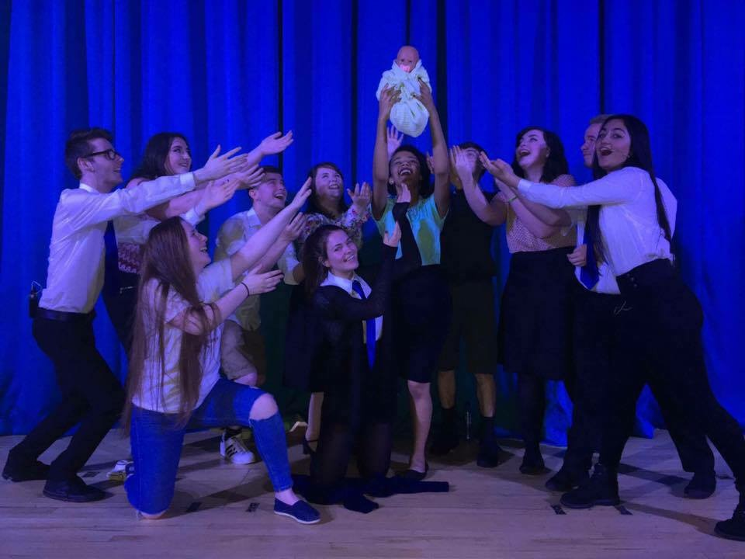

Blood Brothers

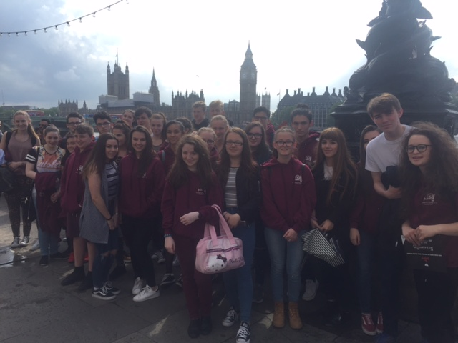
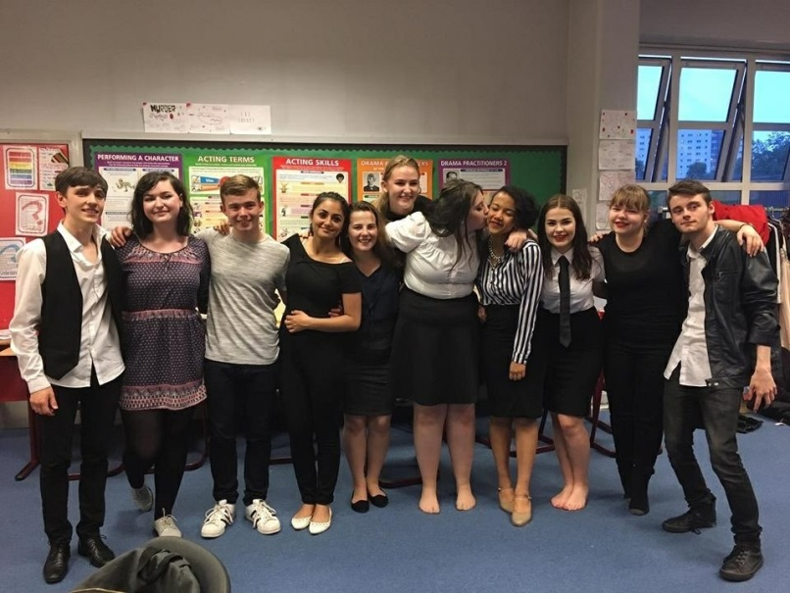
On Wednesday the 15th June 34 pupils and 4 members of staff headed off by coach for the annual Performing Arts trip to London. They spent 2 nights and three days exploring the capital and participating in exciting activities that helped to support their education in the Creative Industries. On the Itinerary was a trip to the Making of Harry Potter Studio Tour, a drama workshop with two West End actors, the London Dungeons (where everyone was really brave… NOT!!) and the fantastic opportunity to see professional actors at work in two West End shows; Charlie and The Chocolate Factory and The Curious Incident of The Dog in the Night Time. Everyone involved had a wonderful time in London and we returned safely to Lourdes (if not a little exhausted) in the early hours of Saturday Morning. All S3-S6 pupils should keep an eye out for detail of next year’s trip in August. A massive thank you from all pupils on this year’s trip to Miss Wilcock for organising such a wonderful experience.

From 8th – 10th June Lourdes Secondary presented the play Blood Brothers. This was not the usual Performing Arts Department production as there were NO teachers involved in the whole process!
This was the brainchild of Scott Callaghan and Robbie McEwan who had asked Mrs MacVicar if they could produce and direct a final show before they left Lourdes. So off they went and did exactly that!
The cast…
Scott Callaghan, Robbie McEwan, Beth Johnston, Hollie Feeney, Sabrina Mandulu, Jennifer Finn, Brid Gallagher, Hannah McLeod, Aya Cetinkaya, Jordan Harte, Keiran McKenzie
The crew/stage/sound management…
Hannah O’Sullivan and Eileen O’Sullivan were helped by Emily Harley and Vlada Shumko.

The production performed for three evenings to very appreciative audiences who gave standing ovations each night! The whole cast were a credit to themselves and the school and displayed the tremendous skills that they have developed through their experiences in Lourdes, especially the Performing Arts Department.

London Trip



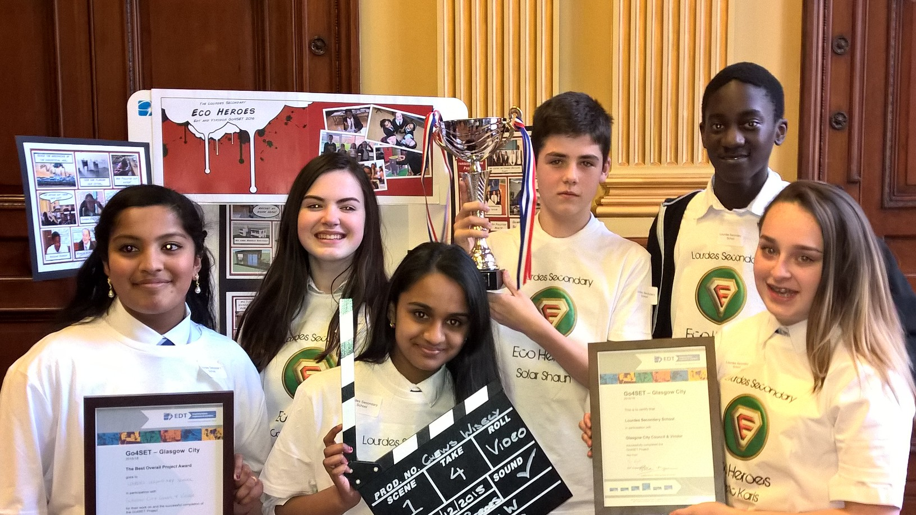
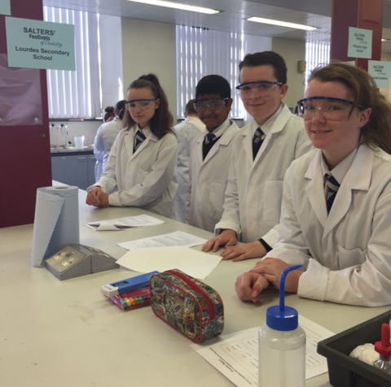
Go4SET

This year 6 of our S2 pupils took part in a 12 week National Engineering Challenge which saw them compete against over 100 other schools from around the country. The group were tasked with designing and making their own Eco Classroom. The pupils wrote a report, build a model and presented their idea at the Glasgow City Chambers at the beginning of June. The teams stellar work clearly paid off as they were crowned Glasgow Champions and placed top 10 in Scotland. The amazing pupils involved were:
- Shaun Harley
- Merlin Kunjumon
- Jovana Joseph
- Nassor Salim
- Karis Carvill
- Cara Brooks

Salter Chemistry Festival

At the end of May 4 of our S1 pupils visited Glasgow University for the day to take part in the Salter Chemistry Festival. The pupils were put through their paces as they competed in Chemistry based challenges and activities all day against 19 other schools from Glasgow and the West. Their teamwork, problem solving and STEM skills were put to the test and the pupils placed 3rd! The pupils who took part were:
- Jack Donnelly
- Joel Soul
- Jennifer Ward
- Kathleen Burns

Engineering Summer School

This year three of our S3 pupils have secured a place at the prestigious Strathclyde University Engineering Summer School for girls. Amani Younis, Charlotte Fraser and Julia May Ramos were chosen over of 100's of applications from all over Scotland and will spend a week at the University honing their engineering skills through a series of challenges and activities. This is an amazing achievement and we wish the girls the very best of luck!

STEM Club of the Year

The Lourdes Secondary STEM club has only been running for 1 year but the club has achieved so much in such little time. Events have been run for pupils in S1 all the way through to S4 and mentoring opportunities have been available for our senior pupils. The club have competed in one off events, science festivals, in school activities, National and even International competitions. The efforts of the team were recognised by Young Engineers and Science Clubs Scotland and were nominated for this year Scottish STEM Club of the year!

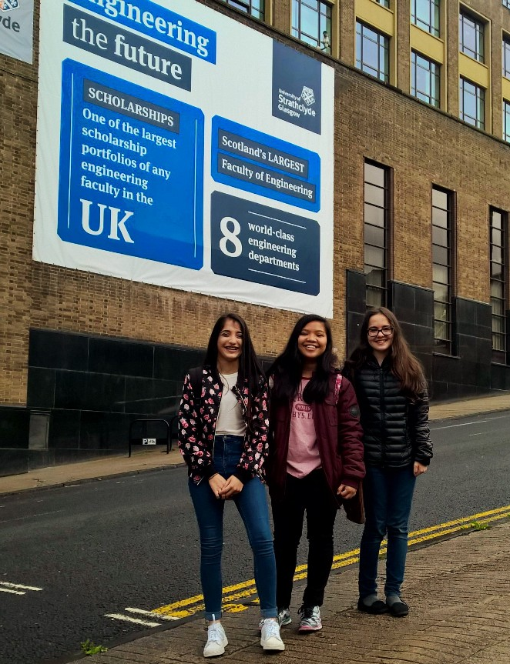

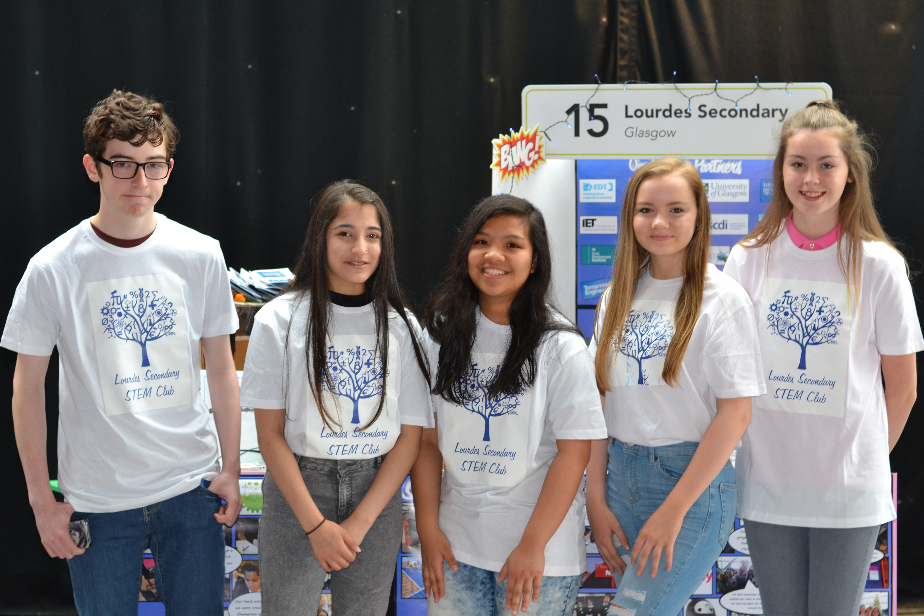


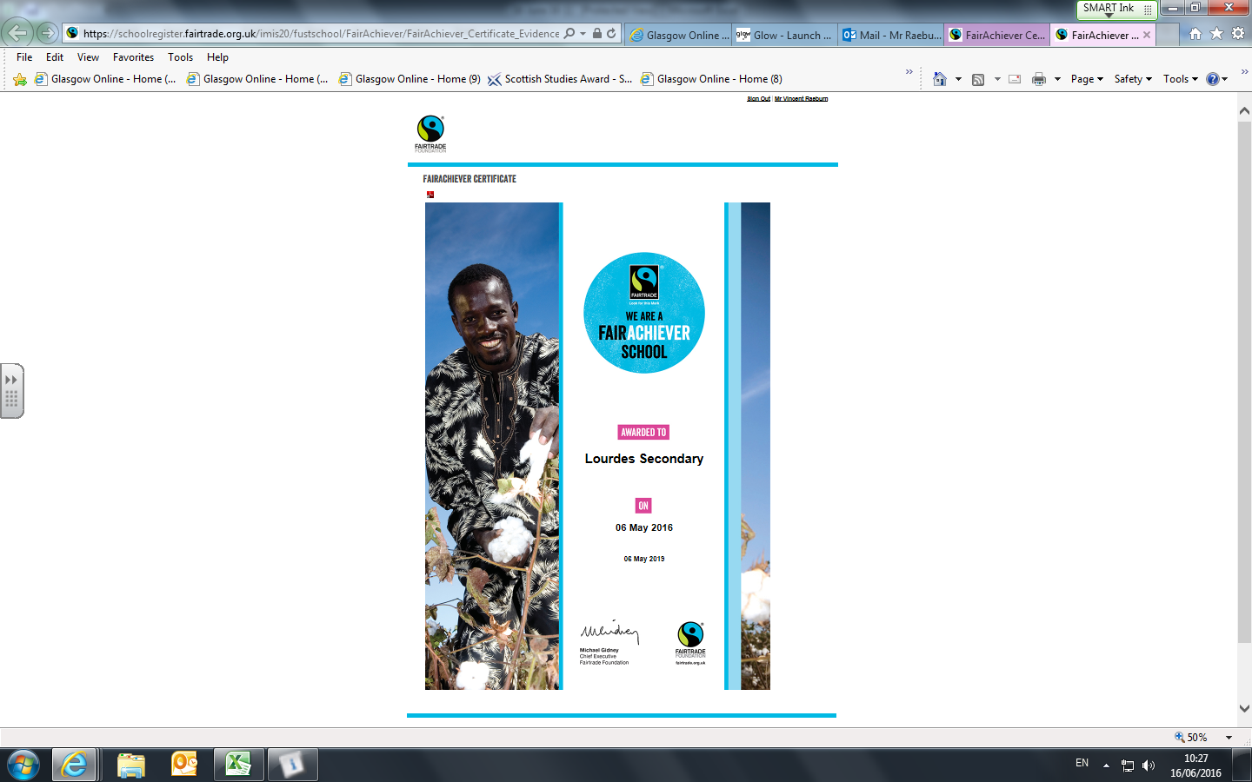
The school was successful in its recent submission of evidence to the Fairtrade Foundation and Lourdes Secondary has now retained its status as a Fairtrade School, with the next renewal due in May 2019. This latest renewal comes 10 years after we became the first school in Glasgow to have gained this achievement.
Many thanks to those pupils, staff, parents and Fairtrade partners in the community who have helped to make this possible through their support.
Lourdes Secondary was presented with a third green flag by Eco Schools Scotland in June 2014, having gained the first flag in April 2008 . . . we are only the second secondary school in Glasgow to reach this milestone. Evidence to support another flag will be required in a year’s time.
These two whole school initiatives are excellent examples of demonstrating Global Citizenship and Learning for Sustainability, two key aspects of Scottish education in the 21st century.
I have taken great satisfaction and enjoyment from leading these projects over the past 11 years and as I am retiring this summer, I am hopeful that this legacy can continue.

Vincent Raeburn

Within the Business Education and Computing Science department we have recently introduced Micro-bit technology into the classroom and the pupils have responded positively to this. A Micro-bit is a new piece of technology created and supplied by the BBC and its purpose is to get pupils in S2 more actively involved in Computer programming. The Micro-bit allows pupils to create fun and interactive programs, giving them a taste of what it would be like to choose a career path in programming.

BECS Microbits

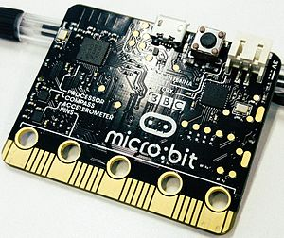
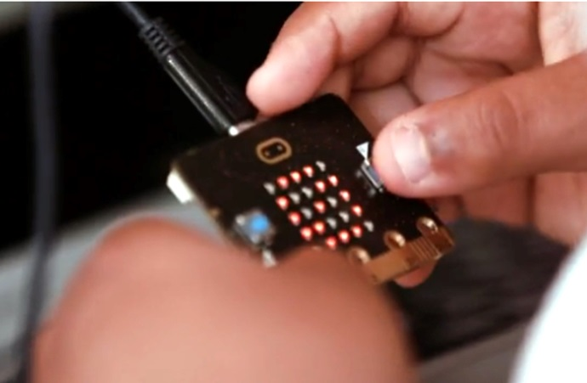

Library News from Miss O

School librarian Miss O'Neill recently held a competition for pupils to win a copy of David Almond's book Skellig. The pupils were challenged to show how they imagined an angel, in art, in words, in any way they liked. The entries were all of a very high standard, and the winners were: Weronika Badach, Kathleen Burns, Brooklyn Cunningham, Denise Foley, Rebecca Hardcastle, Alya Imran, Helga Joseph, Ryan Kenna, Ellie McDougall, Nicola Mc Garrity, Gabriel McNeill, Kevin Maguire, Caitlyn Murray, Mia Quinn, Alphi Robert, and Dominik Szczepkowski. They all got a certificate as well. All competition entries will be on display in the library at the start of the new school year.

Summer Reading
Reading for pleasure is a great way to relax over the summer holidays, whether you are at home, on the beach or in the park. It is also a fantastic way to improve your language skills and fire your imagination.
Your local library will always be able to recommend the latest and most popular books for your age and interests. Additionally, you can visit https://www.goodreads.com/ to access lists of the most popular books, voted by readers.
Books by classic authors have entertained readers for generations, and explored timeless themes about what makes us human: https://www.goodreads.com/shelf/show/classic-literature
“I read for pleasure, and that is the moment I learn the most.”
Margaret Atwood.



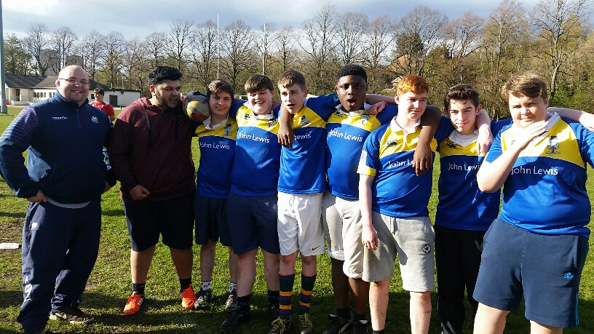
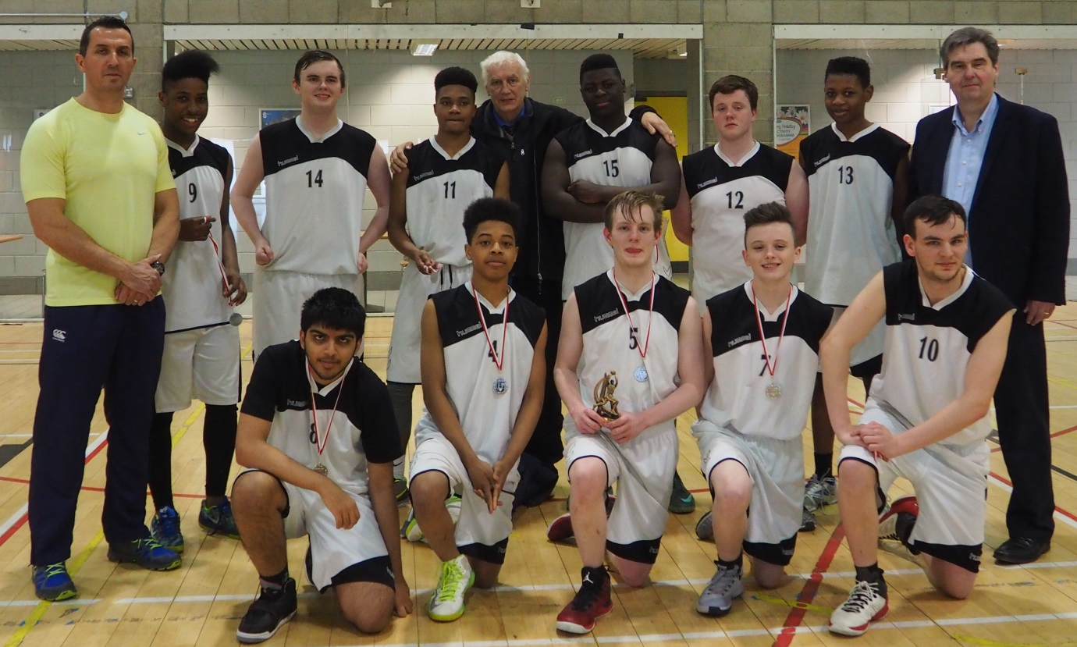

Sports Report

Rugby
Mr Lowe has been working alongside our local development officer in establishing a rugby club at Lourdes for the first time. The school now has under 14, 16 and 18 teams competing in local competitions. Next season there will be even more potential to get involved in for more games in a league format. The boys have had many opportunities to play at Cartha Rugby Club in 2016 with a particular mention to the under 14 team which took part in their first ever tournament on 4th May. The team did brilliantly well winning 3 out of 5 of their games against schools that have been competing for much longer than them – for some boys, it was their first ever game!.
Next year Marcus Goodwin in S6 will have the qualifications to coach along with our development officer and Mr Lowe. Training sessions are on a Wednesday after school along with games every 2-3 weeks, so the boys will be kept very busy. The rugby will develop throughout next year and we are confident there will be further success in the near future.

Football
It was a successful season for the Lourdes football teams this year with the under 16 team winning the Glasgow Cup Final versus Holyrood Secondary. This was a fantastic result for the boys where they played brilliantly well in the final to win. The under 18 team also had a great season getting to the final of the Glasgow Cup at Ibrox Stadium, unfortunately losing to Bishopbriggs. They beat some excellent teams to get to the final, and on another day, would have won the game. The under 18 team also reached the semi-final of the Scottish Cup narrowly being defeated on penalties after leading the game in the last period. There are high hopes for the team next year as some of the successful players that won the Glasgow Cup in S4 will be part of their team. Most of the under 18 team is made up of S5 boys who will be coming back hungry to gain silverware next year!
The girls’ football team have had another successful year getting to the semi-final of the Scottish Cup. There are a number of rising stars in the Lourdes team including Carly Girasoli getting into the Scotland squad which is a fantastic achievement for her.

Basketball
Lourdes has continued with the successes of previous years in basketball with all teams competing to a high level in their leagues and cups. The S1 team won the John Campbell cup beating St. Aloysius in the final by a large margin. The S1 team have very promising players that play in the local area basketball leagues, making our teams stronger.
The under 18 team came so close to winning the Glasgow Cup only to be defeated by Hillhead in the final by 3 points. The semi-final against St. Rochs was one of the most exciting games that had been seen for years. The Lourdes team were 12 points behind after the second quarter only to fight back and take the lead going into the third quarter; St. Rochs then came back to force overtime. During the 5 minutes of extra time, the Lourdes team played fantastically well and won the game by 4 points. They were also runner up in the Knightswood Cup competition, losing to St. Rochs in the final.

Under 18 runners up in Glasgow Cup

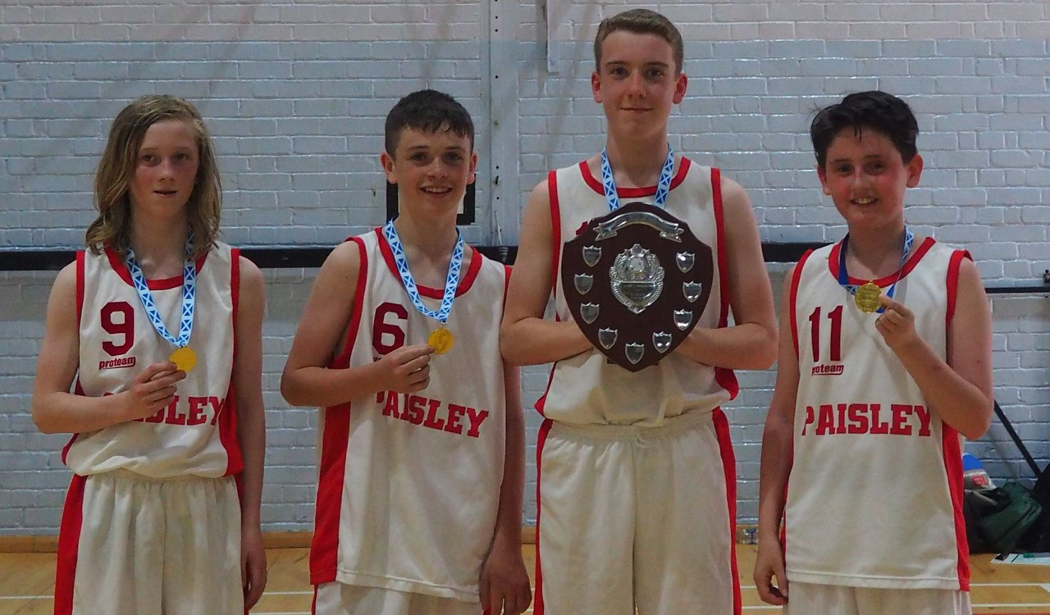

S1 John Campbell Cup Winners –
Oliver Power, Nathan Brown,
Matthew Beaton and Michael Andrew


Netball
The netball club has only recently started, but boasts very healthy numbers that attend on a Thursday after school. Ms Sellars, Mrs Dunn and Mr Fagan have been getting friendly fixtures organised for the girls in S1 and S2 to prepare them for the leagues they will be entering into next year. The girls played against Cardinal Newman High School and Rosshall and came out on top in each game. These schools have been involved in leagues for a number of seasons so our girls did extremely well to be able to compete and win the games. An exciting year lies ahead for the many girls that come along to training!

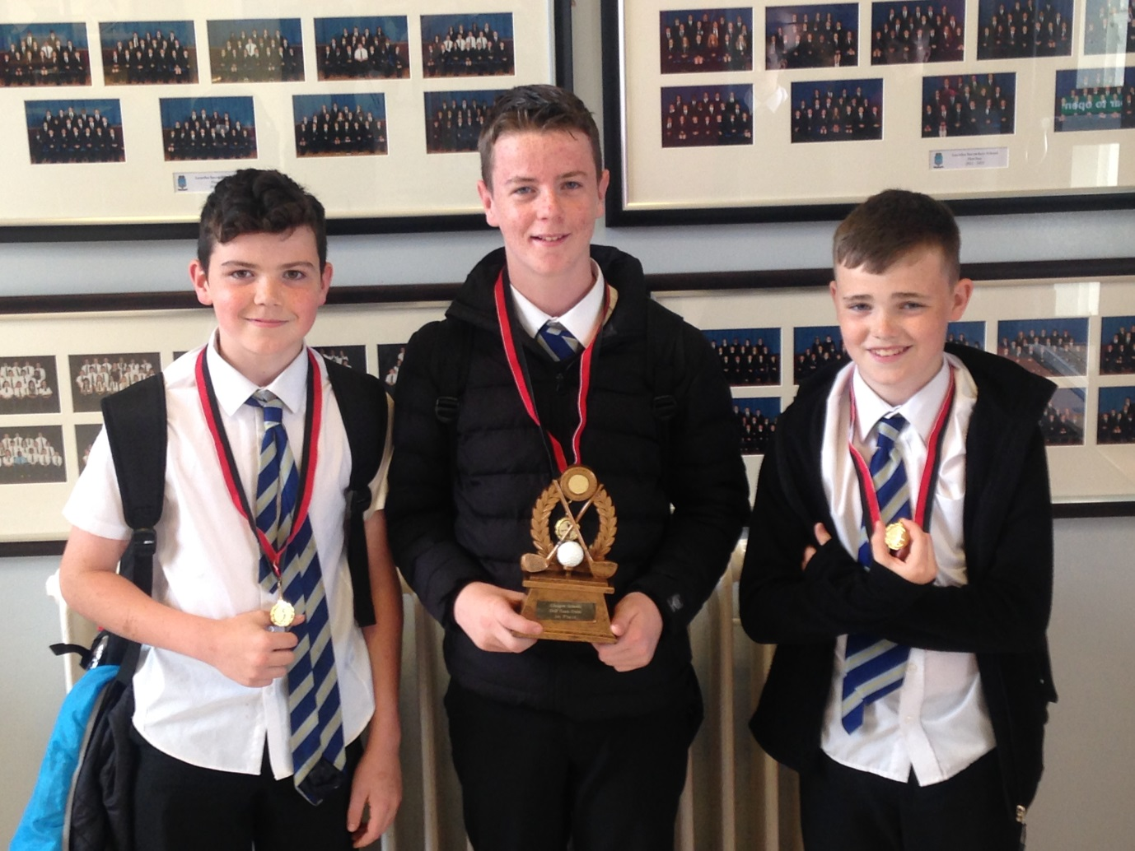
Golf
Lourdes entered the Glasgow Schools golf competition on 2nd June and picked up a first place winning a lovely trophy and medals for their efforts. Golf is a sport that Glasgow Competition is trying to develop so there will be some great opportunities coming up for our young people to get involved. Congratulations to the following boys:
Kerr Brooks / Rory Bogle / Daniel Elliot

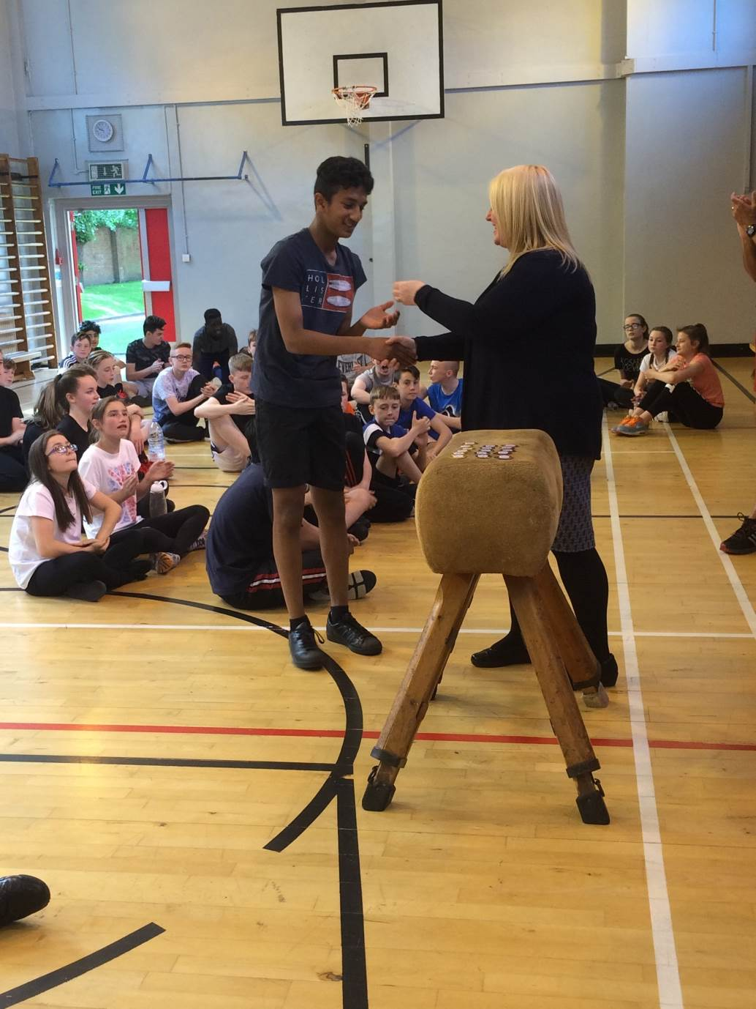
School Athletics Day and Heats
Lourdes athletes continue to strive to break records in their classes and on heats and finals day in athletics. The top times, distances and heights for all running events, shot putt and high jump are recorded in class with the top athletes being selected to come along to the heats. They then go up against all the other fastest, longest and highest pupils from the other classes to see who will go forward to the finals day.

Throughout the heats and finals there were some exceptional performances. In the high jump Nasser Salim jumped 1.55 metres off a scissor kick, winning gold by quite some margin. Chidera Nnamani won a very close 80 metres race only just beating Tashen Rajakaruna, posting an excellent time in the process. Chloe MacDonald also ran exceptionally well in the 800 metres winning a gold medal for herself. Jade Menzies won the 80 metres and 400 metres gaining an excellent 2 golds medals.
Congratulations go to every pupil that took part in the competitions.

Mrs Downie presenting a medal to Tashen

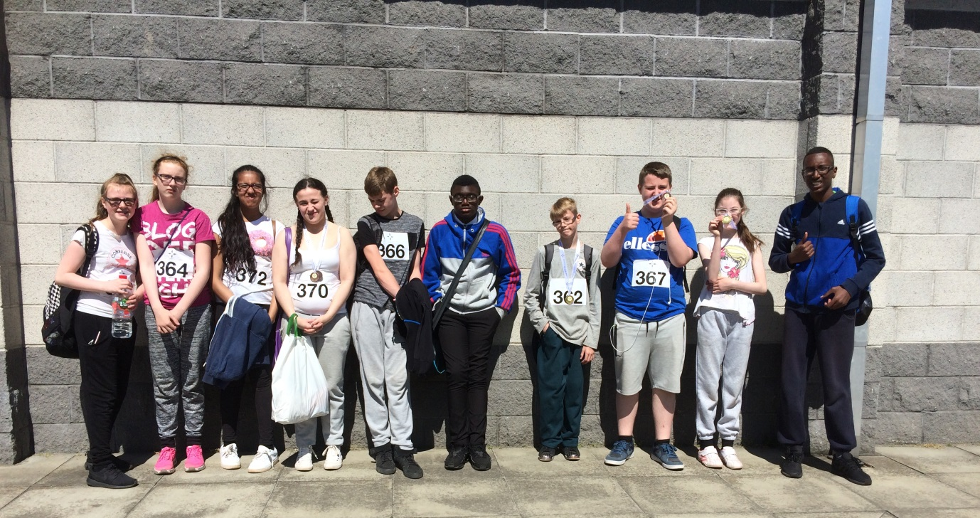
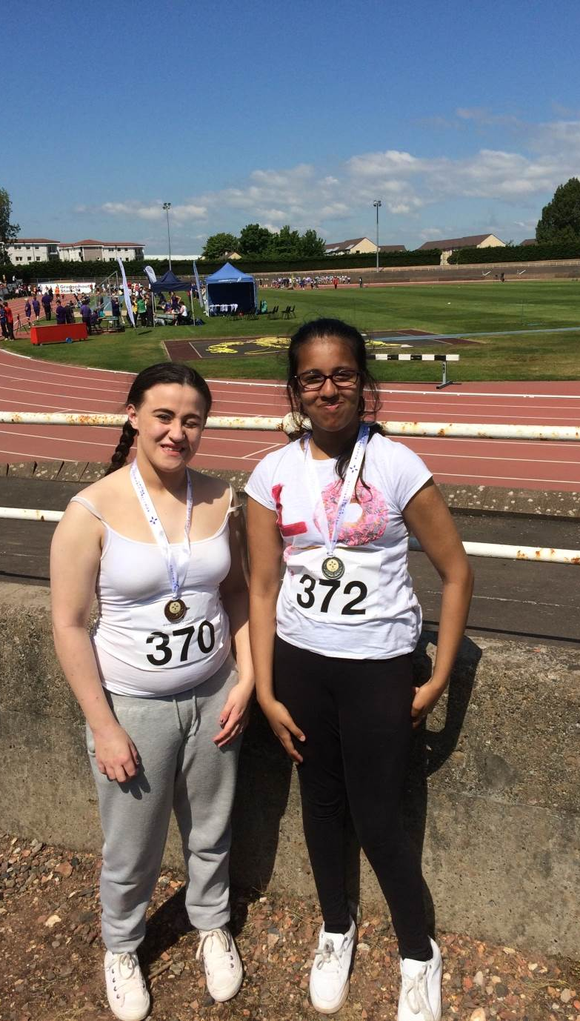
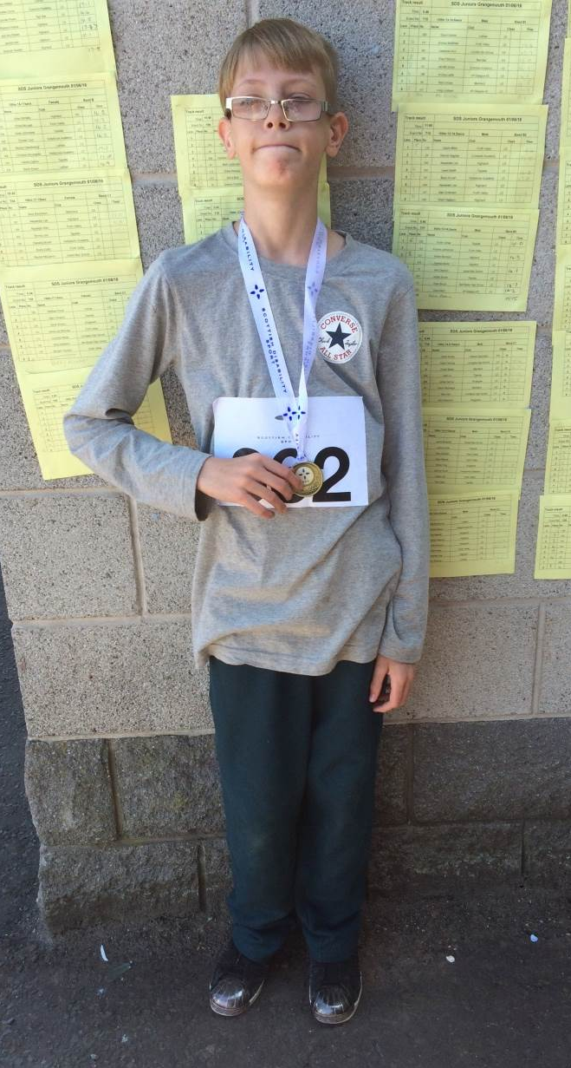
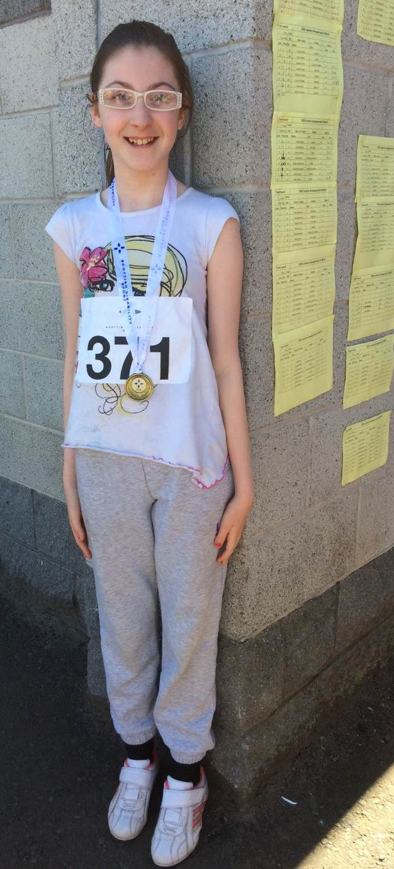
Disability Sports Athletics Championships

11 pupils from Lourdes were selected to compete at the Grangemouth event taking part in 60, 100 and 400 metres. This was the first time the school had sent a team to these championships and by all accounts, the pupils had a great day. Not only this, they came back with 10 medals – 2 golds, 5 silver and 3 bronze. Massive congratulations to all of our amazing athletes that took part.

Ryan Kenna – gold in the 60 metres.

Lauren O’Neill won silver in the 60 metres.
Zahra Bilal won silver in the 60 metres.

Robyn McGilp won a gold medal in the 60 metres.

Our participating Atheletes

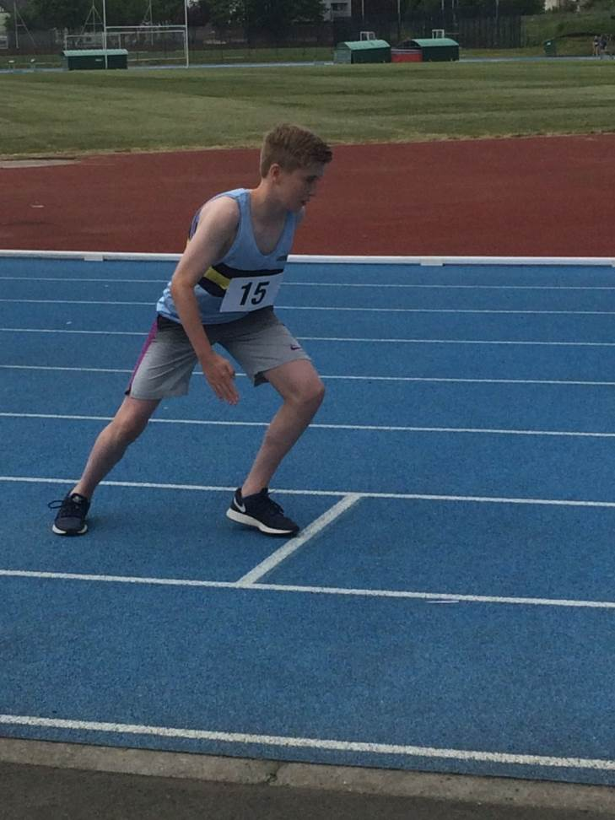
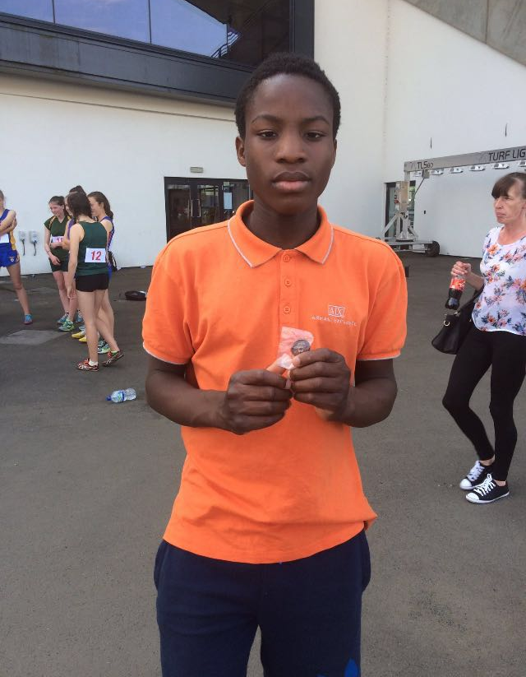
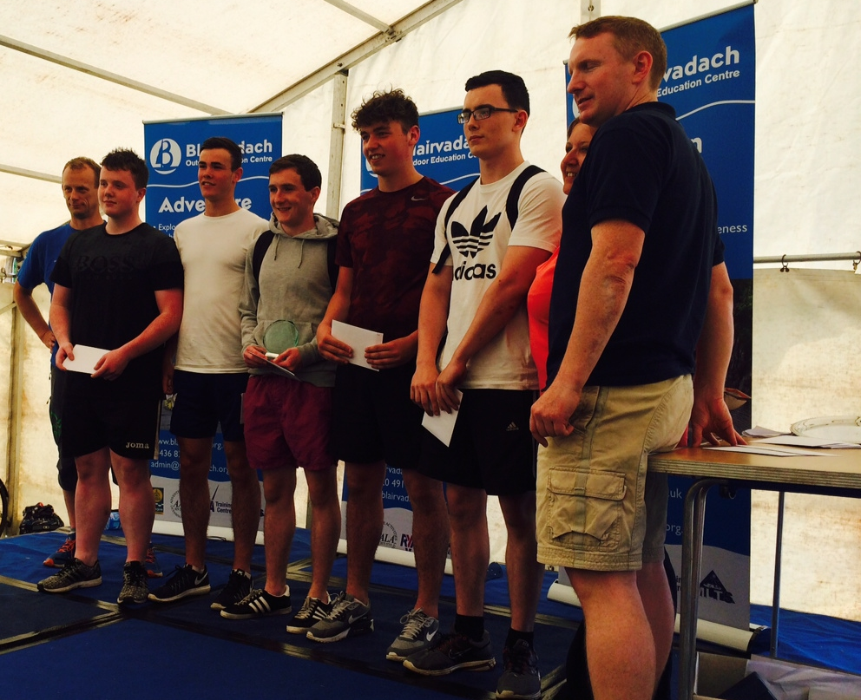
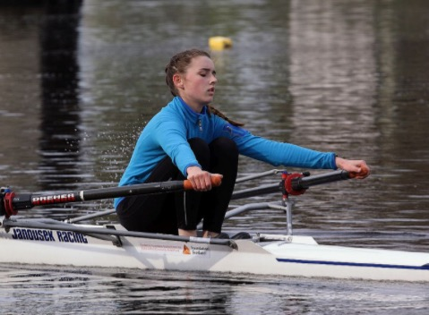
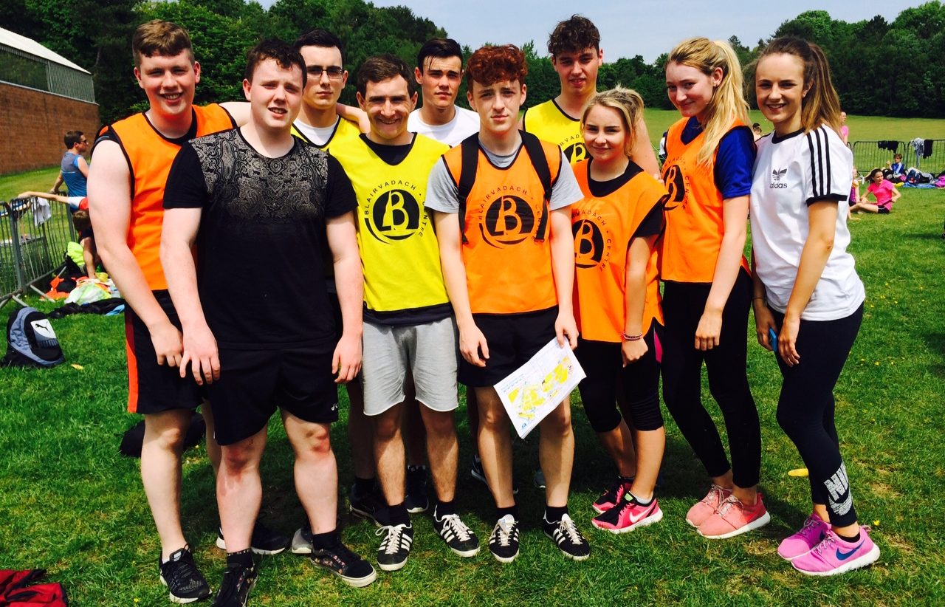
Glasgow School Athletics Championships
Glasgow Schools Athletics is an event where all schools send their best athletes to compete; the standard has always been very high. Lourdes sent a relatively small team to this event due to the timing of their athletics day. We still had 26 pupils going along to compete in track and field athletics. Oluwaseyi Fadun won a bronze medal for the school in the 800 metres, so a huge congratulation to him! Next year there will be more pupils going along to compete at this event and will be better prepared due to the school having an earlier sports day.

Adventure Race
10 senior pupils competed in this event for Lourdes where they had to cycle, climb, go over an obstacle course and complete a team challenge on a very hot day in Pollock Park on the 7th June. There were 19 teams and 15 schools taking part in the race. It was a team event where the pupils were timed on how long it took them to complete each stage of the course. We had 2 teams entered, one of them came 2nd very narrowly losing by 2 minutes – they took 96 minutes to complete the course, highlighting how close it was!! The pupils received a gift voucher worth £25 towards a bike and a lovely trophy for our school. Congratulations to the following pupils for their efforts:
Charlotte McLeod / Nicole Bonner / Gemma Lyons / Paul McCallum
Mitchell MacDonald / Mark McDaid / Rhys Fraser / Ryan Bayless / Andrew Eaglesham

Rowing
Rowan Andrew continues her quest to be the best at her age group and above in Scotland at rowing. She won the 2016 Regatta Race and we are sure there is much more to come.

She is such a committed individual who will undoubtedly reach her potential due to the determination she demonstrates continually to her training and races.

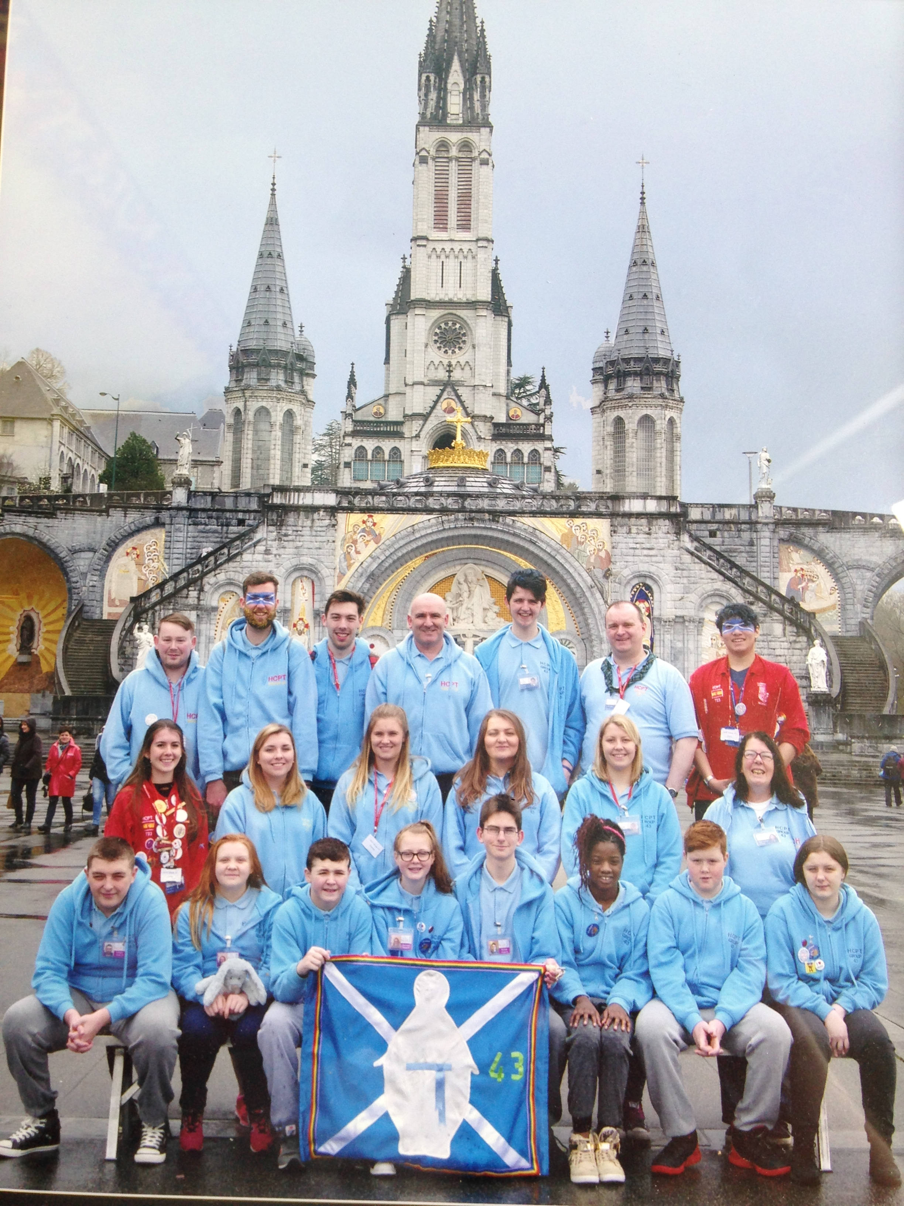
We sent four of our pupils on a pilgrimage to Lourdes for one week in April. The pupils departed from Glasgow Airport on Easter Sunday and were accompanied by the trained volunteers from HCPT Group 43.
In Lourdes, the pupils took part in many varied activities. Mass was celebrated every day. On one occasion it was celebrated in the underground basilica to celebrate the 60th anniversary of HCP; on another it was celebrated high up in the Pyrenees mountains! The group visited the Marian shrine at Lourdes and also the small house where Bernadette lived with her parents and siblings. The pupils learned about Bernadette’s life and how her family were very poor and the whole family stayed in a room half the size of a classroom.
The group also visited Hosanna House, which is where Bernadette went when she became a nun. They fed the rabbits and sheep, which are looked after in that area. Much fun was also had. A fancy dress party was held and the group went donkey riding in a place called Gavarnie which is up in the mountains. All of our pupils had a wonderful time and all have said that they would love to return one day!

Lourdes Pilgrimage Easter 2016

Scouting News

We are delighted to report the success that some of our pupils have had within the Scouts. Two of our Third Year pupils, Kerry Stevenson and Lauren Donnelly, have each won a Scouts’ Gold Award. The girls went to a training camp where they learned how to build fires, build gates and cook outdoors.
We are also delighted to announce that former pupil Rebecca Running has recently won a Queen’s Scout Award and to this end recently participated in the Queen’s Scouts Parade at Windsor Castle. As part of Rebecca’s activities for this award she went on an expedition to Indonesia and engaged in a conservation project with turtles. She is now at the university of Aberdeen studying Marine Biology.
Congratulations and well done to all!

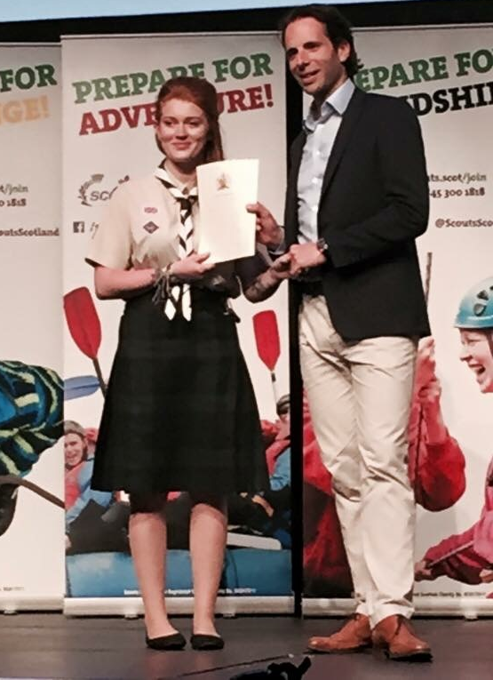
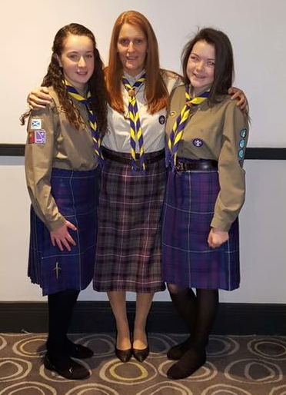

Blackpool Trip

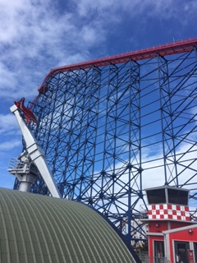
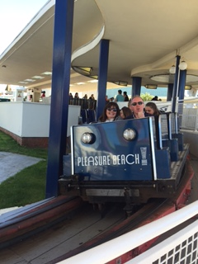
On the 20th June, almost 200 pupils from the new second, third and fourth year made the journey to Blackpool and its famous 'Pleasure Beach' theme park.
Despite the very early start, the group left in high spirits with many pupils (and staff) feeling very excited about trying out some of the park's most famous attractions such as 'The Big One' roller coaster and the 'Valhalla' water ride.
The buses arrived in Blackpool just in time for the sun to break through the clouds, providing staff and pupils with the perfect backdrop to enjoy the rides and attractions of the park.
All pupils behaved in an exemplary manner and were a credit to the school.



