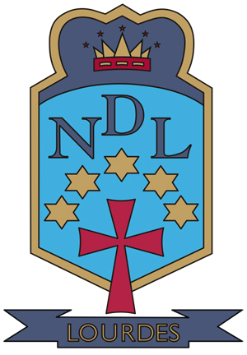


Summer Newsletter

June 2015

Summer Salutations

Dear Parent/Carer

This has been another successful year in Lourdes Secondary. As you will see from the many stories in the newsletter it has been a busy term to end a busy year. I am delighted to hear from feedback that our newsletters are very much enjoyed by parents and are giving you a real insight into the life of our school community. I am sure you will really enjoy this summer 2015 edition.

Our recent S1, S2 and S3 Award Ceremonies gave us a wonderful opportunity to celebrate all the learning, the many gifts, talents and the wide range of achievements demonstrated by our young people in those year groups. On each occasion our Concert Hall was full to capacity with happy students and proud parents. Congratulations to every pupil who received an award to celebrate your success! We are very proud of you all. Our website contains photographs taken at these events

https://blogs.glowscotland.org.uk/gc/LourdesSecondarySchool/

I would like to thank all parents for their support in maintaining a high standard of uniform across all year groups. Our uniform is an important symbol of the school in the wider community and the many favourable comments received from local residents is a clear indication that the smart appearance of our young people is highly regarded. I ask that you ensure that your child returns to school in August 2015 in full school uniform – shirt, tie, dress trousers or dress skirt, black shoes or completely black trainers and a blazer. Denims, leggings or any type of jeans should not be worn.

Trips to New York and Paris have taken place during these last two weeks of term and word from the organisers is that these have gone down very well. Our annual trip to Alton Towers takes place on Friday 19 June and Monday 22 June is our whole school day Activity Day, where activities like paintballing, go karting and a myriad of others can be enjoyed.

As we start to look forward to well-deserved holidays our S4-S6 pupils – and their parents – will soon be thinking about SQA results arriving in August. On behalf of all the staff in Lourdes I would like to wish all of our students the very best of luck and hope that they achieve results which will allow them to continue to build a positive future. I am looking forward to lots of positive news and well deserved awards for young people who have worked very hard.

May I wish you, and your families, an enjoyable summer and restful holiday.

With best wishes

Gerry McGuigan

Lourdes Secondary School 47 Kirriemuir Avenue Cardonald Glasgow G52 3DF
T: 0141 582 0180 F:0141 582 0181 W: www.lourdes-sec.glasgow.sch.uk




Former Art and Design student hits TOP MARKS!

Former student Peter Quinn has been awarded a First Class Degree in Interior Design from the prestigious Glasgow School of Art. Peter was a fantastic student who studied Standard Grade and Higher Art and Design through to an Advanced Higher Design Enquiry, where he made a decision in S6 to focus on Interior Design. Peter made the right decision and has already been interviewed for several exciting interior design jobs. Well done Peter!

Visiting Portrait and Figure Artist

Jackie Anderson


Internationally exhibited Glasgow artist Jackie Anderson visited the Art and Design Department in May 2015 to share her experience and art practice with pupils and staff. Pupils took part in a dialogue with Jackie regarding her influences, subject matter and painterly methods. This was an invaluable experience and one which will be built on in S4 when National 4 and National 5 students will have the opportunity to write about a contemporary artist. The art staff were impressed with the level of discussion and understanding of Jackie’s work the students demonstrated and we look forward to seeing her work influence both the student’s written and practical art work.


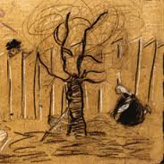
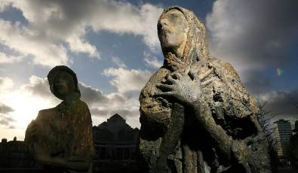

Holocaust Memorial Experience
S3 Art and Design pupils visited St Mungo’s Museum of Religion and experience a very intimate dialogue with Holocaust survivor Ella Weisberger. Focussing on the paintings she created as a child in the death camps. Her Art teacher kept her focussed on being positive by expressing her vision through her art.
Pupils were moved by the artwork and Ella’s words of the past.

Irish Famine Memorial Project
S5 Erin McEvoy and Vlada Shumko were granted a fantastic opportunity to take part in a live Glasgow art student project to organise a piece of public art in the form of a sculpture pathway. The sculpture pathway will be located in Glasgow Green and will combine public art and a garden walkway. This project is designed to remind us of the struggles of the past where many Irish people fled to Glasgow due to famine . Students researched the concept of the famine memorial, they met with artists, made site visits to the location and over a few months had meetings with council officials. The students presented their concepts and preferred artist(s)to the council. There has been a substantial amount of funding for this project (thousands of pounds!), next session the winning artist(s) will start work on site. We will keep you updated on their progress!


This summer four new S6 students have been selected, against fierce competition to represent Lourdes Secondary in the famous Ardentinny Summer Art Course. Along-with 60 – 80 students from all across Glagow the students will travel to Ardentinny Outdoor Centre, living and creating art for a week. While there, they will explore the great outdoors (hail rain or shine) and create a wide range of art and design works from land art to photography to nature inspired fashion! Students’ work will then be exhibited in the Tramway, Glasgow next term. For many buddying artists this is their chance to exhibition their work for the first time. We will watch the art careers of Emily Boyd, Vlada Shumko, Danielle Donaghy and Erin McEvoy blossom!

Ardentinny Art

GSA S4 Summer Art Course


This summer we look forward to seeing some lucky S4 take part in a week long course at Glasgow School of Art! Eve, Elisa, Rachel, Luke, Samantha and Philip will join 20 other pupils from across Scotland to focus on exciting creative techniques in drawing and making.

GSA: The Big Crit

3 lucky S6 students from Lourdes Secondary will take part in THE BIG CRIT at Glasgow School of Art on Wednesday 17th June 2015. Students will tour the annual degree shows of the Design School, the Fine Art School and the school of Architecture. They will then receive training on how to be an Art Critic for the day. This is an invaluable experience which will develop their understanding of contemporary art and design and develop their Higher Order Thinking Skills (HOTS) where they will experience analysing, evaluating, understanding the creative processes. We wish the students well and look forward to reading their critical reviews of the Glasgow art scene.

School Show Props
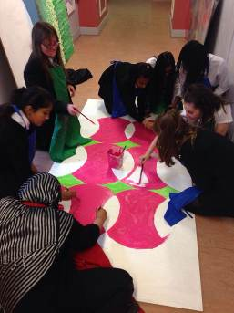
The Art Dept would like to give a huge shout out of thanks to all the pupils who helped paint and create scenery and props for the school shows.
The Dept has been very impressed by the responsibility and enthusiasm of these pupils and we encourage these students to pursue their artistic dreams and aspirations ☺

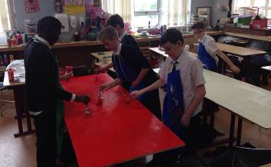



Dancing In Yer Street

Last week the Performing Arts Department put on five fantastic performances of the new musical Dancin’ in yer Street written by our very own Mr Sweeney and Mrs Simpson. The department would like to thank all staff and departments involved with the show for their hard work and dedication. Many months of rehearsals, production and organisation had been put into producing such a top quality show and I am sure, those who attended, would agree the pupils put on a superb performance!

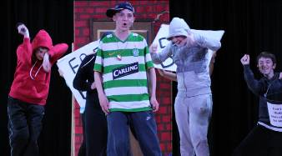
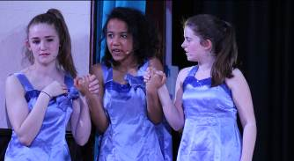
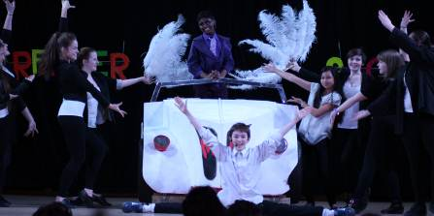
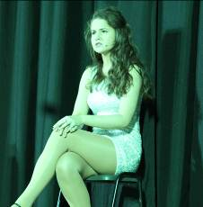
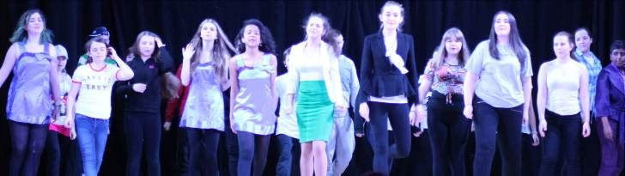
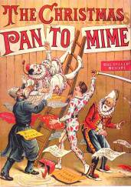


“This was such a joy to come and see. The gallus humour came through strongly and the songs were wonderful. Ab fab! What stars!”

“Absolutely incredible! Terrific music, great acting. Haven't laughed so much for ages!”

“Brilliant show. Funny, heart-warming and made you feel all the emotions it should. Live music was amazing and all the cast were amazing. Brilliantly written. Totally loved it.”

“Absolutely wonderful! What a talented bunch – front & backstage.”

“Fantastic, polished performance. Lots of stars in the making. Who knew so many teachers could dance?!”

“This was terrific because of the terrific talent that has been developed here at Lourdes.”

“Superb show! Catchy tunes, harmonies to die for, comedy, sing-a-longs and great dancing. I'll be dancing in MY street tonight!”

If you missed Dancing In Yer Street, don’t panic! You can still the wonderfully talented pupils we have!

The Performing Arts Department will be back with a Panto Spectacular the week before Christmas – so make sure your diaries are free that week and please watch out for further information at the beginning of term.

During all performances of Dancing In Yer Street we had a Comments Corner where you could give your thoughts on the performance you saw.

Here is a selection of your fantastic quotes!

Coming soon – Oh no it isn’t, oh yes it is!
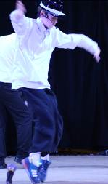
This talented group of young men have had a very successful year and have been developing their skills with great success. This year they have been working on music by The Script, Ed Sheeran, Wham! and Hozier to name but a few. The boys have also been working on strengthening their voices through vocal exercises and have been learning how to sing harmonies. Watch this space folks, the skies the limit for this group!
As a culmination of this hard work and commitment the boys have completed brilliant, professional performances. The first performance of the year was at the department’s Christmas concert, which was a tremendous effort. The B sharps also provided a show-stealing performance in our School Show “Dancin’ In Yer Street.” For this performance the boys channelled their inner Michael Jackson, wowed the audience with their dance moves, and as always their singing, accompanied brilliantly on the Guitar by Joseph and Mark. The boys should really be commended for their effort, skills and commitment to this group. It is growing in numbers and the boys are getting better and better every rehearsal. Well done boys – what a BRILLIANT year of work!

The B#’s

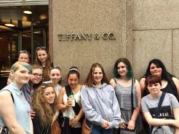


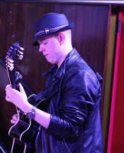
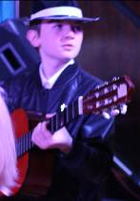
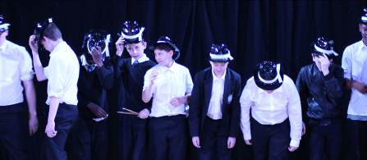


Lourdes hit the Big Apple
From the 15th-19th of June 2015, 38 pupils plus Mrs Gray, Mrs Beaton, Mrs Carpy, Mr McLellan and Mr Peck visited New York. During our trip pupils saw a number of iconic New York landscapes including the Statue of Liberty, Grand Central station, Central Park and Times Square. We also scaled the Empire State Building for breath taking views of Manhattan. Pupils had the chance to feel like Broadway stars by taking part in a workshop run by Broadway performers in the Manhattan Theatre Club followed by a performance of Aladdin The Musical. There was also the chance to spend a few of our hard earned dollars during a visit to Bloomingdales and Macy’s department store before heading back to Glasgow.

Behind the Noise
Congratulations to the S5 pupils involved in the ‘Behind The Noise’ project this year. Erin McEvoy (vocals), Courtney Mackin (vocals), Seamus Brady (guitar), Ross Mills (bass guitar) and Joshua McBride (drums) formed a band called ‘Green Light District’ and participated in a number of music industry based workshops and recording sessions. The project finished with a spectacular performance at the sold out ‘Gig at the Grand’ at the Classic Grand in Glasgow!



Paris 2015

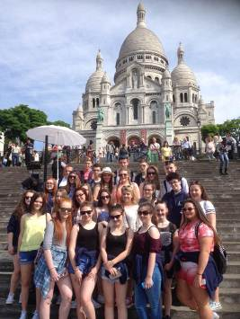
On the 15th of June, 29 of our young people in S3 set off for Paris. We visited the Sacre Coeur & MontMartre, the Eiffel Tower and the Champs Elysée. We enjoyed a boat trip on the River Seine and we also spent a day at Euro Disney. The pupils were able to practise their French listening and talking skills and had a great time working out what different words meant on signs and in menus. Well done to all the pupils who participated as they were excellent ambassadors for Lourdes Secondary School.

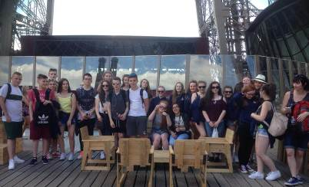


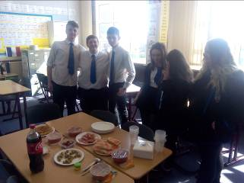

S3 Languages for Life and Work Award
Congratulations to all of our S3 pupils who have successfully completed the SQA Languages for Life & Work Award. They have worked very hard this year to complete 3 units: Languages for Life, Languages for Work and Building Employability Skills. Mrs. Hamill from Jobs & Business Glasgow worked with each class to complete the Employability Unit and our young people demonstrated some of the skills and knowledge required for the world of work. SQA certificates are in the post.

National 4 Spanish Fiesta
To celebrate the success of our S5 and S6 pupils passing all their National 4 Spanish Units, Jennifer (our Spanish foreign language assistant) and Mrs. Ritchie prepared a Spanish tapas lunch.

Everyone enjoyed tasting typical Spanish dishes!


Modern Languages Pupils of the month

The following pupils were awarded pupil of the month in Modern Languages for May 2015!
Bon Travail!
Class | Pupil
1/1 | Matthew Donaghy
1/2 | Alphi Robert
1/3 | Katie Kerr
1/4 | Amy Parker
1/5 | Christopher Gallacher
1F6 | Kristen McConnell
1F7 | Alya Imran
1/8 | Olivia Lauter
2/1 | Ellie Russell
2/2 | Rachel McGirr
2/3 | Stephen O’Connell
2/4 | Jack MacLeod
2/5 | Janet Johnny
2/6 | Adam Wilson
2/7 | Bernard Watson
2/8 | Adrian Grzymkowski
3C1 | Erin Maguire
3C2 | Liam Docherty
3C3 | Dylan Whitten
3D1 | Casey Pyper
3D2 | Emma Neary
3D3 | Puoja Rajendram






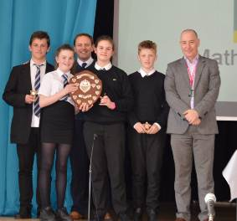

UKMT Challenges
Each year the UK Mathematics Trust holds 3 competitions throughout the year for all secondary schools. The following pupils were awarded certificates.

Junior Challenge
S1 Silver Winners: Amy Paterson (Best in Year), Jhozef Sheldia, Drew Garry, Suzannah McNulty
S1 Bronze winners: Morgan Grant, Laura Stewart, Emma McConville, Dilina Loku Yaddehig Shaheen Walizada
Ross Menzies, Olivia Watret, Lewis McNab,Weronika Badach

S2 Gold Winner who progresses to next round: Danny Menzies (Also Best in School and Best in Year)
S2 Silver Winners: Thomas Joyce, Charlotte Fraser
S2 Bronze Winners: Sairah Amjad, Dylan Paterson, Daniel Welsh, Paul Woulfe, Bernard Watson, Eileen O’Sullivan, Kaitlyn Rodger

Intermediate Challenge
S3 Bronze Winner and Best in Year: Ohiaofe Nnamani
S4 Bronze Winners: Adil Sattar (Best in Year and Best in School), Hannah O’Sullivan, Jakub Choluj, Jenna Ritchie, Ryan McAree, Lois McGougan

Senior Challenge
S5 Silver Winner, Best in Year and Best in School: Scott Callaghan
S5 Bronze Winner: John Campbell
S6 Bronze Winners: Ciaran Mulcahy (Best in Year), Scott Ferguson, Rachael Todd

Glasgow Schools Maths Challenge
All Secondary schools in Glasgow were invited to compete in the Glasgow School’s Maths Challenge on Friday 5th June. Teams had to work through two rounds of problems. It was a close call and the top 5 teams were split by only 5 points! From 23 teams, Lourdes Secondary triumphed! Congratulations to Jhozef Sheldia, Amy Paterson, Drew Garry and Morgan Grant!

Lourdes Secondary Primary Maths Challenge
Mrs Chapman’s S4 class took part in the annual Mathematiques sans frontieres competition and have placed in the top 10. This competition is open to all Secondary schools in Scotland and consists of maths problems, two of which are written in French and have to be answered in French. Placing in the top 10 is quite an achievement! They will find out their final placing at the Award Ceremony on Thursday 18th June.

Maths Sans Frontieres
On Thursday 4th June, Lourdes Secondary’s Maths Department held their fourth Primary Maths Challenge event.
Once again, schools entered two teams into the competition, meaning pupils were competing against each other and to be the best team in their school!! Rounds included solving Math-anagrams, Countdown puzzles, Logic Round and the Relay race. At the half way point, teams from two schools were tied for first place!
Previous winners Lourdes Primary retained the trophy with an excellent performance in the final two rounds with Our Lady of the Rosary Primary finishing as runners up. The victorious team were delighted to be awarded the trophy, presented by Mr McGuigan.


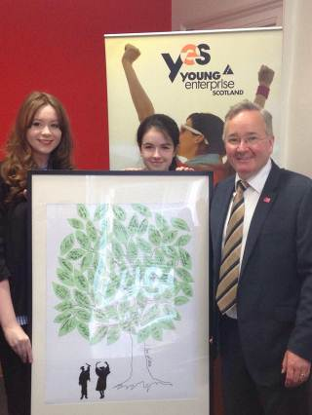

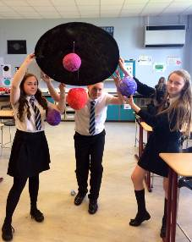

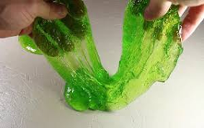
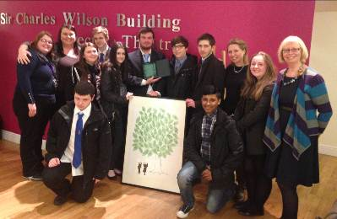
Our S6 Young Enterprise Group InsigniUs triumphed at the Glasgow area board finals with a win for Most Innovative Company. The group created a signature souvenir for school leavers, weddings or for any bespoke large gathering a customer might have.
Their innovative idea attracted the eyes of the judges and especially the eye of the Chief Executive of Young Enterprise Scotland Geoff Leask who invited the team to Young Enterprise Headquarters to do a case study on their success with their product and their learning throughout the programme. The pupils were met by the leader of the City Council Gordon Matheson and congratulated on their successful product and company.
The company have been a delight to work with and we hope they continue to go from strength to strength.

InsigniUs Success
Miss Dunn and Miss McCaughey setup a Science Club this session for S1-3 pupils. The pupils meet after school every Wedensady to do lots of cool and exciting experiments. The club have made: slime; fireworks and sparklers; optical illusions; fire writing; lava lamps; indicator flowers; bath bombs; solar eclipse viewers and solar system models. Look out for the Science Club next session!


Lourdes’ Pro-Life Group ran a ‘Life week’ in the school from the 1-5th June. The twin focus of the event was The Right to Life and what we can do to protect Life.
There were a range of pupil-lead activities; including cake stalls and the sale of Fathers’ Day gifts as well as visiting speakers such as John Deighan of SPUC who addressed a large number of S2 pupils. A lunchtime mass was celebrated in the oratory which was well attended by staff and pupils who enjoyed refreshments together afterwards. Eucharistic Adoration was held on the final day of Life Week and a number of staff and pupils took the opportunity to spend a few moments of silence in front of the Blessed Sacrament.

A Life Tree was displayed in the front entrance and a large number of pupils and staff took the opportunity to donate baby-care items such as wipes and talcum powder to The Cardinal Winning Pro-life Initiative. The items will be passed to new or expectant mothers who are experiencing financial hardship. The Pro-Life group wish to express their gratitude to all those who contributed or supported our events in any way.

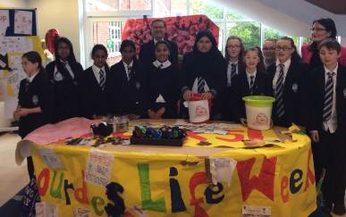

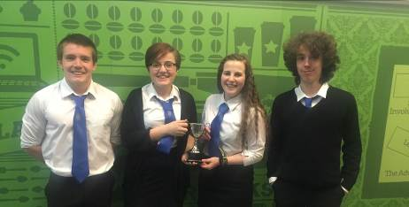

Joy Cowan, Jennifer Finn, Matthew McShane and Daniel Carlton (all new S6) won ‘The Debate League Cup’ competition at the start of June.

They took part in 3 debates on topics including reality TV and what should be taught in an English classroom and beat 5 other Glasgow schools to take home the cup.

Our Duke of Edinburgh Award pupils Ethan McIlwaine, Scott Callaghan, Lewis Kerr, Matthew McShane, Mhairi Sheridan and Caitlin Sloey alongside Mrs Chainey and Mr Flannagan have just completed the expedition part of their Bronze Award.
The pupils put in a grueling shift of walking for several hours before pitching their tents in the leafy forrest near Aberfoyle.
All pupils successfully completed the challenge and are raring to go for the next one!

Pitching up!

Debating stars!

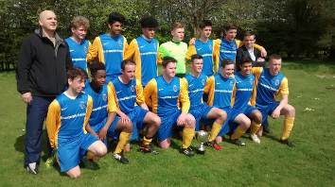


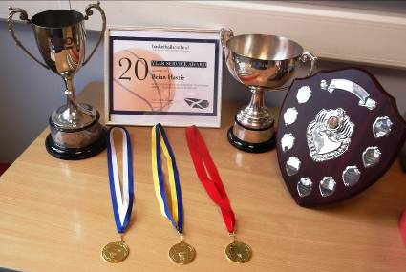

The boys U/18s Basketball team completed another successful season by winning the Glasgow League and the Knightswood Cup to add to the Glasgow Cup they won earlier.
This treble makes them the most successful Basketball Team in the history of Lourdes Secondary. Since S2, when they won the U/14’S Double, they have won Trophies in S3, S4 (the U/16’s), S5 and S6.
As most of the boys were in S6, they will leave school as Triple Double Winners! Congratulations! Three different boys, Josh McAlpine, Stephen Hume and Thomas McGoran won the 3 Most Valuable Player awards in the 3 finals, but it was a great, season long, Team Effort under pressure that kept a winning mentality intact. Well Done to all!
I would like to thank Donald and Sarah for their coaching expertise and patience with me over the years that we have taken the team. It has been an amazing journey and it would not have been possible, without their help.
In their final, with 10 minutes to go, we were winning by 10 points and I finally stopped shouting instructions and sat down to watch history unfold. I was very proud of them and their confidence to see the game out. They didn’t need me anymore and I felt my job was done. I don’t expect to see their likes again.
B. Hastie

The under 16 football team had another successful season winning the RS McColl Cup and, unfortunately, being beaten narrowly in the semi-final of the league championship, ironically by the team whom they beat in the final of the cup competition. Next year they will progress to senior level where they again, hope to be competing for the honours on offer.


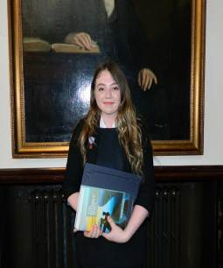

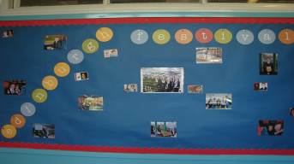


English Department News
One of our S6 pupils did extremely well in being selected as one of the final 16 young people in Scotland for the Young Scottish Writers of the Year Award. Laura Murphy had to write a piece of non-fiction of 1000 words which was one of over 200 entries. Laura, along with Mr Peck, attended the awards ceremony on Friday 12th June at the Royal College of Surgeons and Physicians on St Vincent St in Glasgow. Laura was given a commendation for her work and received a certificate and a collection of writing.

Young Scottish Writers of the Year

New Book Group!
A new book group has started for all of our keen readers in S1-S3. The readers gather every lunchtime and are given the opportunity to read some of the new titles for young people. The group discuss the books and go on to consider aspects of the text such as character and theme. The group is ably led by Carly Horne and Lee Haggarty in S3.

In August the English Department will be taking groups of S1-S3 pupils to the Edinburgh Book Festival. Pupils will have the chance to listen to authors speak, ask questions, purchase new books and generally soak up the festival atmosphere. Any pupils who would like the opportunity to be involved should let Ms Baker know as soon as possible.

Edinburgh Book Festival


Yeargroup | Pastoral Care Teacher
S1 | Mr MacKinnon
S2 | Mr Downes
S3 | Mrs Black
S4 | To be confirmed
S5/6 | Mrs Kennedy/Mrs Hughes


Year Group | Depute Head Teacher
S1 and S6 | Mrs Downie
S2 and S3 | Mr Kerr
S4 | Ms Cairney
S5 | Mrs Devine

The Named Person in Lourdes Secondary School
GIRFEC stands for ‘Getting It Right For Every Child’. Part of The Children and Young People Act (Scotland) 2014, it is the Scottish Government-led approach to making sure that our children and young people – and their parents or carers – can get all the help and support they need from birth right through to age 18 (or beyond if still in school).

The vast majority of Scotland’s children and young people get the love and support they need from within their families and their wider, local communities. But even the most loving and caring families can sometimes need extra support. The GIRFEC approach aims to make it as easy as possible for any child or young person (and their parents) to get that help or support if they need it.

To provide that support when needed, every child in Scotland has a named individual, the Named Person, as a single point of contact. This Named Person has a responsibility to provide help and support when asked and can draw together other services if needed, co-ordinating help for the child or parents. Please do not hesitate to contact your child’s Named Person at any time.

The Named Person in Lourdes Secondary School is the Principal Teacher of Pastoral Care.

From August 2015 we are changing the structure of Pastoral Care. Pastoral care will no longer be delivered by House groups. Each year group will be supported by one Pastoral Care teacher as follows:

Mrs Dolan will be the Pastoral Care teacher for pupils who access the ALN provision and for a small number of pupils in S1/3 after discussion with parents and staff.

Pastoral Care staff will lead a group of Tutors for each year group who will work with a group of 20 pupils.

In Lourdes Secondary the Pastoral Care staff are supported by Depute Headteachers. We have a new Depute Head Teacher joining us in August – Welcome to Mr Monaghan.

The Depute Headteachers will work with the following year groups this session:



Your Say – Parental Questionnaires Feedback
Thank you to all parents who responded to our questionnaires this spring.
Your feedback is very important to us and helps to inform our future plans.

Some of your feedback included:

98% of parents are happy with the school

98% of parents say their child feels safe at school

98% of parents feel their child’s learning is progressing well.

95% of you said the school is helping your child to become more confident

YOU SAID:
- I feel my child is doing well at Lourdes and I feel it’s the best school in the area.
- All children are treated fairly and are encouraged to be the best that they can be.
- I am very pleased that my children are in Lourdes Secondary School. Thank you to the teachers that are supporting my children.



Period | Time
1 | 8.50-9.35am
2 | 9.35-10.20am
3 | 10.20-11.05am
Interval | 11.05-11.20am
MY Time | 11.20-11.35am
4 | 11.35-12.20pm
5 | 12.20-1.05pm
Lunchtime | 1.05-1.45pm
6 | 1.45-2.30pm
7 | 2.30-3.15pm

Changes to our school day
As you are aware the structure of our school day will be changing from the start of term in August. School will now end at 3.15pm every day. Detailed below is the new daily structure that will be in place for the pupils return in August.

Return Date for Teachers | Tuesday 11 August 2015
Return Date for Pupils | Thursday 13 August 2015
September Weekend | Friday 25 and Monday 28 September 2015
First Mid-Term | Monday 12 to Friday 16 October 2015  (inclusive)
In-service Day | Monday 19 October 2015
Christmas/New Year | Wednesday 23 December 2015 to Tuesday 5 January 2016  (inclusive)  * Please note that the school will close at 2.30pm on the last school day before the holiday
2016 Return to School | Wednesday 6 January 2016
Second Mid-Term | Monday 15 and Tuesday 16 February 2016
In-service Day | Wednesday 17 February 2015
Good Friday  Spring Holiday (Easter) | Good Friday 25 March 2016 and Easter Monday 28 March 2016  Monday 4 to Friday 15 April 2016  (inclusive)  * Please note that schools will close at 2.30pm on the last school day before the holiday
May Day | Monday 2 May 2016
In-service Day/Election day | Thursday 6th May
May Weekend | Friday 27 and Monday 30 May 2016
School Close | Friday 24 June 2016  * Please note that school will close at 1pm on the last school day before the holiday


Dates for your diary

Important Liturgical Dates
All Saints Day Sunday 1st November

Ash Wednesday Wednesday 10th February

Our Lady of Lourdes Day Thursday 11th February

Ascension of the Lord Thursday 5th May

Happy Summer Holidays from the staff and pupils

at Lourdes Secondary School


