**Numeracy**

We are learning:

* 4 operation strategies
* Ordering and comparing numbers
* Area
* Money
* Shape

**Primary 5**

**Term Two**

**Curriculum Map**

Visit our blog

*https://blogs.glowscotland.org.uk/gc/2021stalbertsp5/*

**Learning for Sustainability**

* We are learning about COP26
* Amal Project

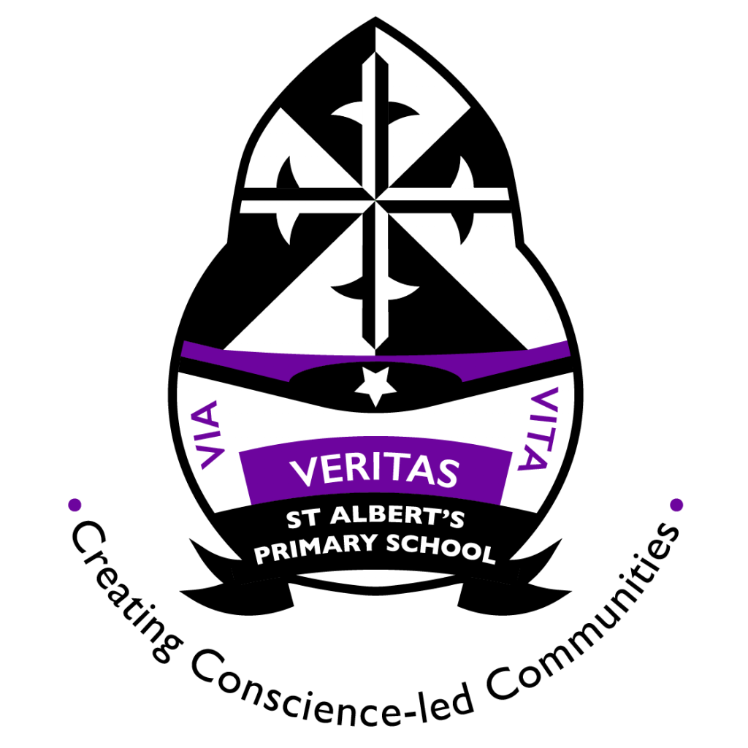

**Our local community**

* Park visits
* Christmas fare
* Window wanderland

**Literacy**

* We are learning to visualise, predict, infer and summarise when reading
* We are learning to write persuasive texts and poetry.
* Handwriting.
* Philosophy discussions for talking and listening.

**R.E.**

* Advent
* St Albert and St Andrew

**Expressive Arts**

* COP26 art exhibition
* Samba

**Science Technology/ Forest School**

* Biodiversity and Interdependence
* Classification
* Food Webs

**Health and Wellbeing**

* Substance misuse
* Health and Relationships
* Hygiene and textiles

**P.E**

* Badminton
* Football

**Things you can do at home**

* Spelling
* Termly art task
* Bug Club reading books online
* Times table practice
* Sumdog

**Useful Websites**

* <https://www.activelearnprimary.co.uk/login?c=0>
* https://www.sumdog.com/user/sign_in